## **Source: Samsung Electronics Co., Ltd.**

## **Title: [FS_eiRTCW] Proposed updates on PD**

## **Document for: Discussion and Agreement**

## **Agenda Item: 10.6**

1. **Introduction**

This contribution proposes to update the FS_eiRTCW Permanent Document v0.0.1 (S4-220516) to clarify the following points:

* What have been done in WebRTC access to IMS specified in TS 23.228 for stage 2 and TS 24.317 for stage 3, respectively
* Scope of iRTCW
* Handling of SDP in WebRTC

1. **Proposed updates**
2. Scope

The present document extends immersive Real-time Communication for WebRTC (iRTCW) and introduces a new concept called native WebRTC signalling.

In 3GPP, the use of WebRTC technology has been investigated since Rel-12 (around 2014). They are a network-based architecture for WebRTC access to IMS specified in Annex U to TS 23.228 and its stage 3 protocols specified in TS 24.371. They define functional entities including WIC (WebRTC IMS Client) and eP-CSCF (P-CSCF enhanced for WebRTC). The eP-CSCF is assumed to be located in the Home IMS domain and communicates with other IMS entities using the existing interfaces. For the C-plane signalling between WIC and eP-CSCF, those specifications specify an option to use SIP over WebSocket, whose information model can be used for options other than SIP and WebSocket. Although SIP satisfies almost all conversational applications, it is somewhat over-engineered or too strict to extend. Another method which is flexible, extensible, and can be optimized for new XR conversational applications, therefore, should be investigated. These requirements remind us of the original design principle of WebRTC. WebRTC, by its inherent characteristics, does not regulate C-plane signalling and allow a wide range of C-plane signalling. This study looks over this design principle again and investigates a new SIP-decoupled C-plane signalling, called native WebRTC.

Regarding the level of signalling details, TS 24.371 specifies a signalling transport mechanism using SIP over WebSocket, but it is not a mandatory mechanism for eP-SCSF. Even though there are other options such as XMPP or other application protocols over WebSocket, a RESTful based interface, etc., TS 24.371 does not specify any details of C-plane signalling using other options. Each service provider (e.g., operator) develops its own application by following the guidelines in TS 24.371. Its subscriber downloads the application and connects to the service and other subscribers only within the same service. Detailed C-plane signalling is left open to each operator’s design. In contrast, this study tries to identify a new C-plane signalling in detail (as an interface specification) to the extent that client implementations based on it have enough interoperability. This realizes connectivity to any operators or roaming services for new XR real-time communications. Operators can provide the interface common to them according to well-defined C-plane signalling specifications. Clients can connect to any operators via the interface (see Figure1).

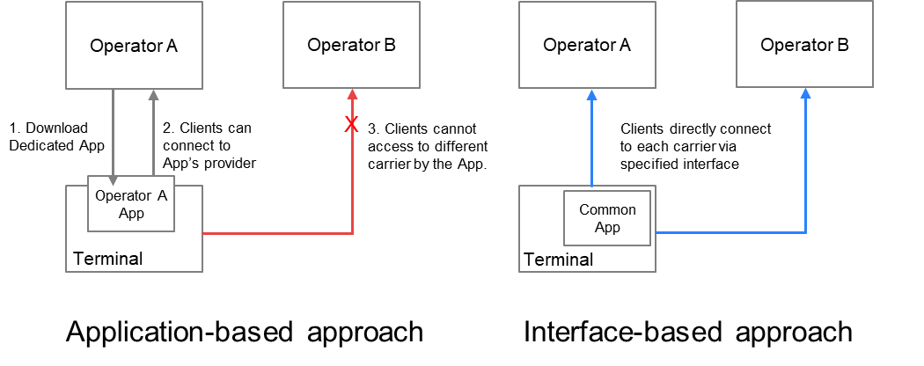

Figure 1. Two approaches for defining specifications and their application connectivity

2 Motivations for Native WebRTC Signalling

2.1 C-plane Signalling comparison

The C-plane signalling can be expressed as follows. Now, there are roughly four possible methods, classified in terms of their protocol stacks (see Figure 2).

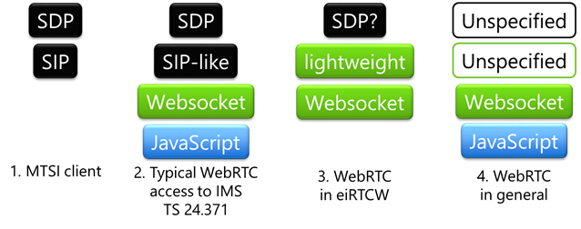

**Figure 2. Comparison of protocol stacks**

The first method is MTSI-based, using SIP and SDP. General C-plane signalling requirements for conversational services can be covered by SIP. Interoperability is fine with the existing 5G core network. It is to be treated in IMS-based AR Conversational Services (IBACS).

The second is the method specified in TS 24.371. It enables the WebRTC clients to communicate over an IMS-based core network; only the interfaces for downloading dedicated applications and the signalling path using WebSocket are specified for C-plane signalling. Ordinary implementations adopt SIP-like protocols over WebSocket. In most cases, it is partially SIP-compliant or tightly coupled with SIP to adapt WebRTC clients in IMS domain.

The third method is an alternative to the second method that uses SIP-like protocol over WebSocket. The third method uses another signalling protocol over WebSocket, but SIP-decoupled approaches are investigated. It can be more lightweight, omitting features that is not used in XR conversational. Some constraints on SDP are necessary for interoperability. Non-browser based implementations are also in the scope. This method is the main subject of this study, FS_eiRTCW.

The other is a general WebRTC protocol stack that is not specified and left open to the users (i.e., service providers). C-plane may be SIP, XMPP, http, etc. The application can encode SDP into any other formats and use its own mechanism to send the encoded SDP to the remote peer..

Editor’s Note:   
- The reason why WebRTC signalling is necessary  
- Comparison interworking between WebRTC signalling and existing SIP

1. **Proposal**

We propose to agree the proposed corrections in section 2 and integrate it into FS_eiRTCW Permanent Document.