**Agenda item:** 10.6

**Source:** China Mobile Com. Corporation

**Title:** **A Use Case for one-on-one Communication Method**

**Document for** Discussion andAgreement

# Introduction

In this contribution, we propose 3D Video Call as a use case for one-on-one communication method.

# A Use Case for one-on-one Communication Method

3D Telepresence is a real-time bidirectional video communication system that enables two people to communicate at distance as if they were physically together. Using the benefits of WebRTC, we can combine 3D Telepresence with a regular video call service. It offers users a more natural and intuitive way for remote connection.

3D Video Call establishes a one-on-one communication between users to guarantee low latency and high security holographic communication experience. The 3D video stream and the audio stream are being compressed and real-time transmitted over WebRTC protocol. Both ends support incoming and outgoing calls.

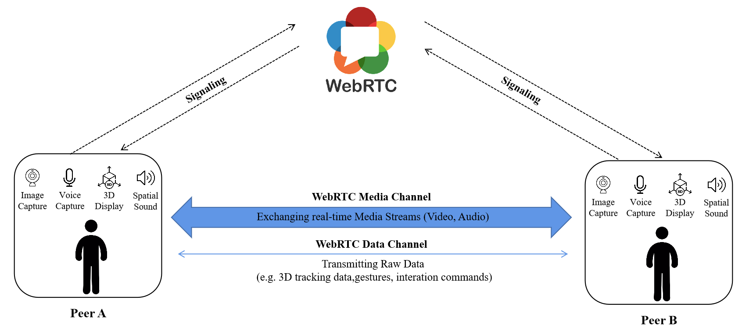

For example, Alice sits in a conference room in Midtown Manhattan, there are cameras, microphones, and sensors to capture her image, voice and movements from multiple vantage points. The captured imagery and voice get transmitted in real-time to the remote peer Bob, who is working in his studio in Boston. Both of them can see each other’s imagery in three dimensions and also hear the voice. They can talk naturally with the full range of communication cues, such as eye contact, hand gestures, and body languages. The whole experience makes them feel like they’re actually sitting in the same room.

# Proposal

We propose to include section 2 of this document into clause 3 of the permanent document as a use case for discussion.

# References

[1] W3C, “WebRTC 1.0: Real-Time Communication Between Browsers”, W3C Recommendation 26 January 2021

[2] Project starline: a high-fidelity telepresence system. ACM Trans. Graph. 40, 6, Article 242 (December 2021), 16 pages. https://doi.org/10.1145/3478513.3480490