**3GPP TSG-SA WG4 Meeting #119e *S4-220695***

**, 2022**

|  |  |  |  |  |  |  |  |  |
| --- | --- | --- | --- | --- | --- | --- | --- | --- |
| *CR-Form-v12.2* | | | | | | | | |
| **draft CHANGE REQUEST** | | | | | | | | |
|  | | | | | | | | |
|  | **26.346** | **CR** |  | **rev** | **-** | **Current version:** | **17.0.0** |  |
|  | | | | | | | | |
| *For* [***HE******LP***](http://www.3gpp.org/3G_Specs/CRs.htm#_blank)*on using this form: comprehensive instructions can be found at* [*http://www.3gpp.org/Change-Requests*](http://www.3gpp.org/Change-Requests)*.* | | | | | | | | |
|  | | | | | | | | |

|  |  |  |  |  |  |  |  |  |
| --- | --- | --- | --- | --- | --- | --- | --- | --- |
| ***Proposed change affects:*** | UICC apps |  | ME | **x** | Radio Access Network |  | Core Network | **x** |

|  |  |  |  |  |  |  |  |  |  |  |
| --- | --- | --- | --- | --- | --- | --- | --- | --- | --- | --- |
|  | | | | | | | | | | |
| ***Title:*** | [5MBP3]: Feature reduced FLUTE FDT Schema | | | | | | | | | |
|  |  | | | | | | | | | |
| ***Source to WG:*** |  | | | | | | | | | |
| ***Source to TSG:*** | S4 | | | | | | | | | |
|  |  | | | | | | | | | |
| ***Work item code:*** | 5MBP3 | | | | |  | ***Date:*** | | | 31.3.2022 |
|  |  | | | |  | |  | | |  |
| ***Category:*** | B |  | | | | | ***Release:*** | | |  |
|  | *Use one of the following categories:* ***F*** *(correction)* ***A*** *(mirror corresponding to a change in an earlier release)* ***B*** *(addition of feature),* ***C*** *(functional modification of feature)* ***D*** *(editorial modification)*  Detailed explanations of the above categories can be found in 3GPP [TR 21.900](http://www.3gpp.org/ftp/Specs/html-info/21900.htm). | | | | | | | | *Use one of the following releases: Rel-8 (Release 8) Rel-9 (Release 9) Rel-10 (Release 10) Rel-11 (Release 11) … Rel-16 (Release 16) Rel-17 (Release 17) Rel-18 (Release 18) Rel-19 (Release 19)* | |
|  |  | | | | | | | | | |
| ***Reason for change:*** | | There are many FLUTE FDT Schema extension defined over the years. 5MBS supports only the MBMS Download Delivery Profile as defined in Annex L.4. It is therefore reasonable, that new 5MBS Client and MBSTFs can use a schema according to Annex L.4. | | | | | | | | |
|  | |  | | | | | | | | |
| ***Summary of change:*** | | A new FLUTE FDT Scheme is provided, which only contains features according to the FLUTE Profile from Annex L.4. A new heading is inserted in Clause 7.3.2 to make the hanging paragraph referencable. | | | | | | | | |
|  | |  | | | | | | | | |
| ***Consequences if not approved:*** | |  | | | | | | | | |
|  | |  | | | | | | | | |
| ***Clauses affected:*** | | 7.3.2, L.6 (new) | | | | | | | | |
|  | |  | | | | | | | | |
|  | | **Y** | **N** |  | | | |  | | |
| ***Other specs*** | |  |  | Other core specifications | | | | TS/TR ... CR ... | | |
| ***affected:*** | |  |  | Test specifications | | | | TS/TR ... CR ... | | |
| ***(show related CRs)*** | |  |  | O&M Specifications | | | | TS/TR ... CR ... | | |
|  | |  | | | | | | | | |
| ***Other comments:*** | |  | | | | | | | | |
|  | |  | | | | | | | | |
| ***This CR's revision history:*** | |  | | | | | | | | |

## Agreement from offline

1: Avoid Copying, work with reference

2: extend 26.346, adding a terminology mapping sections, this is ffs

3: extend 26.346, adding a new 2022 FDT schema, which removes all the profiled out elements (Annex L.4) from the schema

4: 26.517 should reference 26.346, offering a fully backward compatible solution, and this new schema.

5: 26.517 may need to define a new SDP line for MBS Service Type.

6: SDP & QOS, hmmm

7: Similar “referencing” for Packet Distribution

**** First Change ****

### 7.3.2 SDP Parameters for MBMS download session

#### 7.3.2.0 General

The semantics of a Session Description of an MBMS download session includes the following parameters:

- The sender IP address.

- The number of channels in the session.

- The destination IP address and port number for each channel in the session per media.

- The Transport Session Identifier (TSI) of the session.

- The start time and end time of the session.

- The protocol ID (i.e. FLUTE/UDP).

- Media type(s) and fmt-list.

- Data rate using existing SDP bandwidth modifiers.

- Mode of MBMS bearer per media.

- FEC capabilities and related parameters.

- Service-language(s) per media.

- QoE Metrics (as defined in sub-clauses 8.3.2.1 and 8.4).

- Alternative TMGI

This list includes the parameters required by FLUTE in RFC 3926 [9]

These shall be expressed in SDP ([14] and [15]) syntax according to the following clauses.

**** Second Change ****

# L.6 Profiled FLUTE FDT schema

## L.6.1 Profiled FLUTE FDT syntax

The following is the definition of the FDT schema. The name of the file is FLUTE-FDT-3GPP-Main-2022.xsd.

Listing L.6.1‑1: FDT schema definition FLUTE-FDT-3GPP-Main-2022.xsd

|  |
| --- |
| <?xml version="1.0" encoding="UTF-8"?>  <xs:schema  xmlns="urn:3GPP:metadata:2022:FLUTE:FDT"  xmlns:xs="http://www.w3.org/2001/XMLSchema"  targetNamespace="urn:3GPP:metadata:2022:FLUTE:FDT"  elementFormDefault="qualified"  version="1">  <xs:element name="FDT-Instance" type="FDT-InstanceType"/>  <xs:complexType name="FDT-InstanceType">  <xs:sequence>  <xs:element name="File" type="FileType" maxOccurs="unbounded"/>  <xs:element name="schemaVersion" type="xs:unsignedInt"/>  <xs:element name="delimiter" type="DelimiterType"/>  <xs:any namespace="##other" processContents="skip" minOccurs="0" maxOccurs="unbounded"/>  </xs:sequence>  <xs:attribute name="Expires" type="xs:string" use="required"/>  <xs:attribute name="Complete" type="xs:boolean" use="optional"/>  <xs:attribute name="Content-Type" type="xs:string" use="optional"/>  <xs:attribute name="Content-Encoding" type="xs:string" use="optional"/>  <xs:attribute name="FEC-OTI-FEC-Encoding-ID" type="xs:unsignedLong" use="optional"/>  <xs:attribute name="FEC-OTI-FEC-Instance-ID" type="xs:unsignedLong" use="optional"/>  <xs:attribute name="FEC-OTI-Maximum-Source-Block-Length" type="xs:unsignedLong" use="optional"/>  <xs:attribute name="FEC-OTI-Encoding-Symbol-Length" type="xs:unsignedLong" use="optional"/>  <xs:attribute name="FEC-OTI-Max-Number-of-Encoding-Symbols" type="xs:unsignedLong" use="optional"/>  <xs:attribute name="FEC-OTI-Scheme-Specific-Info" type="xs:base64Binary" use="optional"/>  <xs:anyAttribute processContents="skip"/>  </xs:complexType>  <xs:complexType name="FileType">  <xs:sequence>  <xs:element name="Cache-Control" type="CacheControlType" minOccurs="0"/>  <xs:element name="delimiter" type="DelimiterType"/>  <xs:any namespace="##other" processContents="skip" minOccurs="0" maxOccurs="unbounded"/>  </xs:sequence>  <xs:attribute name="Expires" type="xs:string" use="optional"/>  <xs:attribute name="Content-Location" type="xs:anyURI" use="required"/>  <xs:attribute name="TOI" type="xs:positiveInteger" use="required"/>  <xs:attribute name="Content-Length" type="xs:unsignedLong" use="optional"/>  <xs:attribute name="Transfer-Length" type="xs:unsignedLong" use="optional"/>  <xs:attribute name="Content-Type" type="xs:string" use="optional"/>  <xs:attribute name="Content-Encoding" type="xs:string" use="optional"/>  <xs:attribute name="Content-MD5" type="xs:base64Binary" use="optional"/>  <xs:attribute name="FEC-OTI-FEC-Encoding-ID" type="xs:unsignedLong" use="optional"/>  <xs:attribute name="FEC-OTI-FEC-Instance-ID" type="xs:unsignedLong" use="optional"/>  <xs:attribute name="FEC-OTI-Maximum-Source-Block-Length" type="xs:unsignedLong" use="optional"/>  <xs:attribute name="FEC-OTI-Encoding-Symbol-Length" type="xs:unsignedLong" use="optional"/>  <xs:attribute name="FEC-OTI-Max-Number-of-Encoding-Symbols" type="xs:unsignedLong" use="optional"/>  <xs:attribute name="FEC-OTI-Scheme-Specific-Info" type="xs:base64Binary" use="optional"/>  <xs:attribute name="FEC-Redundancy-Level" type="xs:unsignedInt" use="optional"/>  <xs:attribute name="File-ETag" type="xs:string" use="optional"/>  <xs:anyAttribute processContents="skip"/>  </xs:complexType>  <xs:complexType name="CacheControlType">  <xs:choice>  <xs:element name="no-cache" type="xs:boolean" fixed="true"/>  <xs:element name="max-stale" type="xs:boolean" fixed="true"/>  <xs:element name="Expires" type="xs:unsignedInt"/>  </xs:choice>  <xs:anyAttribute processContents="skip"/>  </xs:complexType>  <xs:simpleType name="DelimiterType">  <xs:restriction base="xs:byte"/>  </xs:simpleType></xs:schema> |

The syntax defined by the above schema is illustrated in figure L.6.1‑1 below.

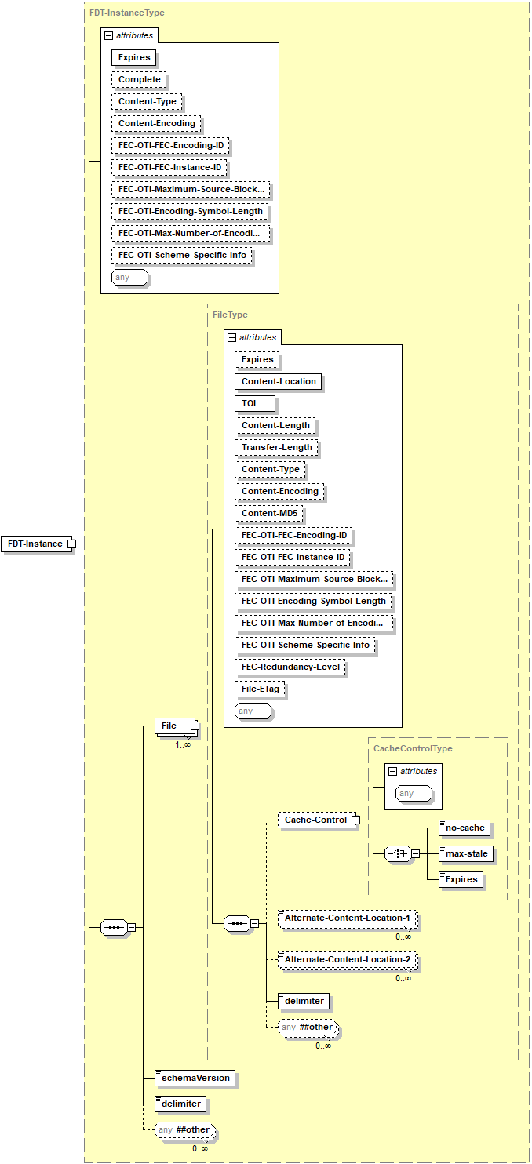

Figure L.6.1‑1: Visualisation of FDT schema FLUTE-FDT-3GPP-Main-2022.xsd

## L.6.2 Profiled FLUTE FDT semantics

The semantics of the elements and attributes defined in the schema at clause L.6.1 are as follows.

- When the optional *File@Expires* attribute is provided, its value shall take precedence over that of the *FDT@Expires* attribute.

- The child elements of the *Cache-Control* element are defined in clause 7.2.13.

- The attribute *FEC-Redundancy-Level* is defined in clause 7.2.10.6.

- The *File-ETag* represents the value of the Etag, or entity-tag as defined in RFC 2616 [18] which may also serve as the version identifier of the file object described by the FDT Instance.

NOTE: The signalling of object repair within the FDT Instances is for further study.

## L.6.3 Schema version signalling

The schema defined in clause L.6.1 defines two XML Schema elements necessary for the receiver and the sender side to maintain forward and backward compatibility: *schemaVersion* and *delimiter*.

- The schema *version* attribute (part of the schema instruction) shall be included in the FDT schema defined in clause L.6.2 and its value shall be 1.

- The sender shall set the *schemaVersion* element, defined as a child of *FDT-Instance* element, to 1 in all instance documents that comply with the schema defined in clause L.6.2.

NOTE: The value of the *schemaVersion* element and *version* attribute is intended to be increased by 1 in every future release where new element(s) or attribute(s) are added to the schema definition.

When a receiver receives an FDT instance document compliant with this schema, it shall determine the schema version required to parse the instantiation as follows:

- If the receiver supports one or more versions of the FDT schema with the schema *version* attribute, then it shall use the schema that has the highest schema *version* attribute value that is equal to or less than the value in the received *schemaVersion* element;

- The *delimiter* element shall be set by the network to a value of 0, and the element content shall be ignored by the receiver.

## L.6.4 Example of FDT

Listing L.6.4‑1: Example FDT schem instance compliant with clause L.6.2

|  |
| --- |
| <?xml version="1.0" encoding="UTF-8"?>  <FDT-Instance  xmlns="urn:3GPP:metadata:2022:FLUTE:FDT"  xmlns:xsi="http://www.w3.org/2001/XMLSchema-instance"  xsi:schemaLocation="urn:3GPP:metadata:2022:FLUTE:FDT FLUTE-FDT-3GPP-Main-2022.xsd"  Expires="331129600">  <File  Content-Type="application/sdp"  Content-Length="7543"  TOI="2"  FEC-OTI-FEC-Encoding-ID="1"  FEC-OTI-Maximum-Source-Block-Length="8192"  FEC-OTI-Encoding-Symbol-Length="16"  FEC-OTI-Scheme-Specific-Info="AAECCA=="  Content-Location="<http://www.example.com/fancy-session/main.sdp>">  <Cache-Control>  <Expires>331129630</Expires>  </Cache-Control>  <delimiter>0</delimiter>  </File>  <File  Content-Type="String"  Content-Length="161934"  Expires="331129200"  TOI="3"  FEC-OTI-FEC-Encoding-ID="1"  FEC-OTI-Maximum-Source-Block-Length="8192"  FEC-OTI-Encoding-Symbol-Length="200"  FEC-OTI-Scheme-Specific-Info="AAECCA=="  Content-Location="http://www.example.com/fancy-session/trailer.3gp">  <delimiter>0</delimiter>  </File>  <schemaVersion>1</schemaVersion>  <delimiter>0</delimiter>  </FDT-Instance> |

**** Last Change ****