**3GPP TSG- S4 Meeting #116e *S4-211516***

**Electronic Meeting, 10th November – 19th November 2021**

|  |  |  |  |  |  |  |  |  |
| --- | --- | --- | --- | --- | --- | --- | --- | --- |
| *CR-Form-v12.1* | | | | | | | | |
| **Pseudo CHANGE REQUEST** | | | | | | | | |
|  | | | | | | | | |
|  | **26.502** | **CR** | **<CR#>** | **Rev** | **<Rev#>** | **Current version:** | **<Version#>** |  |
|  | | | | | | | | |
| *For* [***HE******LP***](http://www.3gpp.org/3G_Specs/CRs.htm#_blank)*on using this form: comprehensive instructions can be found at* [*http://www.3gpp.org/Change-Requests*](http://www.3gpp.org/Change-Requests)*.* | | | | | | | | |
|  | | | | | | | | |

|  |  |  |  |  |  |  |  |  |
| --- | --- | --- | --- | --- | --- | --- | --- | --- |
| ***Proposed change affects:*** | UICC apps |  | ME |  | Radio Access Network |  | Core Network |  |

|  |  |  |  |  |  |  |  |  |  |  |
| --- | --- | --- | --- | --- | --- | --- | --- | --- | --- | --- |
|  | | | | | | | | | | |
| ***Title:*** | [5MBUSA] Annex A: Deployment Models | | | | | | | | | |
|  |  | | | | | | | | | |
| ***Source to WG:*** | Ericsson LM | | | | | | | | | |
| ***Source to TSG:*** | S4 | | | | | | | | | |
|  |  | | | | | | | | | |
| ***Work item code:*** | 5MBUSA | | | | |  | ***Date:*** | | | <Res_date> |
|  |  | | | |  | |  | | |  |
| ***Category:*** | **<Cat>** |  | | | | | ***Release:*** | | | <Release> |
|  | *Use one of the following categories:* ***F*** *(correction)* ***A*** *(mirror corresponding to a change in an earlier release)* ***B*** *(addition of feature),* ***C*** *(functional modification of feature)* ***D*** *(editorial modification)*  Detailed explanations of the above categories can be found in 3GPP [TR 21.900](http://www.3gpp.org/ftp/Specs/html-info/21900.htm). | | | | | | | | *Use one of the following releases: Rel-8 (Release 8) Rel-9 (Release 9) Rel-10 (Release 10) Rel-11 (Release 11) … Rel-15 (Release 15) Rel-16 (Release 16) Rel-17 (Release 17) Rel-18 (Release 18)* | |
|  |  | | | | | | | | | |
| ***Reason for change:*** | |  | | | | | | | | |
|  | |  | | | | | | | | |
| ***Summary of change:*** | | This document presents a set of relevant deployment options, which should be considered during the 5MBUSA design. The deployments will later help readers to understand the specification. | | | | | | | | |
|  | |  | | | | | | | | |
| ***Consequences if not approved:*** | |  | | | | | | | | |
|  | |  | | | | | | | | |
| ***Clauses affected:*** | | A | | | | | | | | |
|  | |  | | | | | | | | |
|  | | **Y** | **N** |  | | | |  | | |
| ***Other specs*** | |  |  | Other core specifications | | | | TS/TR ... CR ... | | |
| ***affected:*** | |  |  | Test specifications | | | | TS/TR ... CR ... | | |
| ***(show related CRs)*** | |  |  | O&M Specifications | | | | TS/TR ... CR ... | | |
|  | |  | | | | | | | | |
| ***Other comments:*** | |  | | | | | | | | |
|  | |  | | | | | | | | |
| ***This CR's revision history:*** | |  | | | | | | | | |

**** First Change ****

# A.1 Group Communication

Editor’s Note: This clause should contain a deployment model for Group Communication.

# A.2 5G Media Streaming

Editor’s Note: Reference to TS 26.501.

# A.3 AF/AS in Trusted DN

Figure A.3-1 depicts a collaboration in which the AF/AS (MBS Application Provider) is deployed within the Trusted DN.

1. The AF/AS uses the Nmbsf service directly at reference point Nmb10.

2. The MBSTF injects packets into the MB‑UPF via reference point Nmb9.

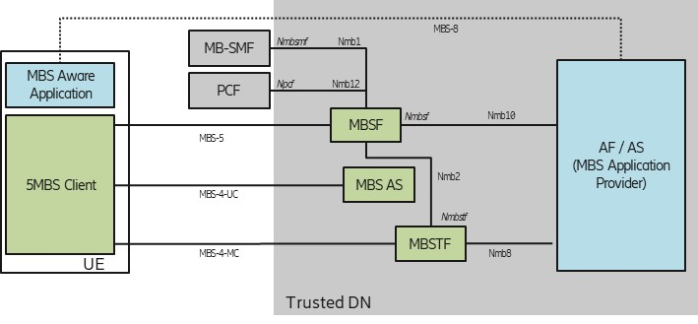

NOTE: Italic type is used to annotate service-based interactions.

Figure A.3-1: Deployment with AF/AS in Trusted DN

# A.4 AF/AS in external DN

Figure A.4-1 depicts a collaboration in which the AF/AS (MBS Application Provider) is deployed within the External DN.

1. The AF/AS invokes the Nnef service at reference point N33 to access the MBSF via the NEF. The NEF, in turn, invokes the Nmbsf service on the MBSF at reference point Nmb5 on behalf of the AF/AS.

2. The MBSTF injects packets into the MB‑UPF via reference point Nmb9.

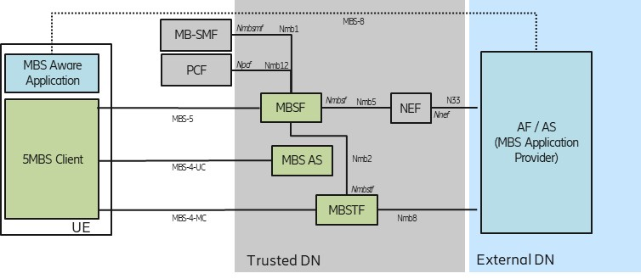

NOTE: Italic type is used to annotate service-based interactions.

Figure A.4-1: Deployment with AF/AS in External DN

# A.5 MBSF/MBSTF-like functions in External DN

Figure A.5-1 depicts a transport-only deployment.

1. The MBSF-like function provisions MBS Services in the MB‑SMF via the Nnef service at reference point N33.

2 The AF/AS (MBS Application Provider) uses an MBSTF-like function to produce packet data compliant with reference point MBS‑4‑MC. The packets are injected directly into the MB-UPF at reference point N6mb (not shown).

3. An AF/AS (MBS Application Provider) in an External DN uses an MBSF-like function to generate a Service Announcement for MBS User Services.

4. The AF/AS (MBS Application Provider) makes file repair available from an MBS AS-like function that is compliant with reference point MBS‑4‑UC.

The MBSF-like, MBSTF-like and MBS AS-like functions produce data streams which are compliant with the present document. Although the 5G System sets up a Transport-only Mode (see Option 1 in Annex A of TS 23.247 [5]), the 5MBS Client in the UE follows the procedures defined in the present document.

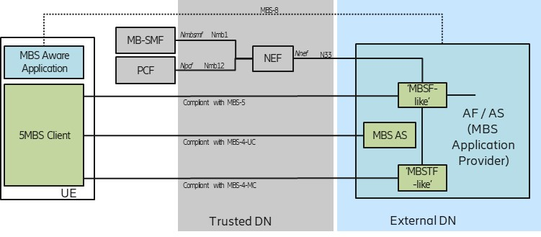

NOTE: Italic type is used to annotate service-based interfaces.

Figure A.5-1: Deployment with MBSF/MBSTF-like functions in External DN

**** Last Change ****