**3GPP TSG- S4 Meeting #116e *S4-211516***

**, – 19th November 2021**

|  |  |  |  |  |  |  |  |  |
| --- | --- | --- | --- | --- | --- | --- | --- | --- |
| *CR-Form-v12.1* | | | | | | | | |
| **Pseudo CHANGE REQUEST** | | | | | | | | |
|  | | | | | | | | |
|  |  | **CR** |  | **Rev** |  | **Current version:** |  |  |
|  | | | | | | | | |
| *For* [***HE******LP***](http://www.3gpp.org/3G_Specs/CRs.htm#_blank)*on using this form: comprehensive instructions can be found at* [*http://www.3gpp.org/Change-Requests*](http://www.3gpp.org/Change-Requests)*.* | | | | | | | | |
|  | | | | | | | | |

|  |  |  |  |  |  |  |  |  |
| --- | --- | --- | --- | --- | --- | --- | --- | --- |
| ***Proposed change affects:*** | UICC apps |  | ME |  | Radio Access Network |  | Core Network |  |

|  |  |  |  |  |  |  |  |  |  |  |
| --- | --- | --- | --- | --- | --- | --- | --- | --- | --- | --- |
|  | | | | | | | | | | |
| ***Title:*** |  | | | | | | | | | |
|  |  | | | | | | | | | |
| ***Source to WG:*** |  | | | | | | | | | |
| ***Source to TSG:*** | S4 | | | | | | | | | |
|  |  | | | | | | | | | |
| ***Work item code:*** | FS_5GMS_EXT | | | | |  | ***Date:*** | | |  |
|  |  | | | |  | |  | | |  |
| ***Category:*** |  |  | | | | | ***Release:*** | | |  |
|  | *Use one of the following categories:* ***F*** *(correction)* ***A*** *(mirror corresponding to a change in an earlier release)* ***B*** *(addition of feature),* ***C*** *(functional modification of feature)* ***D*** *(editorial modification)*  Detailed explanations of the above categories can be found in 3GPP [TR 21.900](http://www.3gpp.org/ftp/Specs/html-info/21900.htm). | | | | | | | | *Use one of the following releases: Rel-8 (Release 8) Rel-9 (Release 9) Rel-10 (Release 10) Rel-11 (Release 11) … Rel-15 (Release 15) Rel-16 (Release 16) Rel-17 (Release 17) Rel-18 (Release 18)* | |
|  |  | | | | | | | | | |
| ***Reason for change:*** | |  | | | | | | | | |
|  | |  | | | | | | | | |
| ***Summary of change:*** | | This document presents a set of relevant deployment options, which should be considered during the 5MBUSA design. The deployments will later help readers to understand the specification. | | | | | | | | |
|  | |  | | | | | | | | |
| ***Consequences if not approved:*** | |  | | | | | | | | |
|  | |  | | | | | | | | |
| ***Clauses affected:*** | |  | | | | | | | | |
|  | |  | | | | | | | | |
|  | | **Y** | **N** |  | | | |  | | |
| ***Other specs*** | |  |  | Other core specifications | | | | TS/TR ... CR ... | | |
| ***affected:*** | |  |  | Test specifications | | | | TS/TR ... CR ... | | |
| ***(show related CRs)*** | |  |  | O&M Specifications | | | | TS/TR ... CR ... | | |
|  | |  | | | | | | | | |
| ***Other comments:*** | |  | | | | | | | | |
|  | |  | | | | | | | | |
| ***This CR's revision history:*** | |  | | | | | | | | |

**** First Change ****

# A.1 Group Communication

Editor’s Note: This section should contain a deployment model for Group Communication.

# A.2 5G Media Streaming

Editor’s Note: Reference to TS 26.501.

# A.3 AF/AS in Trusted DN

Figure A.3-1 depicts a deployment with AF/AS within the Trusted DN. Italic font is used for service based interfaces. The AF/AS uses the Nmbsf API directly (Nmb10 reference point). The MBSTF uses the Nmb9 reference point for ingesting data into the MB-UPF.

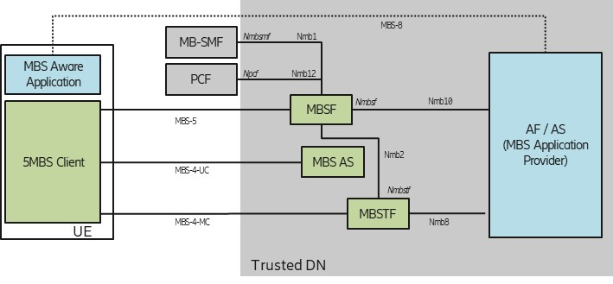

Figure A.3-1: Deployment with AF / AS in Trusted DN

# A.4 AF/AS in external DN

Figure A.4-1 depicts a deployment with AF/AS within the external DN. Italic font is used for service based interfaces. The AF/AS uses the Nnef (N33) API for accessing MBSF services. The NEF uses the Nmbsf API (Nmb5 reference point) to access MBSF Services. The MBSTF uses the Nmb9 Reference Point for ingesting data into the MB-UPF.

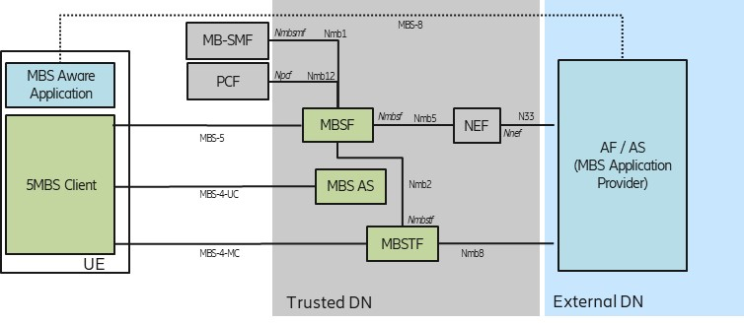

Figure A.4-1: Deployment with AF / AS in External DN

# A.5 MBSF/MBSTF-like functions in external DN

Figure A.5-1 depicts a transport-only deployment. Italic font is used for service based interfaces. Here, an external AF/AS uses an MBSF/MBSTF-like function for producing delivery method data. The MBSF-like function uses Nnef (N33) for accessing MB-SMF services. The MBSTF-like function uses the N6mb Reference Point for ingesting data into the MB-UPF.

The MBSF and MBSTF-like functions produce data streams, which is compliant with this specification. Although the 5G System sets up a Transport Only Mode (See TS 23.247 [x], Annex A, Option 1), the 5MBS Client in the UE follows procedures as defined in this specification.

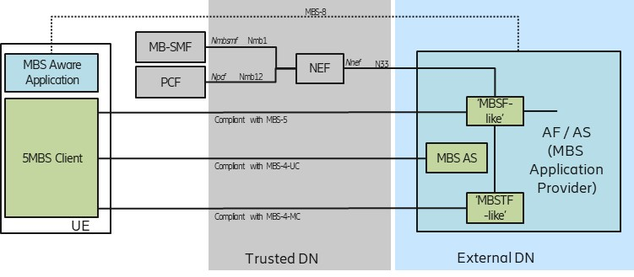

Figure A.5-1: Deployment with AF / AS in External DN

**** Last Change ****