**3GPP TSG- S4 Meeting #116e**

**, – 27th November 2021**

|  |  |  |  |  |  |  |  |  |
| --- | --- | --- | --- | --- | --- | --- | --- | --- |
| *CR-Form-v12.1* | | | | | | | | |
| **Pseudo CHANGE REQUEST** | | | | | | | | |
|  | | | | | | | | |
|  |  | **CR** |  | **rev** |  | **Current version:** |  |  |
|  | | | | | | | | |
| *For* [***HE******LP***](http://www.3gpp.org/3G_Specs/CRs.htm#_blank)*on using this form: comprehensive instructions can be found at* [*http://www.3gpp.org/Change-Requests*](http://www.3gpp.org/Change-Requests)*.* | | | | | | | | |
|  | | | | | | | | |

|  |  |  |  |  |  |  |  |  |
| --- | --- | --- | --- | --- | --- | --- | --- | --- |
| ***Proposed change affects:*** | UICC apps |  | ME |  | Radio Access Network |  | Core Network |  |

|  |  |  |  |  |  |  |  |  |  |  |
| --- | --- | --- | --- | --- | --- | --- | --- | --- | --- | --- |
|  | | | | | | | | | | |
| ***Title:*** | [FS_NPN4AVProd] QoS Separation | | | | | | | | | |
|  |  | | | | | | | | | |
| ***Source to WG:*** | , BBC, EBU | | | | | | | | | |
| ***Source to TSG:*** | S4 | | | | | | | | | |
|  |  | | | | | | | | | |
| ***Work item code:*** | FS_NPN4AVProd | | | | |  | ***Date:*** | | |  |
|  |  | | | |  | |  | | |  |
| ***Category:*** |  |  | | | | | ***Release:*** | | |  |
|  | *Use one of the following categories:* ***F*** *(correction)* ***A*** *(mirror corresponding to a change in an earlier release)* ***B*** *(addition of feature),* ***C*** *(functional modification of feature)* ***D*** *(editorial modification)*  Detailed explanations of the above categories can be found in 3GPP [TR 21.900](http://www.3gpp.org/ftp/Specs/html-info/21900.htm). | | | | | | | | *Use one of the following releases: Rel-8 (Release 8) Rel-9 (Release 9) Rel-10 (Release 10) Rel-11 (Release 11) … Rel-15 (Release 15) Rel-16 (Release 16) Rel-17 (Release 17) Rel-18 (Release 18)* | |
|  |  | | | | | | | | | |
| ***Reason for change:*** | |  | | | | | | | | |
|  | |  | | | | | | | | |
| ***Summary of change:*** | | The pCR provides more details around usage of QoS and Network Slices within Media Production use cases. Four solutions using different traffic identification methods is provided. | | | | | | | | |
|  | |  | | | | | | | | |
| ***Consequences if not approved:*** | |  | | | | | | | | |
|  | |  | | | | | | | | |
| ***Clauses affected:*** | | 5.2.5.3, 5.2.5.4 (deleted) | | | | | | | | |
|  | |  | | | | | | | | |
|  | | **Y** | **N** |  | | | |  | | |
| ***Other specs*** | |  |  | Other core specifications | | | | TS/TR ... CR ... | | |
| ***affected:*** | |  |  | Test specifications | | | | TS/TR ... CR ... | | |
| ***(show related CRs)*** | |  |  | O&M Specifications | | | | TS/TR ... CR ... | | |
|  | |  | | | | | | | | |
| ***Other comments:*** | |  | | | | | | | | |
|  | |  | | | | | | | | |
| ***This CR's revision history:*** | |  | | | | | | | | |

**** First Change ****

# 2 References

The following documents contain provisions which, through reference in this text, constitute provisions of the present document.

- References are either specific (identified by date of publication, edition number, version number, etc.) or non‑specific.

- For a specific reference, subsequent revisions do not apply.

- For a non-specific reference, the latest version applies. In the case of a reference to a 3GPP document (including a GSM document), a non-specific reference implicitly refers to the latest version of that document *in the same Release as the present document*.

[1] 3GPP TR 21.905: "Vocabulary for 3GPP Specifications".

[2] 3GPP TS 22.261: "Service requirements for the 5G system".

[3] 3GPP TS 22.263: "Service requirements for Video, Imaging and Audio for Professional Applications (VIAPA)".

[4] 3GPP TS 22.827: "Study on Audio-Visual Service Production".

…

[43] ISO/IEC 13818‑1: "Information technology — Generic coding of moving pictures and associated audio information — Part 1: Systems".

[44] IETF RFC 3550|STD 64: "RTP: A Transport Protocol for Real-Time Applications".

[45] IETF RFC 8086: "GRE-in-UDP Encapsulation".

[46] IETF RFC 2250: "RTP Payload Format for MPEG1/MPEG2 Video".

[47] IETF RFC 7798: "RTP Payload Format for High Efficiency Video Coding (HEVC)".

[48] OASIS: "MQTT Version 5.0", 7th March 2019, <https://docs.oasis-open.org/mqtt/mqtt/v5.0/mqtt-v5.0.html>

[49] IETF RFC 6416: "RTP Payload Format for MPEG-4 Audio/Visual Streams".

**** Next Change ****

## 3.3 Abbreviations

For the purposes of the present document, the abbreviations given in 3GPP TR 21.905 [1] and the following apply. An abbreviation defined in the present document takes precedence over the definition of the same abbreviation, if any, in 3GPP TR 21.905 [1].

AES Audio Engineering Society

AIMS Alliance for IP Media Solutions

AMWA Advanced Media Workflow Association

ARQ Automatic Repeat Query

CCU Camera Control Unit

DNS Domain Name System

FEC Forward Erasure Correction, Forward Error Correction

HDCP High-bandwidth Digital Content Protection

HDR High Dynamic Range

HFR Higher Frame Rates

IPMX IP Media eXperience

mDNS Multicast DNS

MADI Multichannel Audio Digital Interface

MQTT Message Queuing Telemetry Transport

NDI Network Digital Interface

NMOS Networked Media Open Specifications

NPN Non-Public Network

PA Public Address

PTP Precision Time Protocol

PTZ Pan, Tilt, Zoom

RIST Reliable Internet Stream Transport

SDI Serial Digital Interface

SMPTE Society of Motion Picture and Television Engineers

SRT Secure Reliable Transport

VSF Video Service Forum

WAN Wide Area Network

**** Next Change ****

#### 5.2.5.3 Key Issue #2: Media Protocols on 5G: Using QoS for traffic segregation

##### 5.2.5.3.1 General

This clause focuses on the usage of 5G Systems, assuming that multiple application flows – either from multiple cameras or from a single camera unit (see Figure 5.2.2.4-1) – would experience a different priority treatment by the RAN traffic scheduler and likely by the traffic policing function in 5GC. Different protocols may be used to carry media and other data.

An application flow is typically described by a 5-tuple, i.e. source and destination IP addresses (Layer 3), Layer 4 protocol and Layer 4 source and destination ports. Some protocols may multiplex multiple elementary streams (and potentially other data) into one application flow. Other protocols map one elementary stream to one application flow.

The traffic characteristics and the main flow direction (uplink or downlink) depend on the usage. For example, a program video stream, produced by a camera, is typically of a higher bit rate than a return video stream.

NOTE: Some application flows may carry non-media content, for example camera control, telematics (e.g. battery status), and position information for AR tracking.

Editor’s Note: Solutions may use IP multicast or IP unicast packet routing to transport media streams. IP multicast is popular in AV Production because the same feed from a camera, microphone or talkback circuit can then be consumed by monitoring devices (screens, headphones, etc.) as well as feeding into vision mixers, sound mixers, etc. However, there are challenges to be overcome in using IP multicast over Wide-Area Networks and therefore in Remote Production scenarios.

##### 5.2.5.3.2 Application flow prioritisation

Figure 5.2.5.3.2‑1 depicts the same media flows of a single camera as shown in figure 5.2.2.4-1, but categorized into three priority groups:

- Group 1, with the highest priority, comprises essential media essence flows.

- Group 2, with medium priority, comprises communications flows.

- Group 3, with the lowest priority, comprises control flows.

Depending on the media production scenario, a certain set of media flows are present. For example, a telepromter application flow is only present when a telepromter (autocue) device is attached to the camera.

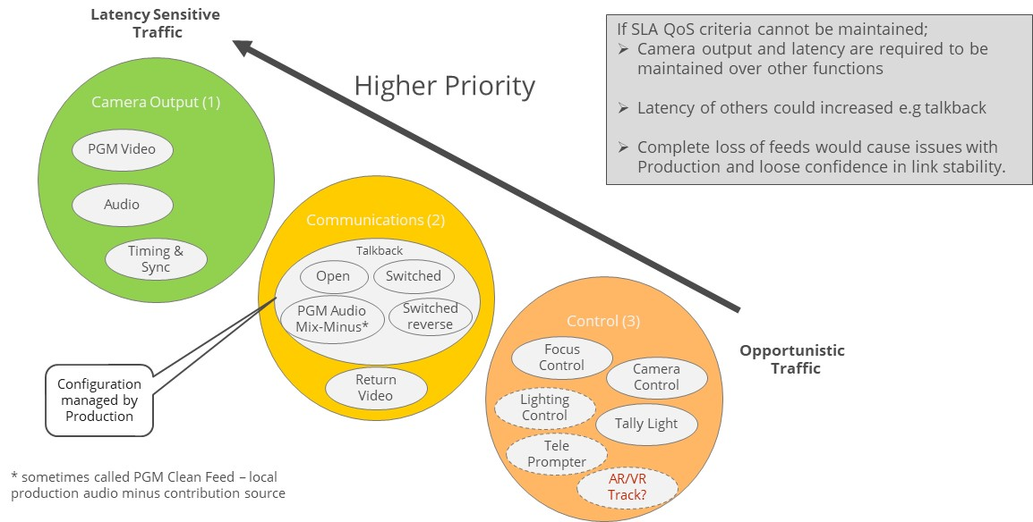

Figure 5.2.5.3.2‑1: Flow Priority

Highest priority is program (PGM) video, which is always present when using a 5G-enabled camera. An audio media flow related to the program video flow is only present in some scenarios. When present, it often has an even higher priority than the program video. A time synchrinization related media flow (e.g. PTP or NTP) is always present and is essential for production.

##### 5.2.5.3.3 Applying Quality of Service to application flows

Quality of Service (QoS) is a tool which only becomes relevant at times of high network utilisation. In these situations, the 5G System may need to prioritize some packets over others. In a well-planned production scenario, the 5G Systems is dimensioned to fit the needs of the media production and high network utilisation only occurs rarely. However, such good planning and dimensioning cannot be achieved in all media production scenarios. Thus, it might be preferred to degrade the output of a camera, keeping the most essential traffic intact. Depending on the scenario, different media flows are more essential than others to the media production.

An example communication protocol stack is illustrated in figure 5.2.5.3.3‑1 below. The different media flows may use different higher layer protocols. For audio and video streams, the RTP protocol is often used, which typically uses UDP as its Layer 4 protocol. Data streams such as tally light control may be carried using, for example, MQTT [48] (AMWA NMOS recommendation) which uses TCP as its Layer 4 protocol. NMOS is describes in Clause 4.5.2 in more detail.

MQTT [48] is a message-oriented application protocol based on the publish–subscribe paradigm which originated at IBM. It was developed as an OASIS open standard and published as ISO/IEC 20922. MQTT uses TCP as its transport protocol. MQTT adds some message headers, which allow (among other things) the byte-stream-oriented TCP protocol to be used for message separation.

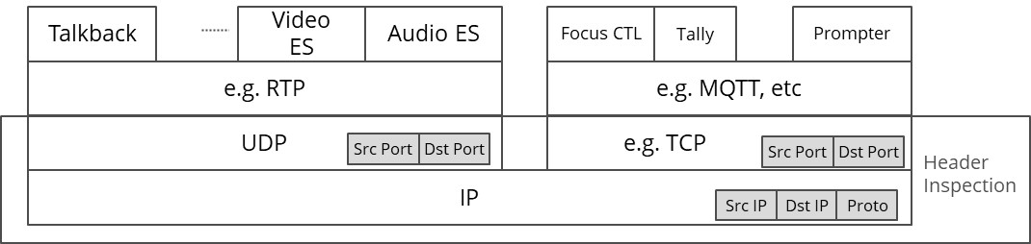

Figure 5.2.5.3.3‑1: Example protocol stacks for different media application flows

The different combinations of media flows (figure 5.2.2.4-1) depend on the media production scenario. In the following, the mappings for some example scenarios are presented and discussed.

##### 5.2.5.3.4 Solutions leveraging 3GPP QoS

###### 5.2.5.3.4.1 General

The 3GPP Quality of Service framework contains many tools to define media flow specific treatment with respect to relative priority, target bit rate, packet delay budget and packet error rate. To apply these tools, the 5G System must be able to identify the associated media flow, based on network-level parameters such as a UDP port number or an IP address. The 5G System (UE and UPF) uses packet header inspection techniques for traffic detection. Based on header inspection, each individual IP packet is assocuiated with a QoS flow and marked accordingly in the 5G System.

###### 5.2.5.3.4.2 Solution Example A: Coarse-grained separation with separated media

It is very common in IP-based media production scenarios to keep elementary streams like audio and video separated in independent UDP/IP flows. Thus, audio and video are not multiplexed together.

It is assumed here that all media flows within one group can be treated with the same QoS class. Thus, audio is equally important as video. All the control data flows are also treated with equal priority.

For Group 1, the application traffic can be identified by a (wildcarded) 5-tuple of packet headers:

- Layer 3 parameters:

- *UE IP:* Any (wildcard).

- *Server IP:* IP address of media gateway or vision/sound mixer.

- *Transport Protocol:* Indicating that UDP is used as the Layer 4 protocol.

- Layer 4 Parameters:

- *UE UDP Port:* Any.

- *Server UDP Port:* Separate UDP ports for audio and video on the Media Gateway or Vision Mixer side.

For Group 3, the application traffic can be identified by a (wildcarded) 5-tuple:

- Layer 3 parameters

- *UE IP:* Any (wildcard).

- *Server IP:* IP address of MQTT Broker or WebSocket server.

- *Transport Protocol:* Indicating that TCP is used as the Layer 4 protocol.

- Layer 4 parameters

- *UE TCP Port:* Any.

- *Server TCP Port:* TCP Port of the MQTT Broker or WebSocket server.

In cases where all video and audio elementary streams are treated with the same priority, the elementary streams can be multipled onto the same UDP/IP flow, e.g. using a multi-programme MPEG‑2 Transport Stream.

NOTE: When using MPEG‑2 Transport Stream as a Payload Format, all multiplexted elementary streams are treated with the same QoS by the 5G System.

###### 5.2.5.3.4.3 Solution Example B: Fine-grained separation with separated media

In this example, a finer-grained separation of media is used:

- Within Group 1, the audio elementary stream has a higher priority than the video elementary stream.

- Talkback (Group 2) audio should have a lower priority than Group 1 traffic.

- In Group 3, tally light control has a higher priority than general camera control.

As result, the individual media flows should be separated into separate application flows, e.g. UDP/IP flows or TCP/IP flows.

In order to enable the 5G System to prioritise the audio elementary stream higher than the video elementary stream in Group 1, the elementary streams need to be carried as individual UDP/IP media flows.

- RIST Simple profile allows usage of separated RTP sessions for different elementary streams, when a native RTP payload format (like RFC 7798 [47] for HEVC or RFC 6416 [49] for AAC) is used.

- RIST Main profile uses GRE tunnelling to encapsulate all media flows in order to simplify NAT/firewall traversal. However, the usage of a GRE tunnel also disables the 5G System capability of providing media flow based QoS.

The talkback audio flow needs to be separated from the main output using dedicated TCP/IP or UDP/IP transmission resources.

If tally light control requires a higher priority than other camera control messages, the event messages should be carried using uniquely identifiable network resources. When MQTT is used for carrying control event messages, the camera needs to set up two MQTT/TCP connections, which can then be clearly prioritized by the 5G System. When WebSockets are used for carrying the event message, the camera should set up two WebSocket/TCP connections to enable separate message prioritization.

##### 5.2.5.3.5 Solutions leveraging Network Slices

###### 5.2.5.3.5.1 General

Network Slicing is a feature which allows a Mobile Network Operator to provide customized networks. Network resources are logically separated so that they can be individually controlled. Each Network Slice contains at least one PDU Session. PDU Sessions cannot be shared across multiple Network Slices.

The UE obtains one IP address for each established PDU Session (Type IP). When a UE establishes multiple PDU sessions, either within a single Network Slice or in different Network Slices, the UE obtains a corresponding number of IP addresses.

###### 5.2.5.3.5.2 Solution Example C: Separation using Multiple Network Slices

In this example, the traffic separation is realized using multiple Network Slices. Here, similar to Example A, a coarse-grained separation is assumed: all application flows belonging to Group 1 are carried by Network Slice #1, Group 2 uses Network Slice #2 and Group 3 uses Network Slice #3.

In general, a Network Slice may contain one or more PDU Sessions. For this example, however, it is assumed that each Network Slice contains only a single PDU Session.

The UE obtains an IP address for each PDU Session. The camera then sends all Group 1 traffic with the IP address for PDU Session in Network Slice #1. All Group #2 application flows are sent with the IP address associated with the PDU Session in Network Slice #2, and all Group 3 traffic has the IP address of the PDU Session in Network Slice #3.

The 5G System then handles the traffic according to the Network Slice priority.

###### 5.2.5.3.5.3 Solution Example D: Separation using Network Slices and QoS

In this example, traffic separation is realized by combining Network Slices with QoS. Here, a more fine-grained separation is assumed, as in Example B:

- Within Group 1, the audio elementary stream has a higher priority than the video elementary stream.

- Group 2 talkback audio has a lower priority than Group 1 traffic.

- In Group 3, tally light control has a higher priority than general camera control.

In this example, all talkback related traffic uses a dedicated Network Slice for talkback. Meanwhile, all Group 1 camera traffic, all Group 3 traffic, and the return video from Group 2 share a second Network Slice.

As in Example C, each Network Slice is configured with a single PDU Session. The camera is therefore assigned a different IP address for the PDU Session in each Network Slices.

The camera uses the IP address associated with the talkback Network Slice for all talkback audio flows. All other application flows use the IP address associated with other Network Slice. Fine-grained prioritization using QoS is then applied for application flows within the second Network Slice.

*** Next Change ****

**** Last Change ****