Agenda Item: | 10.9
Source: | China Mobile Com. Corporation
Title: | [FS_5GSTAR] Update on Use Cases Mapping
Document for: | Discussion and agreement

- Introduction
The AR gaming use case we proposed in SA4#111e meeting (S4-201337) was agreed to move into the permanent document (S4-210270). In the latest version of TR.26.998, we notice that clause 6.3 (5G interactive immersive services) of TR26.998 is one of the core scenarios and AR gaming can be reflected.

Different from other interactive services, like AR sharing and AR remote cooperation,
- AR gaming focuses on real-time interaction of user actions, which means higher requirements for streaming and rendering delays
- AR gaming involves multiple players and requires synchronization.
- 2D/3D objects overlaying on top of AR gaming video streams have higher rendering accuracy requirements to satisfy an immersive and comfortable experience, rather than practicality and efficiency.
- AR gaming is less dependent on the user's actual environment.

And beyond that, we notice that TR 26.998 gives a definition of 5G cognitive immersive service
<Cognitive means that I am sending environment data>
And as described in A.2 Use Case 16: AR remote cooperation,
“…And he marks possible points of failure by drawing instructions on the top of these video contents in order that the remote engineer can see the marks and make a detailed discussion.”
This kind of marking operation requires environmental understanding, including environment point cloud information generation and feature point extraction (like feature point information for the car part in this use case). So, it is more appropriate to reflect this kind of use cases in 5G cognitive immersive service.

This pCR is proposing to update use case mapping in TR26.998, so that it can going with the further discussion.

- Proposal
*** Change 1 ***

Table 5.1. List of use cases for AR/MR services
No | Use Case | Reference
1 | 3D Image Messaging | Annex A.2 in [x]
2 | AR Sharing | Annex A.3 in [x]
3 | Real-time 3D Communication | Annex A.8 in [x]
4 | AR guided assistant at remote location (industrial services) | Annex A.9 in [x]
5 | Police Critical Mission with AR | Annex A.10 in [x]
6 | Online shopping from a catalogue – downloading | Annex A.11 in [x]
7 | Real-time communication with the shop assistant | Annex A.12 in [x]
8 | 360-degree conference meeting | Annex A.13 in [x]
9 | XR Meeting | Annex A.16 in [x]
10 | Convention / Poster Session | Annex A.17 in [x]
11 | AR animated avatar calls | Annex A.18 in [x]
12 | AR avatar multi-party calls | Annex A.19 in [x]
13 | Front-facing camera video multi-party calls | Annex A.20 in [x]
14 | AR Streaming with Localization Registry | Annex A.21 in [x]
15 | 5G Shared Spatial Data | Annex A.24 in [x]
16 | AR remote cooperation | Annex A.2
17 | AR remote advertising | Annex A.3
18 | Streaming of volumetric video for glass-type MR devices | Annex A.4
19 | AR Conferencing | Annex A.5
20 | AR IoT | Annex A.6
21 | AR gaming | Annex A.7

*** Change 2 ***
Table 6.1. List of service scenario mapping to use cases
Service Scenario | Clause | Relevant Use Case
Immersive media downlink streaming | 6.2 | 2. AR Sharing¹⁾  14. AR Streaming with Localization Registry  17. AR remote advertising  18. Streaming of volumetric video for glass-type MR  Devices
5G interactive immersive service | 6.3 | 1. 3D Image Messaging  2. AR Sharing¹⁾  4. AR guided assistant at remote location (industrial services) ¹⁾  5. Police Critical Mission with AR¹⁾  15. 5G Shared Spatial Data  16. AR remote cooperation¹⁾  21. AR gaming
5G cognitive immersive service | 6.4 | 4. AR guided assistant at remote location (industrial services) ¹⁾  5. Police Critical Mission with AR¹⁾  14. AR Streaming with Localization Registry¹⁾  16. AR remote cooperation¹⁾  20. AR IoT control
AR two-party calls | 6.5 | 3. Real-time 3D Communication  4. AR guided assistant at remote location (industrial  services) ¹⁾  7. Real-time communication with the shop assistant  11. AR animated avatar calls  16. AR remote cooperation¹⁾
AR conferencing | 6.6 | 8. 360-degree conference meeting  9. XR Meeting  10. Convention / Poster Session  12. AR avatar multi-party calls  13. Front-facing camera video multi-party calls  19. AR Conferencing
1) may be duplicated into multiple scenarios

*** Change 3 ***
A.7 Use Case 21: AR gaming
Use Case Name
AR gaming
Description
By using AR technology, AR gaming is to apply virtual models to the real world and then provides game entertainment experience in a world of virtual-reality combination, which is difficult to experience in reality. People can interact with virtual objects controlled by game operations in the foreground of the real world. For many consumers, immersion is a key factor in their enjoyment of games, and AR can help users achieve such experiences exactly.
For example, Alice wears AR glasses at home and opens an AR golf game application. The AR glasses display a virtual sand table of golf course and golf ball through the spatial location on the floor of her house. Alice needs to use a certain gesture to hit the golf ball and make it go into the hole. Finally, the AR golf game application can calculate Alice's score.
AR gaming can also support multi-player games. Alice invites Bob and Clare to play an online AR shooting game in her living room. They wear AR glasses, log in to the AR shooting game application, select the multi-player team mode, and then they can control the shooting action through a gesture or the tethering device. The virtual target set in the shot game will appear in the living room, and have corresponding response according to their operation and display in their AR glasses. Then they can complete the game task and upgrade.
Categorization
Media Type: Visual / Audio, 3D
Media Source Type: CGI (Computer-Generated Imagery)
Delivery: Uplink, Download, Interactive
Device Type: XR5G-A2, XR5G-A3, XR5G-A4, XR5G-A5
Preconditions
<provides conditions that are necessary to run the use case, for example support for functionalities on the end device or network>
-A game application on an AR device.
-Connectivity to the network
- Rendering according to user data
- Gesture acquisition or other control mode
- Spatial Computing Service
- Content synchronization

Requirements
<provides a summary on potential requirements for following aspects>
- Device functions
- Media processing functions
- KPIs/QoE and QoS>
-
- QoS:
- Sufficiently low latency for rendering.
- low packet loss rate
- QoE:
- Gaming time before vertigo
- Game jams
Feasibility and Industry Practices
<How could the use case be implemented based on technologies available today or expected to be available in a foreseeable timeline, at most within 3 years?
- What are the technology challenges to make this use case happen?
- Do you have any implementation information?
- Demos
- Proof of concept
- Existing services
- References
- Could a reduced experience of the use case be implemented in an earlier timeframe or is it even available today?
>
There are some AR game demonstration examples using AR glasses.
1. The Tech Behind Tilt Five's AR Gaming System
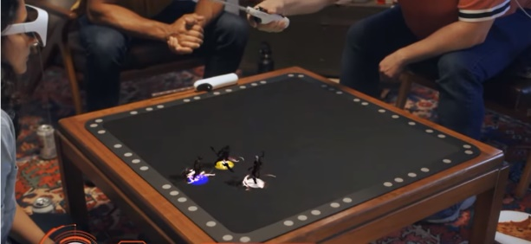
https://www.youtube.com/watch?v=Z3qAio315ak

2.Super Mario Bros Recreated as Life Size Augmented Reality Game
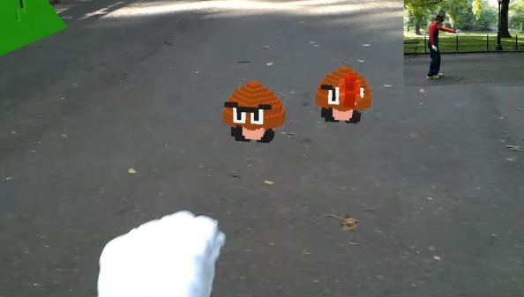
https://www.youtube.com/watch?v=QN95nNDtxjo
During the 2018 World Mobile conference, China Mobile, Tencent and Huawei jointly announced the completion of AR game experimental verification based on 5G enhanced bandwidth stable delay network slice.
Potential Standardization Status and Needs
<identifies potential standardization needs>
- Network conditions that fulfill the QoS and QoE requirements
- Architectures for computing support in the network
- Cloud APIs for group authentication and multiuser synchronization.
- Standardized format and delivery protocols of AR actions and 2D/3D objects
- Standardized format and delivery protocols of posture information
- Metadata for Spatial characteristics of the AR environment (e.g. positioning of users).
- Rendering of overlying AR actions and posture information for virtual and real superposition

*** End of Changes ***

