Source: KPN N.V.
Title: ITT4RT: Presentation Overlay example flow
Agenda Item: 11.5 - ITT4RT
Document for: Discussion & Agreement
Introduction
In the #113-e meeting a solution for presentation-type overlays was presented and accepted. In this follow-up contribution we like to add an example message flow to clarify the use of presentation overlay further. Proposed changes to the permanent document of ITT4RT are indicated with change marks.
Text from PD & example flow

6.3.5 Presentation overlay (screen share)

6.3.5.0 General

One common situation in a meeting is to present additional material (e.g., slides, screen share video, notes, etc.) on a display (screen or projector). When capturing such a display with a 360-degree camera, this can lead to significant quality degradations, based on the characteristics of the camera, display and lighting conditions. Simply most setups will not allow to capture both users and a display in high detail and ideal lighting, further the display refresh rate and camera capture rate are often mis-aligned. To mitigate this problem the ITT4RT client allows to replace the captured content with the original presentation material. Further the replacement might have benefits in terms of reduced bandwidth and processing load the to the receiving Rx client (compared to transmitting the presentation content as overlay parallel to the 360-degree content). We can consider the replacement of image data in the 360-degree video as a special case of overlays that should either be handled in the sending client of the 360-video or in the network (MRF/MCU) in the following way:
- Signal that content replacement is available
- Signal material as display content in 360-recording
- Identify position of content in 360-recording
- Replace content or signal overlay parameters

Signal that content replacement is available
Currently the 360-degree video is indicated with the “a=3gpp_360video” attribute in the SDP negotiation (section 6.1). In order to indicate that content overlay replacement is available, the SDP negotiation should add a new attribute “a=3gpp_360video_overlayreplacement”.
This should be signalled by the offer of the 360-degree ITT4RT-tx client or by the offer/answer of the MRF/MCU and be acknowledged with an accept answer including the same “a=3gpp_360video_overlayreplacement” attribute.

If the replacement is fully handled in the 360-degree sending client (i.e., this client both is responsible for capturing the 360-degree content and the display of the presentation content), it should not signal the “a=3gpp_360video_overlayreplacement” attribute.
Note: The main importance of the “a=3gpp_360video_overlayreplacement” attribute is to distinguish who can perform the replacement in case both the 360-degree capture client and the MRF/MCU support replacement.

Signal material as display content in 360-recording
The availability of the presentation content should be signalled with the SDP parameter “a=content:slides”[29].
Note: this step can be skipped if the replacement is fully handled in the 360-degree sending client (i.e. this client both is responsible for capturing the 360-degree content and the display of the presentation content)

Identify replacement configuration in 360-recording
How the replacement configuration (i.e., configuration in terms of sphere-relative overlay coordinates) is determined should be left as implementation detail that does not need further specification. The output of this analysis shall include the position of the content in the 360-degree video with the associated overlay characteristics to overlay/replace the image accordingly.
Note: Ideally while receiving both the 360-degree video and the presentation content the region should be identified automatically (e.g., with image recognition tasks like pattern matching [28]). However, a manual process could also be possible when handled directly by the sending UE.
Note: Assuming a static configuration of the 360-degree camera the content position only needs to be identified once for the lifetime of a ITT4RT communication session. Even if the presentation content changes positional parameters in the 360-degree video might be reused.

Replace content or signal overlay parameters
The replacement implies a decoding, replacement of the captured presentation content at the (exact) display coordinates in the 360-degree video and finally encoding the new 360-degree video (i.e., with the same encoding parameters as the original 360-degree video).
The solution is based on the definition of OMAF edition 1 that the remote users “viewing position is the centre of the unit sphere” [4] of the 360-degree image of the conference room. This means that all users view the 360-degree conference from the centre of the sphere, which is the capture position of the 360-degree camera.
Two options to replace content are possible, a) replace content directly in the 360-degree video (by injecting and re-encoding an adjusted version of the content given the identified overlay characteristics) and b) sending the video separately as overlay in the way specified in chapter 6.3.
Replacing the content directly in the 360-degree video can be done either in the sending client of the 360-degree video or in the network (MRF/MCU).

6.3.5.1 Presentation overlay example message flow
The following two flow diagrams outline the 4 steps for presentation overlays as described in section 6.3.5.
First the ITT4RT-Tx client sending the 360-degree room capture will negotiate the video transmission with an SDP offer / answer including both the “a=3gpp_360video” and the “a=3gpp_360video_overlayreplacement” flag to indicate 360-degree room capture content including a presentation screen. Followed, by the transmission of the 360-degree video to the MRF accordingly. Subsequently the ITT4RT-Tx client responsible for displaying the presentation in the meeting room will prepare to send the presentation content to the MRF by SDP offer / answer including the “a=content:slides” flag. Followed, by the transmission of the presentation video to the MRF accordingly. With both contents present in the MRF the MRF will decode and analyse the content to identify the position, rotation, and scaling of the presentation content in the 360-degree sphere. Followed by either of 2 options: A) the MRF will constantly decode both contents and replace the presentation in the 360-degree content by applying the position, rotation, and scaling identified and encoding the content to be send to different ITT4RT-Rx client to be displayed to users (shown in Figure 6.3.5.1.1). B) alternatively the MRF might simply forward the two video streams (with individual SDP negotiations) and include the identified position, rotation, and scaling as overlay with the SDP flag “a=3gpp_overlay” and the additional overlay parameters accordingly (shown in Figure 6.3.5.1.2)

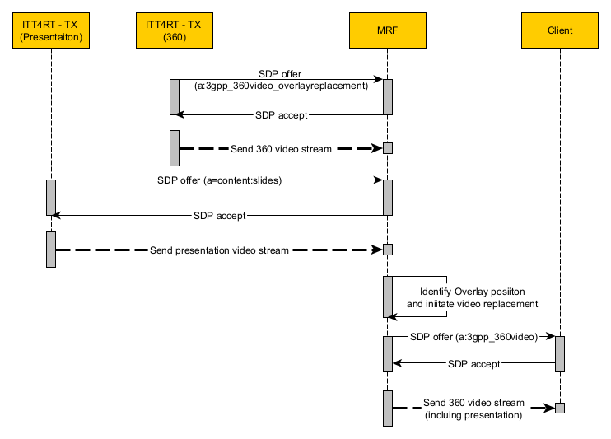
Figure 6.3.5.1.1 Flow for presentation replacement in 360-degree video

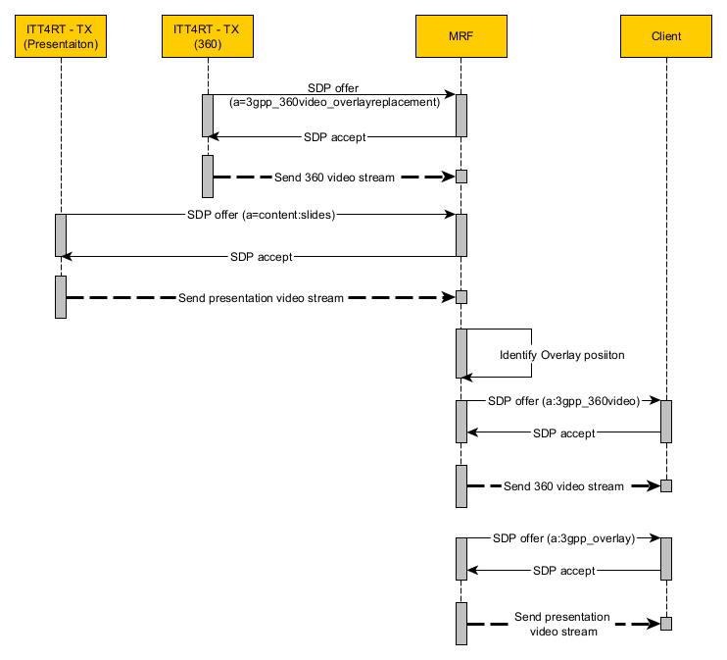
Figure 6.3.5.1.2 Flow for identifying and signaling presentation as overlay

Proposal
With this contribution we propose to add the example flow (section 6.3.5.1) and minor text corrections in section 6.3.5 into the permanent document of ITT4RT.

