3GPP TSG-S4 Meeting #114-e S4-210832r01

e-meeting, 19 - 28 May 2021
CR-Form-v12.1
PSEUDO CHANGE REQUEST
 | 26.805 | CR | - | rev | - | Current version: | 0.1.1
For HELP on using this form: comprehensive instructions can be found at
http://www.3gpp.org/Change-Requests.

Proposed change affects: | UICC apps |  | ME | x | Radio Access Network | x | Core Network

Title: | FS_NPN4AVProd: Utilizing Available Capacity in Multi-Camera Scenarios
Source to WG: | Sony Europe B.V.
Source to TSG: | -
Work item code: | FS_NPN4AVPROD |  |  |  |  |  | Date: |  |  | 2021-05-25
Category: | B |  |  |  |  |  | Release: |  |  | Release 17
 | Use one of the following categories:  F (correction)  A (mirror corresponding to a change in an earlier release)  B (addition of feature),  C (functional modification of feature)  D (editorial modification)  Detailed explanations of the above categories can  be found in 3GPP TR 21.900. |  |  |  |  |  |  |  | Use one of the following releases:  Rel-8 (Release 8)  Rel-9 (Release 9)  Rel-10 (Release 10)  Rel-11 (Release 11)  …  Rel-15 (Release 15)  Rel-16 (Release 16)  Rel-17 (Release 17)  Rel-18 (Release 18)
Reason for change: |  | Provide text to partly address the following objectives of the SID:  “- To identify relevant QoS requirements for media production workflows, including required bit rates, loss rates, formats, latencies and jitter, and to identify their impact on the relevant KPIs for media production workflows (reliability, mean-time-between failure, service-level agreements, etc.).  - To identify relevant 5G System features like NPNs, Network Slicing, QoS classes, network event reporting and assistance, etc. that are useful for media production, and to clarify their usage for media production.”
Summary of change: |  | Document a gap between desired bitrates vs. realistically available capacity, for multi-camera media production scenarios. Document a potential solution.
Consequences if not approved: |  | An important gap is not documented in the technical report
Clauses affected:
 |  | Y | N
Other specs |  |  | x | Other core specifications |  |  |  | TS/TR ... CR ...
affected: |  |  | x | Test specifications |  |  |  | TS/TR ... CR ...
(show related CRs) |  |  | x | O&M Specifications |  |  |  | TS/TR ... CR ...
Other comments:
This CR's revision history:

----------------------------START OF CHANGE---------------------

2 References
[X] 3GPP TR 26.925: "Typical traffic characteristics of media services on 3GPP networks".
----------------------------END OF CHANGE---------------------
----------------------------START OF CHANGE---------------------

6.2.5 Potential issues

6.2.2.3 Utilizing Available Capacity in Multi-Camera Scenarios

6.2.2.3.1 QoS requirements – bit rate
Usual fiber-based studio setups use 3-24 Gbit/s per camera (uncompressed, see [X]). A 5G cellular setup is obviously limited in uplink capacity compared to that. Considering this, SA1 produced a table in [3] containing also somewhat lower numbers, assuming various degrees of compression:
Table 6.2.2.3-1: reproduced from [3] table 6.2.1-3
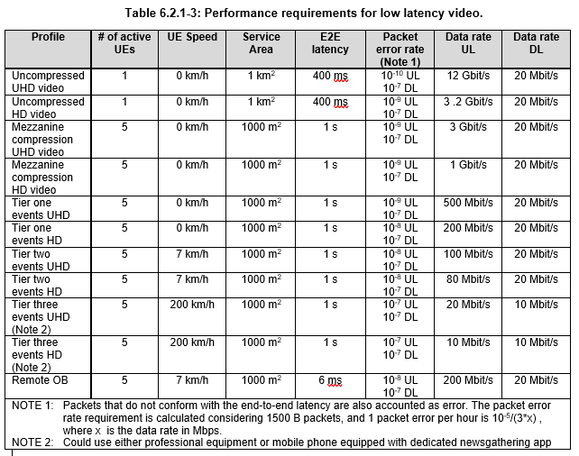
[Editor’s note: the following sentence assumes the table 5.3-1 contributed in S4-210823 is added to the TR:]
Further, Table 5.3-1 in the present document shows a range of bit rates for different event types.
Observation 1: The data rate requirements per camera in [3] span a range of more than 1000 times, from 10 Mbit/s to 12 Gbit/s, depending on the profile/scenario.
Observation 2: The overall uplink capacity of a 5G system with realistic amount of radio spectrum and realistic ratio between downlink and uplink time resources, is in the same order of magnitude as the required/desired data rate for a single camera for tier 2 and tier 1 events.
Conclusion 1: For multi-camera scenarios, there is a need to dynamically control media rates such that not all cameras use the maximum rate all the time.
Conclusion 2: For multi-camera scenarios, there is a desire from the producer’s point of view to see all cameras in pristine quality but in case of increased cell load, there is also a need to quickly reduce media rates to avoid data loss on important camera feeds. Specifically, within a group of cameras that are used for the same live programme, there is need for reducing the rate for lower-prioritized cameras in order to protect the camera that is currently “live” (production camera) and the camera that is next to go “live” (according to the producer’s wishes).
See clause 7.1 for candidate solutions to this issue.
----------------------------END OF CHANGE---------------------
----------------------------START OF CHANGE---------------------

7 Candidate Solutions
< this section should describe, how identified 5G features are used in context of media production>

7.1 Issue #1: Utilizing Available Capacity in Multi-Camera Scenarios

7.1.1 General
As highlighted in clause 6.2.2.3, there is in several scenarios a need to dynamically and proactively control media rates such that not all cameras use the maximum rate all the time. Specifically, within a group of cameras that are used for the same live programme, there is need for reducing the rate for lower-prioritized cameras in order to protect the camera that is currently “live” (production camera) and the camera that is next to go “live” (according to the producer’s wishes). This should be done proactively, considering the radio conditions and load in the network, to avoid loss of quality on important feeds.

7.1.2 Potential solutions
Firstly, uplink streaming protocols (which may be specified outside 3GPP and may be proprietary, see clause 4) need to support dynamic media rate changes.
Network assistance could then help applications to adjust the rate more proactively, considering the knowledge in the RAN. To this end, the Network Assistance node needs to be aware of which cameras should be regarded as a group (within which to distribute the capacity) and their priorities within the group.

7.1.3 Separation of protocols
It is assumed that the media rates of the cameras are controlled using already existing, separate protocols at the application layer (may be specified outside 3GPP and may be proprietary). But the network assistance can provide recommendations about what media rates are suitable considering 3GPP network conditions at a certain time.
NOTE: This is similar to the separation of protocols SA4 has specified in TS 26.512 [Y] for downlink streaming with DASH and network assistance. The network assistance can, where available, be used to guide the player to request the appropriate bit rate using the DASH protocol. Yet the original DASH protocol is 100% separated from the Network Assistance protocol.
----------------------------END OF CHANGE---------------------

