**3GPP TSG- Meeting #**

**, – 28th May 2021**

|  |  |  |  |  |  |  |  |  |
| --- | --- | --- | --- | --- | --- | --- | --- | --- |
| *CR-Form-v12.1* | | | | | | | | |
| **Pseudo CHANGE REQUEST** | | | | | | | | |
|  | | | | | | | | |
|  |  | **CR** |  | **rev** |  | **Current version:** |  |  |
|  | | | | | | | | |
| *For* [***HE******LP***](http://www.3gpp.org/3G_Specs/CRs.htm#_blank)*on using this form: comprehensive instructions can be found at* [*http://www.3gpp.org/Change-Requests*](http://www.3gpp.org/Change-Requests)*.* | | | | | | | | |
|  | | | | | | | | |

|  |  |  |  |  |  |  |  |  |
| --- | --- | --- | --- | --- | --- | --- | --- | --- |
| ***Proposed change affects:*** | UICC apps |  | ME |  | Radio Access Network |  | Core Network |  |

|  |  |  |  |  |  |  |  |  |  |  |
| --- | --- | --- | --- | --- | --- | --- | --- | --- | --- | --- |
|  | | | | | | | | | | |
| ***Title:*** | In-band Fragments in MBMS Download | | | | | | | | | |
|  |  | | | | | | | | | |
| ***Source to WG:*** | Ericsson LM | | | | | | | | | |
| ***Source to TSG:*** | S4 | | | | | | | | | |
|  |  | | | | | | | | | |
| ***Work item code:*** | FS_5GMS_Multicast | | | | |  | ***Date:*** | | |  |
|  |  | | | |  | |  | | |  |
| ***Category:*** |  |  | | | | | ***Release:*** | | |  |
|  | *Use one of the following categories:* ***F*** *(correction)* ***A*** *(mirror corresponding to a change in an earlier release)* ***B*** *(addition of feature),* ***C*** *(functional modification of feature)* ***D*** *(editorial modification)*  Detailed explanations of the above categories can be found in 3GPP [TR 21.900](http://www.3gpp.org/ftp/Specs/html-info/21900.htm). | | | | | | | | *Use one of the following releases: Rel-8 (Release 8) Rel-9 (Release 9) Rel-10 (Release 10) Rel-11 (Release 11) … Rel-15 (Release 15) Rel-16 (Release 16) Rel-17 (Release 17) Rel-18 (Release 18)* | |
|  |  | | | | | | | | | |
| ***Reason for change:*** | | A more verbose motivation of the need for inband fragments is provided in (was S4aI211181). | | | | | | | | |
|  | |  | | | | | | | | |
| ***Summary of change:*** | | A new subsection is inserted into the Nmb2 (former Nx2) API section, studying specifically the handling of inband control fragments.  The revision | | | | | | | | |
|  | |  | | | | | | | | |
| ***Consequences if not approved:*** | |  | | | | | | | | |
|  | |  | | | | | | | | |
| ***Clauses affected:*** | | 5.3 | | | | | | | | |
|  | |  | | | | | | | | |
|  | | **Y** | **N** |  | | | |  | | |
| ***Other specs*** | |  |  | Other core specifications | | | | TS/TR ... CR ... | | |
| ***affected:*** | |  |  | Test specifications | | | | TS/TR ... CR ... | | |
| ***(show related CRs)*** | |  |  | O&M Specifications | | | | TS/TR ... CR ... | | |
|  | |  | | | | | | | | |
| ***Other comments:*** | |  | | | | | | | | |
|  | |  | | | | | | | | |
| ***This CR's revision history:*** | |  | | | | | | | | |

## 5.3 Key Issue 2: Nmb2 Design Considerations

### 5.3.1 Description

#### 5.3.1.1 General

In 5MBS, the existing BM-SC function is split into control plane (MBSF) and user plane (MBSTF) functions, so that a single control plane function can (potentially) control one or more user plane functions. A new interface Nmb2 is introduced between the control and user plane functions.

According to TR 23.757 [7]:

- The new user plane function (MBSTF) receives the traffic using (an evolution of) the xMB‑U interface and/or the MB2-U interface.

- The new control plane function (MBSF) receives provisioning and control commands using either existing MB2‑C or (an evolution of) xMB-C.

The present key issue studies how existing control plane procedures from xMB-C impact Nmb2 transactions. It is assumed that corresponding BM-SC features (like the MBMS Download Delivery, Streaming Delivery or Transparent Delivery) are migrated into 5MBS.

NOTE: The present clause uses BM-SC function terminology. For 5MBS, the functions may be renamed.

#### 5.3.1.2 Model of a BM-SC User-Plane Function for MBMS Download Delivery

The model in Figure 5.3.1.2-1 below assumes that a FLUTE function according to MBMS Download Delivery (clause 7 in TS 26.346 [16]) is mapped into the MBSTF.

NOTE: FLUTE is used in this clause for illustrative purposes to study the interface between a BM-SC control and user-plane. The reuse, evolution or replacement of this object delivery protocol in Release 17 should be studied in a separate Key Issue.

The purpose of this simplified model is to help identify the xMB-C parameters (xMB Service and Session Parameters) needed to configure an MBSTF at Nmb2.

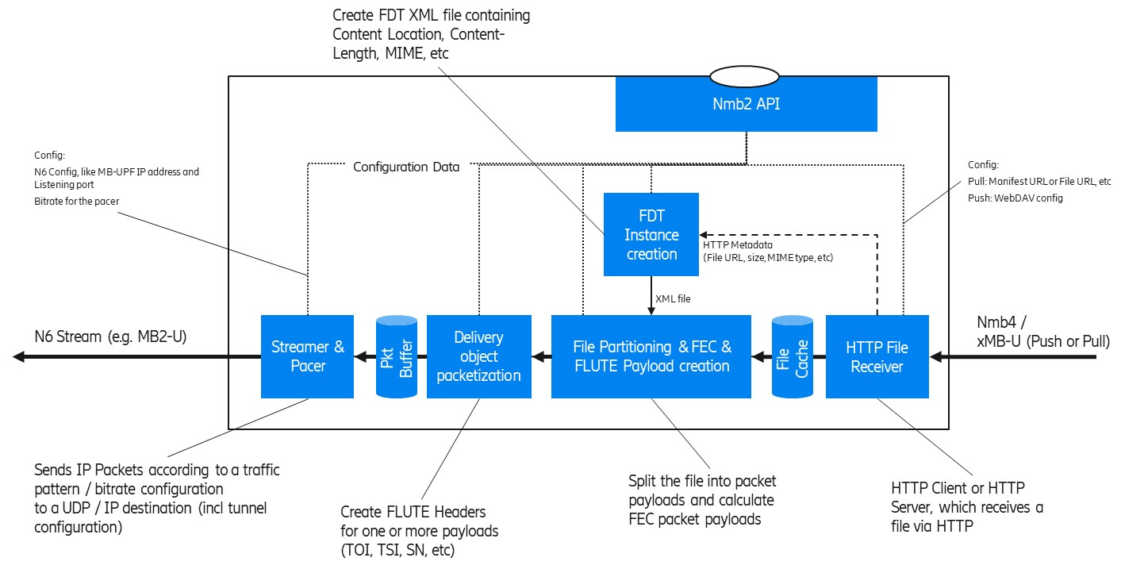

Figure 5.3.1.2-1: Simplified User Plane model for FLUTE (as an MBSTF function)

The model depicts some key functions from an xMB-U ingest to an MB-UPF ingest (N6). In the case of 5MBS Download (e.g. used for DASH/HLS over MBMS or generic file delivery) the MBSTF operates as follows:

1. The **HTTP File Receiver** is responsible for ingesting content resources intended for multicast transmission at xMB-U. It supports two basic content ingest modes:

a) **HTTP Pull**, in which the MBSTF pulls resources from an upstream HTTP server, such as the 5GMSd AS. In this mode, the Nmb2 API is used to provide individual URLs to be downloaded.

b) **HTTP Push**, in which resources are uploaded to the MBSTF by an upstream client using HTTP PUT. In this mode, the Nmb2 API is used to provide a base URL for ingesting data to the API invoker.

2. The MBSTF may store partial or complete resources in a local **File Cache** prior to transmission at N6. Optimized implementations may pipe files through with only minimal buffering/caching.

3. HTTP metadata such as Content-Location (resource URL), Content-Length (resource size), and Content-Type (MIME content type) is provided by the HTTP File Receiver to the **FDT Instance creation** function. This acts as input (with other Nmb2 parameters) to form the FDT Instance XML document.

4. The **File partitioning** function segments resources (including FDT Instances) into one or more multicast packet payloads. In the case where a Forward Error Correction scheme such as Raptor FEC (RFC 5053 [23]) or Compact No-Code FEC (RFC 5445 [24]) is used, there are recommended schemes and parameters to partition a resource into a sequence of packet paylods (called encoding symbols).

5. The **Delivery object packetization** function creates a sequence of IP packets (incl UDP and FLUTE packet headers) for the delivery object. It inserts FLUTE header parameters such as the TSI, sequence number (FEC Symbol ID according to No-Code FEC, RFC 3695 [25] or Raptor FEC, RFC 5053 [23]), etc. As result, a complete UDP packet payload is created, which can be written to a UDP socket at the appropriate time of transmission.

6. Finally, the **Streamer & Pacer** function sends the multicast UDP packets according to a defined bit rate to the configured MP-UPF ingest point, which can be an MB2-U tunnel, some direct multicast, or similar.

#### 5.3.1.3 Handling of In-band ancillary Information for MBMS Download Delivery

TS 26.346 [16] allows transmission of Service Announcement Metadata fragments in band with the session or out of band. Annex L.2.8 of [16] further defines handling of in-band fragments within the Service Announcement Channel (SACH) profile.

The usage of in-band fragments to update service announcement metedata fragments is specifically needed in cases of eMBMS-only transmissions, e.g. in areas of high receiver density or when offering services through a Shared MBMS Network (cf. TS 23.247, Clause 7.5). The usage of unicast is preferably avoided in areas of high receiver density to prevent congestion situations.

The service announcement for 5MBS User Services may evolve. In-band ancillary information is logically part of the 5MBS User Service announcement, and the information objects are sent in-band with the content stream using the same MBS Session. Only 5MBS Clients that have activated reception of the 5MBS Session will receive the in-band ancillary information.

In-band ancillary information objects are typically XML instance documents formatted as regular FLUTE transmission objects and received by the 5MBS Client. In-band ancillary information may be interleaved with other content objects, i.e. the BM-SC sends the packets comprising the in-band ancillary information interleaved with those comprising content object(s). In-band ancillary information may be repeated multiple times in carousel fashion to assist with unsynchronised acquisition by the MBMS Client. When repeating the transmission object corresponding to an in-band ancillary information object it is beneficial to keep the same FLUTE parameters, specifically the Transport Object Identifier (TOI), so that the FLUTE receiver in the 5MBS Client can efficiently detect and ignore repetitions.

The model in Figure 5.3.1.3-1 below extends the FLUTE model from clause 5.3.1.2 to include in-band ancillary information. The in-band-related functions are depicted in green; blue components are identical to those in Figure 5.3.1.2‑1.

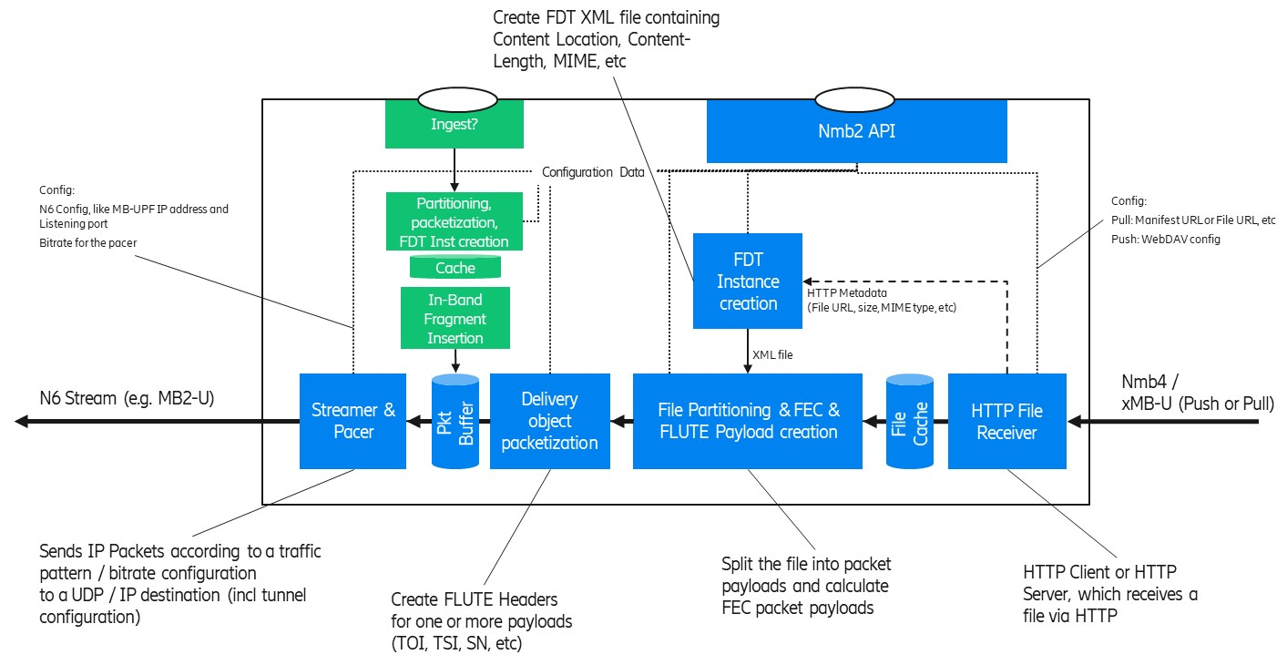 Figure 5.3.1.3-1: In-band ancillary information related functions (in green) of an MBSTF

Two categories of in-band ancillary information objects are considered in the context of 5MBS:

1: ***5MBS Delivery function related***, i.e. sending ancillary information objects (in band) to the 5MBS Client, such as file repair configuration information.

2: ***5MBS User Service function related***, i.e. sending ancillary information objects (in band) to an application component behind the 5MBS Client, such as a Media Player.

The model adds in-band ancillary information related functions to the user plane model:

1. The **Ingest** function is responsible for receiving the control object for in-band delivery. It may support push- or pull-based ingest (similar to xMB-U). Alternatively, in-band ancillary information may be embedded in an Nmb2 control payload, e.g. using Base64 encoding. The control object is typically an XML instance doucment.

2. The **Partitioning, packetization and FDT Instance Creation** function is converting the ingested control object into a sequence of FLUTE packets, including the corresponding FDT Instance object. In-band control objects are identified in the FDT Instance by a distinct MIME content type.

3. The **Cache** function is used to retain a copy of the packetised control object for repetitions.

4. The **In-band ancillary information** **insertion** function interleaves the in-band control object packets with those of other user plane objects.

#### 5.3.1.4 Review of existing xMB properties for MBMS Download MBSTF configuration

This section contains a copy of the xMB service (clause 5.3.7) and Session (clause 5.4.6) properties. The column “related to User Plane” indicates whether the property is related to the user plane handling, e.g. defining the xMB-U ingest, etc. In this case, the MBSTF need to be provisioned with the property value. Likely, the property is exposed via Nmb2.

Table 5.3.1.4-1: List of existing xMB Service Properties

|  |  |  |
| --- | --- | --- |
| Property Name | Related to User Plane (i.e. forwarded to MBSTF) | Note |
| Id | No |  |
| ServiceID | No |  |
| Service Class | No |  |
| Service Languages | No |  |
| Service Names | No |  |
| Receive Only Mode | For Study | This flag is for ROM services. |
| Service Announcement Mode | No |  |
| Consumption Reporting Configuration | For Study |  |
| Push Notification URL | Yes |  |
| Push Notification Configuration | Yes |  |

Table 5.3.1.4-2: List of existing xMB Session Properties

|  |  |  |
| --- | --- | --- |
| Property Name | Related to User Plane (i.e. forwarded to MBSTF) | Note |
| id |  |  |
| Session start | Yes | The MBSTF needs to know when to start generating user plane packets. |
| Session stop | Yes | The MBSTF needs to know when to stop generating user plane packets. |
| Max Bitrate | Yes |  |
| Max Delay | Yes |  |
| Session State | Partially | A session state is needed, but without the state “Session Announced”. |
| Service Announcement start time | No |  |
| Geographical Area | FFS |  |
| QoE Reporting | No |  |
| QoE Report URL | No |  |
| Session Type | yes |  |
| Header Compression | FFS | Unclear whether RoHC header compression is in RAN. |
| FEC | yes |  |
| Transport Mode | | |
| Session Description Parameters for User Plane | yes |  |
| Delivery Mode Configuration for user plane | yes |  |
| Delivery Session Description Parameters | yes |  |
| Streaming | | |
| SDP URL | yes |  |
| TimeShifting |  |  |
| Application (including DASH) | | |
| Application Service Description |  |  |
| Ingest Mode | yes |  |
| Application Entry Point URL |  |  |
| Push URL | yes |  |
| Unicast Delivery |  |  |
| Components |  |  |
| Files | | |
| Ingest Mode | yes |  |
| File List | yes | Except Unicast availability.  Target Reception Completion time is FFS, since unicast File Repair is included. |
| Carousel Mode |  |  |
| Carousel Scheduled Interval | yes |  |
| File delivery manifest URL | yes |  |
| Push URL | yes |  |
| Display Base URL | yes |  |
| SA file URL | no | An SA-file like concept is needed, but the MBSTF is not handling it. |
| Mission Critical | | |
| MC-Extension |  |  |
| TMGI | no | The MBSTF only need the MB-N6 tunnel information to ingest the data into the MB-UPF. The MBSF handles the TMGI. |
| QoS‑Information | no | The MBSTF is not responsible for control plane interactions with the MB-SMF. |

#### 5.3.1.5 Model of a BM-SC User-Plane Function for Group Communication Delivery

The model in Figure 5.3.1.5-1 below assumes that the BM-SC FEC encoding function according to Group Communication Delivery Method (Clause 8A in TS 26.346 [16]) is mapped into the MBSTF. According to TR 23.757 [7], the MBSTF exposes an MB2-U interface, which should be used (only?) when FEC needs to be added to Group Communication. When no FEC is needed, the GCS AS may directly send the traffic to the MB-UPF using N6.

The purpose of this simplified model is to help identify the MB2-C parameters needed to configure an MBSTF at Nmb2. The function “FEC Payload creation” generates a new RTP flow carrying the FEC redundancy information to protect one or more RTP media flows.

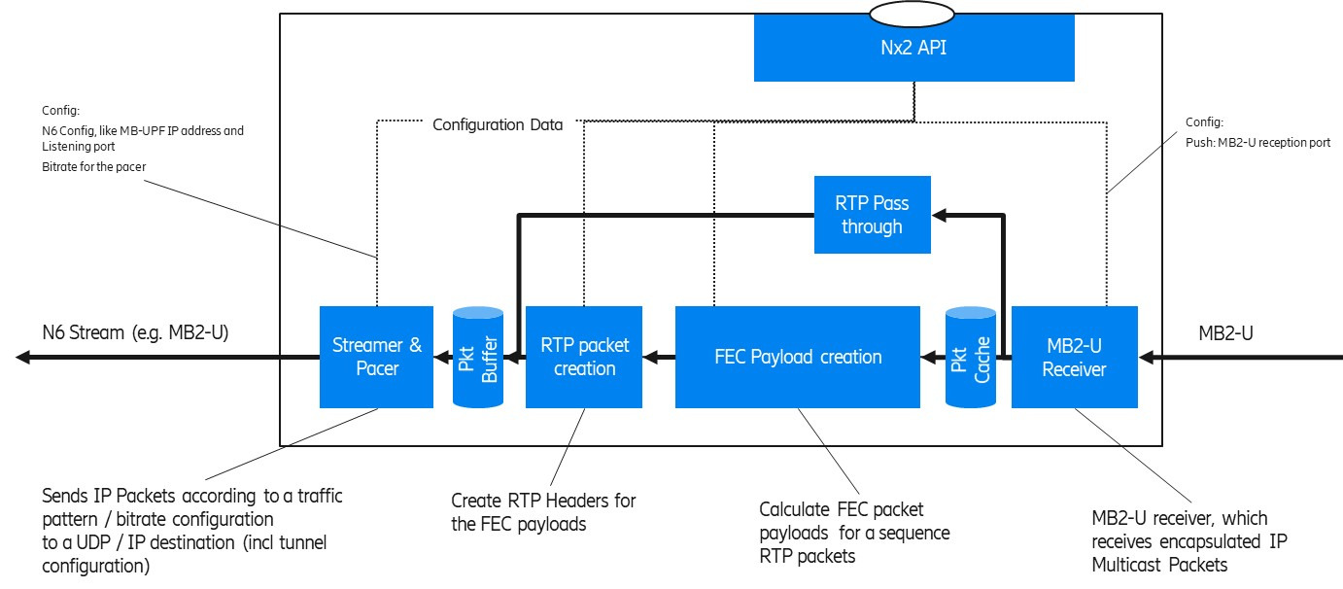

Figure 5.3.1.5-1: Simplified User Plane model for Group Communication Delivery with FEC  
(as an MBSTF function)

The model depicts some key functions from an MB2-U ingest to an MB-UPF ingest (N6). In the case of Group Communication Delivery the MBSTF operates as follows:

1. The **MB2-U Receiver** is responsible for receiving the MB2-U packets. The IP multicast user plane packets are encapsulated into the MB2-U packets. The MB2-U receiver may duplicate the packets so that the original packet can be passed through to the output and the copy remains in the Packet Cache for FEC source block creation.
2. The **RTP Passthrough** passesthe source packets directly to the output.

Editor’s Note: It is ffs, whether the RTP Passthough function appends FEC information (like a source block id), without modifying the original parts.

1. **FEC Payload Creation** calculates the FEC redundancy information which is then carried as a separate RTP flow to the receiver.
2. **RTP packet creation** prepends RTP header fields to the payloads of the FEC flow.
3. The **Streamer & Pacer** ensures a smooth output bit rate according to the configured Guaranteed Bit Rate.

NOTE: Since FEC redundancy is added to the stream, the output bit rate is higher than the input bit rate.

When a GCS AS activates an MB2 session with FEC, the GCS AS provides the following information to the BM‑SC:

- **FEC configuration information** (see clause 6.4.27 of TS 29.468 [18]). A list of the FEC Framework configuration information according to clause 8A.5 of TS 26.346 [16] is depicted in Figure 5.3.1.5-2 below.

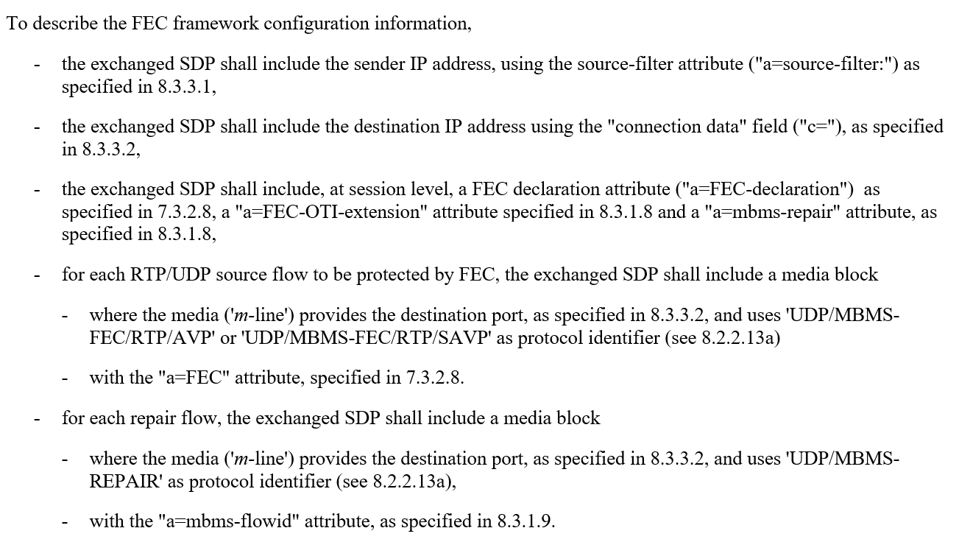

Figure 5.3.1.5-2: FEC Framework configuration information according to TS 26.346 Clause 8A.5

As response, the GCS AS receives the MB2-U tunnel endpoint information (i.e. the BM‑SC Address AVP and BM‑SC Port AVP).

When the BM‑SC is split into MBSF and MBSTF, the MBSF interacts with the MB-SMF in order to obtain the N6 ingest parameters for the MB-UPF. The MBSF provides the FEC framework configuration information together with the MB-UPF N6 ingest information to the MBSTF via Nmb2. The MBSTF allocates the MB2-U tunnel endpoint information and passes the MB2-U ingest information back to the MBSF.

The MBSF may pass the FEC Framework configuration information to the MBSTF as an Octet Stream (see clause 6.4.27 of TS 29.468 [18]) so that the MBSTF parses the SDP information.

### 5.3.2 Identified gaps

1. For the 5MBS Object Delivery Method (former Download Delivery), the Nmb2 API should re-use the xMB-C property for configuration. The configuration should be extended with N6-mb parameters and Streamer parameters (e.g. bit rate). A TMGI or MBS Session Id is not needed.

2. For the 5MBS Transparent delivery methods and Group Communication delivery method, the Nmb2 API should accommodate FEC Framework configuration data. In addition, the N6mb parameters and Streamer parameters (e.g. bit rate) are needed. A TMGI or MBS Session Id is not needed.

3. It is for discussion whether the MBSTF functionality for the Group Communication delivery method can be merged with the Transparent delivery method. It seems that the only differences are configuration aspects, such as usage of MB2-C or xMB-C.

4. The MBSTF is a user plane only function and should not create any ancillary information. The MBSF and/or the AF/AS should be the source of any in-band ancillary information, which are ingested by the MBSTF.

5. The Nmb2 API should support the ingest of in-band ancillary information. A separate ingest point to the delivery function is needed to provide the ancillary information, either embedded in Nmb2 or as separate interface.

NOTE: Ancillary information may be distributed either using unicast or 5MBS. Distribution of ancillary information in-band with other MBS data on the same MBS Session may only needed in some scenarios.

6. The existing xMB-C API does not support the ingest of 5MBS User Service related in-band ancillary information. The 5MBS version of xMB-C (Nmbsf) should be evolved to include this suppport.