3GPP TSG SA WG4 #114e S4-210804

E-meeting, 19th – 28th May 2021
CR-Form-v12.0
Pseudo CHANGE REQUEST
 | 26.802 | CR | <CR#> | rev | - | Current version: | 1.2.8
For HELP on using this form: comprehensive instructions can be found at
http://www.3gpp.org/Change-Requests.

Proposed change affects: | UICC apps |  | ME | X | Radio Access Network |  | Core Network | X

Title: | [FS_5GMS_Multicast] Hybrid Services
Source to WG: | Qualcomm Incorporated
Source to TSG: | SA4
Work item code: | FS_5GMS_Multicast |  |  |  |  |  | Date: |  |  | 2021-05-11
Category: | B |  |  |  |  |  | Release: |  |  | Rel-17
 | Use one of the following categories:  F (correction)  A (mirror corresponding to a change in an earlier release)  B (addition of feature),  C (functional modification of feature)  D (editorial modification)  Detailed explanations of the above categories can  be found in 3GPP TR 21.900. |  |  |  |  |  |  |  | Use one of the following releases:  Rel-8 (Release 8)  Rel-9 (Release 9)  Rel-10 (Release 10)  Rel-11 (Release 11)  Rel-12 (Release 12)  Rel-13 (Release 13)  Rel-14 (Release 14)  Rel-15 (Release 15)  Rel-16 (Release 16)
Reason for change:
Summary of change:
Consequences if not approved:
Clauses affected:
 |  | Y | N
Other specs |  |  | X | Other core specifications |  |  |  | TS/TR ... CR ...
affected: |  |  | X | Test specifications |  |  |  | TS/TR ... CR ...
(show related CRs) |  |  | X | O&M Specifications |  |  |  | TS/TR ... CR ...
Other comments:
56
This CR's revision history:

===== CHANGE =====

5.7 Key Issue #6: Hybrid Services

5.7.1 Description

5.7.1.1 Definition
A hybrid service is defined as a service that fulfills at least one of the following aspects:
1. The same service is available on different delivery systems, for example on multicast, on broadcast or on unicast
2. A service available on one delivery system may be enhanced by additional resources available on a different delivery system
3. The service include sufficient information such that a client can synchronize or seamlessly replace the service on one delivery system with the one on a different one.
The following key aspects need to be studied:
• Study the support for external hybrid services (as defined in clause 5.7.1.2) including live TV services with latency constraints) to support different functionalities such as service continuity etc.
• Study the support for 5GMS-based hybrid services (as defined in clause 5.7.1.3) (including live TV services with latency constraints) to support different functionalities such as service continuity etc.

5.7.1.2 Use Case 1: External Hybrid Service
An overview of the considered system is shown below for which DVB-I (including DVB-I Service Discovery, ABR multicast, DVB-DASH and DVB-AVC codecs) can be used to suitable distribute DVB services to any type of device.
A service provider offers a service in a service list. The services are the same content services, but they are distributed over different distribution means. The service provider wants to include all relevant 5G distribution systems available up to Rel-17.
1. 5GMS using APIs as defined in TS 26.501
2. 5G based broadcast as defined in ETSI TS 103 720 with APIs based on TS 26.348.
5MBS delivery as is expected to be defined in Rel-17.
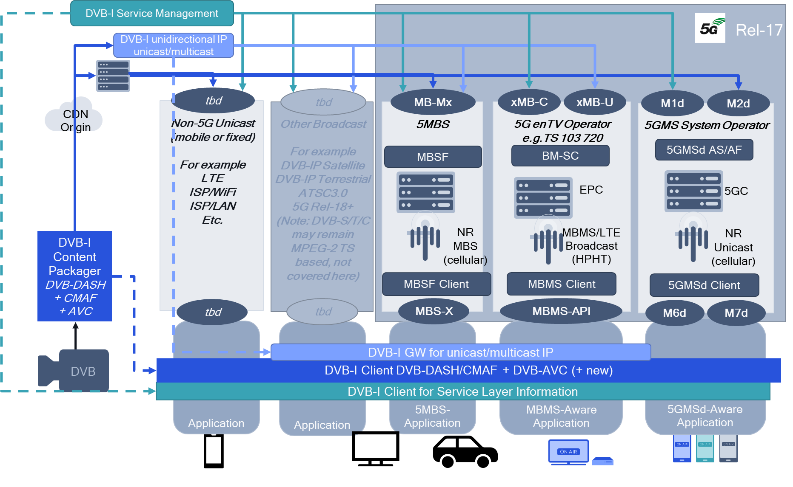
Figure 5.7.1.2-1: External hybrid service
Services may be made available completely or partially on different delivery means. Clients capable of one or multiple 5G Media distribution systems should be able to select suitable delivery services, combine them and/or dynamically switch across these systems. In particular relevant is the hybrid combination that allows that a service may not only be available through a single distribution mean, but may be augmented and enhanced by other means, for example in case no broadcast coverage is available.
One potential use case is provided in the following:
- A Broadcast operator operates a HPHT distribution, for example in a dedicated broadcast spectrum or any other spectrum that is accessible for HPHT distribution
- The Broadcast operator primarily targets non-TV devices (smart phones, tablets, etc.) but also provides the services to TV devices (TV, STB).
- The Broadcast operator provides multiple services, for example public free-to-air or private.
- Broadcast operator has the ambition to run a hybrid service (integrated broadcast/unicast distribution) from day one, for some of the following reasons:
o Perceptually good service continuity to ensure coverage, in particular indoor and urban.
o Providing the same services to devices that do not support broadcast/multicast reception.
o Unicast-based ad insertion (targeted to users, regions, etc.).
o Targeted regional content.
o Service Signalling.
o Content Protection on service/app level (for subscription services).
o QoE metrics reporting.
o Consumption Reporting for operational purposes.
o Enhanced content quality by additional unicast (e.g. through scalable/layered coding or equivalent means) subject to availability of DVB codecs supporting this.
o Fast service start-up and service acquisition while maintaining efficient delivery on broadcast. Different aspects may matter depending on device and service types.
o Unicast-based error recovery if reception on a primary distribution is lossy.
o Auxiliary components on unicast, for example alternative languages or views.
o Audience Measurement
o Ad Tracking
The key aspects of the use case for 5MBS are as follows:
- The service needs to be provisioned
- Ingest needs to be enabled
- The service needs to be announced and discovered
- The MBS-aware application may dynamically monitor and switch on/off the service reception
- The MBS-aware application expects sufficient information to switch across delivery methods
- The MBS-aware application expects sufficient information to consume media received on different delivery systems jointly.

5.7.1.3 Use Case 2: 5GMS Hybrid Service
In a similar fashion as discussed in clause 5.7.1.2, a hybrid service is now offered by an MNO as part of 5G Media Streaming, according to the client architecture depicted in Figure 4.4.2.3-1. The service integrates 5GMS unicast-based and 5MBS-based delivery. The integration of 5G Broadcast based on enTV as defined in ETSI TS 103 720 is covered in key issue #7 in clause 5.8.
In the hybrid case, the following functionalities are supported:
- Same service is offered through 5GMS unicast and 5MBS. Client decides which service to use depending on among others its capabilities, reception quality, etc.
- Content may be targeted, for example for ad insertion (targeted to users, regions, etc.).
- Enhanced content quality by additional unicast (e.g. through scalable/layered coding or equivalent means) subject to availability of DVB codecs supporting this.
- Content may be offered that certain components are available on unicast only, but are combined in the 5GMS client for a combined service.
- Fast service start-up and service acquisition while maintaining efficient delivery on broadcast. Different aspects may matter depending on device and service types.
- Unicast-based error recovery if reception on a primary distribution is lossy.
- Auxiliary components on unicast, for example alternative languages or views.
- Audience Measurement.
- Ad Tracking.

5.7.2 Identified Issues

5.7.2.1 General
This clause collects identified issues for different flavours of the hybrid use case.

5.7.2.2 Use Case 1: External Hybrid Service
For use case 1, this is expected to be solved outside 3GPP. A service provider may provide the same service with different instances over different 5G distribution systems. DVB is currently developing the relevant Commercial Requirements for this purpose.
No immediate gaps in 3GPP are identified.

5.7.2.3 Use Case 2: 5GMS Hybrid Service
The use case is depicted in the figures provided in clause 4.4.5.3 and 4.4.5.4. Three different options are considered, that only marginally differentiate.
In the following, ten different scenarios are identified:
1. Fast 5GMS session start-up via unicast while the 5MBS Client is waiting for initial multicast/broadcast packets to start arriving via MBS-4.
2. Unicast recovery of the application payload data carried in multicast/broadcast packets that are not successfully received via MBS-4, in a manner that is transparent to the 5GMS Client.
3. 5GMS session continuity when multicast/broadcast service is temporarily unavailable, in a manner that is transparent to the 5GMS Client.
4. Switching the operating mode of a 5GMS session to unicast under the direction of network-based multicast operation on demand (MooD), in a manner that is transparent to the 5GMS Client.
5. Enhanced service quality, for which content quality is enhanced by additional unicast (e.g. through scalable/layered coding or equivalent means).
6. Component replacement, for example a component provided over 5MBS session is replaced by a unicast component.
7. Time-shifted viewing: a 5GMSd client decided to watch the service in timeshift mode and hence switches to unicast distribution.
8. Content may be targeted, for example for ad insertion (targeted to users, regions, etc.).
9. Reporting is done also for the 5MBS service.
10. Interactive Service for example with a presentation layer being included.
Categorization of the scenarios above can be done in the following four dimensions:
A. Is the same content provided through 5GMS unicast and 5MBS?
- yes: scenario 2 (unicast recovery), scenario 3 (session continuity) and scenario 4 (MooD).
- no: scenario 5 (enhanced service quality), scenario 6 (component replacement), scenario 8 (content targeting) and 10 (interactive service).
- unclear: scenario 1 (Fast Start-up) and scenario 7 (time-shifted viewing).
- orthogonal: scenario 9 (Reporting).
B. Is only one delivery mode consumed at the same time or multiples?
- multiple continuously: scenario 5 (enhanced service quality), scenario 6 (component replacement), scenario 9 (Reporting), 10 (interactive service).
- multiple sporadically: scenario 1 (Fast Startup), scenario 2 (unicast recovery).
- only one mode at a time: scenario 3 (session continuity), scenario 4 (MooD), scenario 7 (time-shifted viewing), scenario 8 (content targeting).
C. Which entity decides the modes to be used: Application, Media Player, Media Ssession Handler, 5MBS Client, 5GMS AF, MBSTF?
- Application: 10 (interactive service).
- Media Session Handler: scenario 9 (Reporting).
- Media Player: scenario 1 (Fast Start-up), scenario 5 (enhanced service quality), scenario 6 (component replacement), scenario 7 (time-shifted viewing), scenario 8 (content targeting).
- 5MBS client: scenario 2 (unicast recovery) scenario 3 (session continuity).
- AF: scenario 4 (MooD).
D. Which setups provide requirements for 5GMSd AS to Media Player delivery latency?
- Unicast and 5MBS the same: scenario 3 (session continuity), scenario 4 (MooD), scenario 5 (enhanced service quality), scenario 6 (component replacement).
- Unicast faster than 5MBS: scenario 1 (Fast Startup), scenario 2 (unicast recovery).
- No requirements: scenario 9 (Reporting), 10 (interactive service).
- 5MBS faster than unicast: scenario 7 (time-shifted viewing), scenario 8 (content targeting).
===== CHANGE =====

6.2.3 5GMS Hybrid Services

With reference to the architecture depicted in Figure 4.4.5.4-2, Table 6.3.2-1 provides impacted reference points for the ten different hybrid scenarios described in clause 5.7.2.3.
Table 6.3.2-1: Impacted Reference Points for different hybrid scenarios
Scenario | Impacted reference points | Requirements
1 - Fast startup | M1: Fast startup feature is provisioned.  M2: Signaling of unicast fast start-up Representations in presentation manifest.  M4  Signaling of alternative distribution in the manifest, on 5GMS AS, one on 5MBS.  M4: Signaling availability of unicast fast start-up Representations.  Nmb2: Identification of content for 5MBS distribution.  Nmb4/xMB-U: Ingest of content by MBSTF for 5MBS distribution.  M4: Manifest that includes unicast fast start-up Representations and unicast fast start-up Representations.  M5: Potential prioritization of unicast fast start-up Representations.  MBS-4-MC: 5BMS object delivery of non-fast-start up Representations.  MBS-6: Announcement of non-fast-start up Representations by 5MBS Client.  MBS-7: Providing the non-fast-start up Representations from 5MBS Client. | Fast start-up Representations need to be available on 5GMS AS for early access.  The Media player needs to be able to switch to 5MBS distribution once the same content is available on unicast.
2 - Unicast recovery | MBS-5: Identification of unicast repair server.  Nmb2: Identification of content for 5MBS distribution.  Nmb4/xMB-U: Ingest of content by MBSTF for 5MBS distribution.  MBS-4-MC: 5MBS object delivery of content Representations.  MBS-4-UC: File repair.  MBS-7: Partial file delivery in case repair fails. | The unicast URLs need to be announced to the 5MBS Client.
3 - Session continuity | M1: Session-continuity feature is provisioned.  M2: Ingest of content by 5GMS AS.  M4: Signaling availability of alternative distribution in the manifest, on 5GMS AS, one on 5MBS.  Nmb2: Identification of content for 5MBS distribution.  Nmb4/xMB-U: Ingest of content for 5MBS distribution.  MBS-5: Signaling of identical and alternative content.  MBS-4-MC: 5MBS object delivery of content Representations.  MBS-7: Dynamic steering of Media Player from 5MBS to unicast (panic button).  MBS-6/M6: Availability information of 5MBS distribution. | The 5MBS client needs to inform the Media Player about the (non-) availability and of resources through 5MBS distribution.  The service also needs to work with low-latency DASH.
4 - MooD | No considerations for this Release | None.
5 - Enhanced service quality | M1: Enhanced service quality feature is provisioned.  M2: Ingest of enhanced quality content by 5GMS AS.  M4: Signaling availability of distribution in the manifest, on 5GMS AS, one on 5MBS.  Nmb2: Identification of content for 5MBS distribution.  Nmb4/xMB-U: Ingest of content by MBSTF for 5MBS distribution.  MBS-4-MC: 5MBS distribution of content Representations.  M4: Unicast distribution of enhanced service quality.  M5: Potential support of unicast distribution. | The 5MBS Client needs to support the retrieval of components from 5MBS and unicast at the same time.  The service also needs to work with low-latency DASH.
6 - Component replacement | M1: Component replacement feature is provisioned.  M2: Ingest of replacement content by 5GMS AS.  M4: Signaling availability of distribution in the manifest, on 5GMS AS, one on 5MBS.  Nmb2: Identification of content for 5MBS distribution.  Nmb4/xMB-U: Ingest of content by MBSTF for 5MBS distribution.  MBS-4-MC: 5MBS object delivery of content Representations.  M4: Unicast distribution of replacement component.  M5: Potential support of unicast distribution. | The 5MBS client needs to support to retrieve components from 5MBS and unicast at the same time.  The service also needs to work with low-latency DASH.
7 - Time-shifted viewing | M1: Time-shifted viewing feature is provisioned.  M2: Ingest of time-shifted content.  M4: Signaling avaiability of live-edge content on 5MBS, time-shifted content on 5GMS AS.  Nmb2: identification of content for 5MBS distribution.  Nmb4/xMB-U: Ingest of content by MBSTF for 5MBS distribution.  MBS-4-MC: 5MBS object delivery of content Representations.  M4: distribution of time-shifted content. | The transition should be seamless.
8 – Targeted content replacement | M1: Replacement content on unicast is provisioned.  M2: Ingest of replacement content.  M4: Signaling availability of distribution in the manifest, one 5GMS AS, one on 5MBS.  Nmb2: Identification of content for 5MBS distribution.  Nmb4/xMB-U: Ingest of content by MBSTF for 5MBS distribution.  MBS-4-MC: 5BMS distribution of live main content.  M4: Distribution of targeted unicast content for replacement.  M5: Potential support of unicast distribution. | The transition between unicast targeted content and 5MBS content is expected to be seamless
9 – Reporting | M1: Reporting feature is provisioned.  Nmb2: Identification of content for 5MBS distribution.  Nmb4/xMB-U: Ingest of content by MBSTF for 5MBS distribution.  MBS-4-MC: 5MBS object delivery of content.  M5: Reporting.
10 - Interactive service | M1: Interactive content distribution is provisioned.  M2: Ingest of interactive content.  Nmb2: Identification of content for 5MBS distribution.  M8: Content is announced through interactive application.  M6/M7/MBS-6: Find content on 5G MBS.  Nmb4/xMB-U: Ingest of content by MBSTF for 5MBS distribution.  MBS-4-MC: 5BMS object delivery of content.

===== CHANGE =====

7.3.5 Hybrid 5GMS unicast and 5MBS services
Based on the principle considerations in Table 6.2.3-1, for all different hybrid unicast/5MBS services except MooD, the following needs to be done:
- Architecture for Hybrid 5GMS unicast and 5MBS services,
- Call flows for the hybrid services need to be defined.
- The required functions of the reference points need to be checked against existing functions in TS 26.501, TS 26.511, TS 26.512, TS 26.346, TS 26.347 and TS 26.348.
The required functions need to be documented and extended as needed.

