3GPP TSG-SA4 Meeting SA4#113-e S4-210560
April 6th- April 14th 2021

Source: Tencent
Title: Draft CR updates on Additional Overlay Configuration
Document for Agreement
Agenda item: 12.5

Introduction:
This document proposes additional text for the draft CR. The below updates are proposed to be added in section X.6.4.3.3 of the draft CR.

Justification
The below text is from the permanent document section 2.
“In the third scenario, multiple conference rooms are sending 360-degree video to an MRF/MCU. The rooms may choose to receive 2D video streams from other participants including one of the other rooms, which is displayed on the screen in the room. A pictorial representation is shown in Figure 2.3. ”
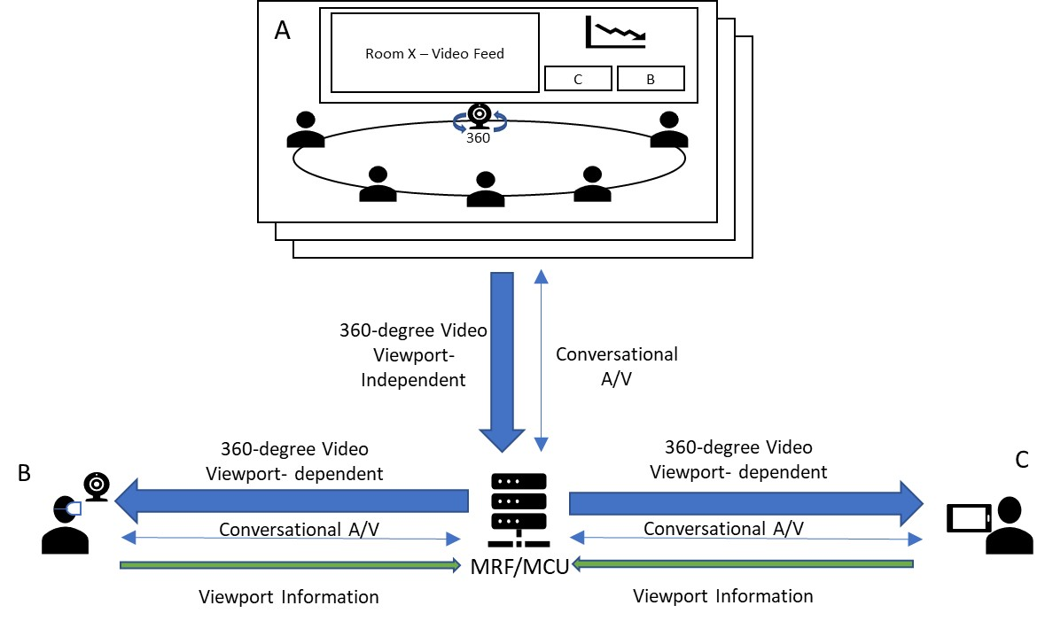
Figure 2.3: Multiple rooms with 360-degree video
Therefore:
- The 360-degree video maybe received as 2D video streams
- The remote ITT4RT-Rx client may receive media streams which are not shared by the ITT4RT-Tx client
Based on the above scenario, there maybe 2 cases:
- The ITT4RT-Tx client may or may not allow the ITT4RT-Rx client to stream overlays not shared by the ITT4RT-Tx client
- The ITT4RT-Tx client includes a flag to prevent overlaps among the overlays: The region where the overlays, not shared by the ITT4RT-Tx client, are to be rendered may be decided by the ITT4RT-Rx client. However, overlay overlap may happen. Therefore, to avoid such overlaps, an overlay_overlap flag maybe added.
First Change
X.6.4.3.4 Additional Overlay Configuration
An ITT4RT client supporting the 3gpp_overlay attribute to configure a sphere-relative overlay or viewport-relative overlay shall additionally include the following parameter for indicating the support for overlays from multiple senders:
- multiple_overlay_flag: Indicates if the ITT4RT-Rx client is allowed to use multiple overlays. When set to 1, the client may stream more than one overlay to be displayed on the 360-degree video. The default value is 1.
- other_senders_overlay_flag: Indicates if the ITT4RT-Rx client is allowed to stream overlays from other ITT4RT-Tx clients. When set to 1, the ITT4RT-Rx client may stream overlays not shared by this ITT4RT-Tx client.
- overlay_overlap_flag: Indicates if the ITT4RT-Rx client is allowed to overlap overlays from other ITT4RT-Tx client. If set to 1, the ITT4RT-Rx client may overlap overlays onto the overlays shared by this the ITT4RT-Tx client.

End of Changes

Proposal
The proposal is to move the agreed changes to the draft CR

