3GPP TSG SA4 Meeting #111e S4-201568
Still At Home, 11. – 20. November 2020
Agenda item: 8.6
Source: Ericsson LM, Qualcomm, BBC
Title: Summary of an 5MBS offline Discussion
Document for: Discussion and Agreement

1 Introduction
This is a short summary of the offline discussions between Ericsson, Qualcomm, BBC, Enensys, Telus, Huawei and Oppo around the new 5G Multicast / Broadcast architecture and the functional split with 5G Media Streaming architecture.
The intention of this document is to share information around the offline sessions and some key take-aways.
We use the following architecture as a first starting point:
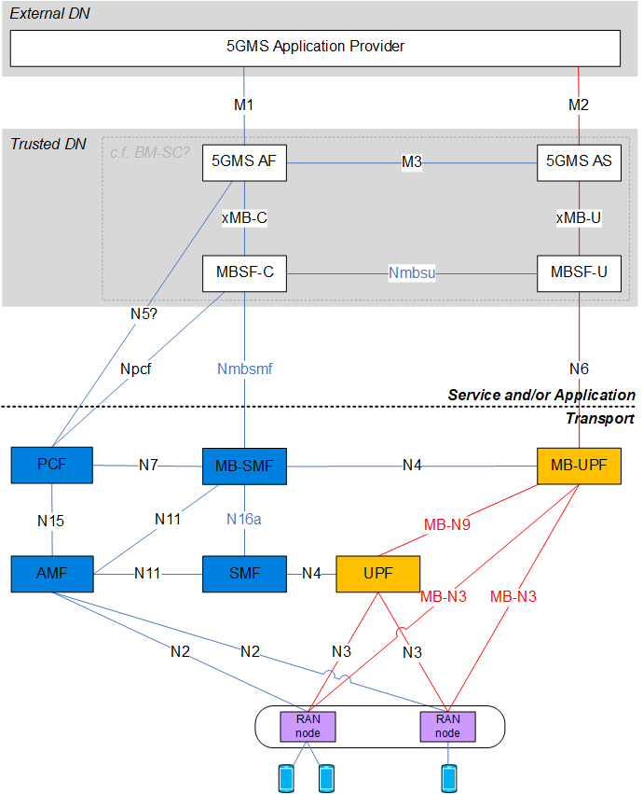

The converged architecture is depicted in Annex A.3 of TR 23.757. It is copied below for convenience.
Figure A.3.2-1: Reference Architecture

Figure A.3.2-2: Configuration options at Service and/or Application

2 Summary
During the offline, we primarily discussed topics around xMB evolution and the handling of the different delivery methods in TS 26.346.
As a starting point, what we agree upon
- The usage of M1 and M2 towards the application provider. Generally, M1 and M2 as defined in 5GMS are expected to be used also for 5G MBS based media distribution. The usage of 5G MBS is primarily transparent to the 5GMS Application provider, but there are cases for which the 5GMS Application provider may explicitly request/encourage/allow/disallow the usage of 5G MBS or Multicast/broadcast in general. Hence, the usage of 5MBS may not be completely hidden to the 5GMS Application provider.
  - There are potentially also use-cases outside 5GMS usage of 5G MBS. However, the FS_5GMSA-Multicast study is around 5GMSA.
  - However, as 5GMS AF and 5GMS AS may be operated outside the trusted operator domains, southbound interfaces (in the above diagram currently named xMB) towards MBSF are also relevant for 5G Media Streaming and hence are in scope of the SA4 study. These southbound interfaces may be used by other applications than 5GMS AF/AS and are hence generic.
- The concept of 5GMS AS connecting to MBSF-U for delivering data over multicast/broadcast/5G MBS. The 5GMS AS addresses content hosting and unicast delivery. MBSF-U does not support unicast delivery (which is different to the BMSC functions defined in TS 26.346).
  - Media would most likely be pushed via an interface resembling xMB-U because M4 only supports HTTP pull. This implies that the 5GMS AS also needs to implement a subset of xMB-U user functions.
  - Media may also be pulled from the 5GMS AS, for example when carouseling of files is requested.
  - xMB-U is expected to be sufficient to support the communication between 5GMS AS and MBSF-U, but possibly only a subset of xMB-U functionalities is needed. Details are for further study.
  - Equivalently, xMB-U support (possibly with subset) is expected to be sufficient as the northbound interface for MBSF-U.
- Support of different collaboration models, specifically Collaboration A and B from 1441. One issue with Collaboration C is that the MBSF is supposed to be located inside the Trusted DN. However, an MBSF-like function may generate a compliant packet stream.
  - Contribution 1441 notes that Collaboration C is consistent with Configuration 1 in figure A.3.2.2 of TR 23.757, but we need to check with SA2 whether a direct supply of a TS 26.346-compliant bit stream to the MB-UPF is permitted from an External DN without going through MBSF-U. The SA2 Use Case for this seems to be currently limited to the Group Communication Service.
  - We believe that this case C does not have the highest priority for 5GMS and this current study, as it is not expected that for 5GMS, the MBSF will be setup outside of the trusted network as this may also have security implications. Feedback from SA2 on this matter would be welcome.
- The MBSF-U contains unidirectional delivery method functions from TS 26.346, e.g.
  - Sourcing of IP Multicast (except “Forward only” mode).
  - Generic packet transport functionalities equivalent to the Transparent delivery mode in TS 26.346
  - File-based and object streams unidirectional delivery on multicast IP equivalent to the download delivery method in TS26.346 without associated delivery procedures.
- In MBMS, the BM-SC includes Services, Delivery Modes and Session level-features. We consider that MBSF should not be overloaded with a service concept.
  - Service Level refers to the compilation of full User Service Description information that includes , e.g. MPD URL, QoE reporting, Delivery session definition, etc. Session Level refers to a multicast delivery, e.g. protocol, bit rate, etc.
  - → The Service Level handling overlaps with 5GMSA offerings, since it combines unicast and multicast delivery. The current thinking is to only have Service-level information in the 5GMSA. The Session-related procedures are offered by MBSF.
  - In case a service concept is needed for a non-5GMS offering on top of the MBSF, this service concept would may have to be implemented by an Application Function. This is for further study.
- We also considered the mapping of the network architecture to the UE. We agree that 5GMS client and a MBSF-U counterpart similar to an MBMS client is able to support the network architecture.
  - The data APIs in TS 26.347, clause 7, can be reused to the most extent in an equivalent fashion as xMB-U is reused on the network side.
  - Providing the IP multicast address and physical resources where the 5G MBS session (or MBMS session) can be accessed by the client, is considered to be part of the AF communication with the respective client function. In case of 5GMS, 5GMS AF would information the Media Session Handler. This MSH would then initiate the access to the session by initiating the “5G MBS/MBMS client”.
- On the MBSF-C, we are currently unsure if it is needed or if the 5GMS AF can directly communicate with MB-SMF and MBSF-U.
  - Before making a decision, more detailed call flows for different deployment scenarios should be done to understand if an MBSF-C is needed.
  - MBSF-C may for example be useful for proper interworking with LTE/EPC.
- We also discussed the Nmbsu API, which is exposed by MBSF-U.
  - It makes sense that SA4 defines the Nmbsu API, since it is directly related to the unidirectional delivery method functions in the MBSF-U.
  - The Nmbsu should be follow SBA, i.e. HTTP REST based is expected.
  - A review of xMB-C indicated, that a high degree of properties should be re-used exposed via the Nmbsu API. xMB-C contains configuration of the xMB-U ingest and other user-plane related functions.
  - SA4 needs more input on the MB-UPF transport options (N6). It is not clear, whether only MB2-U type of transport option is supported by the MB-UPF or others as well.

3 Work Split SA2 and SA4 (stage-2)
- Southbound interface from MBSF-U and MBSF-C is owned by SA2 for definition
- Northbound interface from MBSF-U and MBSF-C (excluding MB2) is owned by SA4 for specification
- The MBSF-U exposes a control interface for MBSF-C. It makes sense that SA4 is defining the Nmbsu API (exposed by the MBSF-U)
- The detailed functions of the MBSF-U and MBSF-C are defined by SA4
- The combination with 5G Media Streaming is defined by SA4
- Any service aspects, if applicable, would be defined by SA4
- Extensions of M1 and M2 to address 5G MBS-based delivery would be defined by SA4

4 Topics for the response LS
- Since SA2 assumes that the MBSF entities can be regarded as an evolution of the BM-SC, SA4 proposes to define the functionality of the MBSF-U.
  - Thus, it feels natural that SA4 also supports or defines the definition of interface Nmbsf.
- We need to get more clarity of the MB-UPF transport options (N6 protocols). For the MBSF-U design (in particular the Nmbsf definition), we need to know the configuration parameters and options for N6.
- The BM-SC hosted the SYNC (for time synchronization) and PDCP layer (for RoHC header compression). The prime reason here is MBSFN operation. 5MBS does not yet have a requirement for synchronization, but normative work is ongoing in RAN. So, we need to clarify whether SYNC and / or RoHC header compression (part of PDCP) should be supported by MBSF-U or not.
- Regarding Configuration 1, Figure A.3.2-2, TR 23.757: Can an Application Function in an external Data Network publish data directly into the MB-UPF via N6/MB2-U? Is Configuration 1 limited to mission critical?
- SA4 kindly asks SA2 to add a note in the final TS that an AF can also support control plane / user plane split.
- Other general comments on basic agreements in clause 2
- Other general comments on the work split in clause 3

5 Proposal
It is proposed to take the above given information into account when
- Agreeing on the principle way forward
- Identifying and defining key issues for SA4 TR 26.802
- Sending an LS to SA2 for the upcoming meeting

