**Source: Qualcomm Incorporated**

**Title: Proposals for data collection of HaNTE – test methods**

## Document for: Agreement

## Agenda Item: 9.6

## Abstract

This contribution proposes test methods that participating companies can use for a data collection round robin in support of the work item on Handsets Featuring Non-Traditional Earpieces (HaNTE), approved at SA#86 [1].

## Background

The objectives of the HaNTE work item, as described in [1] are the following:

- Update 3GPP TS 26.132 with reference to the appropriate version of ITU-T P.64 that addresses HaNTE devices.

- Review performance of HaNTE devices and update requirements in 3GPP TS 26.131 if necessary, to ensure an adequate user experience.

- Establish guidelines for mounting of HaNTE devices to ensure a repeatable and reproducible measurement method in 3GPP TS 26.132.

- Investigate testing RFR/RLR at a single position and at different positions, and report the results; based on those results, and if judged necessary by SA4, new requirements/test methods may be specified.

- Address privacy aspects identified during the study phase and develop requirements/test method if necessary.

- Address distortion aspects identified during the study phase and update requirements/test method if necessary.

- Address out of band noise aspects identified during the study phase and develop requirements/test method if necessary.

At SA4#107, a contribution [2] proposed changes to TS 26.131 and TS 26.132 that address some of the objectives of the work item. The source believes that inter-lab repeatability and reproducibility is a key aspect and must be assessed in connection with new test method proposals prior to agreement. The source then proposed [3], and SQ agreed in principle [4] to:

1. Conduct a round-robin testing of HaNTE devices with willing participating labs.
2. The following tentative time-plan for the round robin:

|  |  |  |
| --- | --- | --- |
| March 3rd, 2020 | SQ SWG Telco | * Agree in principle on conduction of round robin test. * Identify 3 test labs interested in participating in the round robin. |
| March, 2020 | Over email among interested member companies | * Agree on a selection of 3 to 5 HaNTE devices. * Work collectively over reflector on draft test methodology, including mounting guidelines. |
| April, 6th 2020 | SA4#108 e-meeting SQ SWG Telco session 1 | * Review inputs on detailed test methodologies for iii.a., iii.b., iii.c. and iii.d., including choice of codecs and connection instructions. * Review a spreadsheet template for the data collection. |
| April, 8th 2020 | SA4#108 e-meeting SQ SWG Telco session 2 | * Agree on detailed test methodologies * Identify test Lab 1 for first round of measurements |
| April, 2020 |  | * Test Lab 1 conducts measurements |
| May, 2020 |  | * Test Lab 2 conducts measurements |
| May, 25th 2020 | SA4#109, Erlangen | * Review results from Test Labs 1 and 2. |
| Jun, 2020 TBC |  | * Test Lab 3 conducts additional measurements   Editor’s note: lab availability might be shifted in time |
| End of June, 2020, date [TBD] | SQ SWG Telco [TBD] | * Review results of Test Lab 3. |
| July/August, 2020 |  | * Test Lab 4 conducts measurements |
| 24th-28th August, 2020 | SA4#110, US | * Review results of Test Lab 4 * Discuss next steps. |

## Participating labs

As of the writing of this document, the following labs have expressed interest in participating in the round robin test effort:

|  |  |  |  |
| --- | --- | --- | --- |
| Tentative lab order | Lab | Contact Person | Contact email |
| 1 | Qualcomm Incorporated | Andre Schevciw | aschevci@qti.qualcomm.com |
| 2 | HEAD Acoustics GmbH | Jan Reimes | jan.reimes@head-acoustics.de |
| 3 | Orange | Alain Curti | alain.curti@orange.com |
| 4 | Huawei Technologies | Antero Tossavainen | antero.tossavainen@huawei.com |

Editor’s note: for lab 3, one needs to check if facilities are not closed due to the current situation, testing may have to be postponed

## List of Devices

As of the writing of this document, the following devices have been identified as available for the round robin test effort:

|  |  |
| --- | --- |
| Manufacturer | Model |
| Samsung | [A60](https://www.samsung.com/hk_en/smartphones/galaxy-a60-a606/SM-A6060ZKGTGY/) |
| Samsung | [A80](https://www.samsung.com/hk_en/smartphones/galaxy-a80-a805/SM-A8050ZDDTGY/) |
| Huawei | [P30 Pro](https://consumer.huawei.com/en/phones/p30-pro/) |
| Huawei | [Mate 30 Pro](https://consumer.huawei.com/en/phones/mate30-pro/) |
| LG | [G8 ThinQ](https://www.lg.com/us/mobile-phones/g8-thinq) |
| Xiaomi | [Mi MIX](https://www.mi.com/global/mix) |
| Vivo | [NEX](https://www.vivo.com/en/products/nex) |
| Apple | [iPhone 11 Pro](https://www.apple.com/iphone-11-pro/) |

## Test Methods for HaNTE

The descriptions of the test methods to be used for the round-robin test are provided in Appendix.

## 6. References

1. TD SP‑191212 (WID NEW) New WID on Handsets Featuring Non-Traditional Earpieces (HaNTE), Source: SA4
2. Tdoc S4-200173, Proposals for HaNTE, Source: Orange
3. Tdoc S4-AHQ146, Proposals for data collection of HaNTE, Source: Qualcomm Incorporated
4. Tdoc S4-AHQ147, Report from SA4 SQ SWG conf. call on HaNTE (3rd March 2020), Source: SA4 SQ SWG interim Chairman

**Appendix : Test Methods**

# Out-of-band signals in receive direction

# Wideband

NOTE: This test method was originally described in clause 6.3.15 of Final draft ETSI ES 202 739 V1.8.1 (2020-03) Speech and multimedia Transmission Quality (STQ); Transmission requirements for wideband VoIP terminals (handset and headset) from a QoS perspective as perceived by the user. It is adapted here for the purposes of the HaNTE work item. <https://www.etsi.org/deliver/etsi_es/202700_202799/202739/01.08.01_50/es_202739v010801m.pdf>

**Requirement**

The frequency response shall be reported over the fullband frequency range for each DUT.

NOTE: Original requirements from ETSI are provided here only for reference when conducting measurements. There is no working assumption that the requirements below are appropriate for HaNTE purposes.

Any spurious out-of-band image signals in the frequency range from 9 kHz to 12 kHz measured selectively should be lower than the in-band level measured with a reference signal. The minimum level difference between the reference signal level and the out-of-band image signal level shall be as given in Table A.

Table A

|  |  |
| --- | --- |
| Frequency | Signal limit |
| 9 kHz | 50 dB [TBC] |
| 10 kHz | 52 dB[TBC] |
| NOTE1: The limits for intermediate frequencies lie on a straight line drawn between the given values on a linear (dB) - logarithmic (kHz) scale. | |
| NOTE2: Not sufficient experience is available so far with this method. Therefore signal limit numbers are provisional and may be updated with a later revision of the present document | |

**Measurement method**

The handset terminal or the headset terminal is setup as described in clause 5.1.1 of 3GPP TS 26.132, except that the version of ITU-T Recommendation P.64 to be referenced is the 06/2019 version. The handset is mounted in [the standard position of the HATS.]

Editor’s note: take vendor provided position if available?

Measurement is operated at nominal and maximum value of volume control.

The signal used is an activation signal followed by a sine wave signal. For input signals at the frequencies 6 kHz and 7 kHz applied at the level of -16 dBm0, the level of spurious out-of-band image signals at frequencies up to 10 kHz is measured selectively at measurement point.

Editor’s note: frequency range to be confirmed

The female speaker signal of the short conditioning sequence described in clause 7.3.7 of Recommendation ITU-T Recommendation P.501 shall be used for activation. Level of this activation signal shall be -16 dBm0.

# Narrowband

For further study.

Editor’s note: this could be seen as lower priority.

# Super-wideband

For further study.

Editor’s note: check if additional results for SWB could be optionally provided. The only practical issue is how to establish the calls for the handsets available in VoLTE so we can actually test EVS-SWB (if supported at all).

# Objective listening speech quality MOS-LQO in receive direction

# B.1. Wideband

NOTE: This test method was originally described in clause 6.4.2 of Final draft ETSI ES 202 739 V1.8.1 (2020-03) Speech and multimedia Transmission Quality (STQ); Transmission requirements for wideband VoIP terminals (handset and headset) from a QoS perspective as perceived by the user. It is adapted here for the purposes of the HaNTE work item. <https://www.etsi.org/deliver/etsi_es/202700_202799/202739/01.08.01_50/es_202739v010801m.pdf>

The listening speech quality tests are conducted under clean network conditions.

**Requirement**

NOTE: Original requirements from ETSI are provided here only for reference when conducting measurements. There is no working assumption that the requirements below are appropriate for HaNTE purposes.

The requirements for the listening speech quality and the delay under clean network conditions are as follows.

Table B

|  |  |
| --- | --- |
| Speech coder | MOS-LQOF (P.863) |
| AMR-WB | > 4,0 |
| NOTE: Recommendation ITU-T P.863 [21] is using a fullband scale. Not sufficient experience is available so far with this method. Therefore the numbers given for MOS-LQOF are provisional and may be updated with a later revision of the present document | |

**Measurement method**

Objective listening speech quality is measured using Recommendation ITU-T P.863 in fullband mode.

The handset terminal or the headset terminal is setup as described in clause 5.1.1 of 3GPP TS 26.132, except that the version of ITU-T Recommendation P.64 to be referenced is the 06/2019 version. The handset is mounted in [the standard position of the HATS.]

Editor’s note: take vendor provided position if available?

The test signal to be used for the measurements shall be 4 sentence pairs (male/female) fulfilling the requirements of Recommendation ITU-T P.863.1. The 4 sentence pairs are taken from Recommendation ITU-T P.501. It shall be stated, which sentence pairs were used. The test signal level is averaged over all sentence pairs (4 sentence pairs).

Measurement is operated at nominal [and maximum] value of volume control.

Editor’s note: discuss level.

The measurement is done 4 times, every time using another pair of the speech sentences. The result of the measurement is the averaged value of all 4 measurements.

NOTE 3: For the use of P.863 the following applies (see Recommendation ITU-T P.863.1):

* Fullband Context (MOS-LQOF):
  + Reference Signal Fullband flat filtered 20 Hz to 20 kHz.
  + Test Signal Wideband flat low pass filtered 7,8 kHz.

# B.2. Narrowband

For further study

Editor’s note: this could be lower priority.

# B.3. Super-wideband

For further study

Editor’s note: check if additional results for SWB could be optionally provided

# Privacy in Receive Direction (max volume RLR)

**Requirement**

The minimum value of RLR from the POI, when evaluated at a radius of 1 meter from the HATS EEP in points A, B, C, D and E of Figure C1 and Table C, shall be less than [TBD].

Figure C1

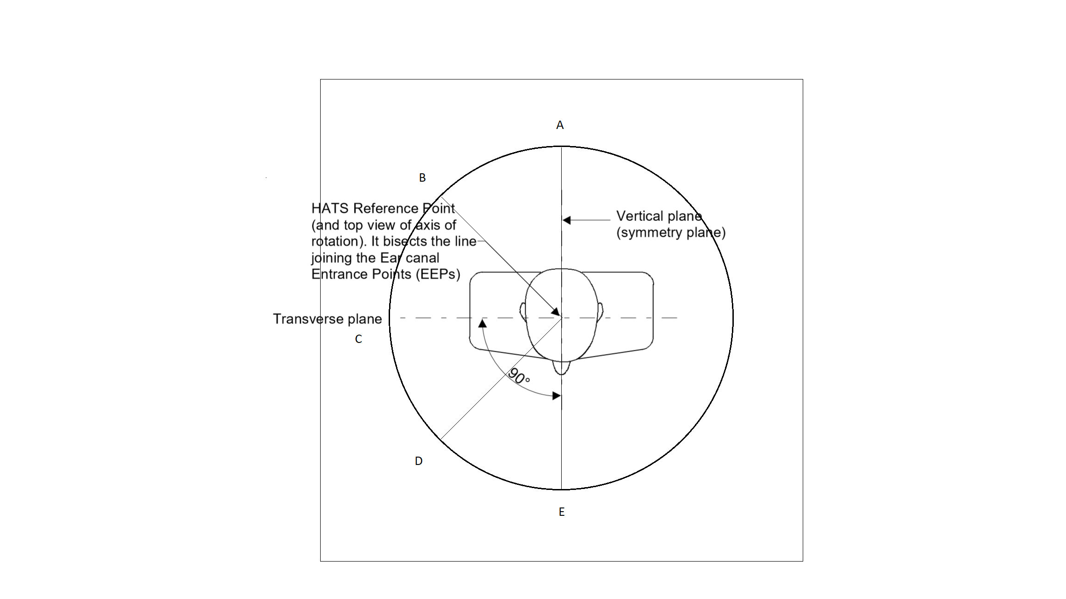

Table C

|  |  |
| --- | --- |
| Measuring position | Measuring angle (starting from E) |
| A | -180° |
| B | -135° |
| C | -90° |
| D | -45° |
| E | 0° |

Editor’s note: This measurement can be conducted with a turntable. It is a bit difficult to identify the proposed angles, it looks like clock-wise, starting at point E

Figure C2

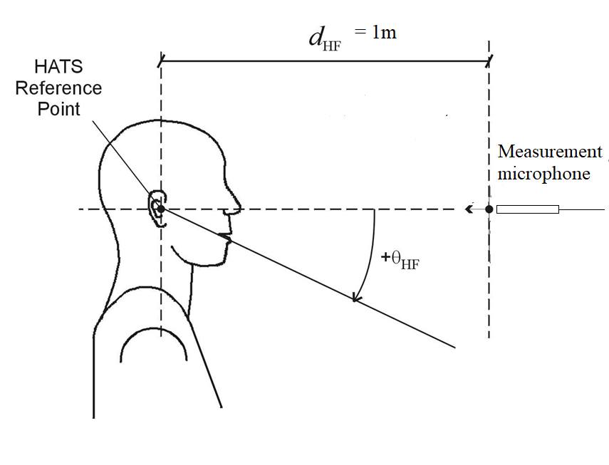

**Measurement method**

a) The test signal to be used for the measurements shall be the British-English single talk sequence described ITU-T Recommendation P.501 [22]. The test signal level shall be -16 dBm0 measured at the digital reference point or the equivalent analogue point. The test signal level is calculated over the complete test signal sequence.

b) The handset terminal or the headset terminal is setup as described in clause 5.1.1 of 3GPP TS 26.132, except that the version of ITU-T Recommendation P.64 to be referenced is the 06/2019 version. The handset is mounted in [the standard position of the HATS.].

Editor’s note: take vendor provided position if available?

c) The volume control setting of the handset, if any, is adjusted to its maximum volume setting. The receiving sensitivity is measured at each of the positions in A, B, C, D and E of Figure C1 with a measurement microphone positioned at the HATS Reference Point height (ear height). If a second HATS is used as a measurement microphone, then it is free-field equalized as described in ITU-T Recommendation P.581. The equalized output signal of each artificial ear is power-averaged over the total duration of the analysis; the right and left artificial ear signals are voltage-summed for each 1/3-octave frequency band; these 1/3-octave band data are considered as the input signal to be used for calculations or measurements. The receiving sensitivity shall be calculated from each band of the 20 frequencies given in table A.2 of ITU‑T Recommendation P.79 Annex A, bands 1 to 20.

Editor’s note: volume control setting to be discussed – an alternative may be to set volume control settings to ensure RLR to -3 dB in normal testing?

d) The receiving sensitivity shall be calculated from each band of the 20 frequencies given in table A.2 of ITU‑T Recommendation P.79 Annex A, bands 1 to 20. For the calculation, the averaged measured level at each frequency band is referred to the averaged test signal level measured in each frequency band.

e) The sensitivity is expressed in terms of dBPa/V and the RLR shall be calculated according to ITU‑T Recommendation P.79, formula (A-23c), over bands 1 to 20, using m = 0,175 and the receiving weighting factors from table A.2 of ITU‑T Recommendation P.79 Annex A.

Editor’s note: Maybe consider reporting also P.56 ASL from the same data, to get an impression about very high RLR values. Alternatively, also check loudness/ITU-T P.700.

d) No leakage correction shall be applied. The hands-free correction as described in ITU‑T Recommendation P.340 shall be applied. To compute the receiving loudness rating (RLR) for hands-free terminals (see also ITU-T Recommendation P.340) when using the combination of left and right artificial ear signals from the HATS the HFLE has to be 8 dB, instead of 14 dB. For further information see ITU-T Recommendation P.581.

Editor’s note: Note that this is measured at the 1m distance microphone. Do you mean also making the traditional RLR measurement simultaneously? Inspired by the currently ongoing ITU-T Q5/12 round robin: One should record the test sequence at the DRP and use it for RFR (applying DRP-to-DF-correction manually), RLR (applying DRP-to-ERP manually). Then get both information with only one measurement.

# Receive Frequency Response Robustness to Holding Position (Wideband)

The test method is the same as in 3GPP TS 26.132 Clause 9.4.1.2, except that the device is measured in a XxX “grid” around the ECRP. Where an ECRP is not provided, the arbitrarily determined ECRP as according to Annex [TBD] shall be used. Additionally, the device is measured at ECRP (or the arbitrarily determined ECRP) with three handset holding point configurations as defined in Annex [TBD].

Note: The test method to be used is the super-wideband test method to allow for observation of potential out-of-band distortion and noise components.

Editor’s note: Possible idea to test at three different testing positions and with three different holding points. The variation should be ideally less than X. We should define at least one mounting/positioning scheme per DUT (may come from the manufacturer, if possible?):

Fork positions (maybe we can mark them with very small adhesive strips directly on the phone?).

Support pins (yes/no?).

Proposal: we could measure a 3x3 “grid” around an arbitrarily determined ECRP. In order to minimize testing time, we could do this with a much shorter speech sample (we made good experience with the P.501 Annex D samples).