Agenda item: 4.13
Source: Qualcomm Incorporated (Rapporteur)
Title: [FS_XRTraffic] Summary of XR Traffic Models for RAN1 and Open Issues
Document for Discussion and Agreement

Introduction
After reviewing the progress and work in the XR-Traffic study, this document reviews the status for each of the traffic models and summarizes the information to RAN1 to the best knowledge of the rapporteur. This document also provides a summary of the main assumptions.
The information is based on
S4aV200575 | [FS_XRTraffic] Permanent Document v0.9 | Qualcomm CDMA Technologies
S4aV200617 | FS_XRTraffic Parameters for XR Conversational | Sony Mobile Communications, Apple
S4aV200619 | [FS_XRTraffic] Proposed Updated Modelling for AR Conversational | Qualcomm CDMA Technologies
S4aV200624 | Minor Update on Traffic Model for Viewport Dependent 3DoF Streaming | HUAWEI Technologies Japan K.K.
S4aV200626 | [FS_XRTraffic] Proposed Updated Modelling for XR Split Rendering | Qualcomm CDMA Technologies
S4aV200628 | [FS_XRTraffic] Comment to S4aV200627 | Sony Mobile Communications, Apple
S4aV200631 | [FS_XRTraffic] Traces and Configurations for VR2, CG and AR2 | Qualcomm CDMA Technologies, Mediatek

The following applications are to be considered as starting points for this study:
- VR1: “Viewport dependent streaming”
- VR2: “Split Rendering: Viewport rendering with Time Warp in device”
- AR1: “XR Distributed Computing”
- AR2: “XR Conversational”
- CG: Cloud Gaming
Note: Use cases in quotes are from TR26.928.

It was agreed to focus on VR2, CG and AR2 initially. Initial information on VR1 is provided. For AR1, more information will be provided later.

Basic Overview
Figure 1 provides a basic overview of the traffic models. In particular the different model functions are provided for the system:
- Content Model: Provides a typically data for the XR content model for video, audio and potentially other data. This content is rendered for XR/CG consumption.
- Content Encoding: Provides the details for the content encoding in order to meet certain objectives. This includes the generation of application data units (slices, video frames, audio frames, etc.) and the incurred delay.
- Content Delivery Model: provides some details on content delivery, for example packetization, delay jitter, but possibly also more sophisticated models such as retransmission, TCP operations and so on. This also includes emulation of 5G Core Network.
- The RAN simulator receives sequences/traces of packets at a given time and of a specified size. The packets may have additional metadata assigned that can potentially be used by the radio simulator. The packet sequences are provided for multiple users and should reflect statistics.
- The RAN simulator provides packet traces after delivery that reflect the occurred delays and losses for each user.
- The delivery receiver converts the packet traces into application units taking into account delays and losses. It may also add additional functions such as retransmission in specific cases.
- The decoding model uses the received application units to model the reconstruction of the individual data taking into account delays, losses and also content model properties (error propagation, refresh data and so on).
- A quality evaluation tool is provided with the received traces to provide a quality that reflects packet, application unit and media quality.
- A model for the uplink traffic in a similar fashion also providing packet traces.

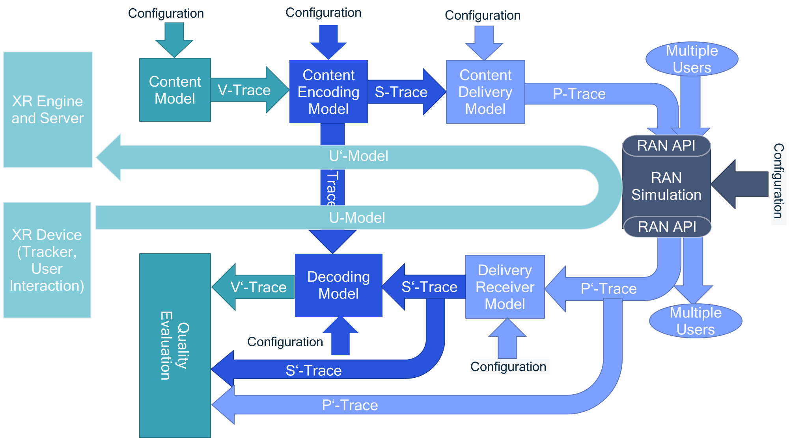
Figure 1 Basic overview for XR Traffic Simulation Model

For each of the cases, in document S4aV200631, proposed trace formats are provided for a simulator. In particular, P-Trace format (identical to P’-Trace format are important) as they interface with the radio simulator.

For each packet in the delivery, the following information is provided. The below is slightly generalized in order to address different use cases.
Name | Type | Semantics
number | BIGINT | Unique packet number in the delivery
time_stamp_in_micro_s | BIGINT | Availability time of packet for next processing step relative to start time 0 in microseconds (0 means lost).
size | BIGINT | packet size in bytes.
user_id | BIGINT | assigns an id to the user in order to differentiate
buffer | BIGINT | The associated eye buffer 1=left 2=right  In general, differentiates application traffic for different buffers, for example audio, video, left eye, right eye. For example mapped to port or track.
delay | BIGINT | Delay observed of the packet in the last processing step (-1 means lost)
render_timing | BIGINT | the rendering generation timing associated to the media included in the packet.
number_in_unit | BIGINT | The number of the packet within the unit (slice), start at 1
last_in_unit | BIGINT | Indicates if this is the last packet in the slice/unit 0=no, 1=yes
type | BIGINT | The data type of the unit  0 unknown  For video 1=intra 2=inter
importance | BIGINT | assigned relative importance information (higher number means higher importance)
index | BIGINT | Unique index increased by 1 and indexing this row in the S-Trace file.
s_trace | STRING | Reference to s_trace file containing information for each slice

Additional trace definitions are provided in S4aV200631.
The configurations are provided as JSON documents.
Some software is provided here: https://github.com/haudiobe/XR-Traffic-Model.
XR Traffic traces are uploaded here: http://dash.akamaized.net/WAVE/3GPP/XRTraffic/Traces
RAN1 is not expected to use the software for generating traces unless RAN1 wants to generate their own traces. In S4aV200631, clause 3.4.3 the basic usage of the traces is provided for RAN.
If a quality evaluation is expected to be done for all users, then resulting P’-Traces for N’ users from the RAN simulation would then be fed to the quality evaluation piece for multiuser evaluation.
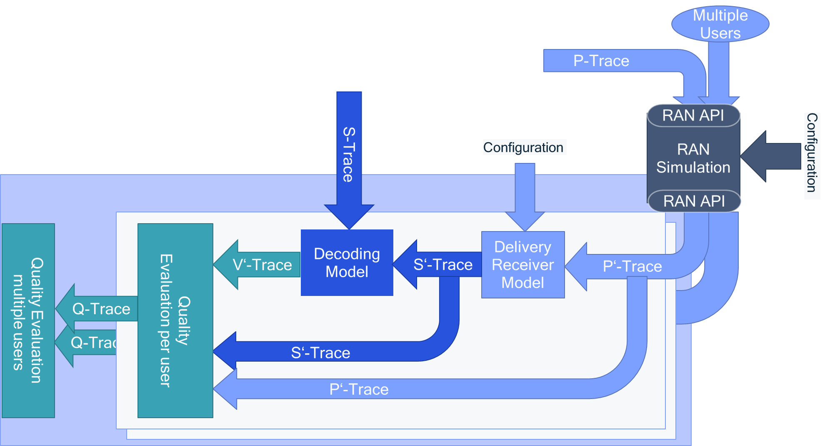

VR2: “Split Rendering: Viewport rendering with Time Warp in device”
Detailed system design and modeling assumptions are provided in S4aV200575, clause 6.2.
Detailed simulation assumptions are provided in in S4aV200575, clause 7.2 with detailed updates in S4aV200626. Detailed recommended configurations are provided in S4aV200631, clause 4.2.
- Content Model:
  - Rendered scene output with 2 eye buffers at 2Kx2K at 60 fps, 8bit.
  - Content and Trace Preview is here: http://dash.akamaized.net/WAVE/3GPP/XRTraffic/Traces/Qualcomm-VR2
  - No audio (considered small, could be added) according to S4aV200626, clause 7.2.12.
- Encoding Model
  - Encoding Models see S4aV200626, detailed configurations in S4aV200631, clause 4.2. Summary provided below
  - HEVC, target bitrate 30 Mbit/s (CBR, capped VBR), equally split across eye buffers, independently encoded.
  - Slice based encoding (8 slices) or 1 frame
  - Intra Refresh (1 slice per frame) or every 8th frame.
  - Left and right eye buffer are independently encoded.
  - Pre-encoding delay: Encoder pre-delay is varying between 10 to 20ms
  - Encoding delay is modelled to vary with mean 4/slice_numbers and std 3/slice_numbers and maximum being the frame interval (aligned with S4aV200607)
- Content Delivery Model
  - Content Delivery Model see S4aV200626, detailed configurations in S4aV200627, clause 4.2. Summary provided below
  - Packet MaxSize 1500 byte (cloud) or unlimited (edge)
  - Edge/Cloud to gNB bitrate is 1.5 media bitrate => delay variance
- Delivery receiver
  - Modeling according to S4aV200626
  - Packets are dropped if late
  - Slice loss model (1 lost packets per slice results in slice loss)
  - Timestamp of slice if time stamp of latest packet of slice
  - Maximum latency for slice: 60ms (see TR 26.928, clause 4 and 6.2.5.1)
- Decoding Model
  - Modeling according to S4aV200626
  - Takes into account slice structure, spatial and temporal error propagation, intra refresh
- Quality evaluation tool.
  - Modeling according to S4aV200626
  - The following metrics are considered for each user and buffer
    - IP Packet loss rate
    - IP Packet late rate
    - Slice loss rate
    - Area loss rate (total amount of Coding Units)
    - Area damage rate (total amount of Coding Units)
    - Average encoded PSNR
    - Average PSNR
  - Average over all buffers
  - Multi-user
    - Average over all users
    - Percentile of support
- A model for the uplink traffic in a similar fashion also providing packet traces.
  - XR Pose is sent uplink
  - Details are in S4aV200626, clause 7.2.13
  - The uplink bitrate for the pose if 200 kbit/s CBR, with 4ms packet interval and packet size 100 byte. This means that the content is rendered with a pose of typically 10-15ms age.
Assumptions are taken for now and may change, either by configuration updates or additional modelling.
For initial RAN simulation, a set of P-Traces for 16 users are provided, each 1 minute duration for 6 fixed configurations provided in clause 4.2.1 of S4aV200631. A summary is below
Configuration | Basic Content Parameters
VR2-1 | 8 slices per eye buffer, 1 slice per frame is intra coded, 30Mbit/s capped VBR with window 200ms, buffer sent at same time, 1500 byte max packet size
VR2-2 | 8 slices per eye buffer, 1 slice per frame is intra coded, 30Mbit/s capped VBR with window 200ms, buffer sent at same time, unlimited packet size
VR2-3 | 8 slices per eye buffer, 1 slice per frame is intra coded, 30Mbit/s CBR with window 1 frame, buffer sent at same time, 1500 byte max packet size packets
VR2-4 | 8 slices per eye buffer, 1 slice per frame is intra coded, 30Mbit/s CBR with window 1 frame, buffer sent at same time, unlimited packet size
VR2-5 | 1 slice per eye buffer, every 8th frame is intra coded, 30Mbit/s capped VBR with window 200ms, buffer sent at same time, 1500 byte max packet size
VR2-6 | 8 slices per eye buffer, 1 slice per frame is intra coded, 30Mbit/s capped VBR with window 200ms, buffers sent interleaved, 1500 byte max packet size

CG: Cloud Gaming
Detailed system design and modeling assumptions are provided in S4aV200575, clause 6.4.
Detailed simulation assumptions are provided in in S4aV200575, clause 7.4 with detailed updates in S4aV200626. Detailed recommended configurations are provided in S4aV200631, clause 4.3.
- Content Model:
  - Game output with 1920 x 1080 and 4096 x 2048 at 60fps.
  - Content and Trace Preview is here:
    - Baolei HD (to be produced)
    - Baolei 4K (to be produced)
  - No audio (considered small, could be added) according to S4aV200626, clause 7.2.12.
- Encoding Model
  - Encoding Models see S4aV200626, detailed configurations in S4aV200631, clause 4.2. Summary provided below
  - HEVC, target bitrate 8 or 30 Mbit/s (CBR, capped VBR).
  - Slice based encoding (8 slices) or 1 frame
  - Intra Refresh (1 slice per frame) or every 8th frame.
  - Pre-encoding delay: Encoder pre-delay is varying between 10 to 20ms
  - Encoding delay is modelled to vary with mean 4/slice_numbers and std 3/slice_numbers and maximum being the frame interval (aligned with S4aV200607)
- Content Delivery Model
  - Content Delivery Model see S4aV200626, detailed configurations in S4aV200627, clause 4.2. Summary provided below
  - Packet MaxSize 1500 byte (cloud) or unlimited (edge)
  - Edge/Cloud to gNB bitrate is 1.5 media bitrate => delay variance
- Delivery receiver
  - Modeling according to S4aV200626
  - Packets are dropped if late
  - Slice loss model (1 lost packets per slice results in slice loss)
  - Timestamp of slice if time stamp of latest packet of slice
  - Maximum latency for slice: 80ms (see TR 26.928, clause 4 and 6.2.5.1)
- Decoding Model
  - Modeling according to S4aV200626
  - Takes into account slice structure, spatial and temporal error propagation, intra refresh
- Quality evaluation tool.
  - Modeling according to S4aV200626
  - The following metrics are considered for each user and buffer
    - IP Packet loss rate
    - IP Packet late rate
    - Slice loss rate
    - Area loss rate (total amount of Coding Units)
    - Area damage rate (total amount of Coding Units)
    - Average encoded PSNR
    - Average PSNR
  - Average over all buffers
  - Multi-user
    - Average over all users
    - Percentile of support
- A model for the uplink traffic in a similar fashion also providing packet traces.
  - XR Pose is sent uplink
  - Details are in S4aV200626, clause 7.2.13
  - The uplink bitrate for the pose if 200 kbit/s CBR, with 4ms packet interval and packet size 100 byte. This means that the content is rendered with a pose of typically 10-15ms age.
Assumptions are taken for now and may change, either by configuration updates or additional modelling.
For initial RAN simulation, a set of P-Traces for 16 users are provided, each 1 minute duration for 4 fixed configurations provided in clause 4.3.1 of S4aV200631. A summary is below
Configuration | Basic Content Parameters
CG-1 | 4K content, 8 slices, 1 slice per frame is intra coded, 30Mbit/s capped VBR with window 200ms, 1500 byte max packet size
CG-2 | 4K content, 8 slices, 1 slice per frame is intra coded, 30Mbit/s capped VBR with window 200ms, unlimited packet size
CG-3 | FullHD content, 8 slices, 1 slice per frame is intra coded, 8Mbit/s capped VBR with window 200ms, 1500 byte max packet size
CG-4 | 4K content, 1 slice, every 8th frame is intra coded, 30Mbit/s capped VBR with window 200ms, 1500 byte max packet size

A script is provided to do quality evaluation based on the traces.

AR2: “XR Conversational”

5.1 Overview
Detailed system design and modeling assumptions are provided in S4aV200617 and S4aV200619.
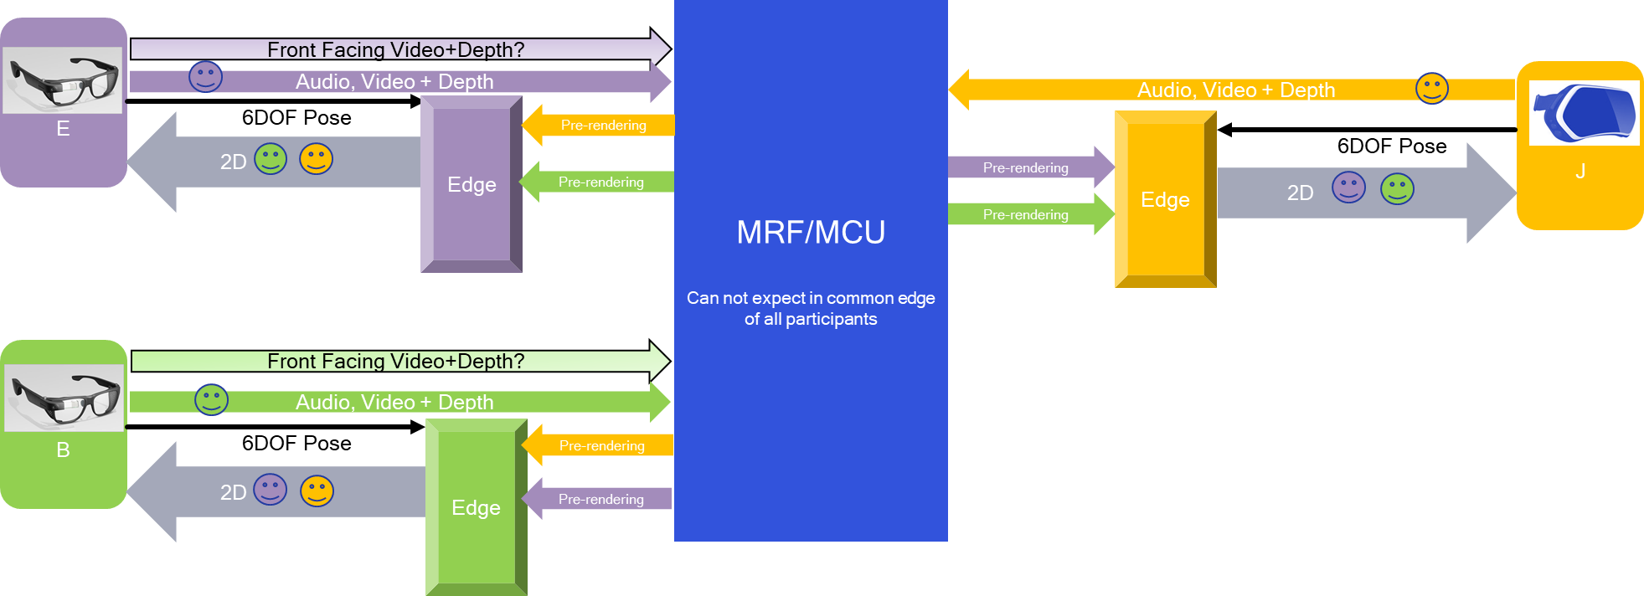
Media | Format and Model | E2E Latency requirement
3/6DOF Pose | Same as for split rendering | UL: 5-10 ms
Video + Depth | 1080p, Capped VBR 10/20 Mbit/s for UL | Conversational 100ms, 200ms
2D Video is split rendering | 1080p or 4K (2 eyes)  same model as split rendering | 60ms  100ms
Front Facing Camera* | 720p, CBR 3 Mbit/s for UL | Conversational  100ms, 200ms
Audio (MPEG-H) | 256/512 kbps for both UL/DL | Conversational 100ms, 200ms
Data StreamCa | 0.5 Mbps for both UL/DL | Conversational 100ms, 200ms

5.2 Simulation Downlink
Downlink simulation model is provided in the following

- Content Model:
  - Video is identical to VR2 simulation
  - edrdseeo
  - (euefo R)
  - Audio
    - Max Sampling Rate: 48 kHz
    - Inter-frame time: 20-21.3 ms
NOTE: For the simulation purposes, the inter-frame time can be assumed to be 21.3 ms considering MPEG-H, or if we consider that the actual conversational audio codec might be a different one, we could assume 20 ms, as this has so far been used for several 3GPP speech codecs
  - Data hneSra
    - Inter-frame time: 10 ms

- Encoding Model
  - Video is identical to VR2 simulation

    - Audio
    - Max Sampling Rate: 48 kHz
    - 1-1): 3GPP MPEG-H Audio (this Operation Point is specified for VR streaming in SA4 and can be used for simulation purposes for conversational services since the IVAS_Codec is not yet available)
    - Average data Rate : 256 / 512 kMbp
    - Packet Loss rate should be below 10e-3
    - : 20-21.3 msNOTE: For the simulation purposes, the inter-frame time can be assumed to be 21.3 ms considering MPEG-H, or if we consider that the actual conversational audio codec might be a different one, we could assume 20 ms, as this has so far been used for several 3GPP speech codecs
    - Average data Rate : <0.5 Mbps
    - Packet Loss rate should be below 10e-3

- Content Delivery Model
  - Identical to VR2

- Delivery receiver

  - Identical to VR2
- Decoding Model
  - Video: identical to VR2
  - Audio: tbd
    - Data: tbd

- Quality evaluation tool.
  - Modeling according to S4aV200626
  - The following metrics are considered for each user and buffer
    - IP Packet loss rate
    - IP Packet late rate
    - Slice loss rate
    - Area loss rate (total amount of Coding Units)
    - Area damage rate (total amount of Coding Units)
    - Average encoded PSNR
    - Average PSNR
  - Average over all buffers
  - Multi-user
    - Average over all users
    - Percentile of support
  - Audio and Data channel are tbd
- A model for the uplink traffic in a similar fashion also providing packet traces.
  - Uplink Pose information
    - Identical to VR2

  - Reverse uplink audio and video encoding see clause 5.3
Assumptions are taken for now and may change, either by configuration updates or additional modelling.

5.3 Simulation Uplink
It is proposed to do a reversed uplink.
- Content Model:
  - Video
    - Camera Signal with 1920 x 1080 at 60fps.
    - Content and Trace Preview is here: tbd
  - Audio
    - Max Sampling Rate: 48 kHz
    - Inter-frame time: 20-21.3 ms
NOTE: For the simulation purposes, the inter-frame time can be assumed to be 21.3 ms considering MPEG-H, or if we consider that the actual conversational audio codec might be a different one, we could assume 20 ms, as this has so far been used for several 3GPP speech codecs
  - Data hneSra
    - Inter-frame time: 10 ms

- Encoding Model
  - Video
    - Encoding Models see S4aV200626, detailed configurations in S4aV200631, clause 4.4. Summary provided below
    - HEVC, target bitrate 10 Mbit/s (capped VBR) or AVC target bitrate 20 Mbit/s (capped VBR).
    - Slice based encoding (4 slices) or 1 frame
    - Intra Refresh (1 slice per frame) or every 60th frame.
    - Pre-encoding delay: Encoder pre-delay is varying between 10 to 20ms
    - Encoding delay is modelled to vary with mean 4/slice_numbers and std 3/slice_numbers and maximum being the frame interval (aligned with S4aV200607)
    - dnia oC o ulDcniE

    - Audio
    - Operation Point (following 3GPP TS 26.118 Table 6.1-1): 3GPP MPEG-H Audio (this Operation Point is specified for VR streaming in SA4 and can be used for simulation purposes for conversational services since the IVAS_Codec is not yet available)
    - Average data Rate : 256 / 512 kbps
    - Packet Loss rate should be below 10e-3
  - Data hneSra
    - Average data Rate : <0.5 Mbps
    - Packet Loss rate should be below 10e-3

    - 48 kHzOperation Point (following 3GPP TS 26.118 Table 6.1-1): 3GPP MPEG-H Audio (this Operation Point is specified for VR streaming in SA4 and can be used for simulation purposes for conversational services since the IVAS_Codec is not yet available)
    - .5 MbpsPacket Loss rate should be below 10e-3
NOTE: For the simulation purposes, the inter-frame time can be assumed to be 21.3 ms considering MPEG-H, or if we consider that the actual conversational audio codec might be a different one, we could assume 20 ms, as this has so far been used for several 3GPP speech codecs
  - Average data Rate : <0.5 Mbps
    - Packet Loss rate should be below 10e-3

  - Identical to VR2
  - Audio and Data: tbd

- Delivery receiver
  - Modeling according to S4aV200626
  - Packets are dropped if late
  - Slice loss model (1 lost packets per slice results in slice loss)
  - Timestamp of slice if time stamp of latest packet of slice
  - Maximum latency for slice: 80ms (see TR 26.928, clause 4 and 6.2.5.1)
  - Audio and Data: tbd

- Decoding Model
  - Modeling according to S4aV200626
  - Takes into account slice structure, spatial and temporal error propagation, intra refresh
  - Audio and Data: tbd

- Quality evaluation tool.
  - Modeling according to S4aV200626
  - The following metrics are considered for each user and buffer
    - IP Packet loss rate
    - IP Packet late rate
    - Slice loss rate
    - Area loss rate (total amount of Coding Units)
    - Area damage rate (total amount of Coding Units)
    - Average encoded PSNR
    - Average PSNR
  - Average over all buffers
  - Multi-user
    - Average over all users
    - Percentile of support
  - Audio and Data channel are tbd

Assumptions are taken for now and may change, either by configuration updates or additional modelling.
For initial RAN simulation, a set of P-Traces for 16 users are provided, each 1 minute duration.
A script is provided to do quality evaluation based on the traces.

5.4 Simulation Framework
For details on downlink, refer to S4aV200631, clause 4.4. Traces will be produced.
For details on uplink, refer to S4aV200631, clause 4.5. Traces will be produced.

- VR1: “Viewport dependent streaming”
An initial set of simulation parameters are provided according to S4aV200575 and S4aV200624, but oeither packet traces nor quality evaluation are yet available.tb

Proposed Model Consideration

Content Delivery Setting
According to 3GPP SA4 study work in [A] and [B], the tiled stream approach can be used for VR 360 video delivery. It allows emphasizing the current user viewport through transmitting non-viewport samples with decreased resolution, i.e. selecting the tiles from the viewport at a high-resolution version and the tiles that do not belong to the viewport at a lower resolution.
With tiled streaming approach, one or multiple decoders are needed, which depends on each of the tiles is encoded as motion-constrained HEVC tiles or separate video streams. When using motion constrained tile HEVC streams, the varying spatial resolution in video picture can be achieved by merging all tiles into a single common bitstream with one decoder needed. When using separately encoded video streams, several decoders are required at the receiver side.
Similarly to the separately encoded video streams, GSMA Cloud AR/VR white paper [C] proposes the Tile Wise Streaming according to MPEG OMAF specification [D]. The tiled based approach with separately encoded video streams are used for Viewport Dependent 3DoF Streaming delivery method. The details can be summarized as below:
- Split the original 8K 360° panoramic video into multiple tiles (such as 42 tiles) and generate a low-resolution 360° panoramic video (such as a 4K 360° panoramic video);
- All tiles and the low-resolution panoramic video are packaged in DASH using spatial relationship descriptors and distributed via the CDN;
- The client player retrieves low-resolution panoramic video and those tiles which are located at the user’s field of view. When the user turns around and causes the field of view to change, the client requests new tiles from the CDN for the new field of view. The multiple tiles would be obtained separately and merged into the FoV-Area pictures in the receiver side. Because it requires a certain amount of time from when the new tiles are requested until they can be rendered, the low-resolution panoramic video will be displayed until the new tiles can be played.

Simulation Parameters and Options
- Streaming:
  - Types of streaming: video-on-demand
- Frame Setting
  - 30fps
- Formats of transmitted content:
  - ERP
  - 8K(7680 * 3840)
  - YUV 4:2:0
- Video Encoder configuration
  - Codec:H.265/HEVC
  - Rate control: VBR
  - Tile settings: 42 per frame
  - Tiles of FoV Area: 18
  - Complexity settings for encoder
  - Segment Length: 1.067s
- Audio Encoder configuration
  - Max Sampling Rate: 48 kHz
  - Operation Point(following 3GPP TS 26.118 Table 6.1-1): 3GPP MPEG-H Audio
- Content Delivery
  - MPEG-DASH-based media delivery (tiled based approach with separately encoded video streams)
- RAN Configuration :
  - QoS Settings (5QI): GBR, Latency, Loss Rate, Mobility, Power Consumption
- Receiver configuration:
  - Buffer size: 3s
- E2E Downlink Budget:
  - 50ms

Output traffic characteristics
- Data rate range:
  - per tiled streaming: 0.71~1.43 Mbps
  - FoV Area Streaming: (0.71~1.43)*18 Mbps
  - low-resolution 4K omnidirectional streaming: 6-8Mbps
- Periodical segment request: 1s per request
- Per tiled Segment size range: 8000 ~ 180000 byte
- Low resolution 4K omnidirectional segment size range: 848386~1681920 byte
- Packet size distribution: fixed size as 1500 bytes

AR1: “XR Distributed Computing”
No information is yet available.

Proposal
It is proposed to:
- Recognize the status
- Addressing the few missing aspects
- Refine the clause 5 during SA4#112 and update RAN1.
- Complete 6 and 7 for SA4#112
- Attached this information to RAN LS.

