Agenda item: 4.13
Source: Qualcomm Incorporated, Mediatek
Title: [FS_XRTraffic] Traces FrasRecoigurations for VR2, CG and AR21
Document for Discussion and Agreement

Introduction
This document provides an overview of software tools, trace formats and configurations.
This model can be used for
- VR2: Split Rendering,
- CG: Cloud Gaming,
- AR2: XR Conversational.
The usage for others service is ffs.
The document also provides initial recommended configurations for each of the above scenarios and provides relevant P-Traces.

Basics
The trace formatsAare defined as CSV files and follow the recommendation in RFC4180 "Common Format and MIME Type for CSV Files". For CSV files, headers are added to identify the data types. From existing CSV types, the online tool https://csv.openbridge.dev/ has been used to
- Validate the csv file
- Create a schema for the files.
The configurations are provided as JSON documents.
The software is provided here: https://github.com/haudiobe/XR-Traffic-Model. Note that not all possible configurations are yet supported.

Software Functions and APIs

3.1 Overview
An overview of the different software modules and APIs are provided in Figure

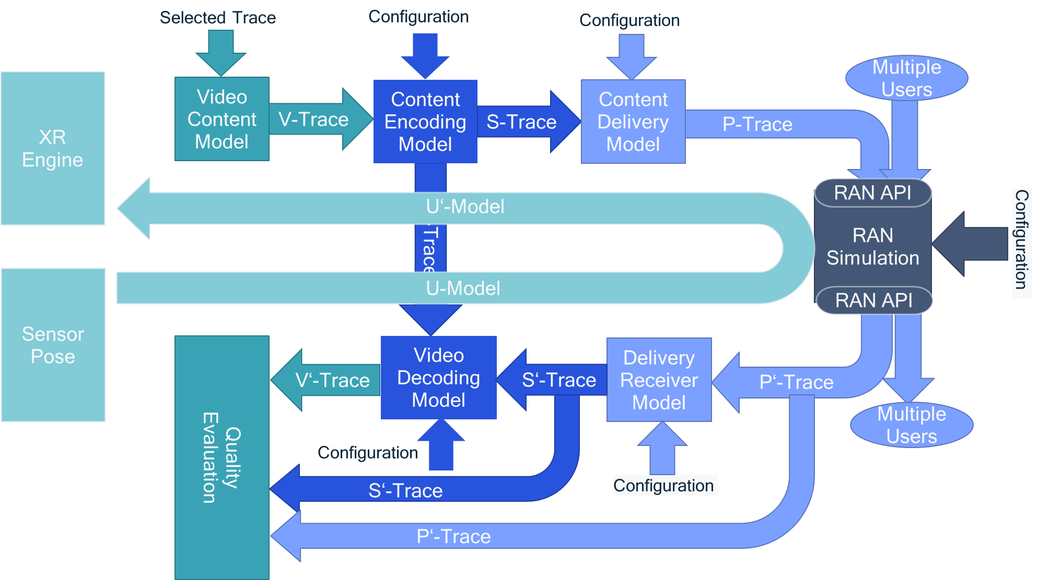
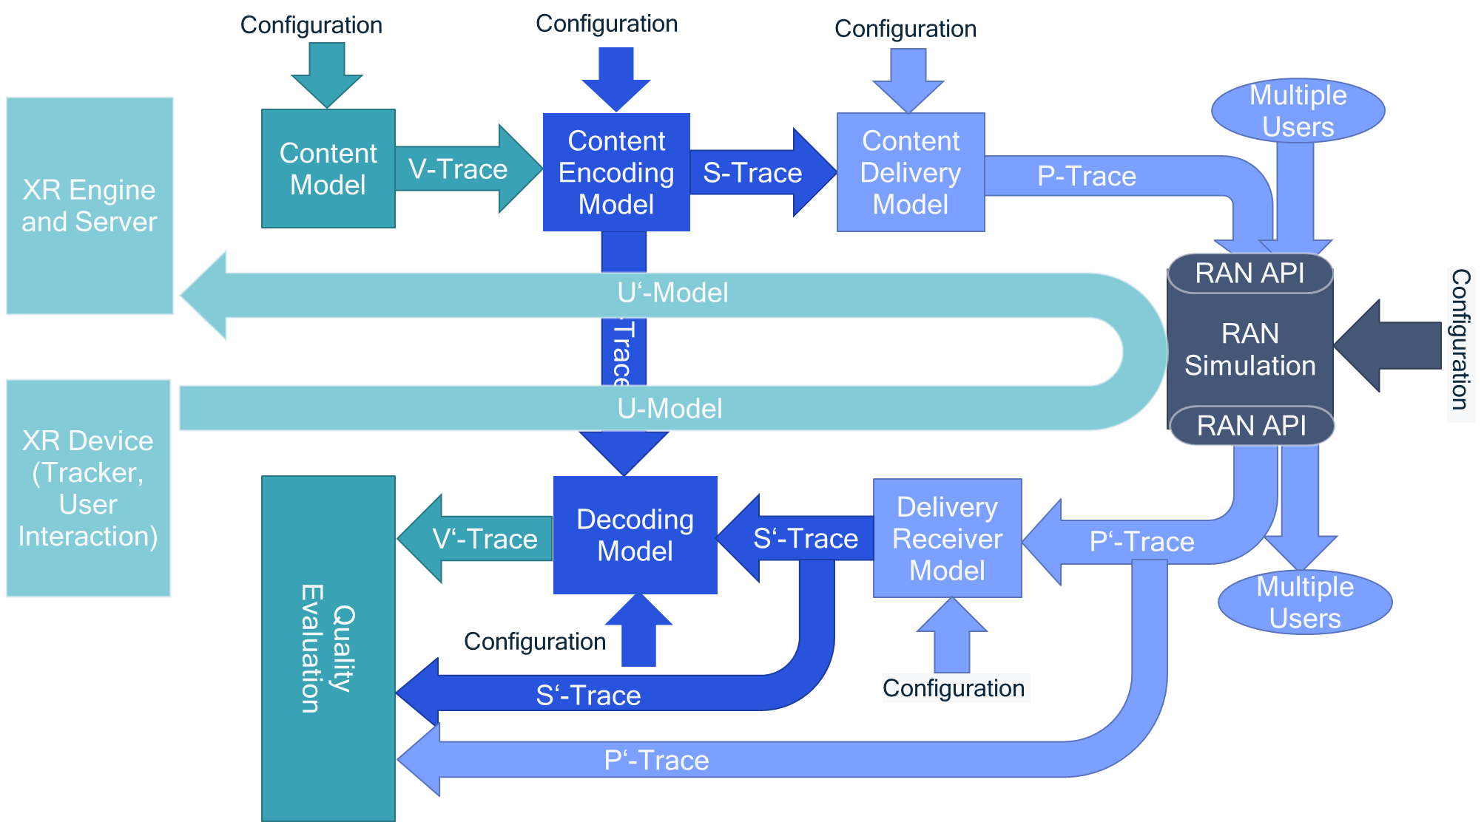
Figure 1 Overview of Software modules, traces and configurations
Figure Overview of the System Simulation Model

For each of the APIs, the data formats are provided and a detailed semantical description.

For RAN, the P-Traces are provided, and RAN simulation provides as outputs of P-Traces.

In clause 3.4, detailed summary of the configuration is provided.

The details of the functional blocks are provided in updates to permanent documents.

3.2 Functions
An overview of the functions is as follows
- Content Model: Provides a typically characteristics for the XR content model for video, audio and potentially other data. This content is rendered for XR/CG consumption.
- Content Encoding Model: Provides the details for the content encoding in order to meet certain objectives. This includes the generation of sequences of application data units (slices, video frames, audio frames, etc.) and the incurred timestamp each of the units are available.
- Content Delivery Model: provides details on content delivery, for example packetization, delay jitter, but possibly also more sophisticated models such as retransmission, TCP operations and so on. This also includes emulation of 5G Core Network. It produces packet traces (timestamp and size of each packet) based on traces of application data units.
- RAN Simulation: The RAN simulator receives sequences/traces of packets at a given time and of a specified size. The packets may have additional metadata assigned that can potentially be used by the radio simulator. The packet traces are provided for multiple users and reflect typical traffic characteristics. The RAN simulator provides packet traces after delivery that reflect the occurred delays and losses for each user.
- Content Receiver Model: The content receiver converts the packet traces into application units taking into account delays and losses occurred. It may also model additional functions such as retransmissions or FEC, is applicable.
- Content Decoding Model: The decoding model uses the received application units to model the reconstruction of timed data (video frames, audio) taking into account delays, losses and also content model properties (error propagation, refresh data and so on).
- Quality Evaluation: A quality evaluation tool is provided that takes into account traces to compute different quality metrics based on packet, application unit and media quality.
- Uplink Model: A model for the uplink traffic in a similar fashion also providing packet traces.

3.3 Traces and Trace Formats

3.3.1 Introduction
This clause provides an overview of the individual trace formats.

3.3.2 V-Trace
For each frame in the video sequence, the following information is provided.
Name | Type | Semantics
time_stamp_in_micro_s | BIGINT | Associated rendering time of the frame
encode_order | BIGINT | The display order of the frames
i_qp | BIGINT | Quantization Parameter decided for the I frame.
i_bits | BIGINT | Number of bits consumed by the I frame.
i_y_psnr | BIGINT | Peak signal to noise ratio for Y planes in dB and multiplied by 1000 for I frame.
i_u_psnr | BIGINT | Peak signal to noise ratio for U planes in dB and multiplied by 1000 for I frame.
i_v_psnr | BIGINT | Peak signal to noise ratio for V planes in dB and multiplied by 1000 for I frame.
i_yuv_psnr | BIGINT | Peak signal to noise ratio for weighted Y, U and V planes in dB and multiplied by 1000 for I frame.
i_ssim | BIGINT | Quality metric that denotes the structural similarity between frames for I frame.
i_ssim_d_b | BIGINT | Quality metric that denotes the structural similarity between frames in dB for I frame.
i_total_frame_time_ms | BIGINT | Total time spent to encode the frame for I frame.
p_poc | BIGINT | The display order of the frames for P
p_qp | BIGINT | Quantization Parameter decided for the P frame.
p_bits | BIGINT | Number of bits consumed by the P frame.
p_y_psnr | BIGINT | Peak signal to noise ratio for Y planes in dB and multiplied by 1000 for P frame.
p_u_psnr | BIGINT | Peak signal to noise ratio for U planes in dB and multiplied by 1000 for P frame.
p_v_psnr | BIGINT | Peak signal to noise ratio for V planes in dB and multiplied by 1000 for P frame.
p_yuv_psnr | BIGINT | Peak signal to noise ratio for weighted Y, U and V planes in dB and multiplied by 1000 for P frame.
p_ssim | BIGINT | Quality metric that denotes the structural similarity between frames for P frame.
p_ssim_d_b | BIGINT | Quality metric that denotes the structural similarity between frames in dB for P frame.
p_total_frame_time_ms | BIGINT | Total time spent to encode the frame for P frame.
intra | DOUBLE PRECISION | Percentage of intra Coding Units in P frame
merge | DOUBLE PRECISION | Percentage of merge Coding Units in P frame
skip | DOUBLE PRECISION | Percentage of skip Coding Units in P frame
inter | DOUBLE PRECISION | Percentage of inter Coding Units in P frame

3.4 S-Trace
For each generated slice, the following information is provided.
Name | Type | Semantics
index | BIGINT | Unique index increased by 1 and indexing this row in the S-Trace file.
time_stamp_in_micro_s | BIGINT | Availability time of slice after encoder relative to start time 0 in microseconds.
size | BIGINT | Slice size in bytes.
render_timing | BIGINT | the rendering generation timing associated to the frame
buffer | BIGINT | The associated eye buffer 1=left 2=right  In general, differentiates application traffic for different buffers, for example audio, video, left eye, right eye.
frame_index | BIGINT | Frame index to identify the frame buffer
type | BIGINT | The slice type 1=intra 2=inter
importance | BIGINT | assigned relative importance information (higher number means higher importance)
start_address_cu | BIGINT | start address of CU in slice
number_cus | BIGINT | total number of CUs in slice
frame_file | STRING | Reference to frame file containing information for each CU including index and eyebuffer

For each frame, a csv file is generated that documents the following information.
Name | Type | Semantics
address | BIGINT | Address of CU in frame.
size | BIGINT | CU size in bits
mode | BIGINT | The mode of the CU 1=intra, 2=merge, 3=skip, 4=inter
reference | BIGINT | The reference frame of the CU 0 n/a, 1=previous, 2=2 in past, etc.
qpnew | BIGINT | the QP decided for the CU
psnr_y | BIGINT | the estimated Y-PSNR for the CU in dB multiplied by 1000
psnr_yuv | BIGINT | the estimated weighted YUV-PSNR for the CU dB multiplied by 1000

3.3.4 P-Trace
For each packet in the delivery, the following information is provided.
Name | Type | Semantics
number | BIGINT | Unique packet number in the delivery
time_stamp_in_micro_s | BIGINT | Availability time of packet for next processing step relative to start time 0 in microseconds (0 means lost).
size | BIGINT | packet size in bytes.
user_id | BIGINT | assigns an id to the user in order to differentiate
buffer | BIGINT | The associated eye buffer 1=left 2=right  In general, differentiates application traffic for different buffers, for example audio, video, left eye, right eye. For example mapped to port or track.
delay | BIGINT | Delay observed of the packet in the last processing step (-1 means lost)
render_timing | BIGINT | the rendering generation timing associated to the media included in the packet.
number_in_unit | BIGINT | The number of the packet within the unit (slice), start at 1
last_in_unit | BIGINT | Indicates if this is the last packet in the slice/unit 0=no, 1=yes
type | BIGINT | The data type of the unit  0 unknown  For video 1=intra 2=inter
importance | BIGINT | assigned relative importance information (higher number means higher importance)
index | BIGINT | Unique index increased by 1 and indexing this row in the S-Trace file.
s_trace | STRING | Reference to s_trace file containing information for each slice

3.3.5 P’-Trace
For each packet in after delivery, the P’-Trace is provided. The P’-Trace has the same format as the P-Trace.

3.3.& S’-Trace

For each generated slice/data unit, the following information is provided.
Name | Type | Semantics
index | BIGINT | Unique slice index increased by 1 and indexing this row in the S-Trace file.
time_stamp_in_micro_s | BIGINT | Availability time of slice at decoder relative to start time 0 in microseconds.
recovery_position | BIGINT | Recovered unit position (0 => lost, in between, full)
size | BIGINT | Original size of slice/data unit in bytes.
render_timing | BIGINT | the rendering generation timing associated to the frame
start_address_cu | BIGINT | start address of CU in slice
number_cus | BIGINT | total number of CUs in slice
frame_file | STRING | Reference to frame file containing information for each CU

3.3.6 V’-Trace
For each slice in after delivery, the following information is provided.

Name | Type | Semantics
time_stamp_in_micro_s | BIGINT | Availability time of frame after decoder relative to start time 0 in microseconds.
render_timing | BIGINT | the rendering generation timing associated to the frame
QP | BIGINT | Quantization Parameter decided for the frame.
bits | BIGINT | number of bits consumed by the frame.
psnr_y | BIGINT | the encoded Y-PSNR for the frame in dB multiplied by 1000
psnr_yuv | BIGINT | The encoded weighted YUV-PSNR for the frame in dB multiplied by 1000
rpsnr_y | BIGINT | the estimated recovered Y-PSNR for the frame in dB multiplied by 1000
rpsnr_yuv | BIGINT | the estimated weighted recovered YUV-PSNR for the frame in dB multiplied by 1000
total_CUs | BIGINT | Total number of CUs
correct_CUs | BIGINT | Number of correct CUs
lost_CUs | BIGINT | Number of lost CUs
damaged_CUs | BIGINT | Number of damaged CUs due to error propagation

3.3.7 Q-Trace
For each user and each buffer, the quality is provided.
Name | Type | Semantics
user | BIGINT | User id.
buffer | BIGINT | the buffer information
total_packets | BIGINT | Total amount of packets that have been sent
duration | BIGINT | Duration of the simulation in ms
PLoR | DOUBLE PRECISION | Packet loss rate
PLaR | DOUBLE PRECISION | Packet late rate
SLR | DOUBLE PRECISION | Slice loss rate
ALR | DOUBLE PRECISION | Area loss rate
DAR | DOUBLE PRECISION | Area damage rate
PSNR | DOUBLE PRECISION | Average encoded PSNR
PSNRyuv | DOUBLE PRECISION | Average encoded PSNRyuv
RPSNR | DOUBLE PRECISION | Average recovered PSNR
RPSNRyuv | DOUBLE PRECISION | Average recovered PSNRyuv

3.4 Configuration

3.4.1 Introduction
This clause provides an overview of the individual configurations for each of the modules. The configuration files are JSON formatted.

3.4.2 V-Traces
The following V-Traces exist:
- Example:
  - Preview:
    - http://dash.akamaized.net/WAVE/3GPP/XRTraffic/Traces/Example/out00004-265.mp4
  - V-Trace xlsx
    - tbd
  - V-Trace csv
    - http://dash.akamaized.net/WAVE/3GPP/XRTraffic/Traces/Example/V-Trace.csv
- Qualcomm VR-1 Trace with left and right eye as available here:
  - 1 minute clip that shows movement through a 3D content.
  - Left Eye:
    - Preview:
      - http://dash.akamaized.net/WAVE/3GPP/XRTraffic/Traces/Qualcomm-VR1/output-left.mp4
    - V-Trace xlsx
      - http://dash.akamaized.net/WAVE/3GPP/XRTraffic/Traces/Qualcomm-VR1/V-Trace-left.xlsx
    - V-Trace csv
      - http://dash.akamaized.net/WAVE/3GPP/XRTraffic/Traces/Qualcomm-VR1/V-Trace-left.csv
  - Right Eye
    - Previews
      - http://dash.akamaized.net/WAVE/3GPP/XRTraffic/Traces/Qualcomm-VR1/output-right.mp4
    - V-Trace xlsx
      - http://dash.akamaized.net/WAVE/3GPP/XRTraffic/Traces/Qualcomm-VR1/V-Trace-right.xlsx
    - V-Trace csv
      - http://dash.akamaized.net/WAVE/3GPP/XRTraffic/Traces/Qualcomm-VR1/V-Trace-right.csv
- Qualcomm VR-2 Export:
  - Car racing: The V-Traces are generated for 1min between 60s and 120s.
  - Left Eye:
    - Preview:
      - http://dash.akamaized.net/WAVE/3GPP/XRTraffic/Traces/Qualcomm-VR2/clip_left.mp4
    - V-Trace xlsx for 60 – 120 seconds
      - http://dash.akamaized.net/WAVE/3GPP/XRTraffic/Traces/Qualcomm-VR2/V-Trace-left.xlsx
    - V-Trace csv for 60 – 120 seconds
      - http://dash.akamaized.net/WAVE/3GPP/XRTraffic/Traces/Qualcomm-VR2/V-Trace-left.csv
  - Right Eye
    - Preview
      - http://dash.akamaized.net/WAVE/3GPP/XRTraffic/Traces/Qualcomm-VR2/clip_right.mp4
    - V-Trace xlsx for 60 – 120 seconds
      - http://dash.akamaized.net/WAVE/3GPP/XRTraffic/Traces/Qualcomm-VR2/V-Trace-right.xlsx
    - V-Trace csv for 60 – 120 seconds
      - http://dash.akamaized.net/WAVE/3GPP/XRTraffic/Traces/Qualcomm-VR2/V-Trace-right.csv

More V-Traces may be generated.

3.4.2 Content Encoding Model Configuration
Overview
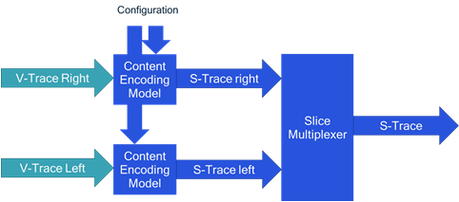
- V-Traces input buffers (1 … N)
  - Source properties
  - Start time
  - total frames (provides how many frames are generated). If frames are more than in V-Traces, this is looped and restarted.
    - Note: if start time is later than 1st frame, then it assumed that all reference frames have been received already.
- Bitrate Control (one of the following):
  - CBR: Constant Bitrate with four parameters
    - Bitrate in bit/s
    - Buffer window in number of frames:
      - 1 => constant frame size
      - 12 => 200ms at 60 fps,
      - 120 => 2 seconds at 60 fps
    - minQP = 10 (optional)
    - maxQP = 40 (optional)
    - Algorithm for bitrate control follows x264 model.
  - VBR: Variable bit rate with Constant Rate Factor with one parameter
    - CRF (default is source CRF)
  - cVBR: Capped VBR
    - Bitrate in bit/s
    - Buffer window in number of frames:
      - 1 => constant frame size
      - 12 => 200ms at 60 fps,
      - 120 => 2 seconds at 60 fps
    - minQP = 10 (optional)
    - maxQP = 40 (optional)
    - Algorithm for bitrate control follows x264 model
  - fVBR: Feedback-based Variable Bitrate
    - Details are tbd
- Slice Setting (one of the following)
  - no: No slices
  - fixed: Fixed number of slices
    - Parameter: number of slices being 1, 4, 8, 16
  - max:
    - Parameter: maximum slice size – number in bytes
- Error Resilience (one of the following)
  - None
  - pIntra: periodic slice intra refresh
    - Parameter: period of slice updates
      - (1 ➔ 1 slice every frame)
      - (2 ➔ 1 slice every 2nd frame)
  - fIntra: feedback Intra intra refresh: add an intra for the lost slice
  - ACK: ACK-mode: only use acknowledge slices in prediction
  - NACK: NACK-mode: use an old reference frame or intra in case of loss
- PreEncoding delay: time from rendered frame until this frame is encoded
  - Constant
    - Parameter1: constant in ms
    - Parameter2: n/a
  - Equally distributed:
    - Parameter1: MinDelay in ms
    - Parameter2: MaxDelay in ms
  - Truncated Gaussian:
    - Parameter1: mean in ms
    - Parameter2: variance in ms
    - Parameter3: MaxDelay in ms
- Encoding delay: one of the following
  - Constant
    - Parameter1: constant in ms
    - Parameter2: n/a
  - Equally distributed:
    - Parameter1: MinDelay in ms
    - Parameter2: MaxDelay in ms
  - Truncated Gaussian delay of the slice generation in the encoder in ms
    - Jitter Average (average after last slice): e.g., 8/(no_slices*no_buffers)
    - Jitter STD (standard deviation): e.g. 3/(no_slices*no_buffers)
    - Max Jitter (maximum jitter): e.g., 1/(FR*no_slices*no_buffers)
- Buffer Interleaving
  - FALSE: Left and right eye appear the same time (generally buffers at the same time)
    - Buffers have same render_time
    - Buffers have same pre-encoding delay
    - Buffer 1 slices are produced and then buffer 2 slices
  - TRUE: Left and right eye appear staggered (staggering is at half of the frame rate)
    - Render_time offset by 1/(FR*n_buffers)
    - independent pre-encoding delay
    - independent production of slice delay
- Output is S-Trace
  - Note that the S-Trace is started from 0 (this also requires that the rendering time is adjusted to 0)

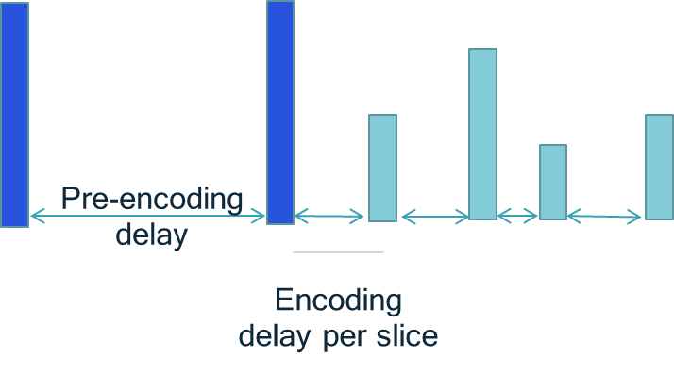
Example
{
"Buffers": [{
"Source": {
"V-Trace": "V-Trace-left.csv",
"frame_width": 2048,
"frame_height": 2048,
"frame_rate": 60,
"start_frame": 1,
"total_frames": 3600,
"buffer": "left"
},
"Source": {
"V-Trace": "V-Trace-right.csv",
"frame_width": 2048,
"frame_height": 2048,
"frame_rate": 60,
"start_frame": 1,
"total_frames": 3600,
"buffer": "right"
}
}],
"Slice": {
"mode": "no",
"parameter": "8"
},
"Bitrate": {
"mode": "CBR",
"bitrate": "10000000",
"window_framerate": "1",
"QPmin": 10,
"QPmax": 25
},
"ErrorResilience": {
"mode": "pIntra",
"parameter": "1"
},
"PreDelay": [{
"Delay": {
"mode": "equally",
"parameter1": "10",
"parameter1": "30"
}],
"EncodingDelay": [{
"Delay": {
"mode": "GaussianTrunc",
"parameter1": "8",
"parameter2": "3"
"parameter3": "1"
}],
},
"bufferinterleaving": true,
"S-Trace": "S-Trace.csv"
}

JSON Config Schema (needs to be added)

3.4.3 Packet Generation
Overview
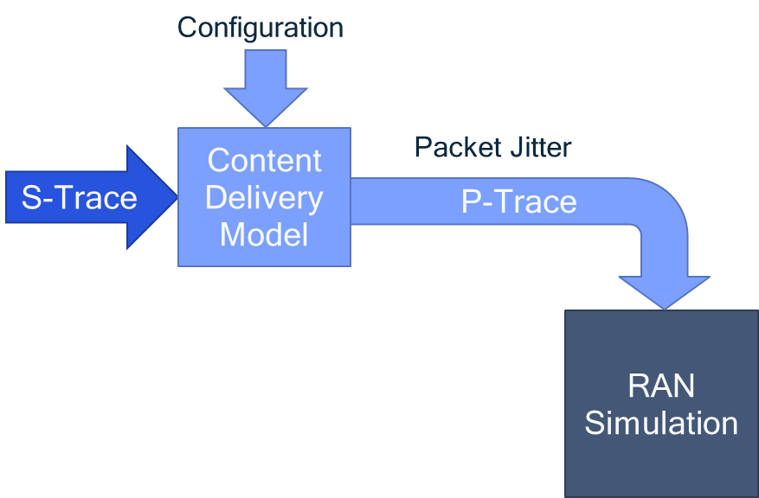

The following configuration parameters are provided
- S-Traces
  - Start time
- Packet Generation
  - MaxSize: maximum size of an output packet in bytes (0 means infinite)
  - PacketOverhead: packet overhead added in bytes (default 40 bytes)
- Packet Delivery Bitrate
  - Provides the bitrate at which the packets are delivered from Encoder to RAN. Packets arrive this value divided by the size of the packet.
NOTE: assumes 1 hop with a bitrate as above, we may also consider more hops
- P-Trace output
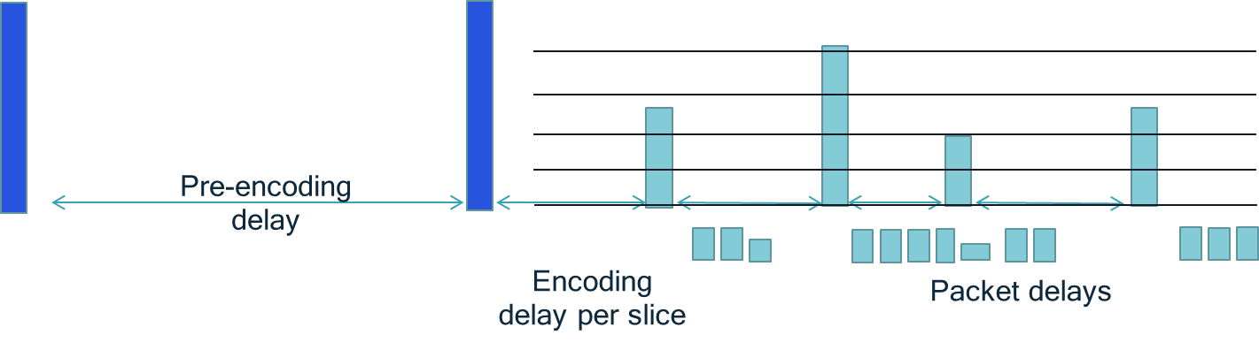
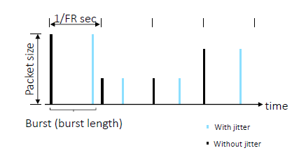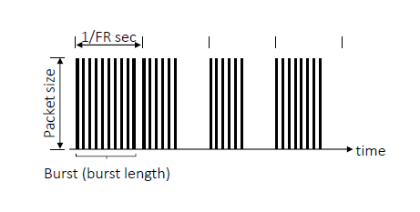
Example
{
"S-Trace": {
"source": "S-Trace.csv",
"startTime": 0
},
"Packet": {
"maxSize": "1500",
"overhead": "40"
},
"Bitrate": "10000000",
"P-Trace": "P-Trace.csv"
}

JSON Config Schema (needs to be added)

3.4.4 Information for RAN Simulation
Overview
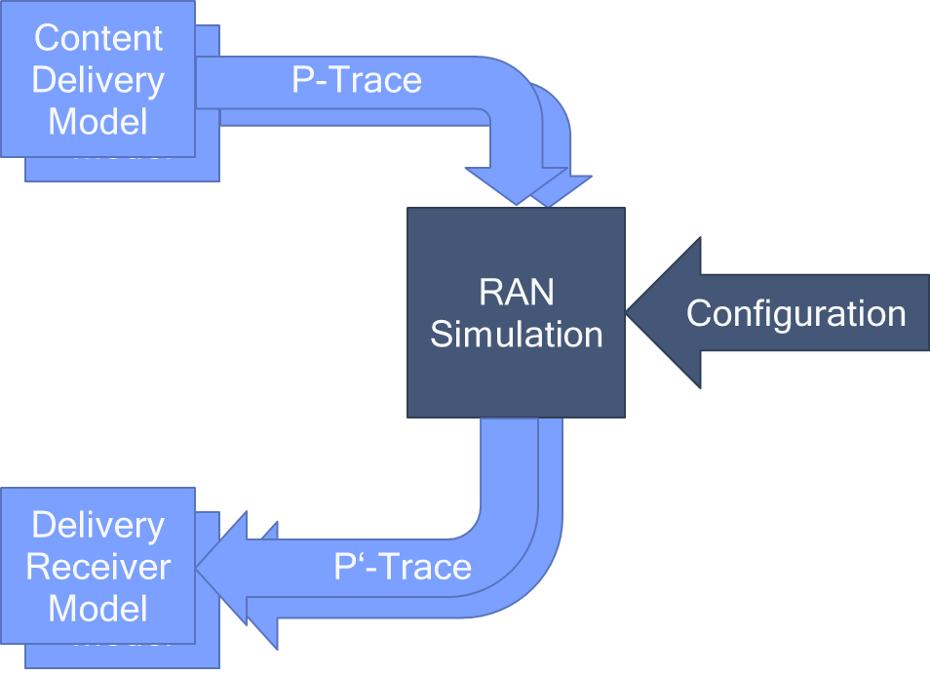
The following configuration parameters are provided from SA4 level
- P-Traces
  - Start time
  - P’-Trace
- osdrdrqieet o o aaeesfrRN
- urnedB(irt)Maximum Packet loss rate (PLR)
  - aiu aktDdlyr

  - Bitrate
  - Packet loss rate
  - Delay requirement
- Service Information
  - Quality criteria
    - Packet loss rate
    - Slice loss rate
    - Number of lost macroblocks
    - Percentage of damaged area
  - Receiver configuration
    - IP packet to slice loss
    - IP packet delay threshold in ms

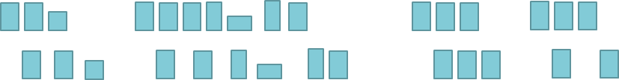

Example
{
"Input": [{
"P-Trace": {
"source": "P-Trace-1.csv",
"startTime": "0",
"target": "Pp-Trace-1.csv"
},
"P-Trace": {
"source": "P-Trace-2.csv",
"startTime": "0",
"target": "Pp-Trace-2.csv"
}
}],
RANConfiguration": {
"PLR": ["10e-2","10e-3","10e-4"],
"Delay": ["10","20"]Parrs":
ate":000", "PLR": "10e-3",

"ServiceInformation": {
"qualityCriteria": "packetloss",
"packetLossEffect": "slice",
"delayThreshold": "60"
}
}

NOTE: The RANConfiguration parameters are illustrations from SA4 understanding and may be provided by RAN experts so that SA4 can assess the impacts on the visual quality depending on the different values of PLR and Delay. Please note that different RANConfiguration parameters may impact the video coding settings and require to run a different model. If RAN colleagues can provide information on suitable RAN configurations, SA4 may provide additional content model configurations for these parameters.
JSON Config Schema (needs to be added)

3.4.5 Receiver Delivery Configuration
Overview
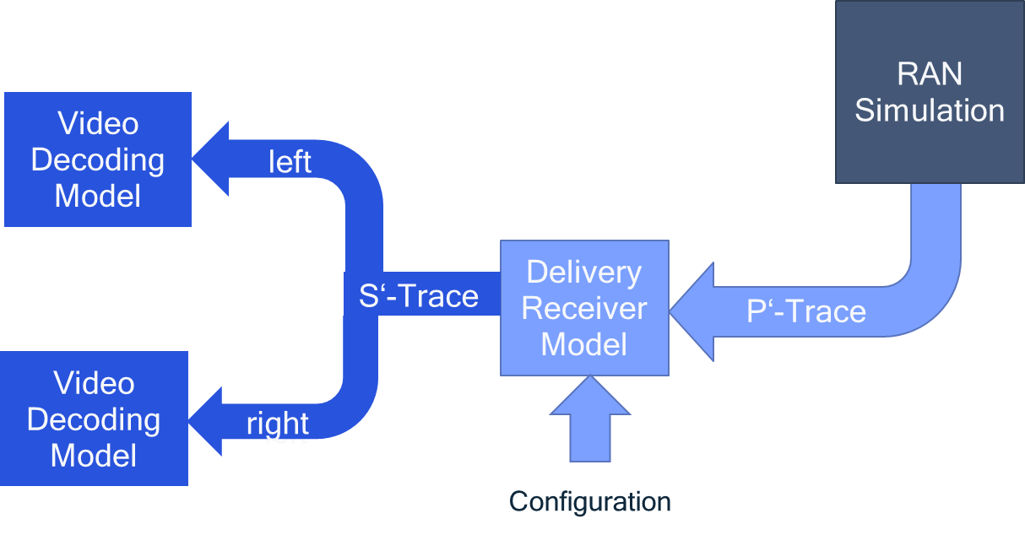
The following configuration parameters are provided
- P’-Trace
- S’-Trace-left
- S’-Trace-right
- Slice recovery strategy
  - Slice loss: If one packet is lost, the entire slice is lost
  - Suffix loss: If packet is lost, all remaining packets are considered as lost.
- Maximum packet delay
  - Maximum delay compared to pose generation (rendering time) in ms.

Example
{
"Input": {
"Pp-Trace": "Pp-Trace-1.csv",
},
"Output": [{
"Sp-Trace": {
"buffer": "left",
"Sp-Trace": "Sp-Trace-left.csv",
"maxDelay": 60,
"sliceLossMode": "packet"
},
"Sp-Trace": {
"buffer": "right",
"Sp-Trace": "Sp-Trace-right.csv"
"maxDelay": 60,
"sliceLossMode": "packet"
}
}]
}

JSON Config Schema (needs to be fixed)

3.4.6 Video Decoding Model
Overview
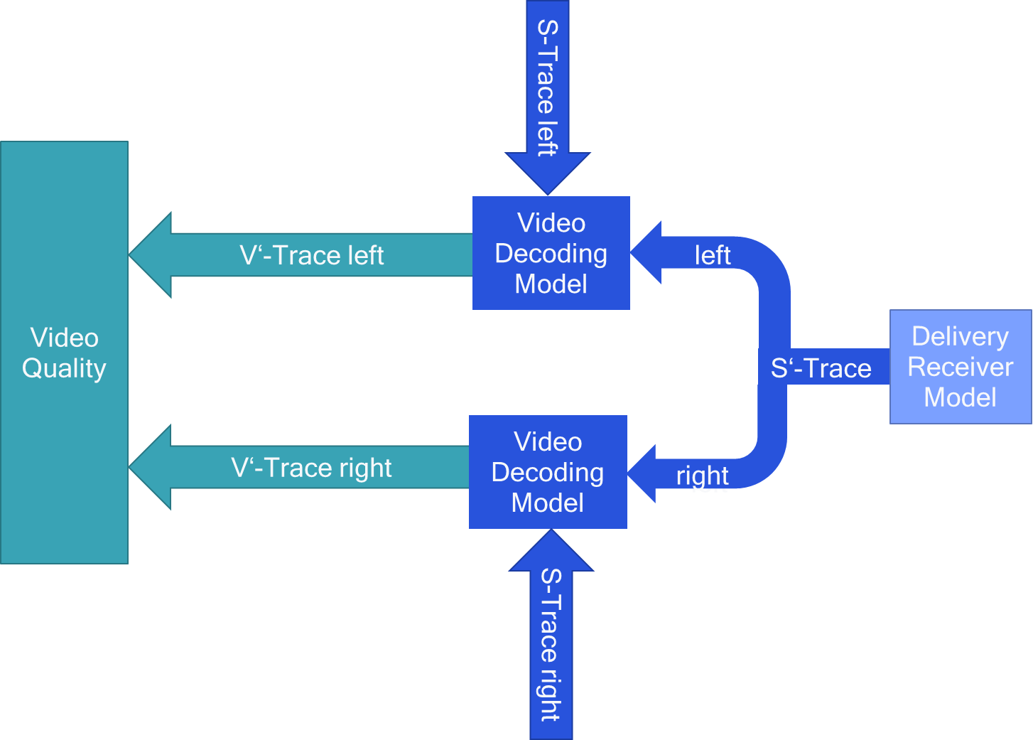
The following configuration parameters are provided:
- Input
  - S-Trace
  - S’-Trace-right
- Output
  - V’-Trace

Example
{
"Input": {
"Sp-Trace": "S1-Trace.csv",
"S-Trace": "S-Trace.csv"
},
"Vp-Trace": "V1-Trace-left.csv"
}

JSON Config Schema (needs to be added)

3.4.7 Quality Model
Overview
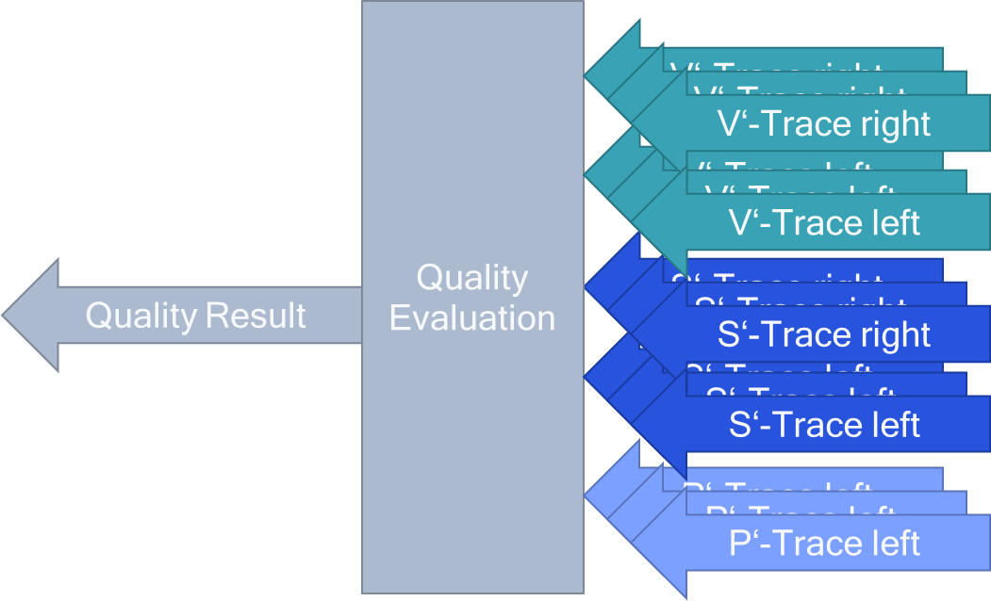
The following configuration parameters are provided
- Input for each user with user id
  - V’-Trace-right
  - V’-Trace-left
  - S’-Trace-left
  - S’-Trace-right
  - P’-Trace
- Output
  - Quality Result as Q-Trace

Example
{
"User": [{
"Input": {
"user": 1,
"buffer": "left",
"Vp-Trace": "Vp-Trace-left-1.csv",
"Sp-Trace": "Sp-Trace-left-1.csv",
"Pp-Trace": "Pp-Trace-1.csv"
},
"Input": {
"user": 1,
"buffer": "right",
"Vp-Trace": "Vp-Trace-right-1.csv",
"Sp-Trace": "Sp-Trace-right-1.csv",
"Pp-Trace": "Pp-Trace-1.csv"
},
"Input": {
"user": 2,
"buffer": "left",
"Vp-Trace": "Vp-Trace-left-2.csv",
"Sp-Trace": "Sp-Trace-left-2.csv",
"Pp-Trace": "Pp-Trace-2.csv"
},
"Input": {
"user": 2,
"buffer": "left",
"Vp-Trace": "Vp-Trace-right-2.csv",
"Sp-Trace": "Sp-Trace-right-2.csv",
"Pp-Trace": "Pp-Trace-2.csv"
},
}],
"Q-Trace": "Quality.csv"
}

JSON Config Schema (needs to be agreed)

3.4 Usage of Software Modules

3.4.1 General
Based on the above,
- generate S-trace from all buffer V-Traces for N users
  - python ./xrtm_encoder.py encoder.json
- generate P-trace from S-trace for N users
  - python ./xrtm_packetizer.py packetizer.json
- generate P’-trace from P-trace for N’ <= N users
  - radio-simulator ran.json
- generate S’-trace from P’-trace for N’ users
  - python ./xrtm_depacketizer.py depacketizer.json
- generate V’-trace from S’-trace for N’ users
  - python ./xrtm_decoder.py decoder.json
- generate Q-trace from V’-trace
  - python ./xrtm_quality.py quality.json
Note: different depacketizer settings may be used to generate different quality results. For example, the permitted delay latency may be adjusted.

3.4.2 SA4 Perspective
From SA4 perspective, the following needs to be done to generate P-Traces
- generate S-trace from all buffer V-Traces for N users
  - python ./xrtm_encoder.py encoder.json
- generate P-trace from S-trace for N users
  - python ./xrtm_packetizer.py packetizer.json
The P-Traces for N-users for one configuration are provided to RAN.
Then the P’-Traces can be handled by a sequence of files. For example, a docker file that runs a sequence as follows:
- generate S’-trace from P’-trace for N’ users
  - python ./xrtm_depacketizer.py depacketizer.json
- generate V’-trace from S’-trace for N’ users
  - python ./xrtm_decoder.py decoder.json
- generate Q-trace from V’-trace
  - python ./xrtm_quality.py quality.json
Note: different depacketizer settings may be used to generate different quality results. For example, the permitted delay latency may be adjusted.

3.4.3 RAN Perspective
From a RAN perspective, for each configuration P-Traces for N users are provided.

The P-Traces are uploaded here:
- http://dash.akamaized.net/WAVE/3GPP/XRTraffic/Traces
Each configuration has attached a recommended set of QoS-Parameters and other parameters that may be used by the RAN simulator.

The P-Traces are input into RAN simulator and P’-Traces are produced.

The resulting P’-Traces for N’ users would then be fed to the quality evaluation piece for multiuser evaluation.
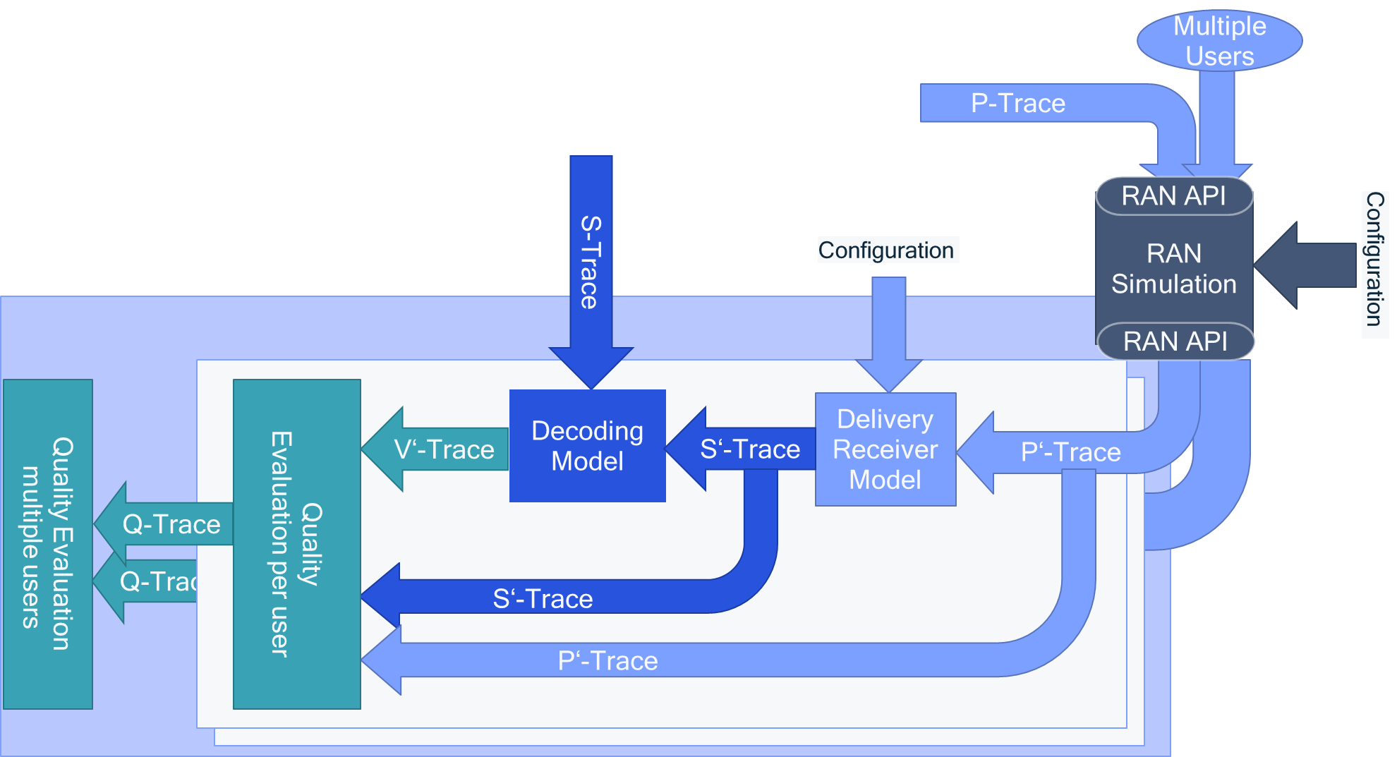

Recommended Configurations

4.1 Introduction
In the following recommended parameter settings are provided to produce P-Traces for different cases.

4.2 VR2: XR Split Rendering

4.2.1 Summary Recommended Configurations
The following parameters are fixed:
- Content Model:
  - Game output with 2 eye buffers at 2Kx2K at 60 fps, 8bit.
  - Content and Trace Preview is here: http://dash.akamaized.net/WAVE/3GPP/XRTraffic/Traces/Qualcomm-VR2
  - No audio
- Encoding Model
  - HEVC model as defined in S4aV200255,
  - target bitrate 30 Mbit/s, equally split across eye buffers, independently encoded.
  - Pre-encoding delay: Encoder pre-delay is varying between 10 to 20ms
  - Encoding delay is modelled to vary with truncated Gaussian
- Content Delivery Model
  - Edge/Cloud to gNB bitrate is 1.5 media bitrate
- Delivery receiver
  - Slice loss model (1 lost packets per slice results in slice loss)
  - Maximum latency for slice: 60ms (see TR 26.928, clause 4 and 6.2.5.1)
Beyond the above, the following configurations are recommended with priority according to order. For each of the configurations, some suitable RAN QoS is provided. Obviously, the actual RAN settings may be different. In call cases the maxBitrate is set to 30 Mbit/s and the packet delay is set to 120ms.
ofgrto | Basic Content Parameters
VR2-1 | 8 slices per eye buffer, 1 slice per frame is intra coded, 30Mbit/s capped VBR with window 200ms, buffer sent at same time, 1500 byte max packet size
VR2-2 | 8 slices per eye buffer, 1 slice per frame is intra coded, 30Mbit/s capped VBR with window 200ms, buffer sent at same time, unlimited packet size
VR2-3 | 8 slices per eye buffer, 1 slice per frame is intra coded, 30Mbit/s CBR with window 1 frame, buffer sent at same time, 1500 byte max packet size packets
VR2-4 | 8 slices per eye buffer, 1 slice per frame is intra coded, 30Mbit/s CBR with window 1 frame, buffer sent at same time, unlimited packet size
VR2-5 | 1 slice per eye buffer, every 8th frame is intra coded, 30Mbit/s capped VBR with window 200ms, buffer sent at same time, 1500 byte max packet size
VR2-6 | 8 slices per eye buffer, 1 slice per frame is intra coded, 30Mbit/s capped VBR with window 200ms, buffers sent interleaved, 1500 byte max packet size

In total there are 6 configurations. Additional configurations may be added.
For uplink modelling, no specific content modelling is considered.
- A model for the uplink traffic in a similar fashion also providing packet traces.
  - XR Pose is sent uplinkDetails are in S4aV200626, clause 7.2.13
  - The uplink bitrate for the pose is 200 kbit/s CBR, with 4ms packet interval and packet size 100 byte. This means that the content is rendered with a pose of typically 10-15ms age.
  - Details are in S4aV200575
  - The recommended QoS settings are
    - Bitrate: 200 kbit/s
    - PLR: 10e-3
    - aelay from UE to XR Server in the range of xDl10ms

4.2.2 Content Encoding Model Configuration
Start frame for N=16 users at different starting positions [1,1801,901,2701,451,2251,1351,3251,226,2026,1126,2926,676,2476,1576,3476]
Note that this is used 16 times.
"Buffers": [
{
"V-Trace": "http://dash.akamaized.net/WAVE/3GPP/XRTraffic/Traces/Qualcomm-VR2/V-Trace-left.csv",
"buffer": "left"
},
{
"V-Trace": "http://dash.akamaized.net/WAVE/3GPP/XRTraffic/Traces/Qualcomm-VR2/V-Trace-right.csv",
"buffer": "right"
}
]
"frame_width": 2048,
"frame_height": 2048,
"frame_rate": 60,
"start_frame": [1,1801,901,2701,451,2251,1351,3251,226,2026,1126,2926,676,2476,1576,3476],
"total_frames": 3600

"S-Trace": "S-Trace-[1,…,16].csv"

Two options for slice mode and error resilience.
For configuration 1, 2, 3, 4, and 6 use slice setting 8 with one intra slice per frame.
"Slice": {
"mode": "fixed",
"parameter": "8"
},
"ErrorResilience": {
"mode": "pIntra",
"parameter": "1"
}

For configuration 5: No slice setting with one I-frame very 8 frames.
"Slice": {
"mode": "no",
},
"ErrorResilience": {
"mode": "pIntra",
"parameter": "8"
}

Bitrate two options
For configurations 1, 2, 5 and 6 capped VBR at 30 Mbit/s total with window size 12 frame (200ms) (target frame size is 31,250 byte per buffer, but buffer may exceed slightly – only over 200ms it is not exceeding). (aligns with S4aV200607).
"Bitrate": {
"mode": "cVBR",
"bitrate": "30000000",
"window_framerate": "12",
"QPmin": 0 (source QP),
"QPmax": 53
}

For configurations 3 and 4: Constant bitrate at 30 Mbit/s total with window size 1 frame (maximum frame size is 31,250 byte per buffer, almost constant).
"Bitrate": {
"mode": "CBR",
"bitrate": "30000000",
"window_framerate": "1",
"QPmin": 1,
"QPmax": 53
}

Delay settings
Encoder pre-delay is varying between 10 to 20ms.
Encoding delay is modelled to vary with mean 4/slice_numbers and std 3/slice_numbers and maximum being the frame interval.
"PreDelay": [{
"Delay": {
"mode": "equally",
"parameter1": "10",
"parameter2": "20"
}],
"EncodingDelay": [{
"Delay": {
"mode": "GaussianTrunc",
"parameter1": "4",
"parameter2": "3"
"parameter3": "1"
}],
},

Buffer interleaving
For configuration 1, 2, 3, 4 and 5, buffer interleaving set to false.
For configuration 6, buffer interleaving set to false.
"bufferinterleaving": [true,false]

4.2.3 Packet Generation
For each of the users, packet traces are generated.
Two options are provided
- For configurations 1, 3, 5, and 6, 1500 byte max packet size (addressing the cloud server case in S4aV200607)
- For configurations 2 and 4, unlimited packet size, i.e. each slice results in a packet (addressing the edge serve case in S4aV200607)
The bitrate is assumed 45 Mbit/s. For a 30 Mbit/s bitrate, this would allow an excess of 1.5. This aligns with the parameters in S4aV200607.
{
"S-Trace": {
"source": "S-Trace-[1,…,16].csv",
"startTime": 0
},
"Packet": {
"maxSize": "1500","0"
"overhead": "40"
},
"Bitrate": "45000000",
"P-Trace": "P-Trace-[1,…,16].csv"
}

4.2.4 Latency Idea
The following provides an idea of the latencies of packets from the time that a frame is rendered in the XR server to the time the packet arrives at the gNB/Radio:
- Min-Latency:
  - Pre-encoding delay: 10ms
  - Encoding delay: 2ms
  - Jitter delay: 3ms
  - Total delay: 15ms
- Max-Latency:
  - Pre-encoding delay: 20ms
  - Encoding delay: 17ms (considered exceptionally large)
  - Jitter delay: 10ms (considered exceptionally large)
  - Total delay: 47ms
- Typical-Latency:
  - Pre-encoding delay: 15ms
  - Encoding delay: 4ms
  - Jitter delay: 11ms
  - Total delay: 30ms
Note that
- the maximum delay of 47ms aligns with the 32ms from S4aV200607 assuming without constant delay of around 15ms.

- typical latency of 30ms aligns with the 32 from S4aV200607 assuming without constant delay of around 15ms

4.2.5 Information for RAN Simulation
A total of N=16 users are provided. RAN simulations may be carried out for N’=1, …, N users using traces for different users starting with 1, 2, … . All P-Traces cover 1min.
Two packet loss configurations are applied: 10e-3 for no maxSize restriction and 10e-4 for maxSize 1500 byte restrictions.
The delay threshold that is used in receiver is provided to be 60ms. This means that packets later than 60ms rendering time are considered late losses. Packets need to be delivered within 13-45ms to be useful in the receiver.
NOTE:
- The RANConfiguration o aaeesaeilsrtons from SA4 understanding and may be refined by RAN experts so that SA4 can assess the impacts on the visual quality depending on the different values of actually observed PLR and Delay.
- The content encoding parameters may be changed if the application is aware of the actual delay and PLR that is happening on the radio. In practical applications, this is dealt by continuously measuring the delay and loss rates and adapting the application aaeesetns(for example intra coding, bitrates, etc). Hence, varigteprmtr usd ftesial o aaeesmyla olwrqaiyrslscmae otecs fteapiainaatt h culRNprmtr.
- If RAN colleagues can provide information on suitable RAN configurations, SA4 may provide additional content model configurations for these parameters.
{
"Input": [{
"P-Trace": {
"source": "P-Trace-1.csv",
"startTime": "0",
"target": "Pp-Trace-1.csv"
},
"P-Trace": {
"source": "P-Trace-2.csv",
"startTime": "0",
"target": "Pp-Trace-2.csv"
}
…
"P-Trace": {
"source": "P-Trace-Np.csv",
"startTime": "0",
"target": "Pp-Trace-Np.csv"
}
}],
"RANConfiguration": {
"PLR": ["10e-2","10e-3","10e-4"],
"Delay": ["10","20"]
QoSPmet { "bitRate": "30000000",
PLR": ["110e-4"] "Delay": "120" "RANConfiguration": {

},
"ServiceInformation": {
"qualityCriteria": "packetloss",
"packetLossEffect": "slice",
"delayThreshold": "60"
}
}

4.3 CG - Cloud Gaming

4.3.1 Summary Recommended Configurations
The following parameters are fixed:
- Content Model:
  - Game output with 1920 x 1080 and 4096 x 2048 at 60fps.
  - Content and Trace Preview is here:
    - Baolei HD (to be produced)
    - Baolei 4K (to be produced)
  - No audio
- Encoding Model
  - HEVC encoding model as defined in S4aV2005752
  - Pre-encoding delay: Encoder pre-delay is varying between 10 to 20ms
  - Encoding delay is modelled to vary with truncated Gaussian
- Content Delivery Model
  - Edge/Cloud to gNB bitrate is 1.5 media bitrate
- Delivery receiver
  - Slice loss model (1 lost packets per slice results in slice loss)
  - Maximum latency for slice: 60ms (see TR 26.928, clause 4 and 6.2.5.1)
Beyond the above, the following configurations are recommended with priority according to order. For each of the configurations, some suitable RAN QoS is provided. Obviously, the actual RAN settings may be different. In call cases except CG-3, the maxBitrate is set to 30 Mbit/s and the packet delay is set to 20ms.For CG-3 it is set to 8Mbit/s.
ofgrto | Basic Content Parameters
CG-1 | 4K content, 8 slices, 1 slice per frame is intra coded, 30Mbit/s capped VBR with window 200ms, 1500 byte max packet size
CG-2 | 4K content, 8 slices, 1 slice per frame is intra coded, 30Mbit/s capped VBR with window 200ms, unlimited packet size
CG-3 | FullHD content, 8 slices, 1 slice per frame is intra coded, 8Mbit/s capped VBR with window 200ms, 1500 byte max packet size
CG-4 | 4K content, 1 slice, every 8th frame is intra coded, 30Mbit/s capped VBR with window 200ms, 1500 byte max packet size

In total there are 4 configurations. Additional configurations may be added.
For uplink modelling, no specific content modelling is considered.
- A model for the uplink traffic in a similar fashion also providing packet traces.
  - Game pose and actions are sent uplink
  - Details are in S4aV2005752,cas ..3
  - The uplink bitrate for the pose is 200 kbit/s CBR, with 4ms packet interval and packet size 100 byte. This means that the content is rendered with a pose of typically 10-15ms age.
  - The recommended QoS settings are
    - Bitrate: 200 kbit/s
    - PLR: 10e-3
    - a 5msCondeemaximum delay between UE and gaming server

4.3.2 Content Encoding Model Configuration
Start frame for N=16 users at different starting positions [1,1801,901,2701,451,2251,1351,3251,226,2026,1126,2926,676,2476,1576,3476]
Note that this is used 16 times.
Two options for content is used
- For configuration 3, FullHD with 1920 x 1088 (to be a multiple of 64) sequence.
- For configuration 1,2 and 4, 4K game content is used for V-Trace
"Buffers": [{
"Source": {
"V-Trace": "http://dash.akamaized.net/WAVE/3GPP/XRTraffic/Traces/Baolei/V-Trace.csv",
"frame_width": [1920, 4096]
"frame_height": [1088, 2048]
"frame_rate": 60,
"start_frame": [1,1801,901,2701,451,2251,1351,3251,226,2026,1126,2926,676,2476,1576,3476],
"total_frames": 3600,
"buffer": "single"
}
}]
"S-Trace": "S-Trace-[1,…,16].csv"

Two options for slice mode and error resilience.
For configuration 1, 2 and 3, use slice setting 8 with one intra slice per frame.
"Slice": {
"mode": "fixed",
"parameter": "8"
},
"ErrorResilience": {
"mode": "pIntra",
"parameter": "1"
}

For configuration 4: No slice setting with one I-frame very 8 frames.
"Slice": {
"mode": "no",
},
"ErrorResilience": {
"mode": "pIntra",
"parameter": "8"
}

Bitrate two options
For configurations 4, Capped VBR at 8 Mbit/s total with window size 12 frame (200ms) (target frame size is 16,667 byte).
"Bitrate": {
"mode": "cVBR",
"bitrate": "8000000",
"window_framerate": "12",

}

For configurations 1 and 2, Capped VBR at 30 Mbit/s total with window size 12 frame (200ms) (target frame size is 62,500 byte).
"Bitrate": {
"mode": "cVBR",
"bitrate": "30000000",
"window_framerate": "12",
}

For configurations 3 CBR at 30 Mbit/s total with window size 1 frame (17ms) (target frame size is 62,500 byte).
"Bitrate": {
"mode": "CBR",
"bitrate": "30000000",
"window_framerate": "1",
}

Delay settings
Encoder pre-delay is varying between 10 to 20ms.
Encoding delay is modelled to vary with mean 4/slice_numbers and std 3/slice_numbers and maximum being the frame interval.
"PreDelay": [{
"Delay": {
"mode": "equally",
"parameter1": "10",
"parameter2": "20"
}],
"EncodingDelay": [{
"Delay": {
"mode": "GaussianTrunc",
"parameter1": "4",
"parameter2": "3"
"parameter3": "1"
}],
},

Buffer interleaving
Only one buffer is provided so this is irrelevant,
"bufferinterleaving": [false]

4.3.3 Packet Generation
For each of the users, packet traces are generated.
Two options are provided
- For configurations 1, 3 and 4, 1500 byte max packet size (addressing the cloud server case in S4aV200607)
- For configurations 2, unlimited packet size, i.e. each slice results in a packet (addressing the edge serve case in S4aV200607)
The bitrate is assumed to be 1.5 the excess of the media bitrate, i.e. 12 or 45 Mbit/s.. This aligns with the parameters in S4aV200607.
{
"S-Trace": {
"source": "S-Trace-[1,…,16].csv",
"startTime": 0
},
"Packet": {
"maxSize": "1500","0"
"overhead": "40"
},
"Bitrate": "12000000", "45000000",
"P-Trace": "P-Trace-[1,…,16].csv"
}

4.3.5 RAN Configuration
For all possible N’ users, the P-Traces are added.
A total of N=16 users are provided. RAN simulations may be carried out for N’=1, …, N users using traces for different users starting with 1, 2, … . All P-Traces cover 1min.
Two packet loss configurations are applied: 10e-3 for no maxSize restriction and 10e-4 for maxSize 1500 byte restrictions.
The delay threshold that is used in receiver is provided to be 60ms. This means that packets later than 60ms rendering time are considered late losses. Packets need to be delivered within 13-45ms to be useful in the receiver.
NOTE:
- The RANConfiguration are illustrations from SA4 understanding and may be refined by RAN experts so that SA4 can assess the impacts on the visual quality depending on the different values of actually observed PLR and Delay.
- The content encoding parameters may be changed if the application is aware of the actual delay and PLR that is happening on the radio. In practical applications, this is dealt by continuously measuring the delay and loss rates and adapting the application settings (for example intra coding, bitrates, etc).
- If RAN colleagues can provide information on suitable RAN configurations, SA4 may provide additional content model configurations for these parameters.
OE The QoS parameters are illustrations from SA4 understanding and may be refined by RAN experts so that SA4 can assess the impacts on the visual quality depending on the different values of actually observed PLR and Delay.
h otn noigprmtr a ecagdi h plcto saaeo h culdlyadPRta shpeigo h ai.I rcia plctos hsi el ycniuul esrn h ea n osrtsadaatn h plcto aaees ec,vrigteprmtr usd ftesial o aaeesmyla olwrqaiyrslscmae otecs fteapiainaatt h culRNprmtIf RAN colleagues can provide information on suitable RAN configurations, SA4 may provide additional content model configurations for these parameters.
"Input": [{
"P-Trace": {
"source": "P-Trace-1.csv",
"startTime": "0",
"target": "Pp-Trace-1.csv"
},
"P-Trace": {
"source": "P-Trace-2.csv",
"startTime": "0",
"target": "Pp-Trace-2.csv"
}
…
"P-Trace": {
"source": "P-Trace-Np.csv",
"startTime": "0",
"target": "Pp-Trace-Np.csv"
}
}],
"RANConfiguration": {
"PLR": ["10e-2","10e-3","10e-4"],
"Delay": ["10","20"]
},
QoSPmet { "bitRate": ["8000000", "30000000"],
PLR": ["110e-4"] "Delay": "20"
"RANConfiguration": {

"ServiceInformation": {
"qualityCriteria": "packetloss",
"packetLossEffect": "slice",
"delayThreshold": "80"
}
}

4.4 AR2d: AR Conversational Downlink

4.4.1 Summary Recommended Configurations
The following parameters are fixed:
- Content Model:
  - Video
    - Same as VR2
  - Audio
    - Max Sampling Rate: 48 kHz
    - Inter-frame time: 20-21.3 ms
NOTE: For the simulation purposes, the inter-frame time can be assumed to be 21.3 ms considering MPEG-H, or if we consider that the actual conversational audio codec might be a different one, we could assume 20 ms, as this has so far been used for several 3GPP speech codecs
  - Data Stream
    - Inter-frame time: 10 ms
  - In total we have 4 buffers, 2 video, 1 audio and one data
- Encoding Model
  - Video
    - Same as VR2
  - Audio
    - Operation Point (following 3GPP TS 26.118 Table 6.1-1): 3GPP MPEG-H Audio (this Operation Point is specified for VR streaming in SA4 and can be used for simulation purposes for conversational services since the IVAS_Codec is not yet available)
    - Average data Rate : 256 / 512 kbps
    - Packet Loss rate should be below 10e-3
  - Data Stream
    - Average data Rate : <0.5 Mbps
    - Packet Loss rate should be below 10e-3
- Content Delivery Model
  - Same as VR2
- Delivery receiver
  - Same as VR2
Beyond the above, the following configurations are recommended with priority according to order.
o aho h ofgrtos oesial A o spoie.Ovosy h culRNstig a edfeet ncl ae h aBtaei e o3 btsadtepce ea sstt 0sNOTE: A subset may be selected for AR2
Configuration | Basic Content Parameters
AR2d-1 | 8 slices per eye buffer, 1 slice per frame is intra coded, 30Mbit/s capped VBR with window 200ms, buffer sent at same time, 1500 byte max packet size
AR2d-2 | 8 slices per eye buffer, 1 slice per frame is intra coded, 30Mbit/s capped VBR with window 200ms, buffer sent at same time, unlimited packet size
AR2d-3 | 8 slices per eye buffer, 1 slice per frame is intra coded, 30Mbit/s CBR with window 1 frame, buffer sent at same time, 1500 byte max packet size packets
AR2d-4 | 8 slices per eye buffer, 1 slice per frame is intra coded, 30Mbit/s CBR with window 1 frame, buffer sent at same time, unlimited packet size
AR2d-5 | 1 slice per eye buffer, every 8th frame is intra coded, 30Mbit/s capped VBR with window 200ms, buffer sent at same time, 1500 byte max packet size

In total there are 5 configurations. Additional configurations may be added.
For uplink modelling, no specific content modelling is considered.
- A model for the uplink traffic in a similar fashion also providing packet traces.
  - XR Pose is sent uplink
  - Details are in S4aV2005752,cas ..3
  - The uplink bitrate for the pose is 200 kbit/s CBR, with 4ms packet interval and packet size 100 byte. This means that the content is rendered with a pose of typically 10-15ms age.
  - The recommended QoS settings are
    - Bitrate: 200 kbit/s
    - PLR: 10e-3
    - Considered maximum delay from UE to XR Server: 10msa 5ms

4.4.2 Content Encoding Model Configuration
Start frame for N=16 users at different starting positions [1,1801,901,2701,451,2251,1351,3251,226,2026,1126,2926,676,2476,1576,3476]
Note that this is used 16 times
"Video" {
"Buffers": [
{
"V-Trace": "http://dash.akamaized.net/WAVE/3GPP/XRTraffic/Traces/Qualcomm-VR2/V-Trace-left.csv",
"buffer": "video-left"
},
{
"V-Trace": "http://dash.akamaized.net/WAVE/3GPP/XRTraffic/Traces/Qualcomm-VR2/V-Trace-right.csv",
"buffer": "video-right"
}
]
"frame_width": 2048,
"frame_height": 2048,
"frame_rate": 60,
"start_frame": [1,1801,901,2701,451,2251,1351,3251,226,2026,1126,2926,676,2476,1576,3476],
"total_frames": 3600
}
"Audio" {
"Buffers": [
{
"Frame-Interval": "21.3",
"data-rate": "512000",
"buffer": "audio"
},
}
"Data" {
"Buffers": [
{
"Frame-Interval": "20",
"data-rate": "500000",
"buffer": "data"
},
}
"S-Trace": "S-Trace-[1,…,16].csv"

Remaining setting are identical
Buffer interleaving
For configuration 1, 2, 3, 4 and 5, buffer interleaving set to false
"bufferinterleaving": [false]

4.4.3 Packet Generation
For each of the users, packet traces are generated.
Two options are provided
- For configurations 1, 3, and 5, 1500 byte max packet size (addressing the cloud server case in S4aV200607)
- For configurations 2 and 4, unlimited packet size, i.e. each slice results in a packet (addressing the edge serve case in S4aV200607)
The bitrate is assumed 46.5 Mbit/s. For a 31 Mbit/s bitrate, this would allow an excess of 1.5. This aligns with the parameters in S4aV200607.

4.4.4 Information for RAN Simulation
A total of N=16 users are provided. RAN simulations may be carried out for N’=1, …, N users using traces for different users starting with 1, 2, … . All P-Traces cover 1min.
Two packet loss configurations are applied: 10e-3 for no maxSize restriction and 10e-4 for maxSize 1500 byte restrictions.
The delay threshold that is used in receiver is provided to be 60ms. This means that packets later than 60ms rendering time are considered late losses. Packets need to be delivered within 13-45ms to be useful in the receiver.
NOTE:
- The RANConfiguration are illustrations from SA4 understanding and may be refined by RAN experts so that SA4 can assess the impacts on the visual quality depending on the different values of actually observed PLR and Delay.
- The content encoding parameters may be changed if the application is aware of the actual delay and PLR that is happening on the radio. In practical applications, this is dealt by continuously measuring the delay and loss rates and adapting the application settings (for example intra coding, bitrates, etc).
- If RAN colleagues can provide information on suitable RAN configurations, SA4 may provide additional content model configurations for these parameters.
OE The QoS parameters are illustrations from SA4 understanding and may be refined by RAN experts so that SA4 can assess the impacts on the visual quality depending on the different values of actually observed PLR and Delay.
h otn noigprmtr a ecagdi h plcto saaeo h culdlyadPRta shpeigo h ai.I rcia plctos hsi el ycniuul esrn h ea n osrtsadaatn h plcto aaees ec,vrigteprmtr usd ftesial o aaeesmyla olwrqaiyrslscmae otecs fteapiainaatt h culRNprmtIf RAN colleagues can provide information on suitable RAN configurations, SA4 may provide additional content model configurations for these parameters.
"Input": [{
"P-Trace": {
"source": "P-Trace-1.csv",
"startTime": "0",
"target": "Pp-Trace-1.csv"
},
"P-Trace": {
"source": "P-Trace-2.csv",
"startTime": "0",
"target": "Pp-Trace-2.csv"
}
…
"P-Trace": {
"source": "P-Trace-Np.csv",
"startTime": "0",
"target": "Pp-Trace-Np.csv"
}
}],
"RANConfiguration": {
"PLR": ["10e-2","10e-3","10e-4"],
"Delay": ["10","20"] "QoSParameters": {
tRa"31000 "PLR": ["10e-3","10e-4"],
},
ervicefom": {
"qualityCriteria": "packetloss",
"packetLossEffect": "slice",
"delayThreshold": "60"
}
}

4.5 AR2u: AR Conversational Uplink

4.5.1 Summary Recommended Configurations
The following parameters are fixed:
- Content Model:
  - Video
    - Camera Signal with 1920 x 1080 at 60fps.
    - Content and Trace Preview is here: tbd
  - Audio
    - Max Sampling Rate: 48 kHz
    - Inter-frame time: 20-21.3 ms
NOTE: For the simulation purposes, the inter-frame time can be assumed to be 21.3 ms considering MPEG-H, or if we consider that the actual conversational audio codec might be a different one, we could assume 20 ms, as this has so far been used for several 3GPP speech codecs
  - Data Stream
    - Inter-frame time: 10 ms
- Encoding Model
  - Video
    - dnia oC o ulDcni noigMdl e 4V055 detailed configurations in S4aV200627, clause 4.1. Summary provided below
    - HEVC, target bitrate 10 Mbit/s (capped VBR) or AVC target bitrate 20 Mbit/s (capped VBR).
    - Slice based encoding (4 slices) or 1 frame
    - Intra Refresh (1 slice per frame) or every 60th frame.
    - Pre-encoding delay: Encoder pre-delay is varying between 10 to 20ms
    - Encoding delay is modelled to vary with mean 4/slice_numbers and std 3/slice_numbers and maximum being the frame interval (aligned with S4aV200607)
  - Audio
    - Operation Point (following 3GPP TS 26.118 Table 6.1-1): 3GPP MPEG-H Audio (this Operation Point is specified for VR streaming in SA4 and can be used for simulation purposes for conversational services since the IVAS_Codec is not yet available)
    - Average data Rate : 256 / 512 kbps
    - Packet Loss rate should be below 10e-3
  - Data Stream
    - Average data Rate : <0.5 Mbps
    - Packet Loss rate should be below 10e-3
- Content Delivery Model
  - Edge/Cloud to gNB bitrate is 1.5 media bitrate
- Delivery receiver
  - Slice loss model (1 lost packets per slice results in slice loss)
  - Maximum latency for slice: 60ms (see TR 26.928, clause 4 and 6.2.5.1)
Beyond the above, the following configurations are recommended with priority according to order. For each of the configurations, some suitable RAN QoS is provided. Obviously, the actual RAN settings may be different. In call cases the maxBitrate is set to 930 Mbit/s and the packet delay is set to 520ms.
fro | ai otn aaees
-1 | llontelices, icame is iracds capped Vh wind0ms, ax packet sz
Configuration | Basic Content Parameters
AR2u-1 | llonteslices,1lie per frame is intra coded, 8Mbit10Mbit/s cape B ith window 200ms, 1500 byte max packet size
AR2u-2 | 4 slices, 1 slice per frame is intra coded, 10Mbit/s capped VBR with window 200ms, unlimited packet size
AR2u-3 | 4 slices, 1 slice per frame is intra coded, 20Mbit/s capped VBR with window 200ms, 1500 byte max packet size
AR2u-4 | 4 slices, 1 slice per frame is intra coded, 20Mbit/s capped VBR with window 200ms, unlimited packet size
AR2u-5 | 1 slice, every 8th frame is intra coded, 10Mbit/s capped VBR with window 200ms, buffer sent at same time, 1500 byte max packet size

ealdcniuain r b.
Proposal
It is proposed to:
- Agree on the csv files
- Agree on the configuration parameters for VR2 and CG and AR2
- Agree on the recommended configurations
- Produce adequate P-traces
- Communicate this to RAN

