**3GPP SA4-e (AH) MBS SWG post 130 S4aI250025**

**Online, December 19th 2024 – February 6th 2025**

**Source: InterDigital**

**Title: Evaluation framework to attribute energy use in a multi-user environment**

**Document for: Agreement**

**Agenda item: 2.7 - FS_MediaEnergyGREEN (Study on Media enerGy consumption exposuRE and EvaluatioN framework)**

**Spec: 3GPP TR 26.942 v1.0.0**

**Work Item: FS_MediaEnergyGREEN**

1. **Introduction**

Much of the infrastructure used to carry mobile data, including media, draws energy irrespective of the presence of data. In reporting applications, this makes the standard energy efficiency metric (kWh/GB) inappropriate for assessing this infrastructure because the energy that is not related to providing service, i.e. not related to, for example, achieved data rates, cannot be easily attributed to the various customers/stakeholders.

1. **Reason for Change**

Reporting of energy consumption requires not only measurement, but also attribution of the measured energy to relevant stakeholders. Without documenting, discussing, and addressing the issue of attribution, TR 26.942 will be incomplete.

1. **Conclusion**

The present proposal aims to redress this situation by providing a flexible solution that facilitates energy attribution.

1. **Proposal**

It is proposed to agree the following changes to 3GPP TR 26.942 v1.0.0.

**Proposed Changes**

* * * First Change * * * *

## 2 References

[CarbonTrust] Carbon Trust: "Carbon impact of video streaming", White Paper, 2021.

* * * Next Change * * * *  
(All new text)

## 7.X Solution #X: Evaluation framework to attribute energy use in a multi-user environment

### 7.X.1 Key Issue mapping

This solution addresses Key Issue #3 (Evaluation Framework) described in clause 6.3.

### 7.X.2 Functional description

The reporting of energy consumption is desirable, as this gives a high-level measure of environmental impact. If one is interested in the energy used by a given device, then the device could be measured, either by a wall-plug that measures power- or energy-consumption, or by built-in measurement hardware. However, if the energy consumption of a given service is to be measured, a variety of complications may arise. A "service" in this context could include sending a video asset over a mobile network, broadcasting a television service, encoding video, caching and serving content, the processing of (media-related) data for a given subscriber by an third party, etc. In general terms, a service is provided by an installation, which could refer to a service provider, a data centre, a Content Delivery Network, or any hardware that implements a (mobile) communication service. The implications are that:

- multiple data-streams may be processed concurrently; and

- energy use and the presence of data are only weakly correlated, meaning that a device, system or data centre may have a fixed energy overhead which is independent of the amount of data transmitted, as shown in figure 7.X.2‑1. In addition, energy use as function of data rate can increase or decrease based on the network provider’s decision to change capacity and/or add infrastructure.

For such installations, associating an amount of energy used to a given data stream is a non-trivial task. Further, such installations still use a significant amount of energy even if no data passes through. This Candidate Solution therefore proposes an accounting system for associating energy use with a data stream passing through a device, or system or service centre. A key feature of this solution is that the reported energy is related to measured data rates, as well as a few fixed system parameters that can be determined ahead of time. The solution is particularly valuable for data streams that require medium to high bit rates, such as those incurred for example by video transmission and game downloads.

Key observations underlying this solution are:

1. For data transmission services, expressing energy use in terms of data rates is desirable, because they are commonly known, whereas energy measurements require additional hardware.

2. Often, energy use and data rates are assumed to be linearly related, but as argued above, this tends to be an over-simplification.

The solution proposed enables energy use to be expressed in terms of data rates, while taking into consideration the complexities of real-world systems that have a fixed energy overhead.

Figure 7.X.2‑1: Relationship between power $P$ and data-rate $d$

The devices and installations involved in the transmission of media can each be adequately modelled using a power model [7] [CarbonTrust], whereby the power $P$ (in Watts) drawn relates to the data-rate $d$ (in *bits/second*) as follows:

$$P=p_{base}+\frac{p_{max}-p_{base}}{d_{max}}d$$

where $p_{base}$ is the base load which is always present (due to cooling requirements, losses incurred by power transformers, activity of transmitters and receivers, etc), $p_{max}$ is the maximum power drawn, which occurs when the system functions at maximum capacity, i.e. with a data-rate $d_{max}$.

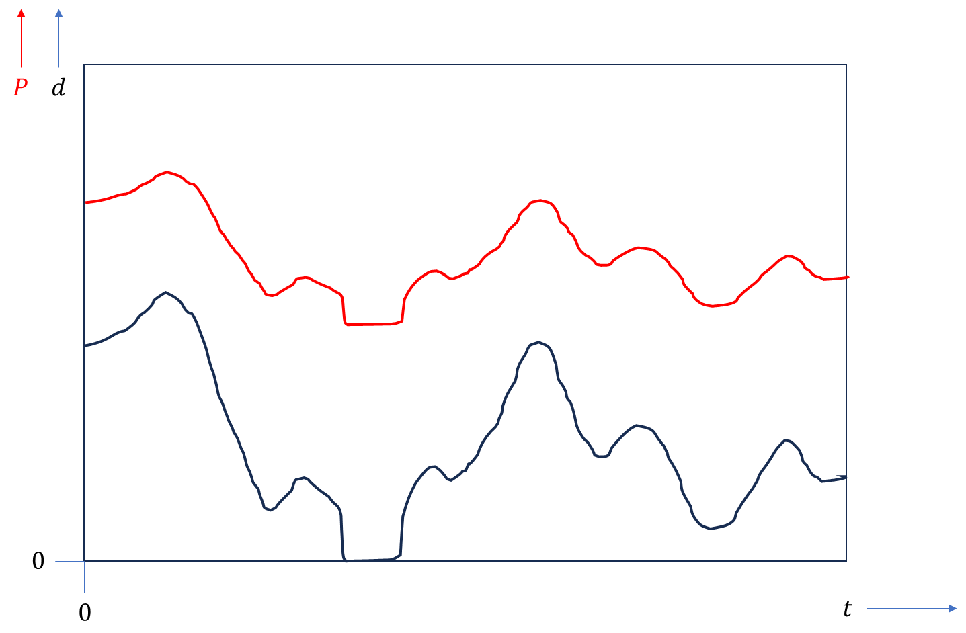

Figure 7.X.2‑2: Idealised example of data-rate $d$ and power $P$ as function of time $t$. This plot shows the trend to be expected, although in practice the relationship between and may be less direct.

In the following it will be assumed that the data-rate $d$ can vary over time, and that therefore the power drawn will vary over time as well, as shown in figure 7.X.2-2. For a given time-interval $(t_{1},t_{2})$, the energy $E$ consumed (in *Watt-seconds*, or derived quantities such as *Wh*, *kWh*) can be determined as follows:

$$E\left(t_{1},t_{2}\right)=\int_{t_{1}}^{t_{2}}{P\left(t\right)}dt$$

This can be rewritten as:

$$E\left(t_{1},t_{2}\right)= \int_{t_{1}}^{t_{2}}{\left(p_{base}+\frac{p_{max}-p_{base}}{d_{max}}d(t)\right)} dt$$

which simplifies to:

$$E\left(t_{1},t_{2}\right)=p_{base}\left(t_{2}-t_{1}\right)+\frac{p_{max}-p_{base}}{d_{max}}\int_{t_{1}}^{t_{2}}{d\left(t\right)dt}$$

Thus, the energy used in the time interval $\left(t_{1},t_{2}\right)$ consists of a fixed component, and a data rate-dependent component.

For installations as described above, the energy of the installation in time interval $\left(t_{1},t_{2}\right)$ is therefore given by $E_{center}$:

$$E_{center}\left(t_{1},t_{2}\right)=E\left(t_{1},t_{2}\right)$$

If there are $N_{i}$ subscribers or customers in time interval $i=\left(t_{1},t_{2}\right)$, then the data-rate $d(t)$ for any time between $t_{1}$ and $t_{2}$ witnessed in the installation can be attributed to each subscriber $n_{i}$ pro-rata, i.e.:

$$d\left(t\right)=\sum_{n_{i}=1}^{N_{i}}{d(n_{i},t)}≤d_{max}$$

The energy used by the installation can be written as:

$$E_{center}\left(t_{1},t_{2}\right)=p_{base}\left(t_{2}-t_{1}\right)+\frac{p_{max}-p_{base}}{d_{max}}\int_{t_{1}}^{t_{2}}{\sum_{n_{i}=1}^{N_{i}}{d(n_{i},t)}dt}$$

In addition, the energy used by subscriber $n_{i}$ is given by:

$${E_{n}}_{i}\left(t_{1},t_{2}\right)=\frac{p_{base}\left(t_{2}-t_{1}\right)}{N_{t}}+\frac{p_{max}-p_{base}}{d_{max}}\int_{t_{1}}^{t_{2}}{d(n_{i},t)dt}$$

NOTE: In the above equations the number of subscribers $N_{i}$ is assumed to remain constant over time interval $i$. If the number of subscribers changes, the start and end times of a time interval can correspond to the arrival or departure of a subscriber. Alternatively, the equations can be modified trivially to accommodate a varying number of subscribers for each time $t$ in a time interval $i$. For example, assuming that at time $t$ there are $N_{t}$ subscribers, then the energy for the installation and the energy for subscriber $n_{t}$ are:

$$E_{center}\left(t_{1},t_{2}\right)=p_{base}\left(t_{2}-t_{1}\right)+\frac{p_{max}-p_{base}}{d_{max}}\int_{t_{1}}^{t_{2}}{\sum_{n_{t}=1}^{N_{t}}{d(n_{t},t)}dt}$$

$$E_{n_{t}}\left(t_{1},t_{2}\right)={\frac{1}{N_{t}} p}_{base}\left(t_{2}-t_{1}\right)+\frac{p_{max}-p_{base}}{d_{max}}\int_{t_{1}}^{t_{2}}{d\left(n_{t},t\right)dt}$$

The sum of energies used by all subscribers is equal to the energy used by the installation:

$$E_{center}\left(t_{1},t_{2}\right)=\sum_{n_{i}=1}^{N_{i}}{E_{n_{i}}\left(t_{1},t_{2}\right)}$$

Finally, if the data-rate $d\left(n_{t},t\right)$ over time interval $\left(t_{1},t_{2}\right)$ is constant for subscriber $n_{t}$, then the above equation can be simplified as follows:

$${E_{n}}_{i}\left(t_{1}t_{2}\right)=\left(t_{2}-t_{1}\right)\left(\frac{p_{base}}{N_{t}}+\frac{p_{max}-p_{base}}{d_{max}}d(n_{i},t)\right)$$

The above two equations for $E_{n_{i}}$ constitute a method whereby the data-rate along with the number of subscribers are the only two variables required to determine the energy used by a single subscriber at a given time interval. The remaining parameters are constants which depend on the configuration of the installation.

### 7.X.3 Fair attribution of base load

The basic Candidate Solution outlined in clause 7.X.2 requires a refinement because it would not be reasonable to split the base load evenly over the subscribers that are present at a given time interval. To begin with, in this approach the owner of the installation would not be responsible for any of the base load energy. Secondly, corner cases would lead to aberrant attributions. For example, if a single subscriber is present in a system that is capable of serving thousands of subscribers, the entire base load would be attributed to this single subscriber.

The refinement proposed here relies on the notion that each subscriber has access to a certain capacity, either implied through the capabilities of client hardware, or explicitly defined through the hire of capacity (as is the case for example in the use of data centres). Especially in the latter case, installations are specified according to peak capacity requested by their subscribers. In turn, it is known that the base load energy used is strongly related to the requested peak capacity of an installation. It is therefore reasonable to attribute the base load energy according to the peak capacity which may be delivered to a subscriber.

The capacity can be measured as a maximum data rate. The capacity allocated to subscriber $n$ may be indicated with $c_{n}$, and the total capacity of the installation may be indicated with $C$. If the total number of subscribers under contract with the installation is $N$, then the following equation holds:

$$C=\sum_{n=1}^{N}{c_{n}}$$

For a given time interval, a subscriber $n_{t}$ would have an allocated capacity of $c_{n_{t}}$. The fraction of the total capacity allocated to subscriber $n_{t}$ is then $c_{n_{t}}/C$. As a result, the installation's energy use to be attributed to subscriber $n_{t}$ will be:

$$E_{n_{t}}\left(t_{1},t_{2}\right)= \frac{c_{n_{t}}}{C}p_{base}\left(t_{2}-t_{1}\right)+\frac{p_{max}-p_{base}}{d_{max}}\int_{t_{1}}^{t_{2}}{d\left(n_{t},t\right)dt}$$

The total amount of energy used by the installation that can be attributed to subscribers is then:

$$E_{attributed}\left(t_{1},t_{2}\right)=p_{base}\left(t_{2}-t_{1}\right)\sum_{n_{t}=1}^{N_{t}}{\frac{c_{n_{t}}}{C}}+\frac{p_{max}-p_{base}}{d_{max}}\int_{t_{1}}^{t_{2}}{\sum_{n_{t}=1}^{N_{t}}{d(n_{t},t)}dt}$$

The base load energy not attributed to any subscribers in this time interval is:

$$E_{not attributed}\left(t_{1},t_{2}\right)=p_{base}\left(t_{2}-t_{1}\right)\sum_{n_{t}=N_{t}+1}^{N}{\frac{c_{n_{t}}}{C}}$$

And the total energy used by the installation is:

$$E_{center}\left(t_{1},t_{2}\right)=E_{attributed}\left(t_{1},t_{2}\right)+E_{not attributed}\left(t_{1},t_{2}\right)$$

While it is reasonable to attribute to the owner of the installation the part of the base load energy that was used to provide capacity for subscribers that are not currently using the installation, the above solution does afford a further refinement. The issue is that a subscriber that is allocated a large capacity $c_{n}$, but is using only a small portion of it (i.e. a low data rate $d$), is attributed the full base load energy associated with the allocation. It is, however, possible to attribute the base load energy according to some function $f(),$ which itself is dependent on at least the actual data rate. The energy attributed to subscriber $n_{t}$ is then:

$$E_{n_{t}}\left(t_{1},t_{2}\right)= f(d\left(n_{t},t\right))\frac{c_{n_{t}}}{C}p_{base}\left(t_{2}-t_{1}\right)+\frac{p_{max}-p_{base}}{d_{max}}\int_{t_{1}}^{t_{2}}{d\left(n_{t},t\right)dt}$$

The requirements on the function $f()$ are that $f\left(0\right)≥0$ and 1. Note that in most cases $f\left(d_{max}\right)$ would equal 1, where $d_{max}$ is the peak data rate available to customer $n_{t}$. The total energy attributed to the set of available subscribers in time interval $(t_{1},t_{2})$ is then:

$$E_{attributed}\left(t_{1},t_{2}\right)=p_{base}\left(t_{2}-t_{1}\right)\sum_{n_{t}=1}^{N_{t}}{f(d\left(n_{t},t\right))\frac{c_{n_{t}}}{C}}+\frac{p_{max}-p_{base}}{d_{max}}\int_{t_{1}}^{t_{2}}{\sum_{n_{t}=1}^{N_{t}}{d(n_{t},t)}dt}$$

The installation's energy not attributed to any subscribers is then:

$$E_{not attributed}\left(t_{1},t_{2}\right)=p_{base}\left(t_{2}-t_{1}\right)\left(\sum_{n_{t}=1}^{N_{t}}{\left(1-f(d\left(n_{t},t\right))\right)\frac{C_{n_{t}}}{C}+}\sum_{n_{t}=N_{t}+1}^{N}{\frac{c_{n_{t}}}{C}}\right)$$

And rhe total energy used by the installation is:

$$E_{center}\left(t_{1},t_{2}\right)=E_{attributed}\left(t_{1},t_{2}\right)+E_{not attributed}\left(t_{1},t_{2}\right)$$

An appropriate and configurable function $f()$ is given by:

$$f\left(d\right)=\frac{d}{d+d_{max}/k}+ \frac{1}{k+1}$$

where $d_{max}$ is the maximum data rate available to subscriber $n_{t}$. This function attributes the base load energy to subscriber $n_{t}$ in a progressive, non-linear manner. It also triggers an attribution of the base load by a fraction of allocated capacity determined by the constant $k$ to subscriber $n_{t}$ the moment data is present. For example, 50% of the energy related to allocated capacity is attributed if $k=2$. This reduces to 25% for $k=3$. Given that the value of $k$ can be chosen freely, it can be set for example by a network operator to different values for different subscribers. It can also be set to different values at different times, for example linked to the amount of traffic an installation is witnessing. Finally, this parameter can be linked to the notion of energy credits, as defined in TR 22.261 [5].

### 7.X.4 Summary

The solution enables an attributional model to assign energy expenditure to users of multi-user installations, taking into consideration that such installations often have a non-negligible base load that is otherwise difficult to attribute to the actual users of the system. Additionally, the solution allows data rate information, which is commonly available, to be used as a proxy for energy use.

The method proposed here enables a technical solution to the energy attribution problem, which leaves sufficient flexibility in the form of free parameters to adapt to market needs and emerging/future regulatory requirements.

* * * End of Changes * * * *