**3GPP TSG-SA4 Meeting #0-e (AH) MBS SWG post 130 *S4aI250021***

**Online, , 19th Dec 2024 - 6th Feb 2025**

|  |  |  |  |  |  |  |  |  |
| --- | --- | --- | --- | --- | --- | --- | --- | --- |
| *CR-Form-v12.3* | | | | | | | | |
| **CHANGE REQUEST** | | | | | | | | |
|  | | | | | | | | |
|  | **26.501** | **CR** | **0104** | **rev** | **-** | **Current version:** | **18.7.0** |  |
|  | | | | | | | | |
| *For* [***HE******LP***](http://www.3gpp.org/3G_Specs/CRs.htm#_blank)*on using this form: comprehensive instructions can be found at* [*http://www.3gpp.org/Change-Requests*](http://www.3gpp.org/Change-Requests)*.* | | | | | | | | |
|  | | | | | | | | |

|  |  |  |  |  |  |  |  |  |
| --- | --- | --- | --- | --- | --- | --- | --- | --- |
| ***Proposed change affects:*** | UICC apps |  | ME | **X** | Radio Access Network |  | Core Network | **X** |

|  |  |  |  |  |  |  |  |  |  |  |
| --- | --- | --- | --- | --- | --- | --- | --- | --- | --- | --- |
|  | | | | | | | | | | |
| ***Title:*** | [AMD-ARCH-MED] Improved QoS support for Media Streaming services | | | | | | | | | |
|  |  | | | | | | | | | |
| ***Source to WG:*** | Huawei, HiSilicon | | | | | | | | | |
| ***Source to TSG:*** |  | | | | | | | | | |
|  |  | | | | | | | | | |
| ***Work item code:*** | AMD-ARCH-MED | | | | |  | ***Date:*** | | | 2025-01-03 |
|  |  | | | |  | |  | | |  |
| ***Category:*** | **B** |  | | | | | ***Release:*** | | | Rel-19 |
|  | *Use one of the following categories:* ***F*** *(correction)* ***A*** *(mirror corresponding to a change in an earlier release)* ***B*** *(addition of feature),* ***C*** *(functional modification of feature)* ***D*** *(editorial modification)*  Detailed explanations of the above categories can be found in 3GPP [TR 21.900](http://www.3gpp.org/ftp/Specs/html-info/21900.htm). | | | | | | | | *Use one of the following releases: Rel-8 (Release 8) Rel-9 (Release 9) Rel-10 (Release 10) Rel-11 (Release 11) … Rel-17 (Release 17) Rel-18 (Release 18) Rel-19 (Release 19)  Rel-20 (Release 20)* | |
|  |  | | | | | | | | | |
| ***Reason for change:*** | | In FS_AMD, several QoS features which could be beneficial to the Media Delivery System have been studied, including ECN marking for L4S, PDU Set handling and QoS monitoring. As concluded and recommended, this paper intends to integrate the ECN marking for L4S and QoS monitoring features into the architectures, high-level call flows and collaboration scenarios for both 5GMSd and 5GMSu. | | | | | | | | |
|  | |  | | | | | | | | |
| ***Summary of change:*** | | 1. Integrate ECN marking for L4S into the architectures, high-level call flows and collaboration scenarios for both 5GMSd and 5GMSu. 2. Integrate the QoS monitoring feature into the architectures, high-level call flows and collaboration scenarios for both 5GMSd and 5GMSu. | | | | | | | | |
|  | |  | | | | | | | | |
| ***Consequences if not approved:*** | | Feature not supported | | | | | | | | |
|  | |  | | | | | | | | |
| ***Clauses affected:*** | |  | | | | | | | | |
|  | |  | | | | | | | | |
|  | | **Y** | **N** |  | | | |  | | |
| ***Other specs*** | |  | **X** | Other core specifications | | | | TS/TR ... CR ... | | |
| ***affected:*** | |  | **X** | Test specifications | | | | TS/TR ... CR ... | | |
| ***(show related CRs)*** | |  | **X** | O&M Specifications | | | | TS/TR ... CR ... | | |
|  | |  | | | | | | | | |
| ***Other comments:*** | |  | | | | | | | | |
|  | |  | | | | | | | | |
| ***This CR's revision history:*** | |  | | | | | | | | |

## ===== CHANGE =====

# 2 References

The following documents contain provisions which, through reference in this text, constitute provisions of the present document.

- References are either specific (identified by date of publication, edition number, version number, etc.) or non‑specific.

- For a specific reference, subsequent revisions do not apply.

- For a non-specific reference, the latest version applies. In the case of a reference to a 3GPP document (including a GSM document), a non-specific reference implicitly refers to the latest version of that document *in the same Release as the present document*.

[1] 3GPP TR 21.905: "Vocabulary for 3GPP Specifications".

[2] 3GPP TS 23.501: "System architecture for the 5G System (5GS)".

[3] 3GPP TS 23.502: "Procedures for the 5G System (5GS)".

[4] 3GPP TS 23.503: "Policy and charging control framework for the 5G System (5GS); Stage 2".

[5] Void

[6] 3GPP TS 26.307: "Presentation layer for 3GPP services".

[7] 3GPP TS 26.247: "Transparent end-to-end Packet-switched Streaming Service (PSS); Progressive Download and Dynamic Adaptive Streaming over HTTP (3GP-DASH)".

[8] 3GPP TS 26.234: "Transparent end-to-end Packet-switched Streaming Service (PSS); Protocols and codecs".

[9] 3GPP TS 23.003: "Technical Specification Group Core Network and Terminals; Numbering, addressing and identification".

[10] 3GPP TS 28.530: "Management and orchestration; Concepts, use cases and requirements".

[11] 3GPP TS 28.531: "Management and orchestration; Provisioning".

[12] 3GPP TS 28.541: "Management and orchestration; 5G Network Resource Model (NRM); Stage 2 and stage 3".

[13] 3GPP TS 23.222: "Common API Framework for 3GPP Northbound APIs".

[14] IETF RFC 1034: "Domain names - concepts and facilities".

[15] 3GPP TS 23.548: "5G System Enhancements for Edge Computing; Stage 2".

[16] 3GPP TS 23.558: "Architecture for enabling Edge Applications".

[17] 3GPP TS 28.538: "Management and orchestration; Edge Computing Management".

[18] 3GPP TS 23.246: "Multimedia Broadcast/Multicast Service (MBMS); Architecture and functional description".

[19] 3GPP TS 26.346: "Multimedia Broadcast/Multicast Service (MBMS); Protocols and codecs".

[20] 3GPP TS 26.347: "Multimedia Broadcast/Multicast Service (MBMS); Application Programming Interface and URL".

[21] 3GPP TS 26.348: "Northbound Application Programming Interface (API) for Multimedia Broadcast/Multicast Service (MBMS) at the xMB reference point".

[22] 3GPP TS 26.531: "Data collection and reporting; General description and architecture".

[23] 3GPP TS 23.288: "Architecture enhancements for 5G System (5GS) to support network data analytics services".

[24] 3GPP TS 27.007: "AT command set for User Equipment (UE)".

[25] CTA-5005: "Web Application Video Ecosystem – DASH-HLS Interoperability Specification".

[26] 3GPP TS 26.511: "5G Media Streaming (5GMS); Profiles, Codecs and Formats".

[27] ISO/IEC 23000-19: "Information Technology Multimedia Application Format (MPEG-A) – Part 19: Common Media Application Format (CMAF) for segmented media".

[28] IETF RFC 8216: "HTTP Live Streaming".

[29] ISO/IEC 23009-1: "Information Technology – Dynamic Adaptive Streaming Over HTTP (DASH) – Part 1: Media Presentation Description and Segment Formats".

[30] 3GPP TS 26.502: "5G Multicast-Broadcast User Service Architecture".

[31] Void.

[32] 3GPP TS 26.506: "5G Real-time Media Communication Architecture".

[33] 3GPP TS 23.222: "Common API Framework for 3GPP Northbound APIs".

[34] 3GPP TS 33.122: "Security aspects of Common API Framework (CAPIF) for 3GPP northbound APIs".

[35] IETF RFC 6749: "The OAuth 2.0 Authorization Framework", October 2012.

[X1] IETF RFC 9330:"Low Latency, Low Loss, Scalable Throughput (L4S) Internet Service: Architecture".

[X2] IETF RFC 9331: "Explicit Congestion Notification (ECN) Protocol for Very Low Queuing Delay (L4S)".

[X3] IETF RFC 9332: "Dual-Queue Coupled Active Queue Management (AQM) for Low Latency, Low Loss, and Scalable Throughput (L4S)".

[X4] IETF RFC 3168: "The Addition of Explicit Congestion Notification (ECN) to IP".

## ===== CHANGE =====

## 3.3 Abbreviations

For the purposes of the present document, the abbreviations given in TR 21.905 [1] and the following apply. An abbreviation defined in the present document takes precedence over the definition of the same abbreviation, if any, in TR 21.905 [1].

5GC 5G Core Network

5GMS 5G Media Streaming

5GMSd 5G Media Streaming downlink

5GMSu 5G Media Streaming uplink

5GS 5G Systems

AF Application Function

ABR Adaptive Bit Rate

AMF Access and Mobility Function

ANBR Access Network Bit rate Recommendation

API Application Programming Interface

App Application

AS Application Server

CAPIF Common API Framework

CDN Content Delivery Network

DASH Dynamic and Adaptive Streaming over HTTP

DN Data Network

DNAI Data Network Application Identifier

DNN Data Network Name

DRM Digital Rights Management

ECN Explicit Congestion NotificationEPC Evolved Packet Core

EPS Evolved Packet System

EUTRAN Evolved Universal Terrestrial Radio Access Network

FLUS Framework for Live Uplink Streaming

FQDN Fully-Qualified Domain Name

GPU Graphics Processing Unit

GSM Global System for Mobile communication

HPLMN Home Public Land Mobile Network

HTTP HyperText Transfer Protocol

HTTPS HyperText Transfer Protocol Secure

L4S Low Latency, Low Loss and Scalable Throughput

LTE Long-Term Evolution

MBMS Multimedia Broadcast Multicast System

MNO Mobile Network Operator

MPD Media Presentation Description

MSISDN Mobile Station International Subscriber Directory Number

NA Network Assistance

NEF Network Exposure Function

NR New Radio

NSMF Network Slice Management Function

NSSAI Network Slice Selection Assistance Information

NSSP Network Slice Selection Policy

OAM Operations, Administration and Maintenance

OTT Over-The-Top

PCC Policy and Charging Control

PCF Policy and Charging Function

PDU Protocol Data Unit

PSS Packet-switched Streaming Service

RAN Radio Access Network

RTC Real-Time media Communication

SBA Service based Architecture

SLA Service Level Agreement

TCP Transmission Control Protocol

UPF User Plane Function

URL Unique Resource Identifier

URSP UE Route Selection Policy

## ===== CHANGE =====

### 4.0.6 Dynamic policies

The dynamic policies feature is applicable to both downlink media streaming and uplink media streaming. It enables the 5GMS Client in the UE to manipulate the network traffic handling policies for an ongoing media streaming session.



NOTE: The PCF is accessed via the NEF when the 5GMS network services are deployed outside the Trusted DN.

Figure 4.0.6‑1: High-level arrangement for dynamic policies



Figure 4.0.6‑2: Domain model for dynamic policies

With reference to figure 4.0.6‑2, dynamic policies work as follows:

1. A conceptual *Service Operation Point* is an abstract set of requirements that support a media streaming service (e.g., SD, HD, UHD). It is identified by an *External reference* that is used to tag *Policy Template* resources provisioned in the 5GMS System and *Service Descriptions* included in *Media Entry Point* documents.

2. The Service Operation Point is embodied in the 5G System by a *Policy Template* which is provisioned in the 5GMS network services by the 5GMS Application Provider within the scope of an umbrella *Provisioning Session*. A Policy Template may be defined as being applicable to a particular Data Network and/or Network Slice. The Policy Template carries the *External reference* and Network QoS parameters corresponding to a single Service Operation Point. (Any number of Policy Templates provisioned for different Data Networks and/or Network Slices may reference the same Service Operation Point.) The 5GMS network services may reject attempts to provision a Policy Template that specifies Network QoS parameters outside acceptable bounds imposed by local system configuration.

In addition, the Policy Template may include a reference to an existing Background Data Transfer policy. If no previously defined Background Data Transfer policy exists, the Policy Template may instead include the parameters that are used by the 5GMS network services to provision a Background Data Transfer policy for the current Provisioning Session. These parameters may include desired time windows when Background Data Transfer may be advertised to 5GMS Clients, a quota representing the maximum number of 5GMS Clients that are permitted to take advantage of Background Data Transfers in each such time window and a quota representing a ceiling for the aggregate volume of data that all 5GMS Clients are permitted to transfer in each Background Data Transfer window. Hence, an advertised time window is not a guarantee that a request for Background Data Transfer will actually be granted by the 5GMS System.

The Policy Template may include an *L4S enablement* flag to enable ECN marking for L4S in the 5G System (as described in clause 5.37.3 of TS 23.501 [2]) when this Policy Template is instantiated. This *L4S enablement* flag is configured by the 5GMS Application Provider, which allows the 5GMS Client to select and activate the ECN marking for L4S. After provisioning successfully, the 5GMS AS is supposed to support the detection and reaction to the congestion notification and the 5GMS AF is also capable of requesting ECN marking for L4S to 5GS.

NOTE 1: As described in RFC 9330 [X1], RFC 9331 [X2] and RFC 9332 [X3], the purpose of ECN marking for L4S (Low Latency, Low Loss and Scalable Throughput) is to inform a recipient host at the earliest opportunity that an IP packet has experienced network congestion at some point in its routing path. It exposes congestion information by marking ECN bits in the IP header of the user IP packets between the UE and the Application Server.

The Policy Template may include a QoS monitoring parameters to enable QoS monitoring in the 5G System (as described in clause 5.45 of TS 23.501 [2]) for measurement and reporting of QoS parameters when this Policy Template is instantiated. The QoS monitoring parameters indicate the trigger for reporting (event or periodic), the target entity in the 5GMS network services to which reports are to be sent and, optionally, an indication that notifications are to be sent via the UPF.

3. The 5GMS Application Provider makes one or more *Media Entry Point* documents (e.g., DASH MPDs) available for use by the 5GMS Client. To take advantage of the dynamic policies feature, a Media Entry Point document includes one or more *Service Descriptions*, each identifying the streaming requirements of a presentation that correspond to a single Service Operation Point (e.g., SD, HD, UHD) and identified by means of an *External reference*. The same Service Description may be included in more than one Media Entry Point document in case a common Service Operation Point is applicable to multiple media presentations.

4. When a Media Entry Point is selected by the 5GMS Client at the start of a media streaming session, the 5GMS Client retrieves Service Access Information from a network-side component of the 5GMS System describing the set of available Policy Templates provisioned in step 2 and exposes this to a controlling application on the UE.

4a. If Background Data Transfer was provisioned as part of any Policy Templates in step 2 above, the Service Access Information includes details of the advertised time windows when Background Data Transfers are available and the data volume quota (if any). Maximum bit rates for the 5GMS Client in either or both the uplink and downlink direction may also be nominated by the 5G System and signalled to the 5GMS Client in the Service Access Information. Finally, an endpoint in the 5GMS network services may be provided allowing the 5GMS Client to subscribe to receive real-time notifications of Background Data Transfer warning notifications.

5. At the start of a media streaming session, the controlling application on the UE selects one of the Service Descriptions listed in the Media Entry Point document that realises its preferred Service Operation Point. Either the Media Player (when the Service Descriptions are within the Media Entry Point document) or the controlling application (when the Service Descriptions are not within the Media Entry Point document) informs the 5GMS Client of its choice by passing the corresponding External reference to it.

6. If there is a Policy Template available for the current media streaming session with the indicated External reference, the 5GMS Client instantiates this Policy Template by interacting with a network-side component of the 5GMS System in order to realise the Service Operation Point described by the Policy Template and the Service Description. The effect of this is that the corresponding network Quality of Service is applied to the media streaming session.

7. At any point during one of the advertised Background Data Transfer time windows the 5GMS Client may request a Background Data Transfer by instantiating a Policy Template with a Background Data Transfer specification in the 5GMS network services, including an estimate of the data volume it intends to transfer. The 5GMS network services may grant the request for the Background Data Transfer if the data volume estimate is acceptable and if the quota of requests for the time window in question has not already been exceeded. If the request is granted, the 5GMS network services apply the appropriate Background Data Transfer Quality of Service policy to the media streaming session from the Policy Template in question. The Background Data Transfer grant returned to the 5GMS Client includes an estimate of the time period for which Background Data Transfer is available for the 5GMS Client to use. After this period has expired, the 5GMS network services automatically revert the network Quality of Service back to its state before the grant.

8. The 5GMS media services also subscribe to receive Background Data Transfer warning notifications from the PCF related to the individual Background Data Transfer policy as defined in clause 4.16.7.3 of TS 23 502 [3]. The 5GMS media services shall notify the 5GMS Client when the network performance of that particular media streaming session degrades below the Background Data Transfer policy currently in force or when the aggregate data volume for all data transfers during the current Background Data Transfer time window has been reached.

In addition, the use of dynamic policies by 5GMS Clients is logged by the 5GMS System and, if suitably provisioned, is exposed by it to subscribing 5GMS Application Providers in the form of events (see also clause 4.0.12).

## ===== CHANGE =====

### 4.2.2 5GMSd UE functions

The UE may include many detailed subfunctions that can be used individually or controlled individually by the 5GMSd-Aware Application. This clause breaks down several relevant identified subfunctions for which stage 3 specification is available.

NOTE: This UE architecture is logical; the realization of reference points M6 and M7 inside the logical 5GMS Client is subject to implementation choice.

The 5GMSd-Aware Application itself may include many functions that are not provided by the 5GMSd Client or by the 5G UE. Examples include service and content discovery, notifications and social network integration. The 5GMSd-Aware Application may also include functions that are equivalent to ones provided by the 5GMSd Client and may only use a subset of the 5GMSd client functions. The 5GMSd-Aware Application may act based on user input or may for example also receive remote control commands from the 5GMSd Application Provider through M8d.

With respect to Media Player functions, Figure 4.2.2-1 below shows more detailed functional components of a UE for media player functions to access the 5GMSd AS.



Figure 4.2.2-1: Downlink 5G Media Streaming UE functions (Media Player centric)

The following subfunctions are identified as part of a more detailed breakdown of the Media Player function:

- **Media Access Client:** Accesses media content, such as DASH-formatted media segments, for immediate or delayed consumption.

- **Media Decapsulation:** Extracts the elementary media streams for decoding and provides media system related functions such as time synchronization, capability signalling, accessibility signalling, etc.

- **Consumption Measurement and Logging Client:** Performs the measurement and logging of content consumption-related information in accordance with the Consumption Reporting Configuration part of provisioning data, supplied by the 5GMSd Application Provider to the 5GMSd AF, and forwarded by the 5GMSd AF to the Media Player via the Media Session Handler.

- **Metrics Measurement and Logging Client:** Performs the measurement and logging of QoE metrics in accordance with the Metrics Reporting Configuration part of provisioning data, supplied by the 5GMSd Application Provider to the 5GMSd AF, and forwarded by the 5GMSd AF to the Media Player via the Media Session Handler.

- **DRM Client** (optional): When present, the DRM client might or might not be a part of the Media Player. It provides a content protection mechanism with its unique key management and key delivery system, authentication/‌authorization, policy enforcement and entitlement check. The DRM Client is not defined within 5G Media Streaming specifications.

- **Media Decryption** (optional): When present, media decryption is responsible to decrypt the media samples using the keys provided in the DRM license, and further passing to the Media Decoder to enable playback of encrypted media. The media decryption and media decoding could be implemented on a general-purpose processor in software or hardware or, for a more secure and robust architecture, the decryption, decoding and rendering could be implemented on the hardware of secure processors.

- **Media Decoder**: Decodes the media, such as audio or video.

- **Media Presentation and Rendering:** Presents the media using an appropriate output device and enables possible interaction with the media.

With respect to the Media Session Handler, Figure 4.2.2-2 below shows more detailed functional components of a UE to access the 5GMSd AF.



Figure 4.2.2-2: Downlink 5G Media Streaming UE functions (control-centric)

NOTE 1: The yellow colour indicates here that the 3GPP has created specifications for the function.

NOTE 2: A UE is a logical device which may correspond to the tethering of multiple physical devices or other types of realizations.

The following subfunctions are identified as part of a more detailed breakdown of Media Session Handler:

- **Core Functions:** Realization of a "session" concept for media communications, optionally spanning multiple stateless sessions. May optionally interact with network-based 5GMSd AFs.

- **Metrics Collection and Reporting:** executes the collection of QoE metrics measurement logs from the Media Player and sending of metrics reports to the 5GMSd AF for the purpose of metrics analysis or to enable potential transport optimizations by the network.

- **Consumption Collection and Reporting:** executes the collection of content consumption measurement logs from the Media Player and sending of consumption reports to a 5GMSd AF about the currently consumed media within the available presentation, about the UE capabilities and about the environment of the media session for potential transport optimizations by the network or consumption report analysis.

- **Dynamic Policy:** involves interacting with the 5GMSd AF to instantiate Policy Templates that change the network Quality of Service for a media streaming session. Policy Templates may be selected based on interactions with the Media Player.

NOTE 3: When a Policy Template with a set *L4S enablement* flag is present, the 5GMSd AS is assumed to support the detection and reaction of the congestion notification.

- **Network Assistance:** downlink streaming delivery assisting functions provided by the network to the 5GMSd Client and Media Player in the form of bit rate recommendation (or throughput estimation) and/or delivery boost. Network Assistance functionality may be supported by 5GMSd AF or ANBR-based RAN signalling mechanisms. This function also includes the logging of ANBR-based Network Assistance invocations and their reporting via reference point R2, as defined in clause 4.7.1.

- **Service URL Handling:** a UE function that handles 3GPP Service URLs (see clause 4.10) to support the launch of 5GMSd services and associated functions in the UE and in the network.

NOTE 4: While this function may not be exclusive to 5GMS, this specification only defines Service URL handling for 5GMS.

NOTE 5: Based on such a decomposition, additional interfaces and APIs may exist in inside the UE:

- Media control interface(s) to configure and interact with the different UE media functions.

- Media control interface for media session management.

- Control interface for collection of logged QoE metrics measurements.

- Control interface for collection of logged content consumption measurements.

- Decoded media samples are handed over to the media renderer.

- Decrypted, compressed media samples are handed over to a trusted media decoder.

- In the case of encryption, the encrypted, compressed media samples are handed over to the DRM Client.

NOTE 6: Non-Standalone, Roaming, Non-3GPP Access and EPC-5GC interworking aspects are FFS.

## ===== CHANGE =====

### 4.3.2 UE 5GMSu functions

The UE may include many detailed subfunctions that can be used individually or controlled individually by the 5GMSu-Aware Application. This clause breaks down several relevant identified subfunctions for which stage 3 specification is available.

The 5GMSu-Aware Application itself may include many functions that are not provided by the 5GMSu Client or to the 5G UE. Examples include peripheral discovery, notifications and social network integration. The 5GMSu-Aware Application may also include functions that are equivalent to ones provided by the 5GMSu Client and may only use a subset of the 5GMSu Client functions.

With respect to the Media Streamer and Media Handler functions, Figure 4.3.2-1 shows more detailed functional components of a 5GMSu Client.



Figure 4.3.2-1: Uplink 5G Media Streaming UE functions

NOTE 1: A UE is a logical device which may correspond to the tethering of multiple physical devices or other types of realizations.

The following subfunctions are identified as part of a more detailed breakdown of the UE 5G Uplink Media Streaming functions:

- **5GMSu-Aware Application:** application which is out of scope of the present specification and which uses the UE 5G Uplink Media Streaming functions and APIs.

- **Media Capturing:** Devices such as video cameras or microphones that transform an analogue media signal into digital media data.

- **Media Encoder(s):** Compresses the media data.

- **Media Upstream Client:** encapsulates encoded media data and pushes it upstream to the 5GMSu AS in real time or non-real time.

- **Network Assistance:** uplink streaming delivery assisting functions provided by the network to the 5GMSu Client and Media Streamer in the form of bit rate recommendation (or throughput estimation) and/or delivery boost. Network Assistance functionality may be supported by 5GMSu AF or ANBR-based RAN signalling mechanisms.

- **Dynamic Policy:** involves interacting with the 5GMSu AF to instantiate Policy Templates that change the network Quality of Service for an uplink media streaming session. Policy Templates may be selected based on interactions with the Media Streamer. When a Policy Template with a set *L4S enablement* flag is present, the 5GMSu AS is assumed to support the detection and reaction of the congestion notification.

- **Core Functions:** configures the 5GMSu AS for uplink streaming reception.

**- Service URL Handling:** a UE function that handles 3GPP Service URLs (see clause 4.10) to support the launch of 5GMSu services and associated functions in the UE and in the network.

NOTE 2: While this function may not be exclusive to 5GMS, the present document only defines Service URL handling for 5GMS.

Here are the roles of the different APIs of the UE 5G Uplink Media Streaming functions:

- M6u: API used to control the Core Functions and the Media Remote Control function.

- M7u: API used to configure, activate and stop the Media Capturing, Media Encoding(s) and Media Upstream Client functions, and also to support metrics configuration and collection functionality.

## ===== CHANGE =====

### 5.3.1 Domain model

The M1d baseline domain model is depicted in figure 5.3.1-1 overleaf. It consists of a Provisioning Session, which contains at least one of the following:

- A Content Hosting Configuration,

- A Consumption Reporting Configuration which defines consumption measurement, logging, collection and reporting functionality,

- A Policy Template,

- A Metrics Reporting Configuration which defines QoE metrics measurement, logging, collection and reporting functionality,

- An *Edge Resources Configuration* specifying the requirements for edge processing as defined in TS 23.548 [15] and TS 23.558 [16] in support of the Provisioning Session, including eligibility criteria that indicate the circumstances in which edge computing is to be used for Media Streaming sessions associated with this Provisioning Session and parameters indicating the tolerance of the application for relocation of the Edge AS, or

- An *Event Data Processing Configuration* which contains data manipulation instructions to be performed on UE data by the Data Collection AF including, but not limited to, reporting format conversion, data normalisation, domain-specific anonymisation of data and (dis)aggregation of data into exposed events. This entity includes one or more *Data Access Profiles*, each one defining a specific access level for controlling the event information exposed to an event consumer.

Each Provisioning Session is uniquely identified within the 5GMS System by a Provisioning Session identifier.

When a certain 5GMS feature is selected, the 5GMSd AF compiles the resulting Service Access Information so that the 5GMSd Client can access the services via M4d and/or M5d.



Figure 5.3.1-1: M1d provisioning domain model

The M3d baseline domain model used by the 5GMSd AF to configure Content Hosting in the 5GMSd AS is depicted in figure 5.3.1-2 below. It comprises a set of Content Hosting Configurations, each containing one Ingest Configuration and one or more Distribution Configurations. A Distribution Configuration may reference Server Certificates for presentation at reference point M4d and/or Content Preparation Templates specifying media manipulation by the 5GMSd AS between media ingest at reference point M2d and media distribution at reference point M4d.



Figure 5.3.1-2: M3d configuration domain model

### 5.3.2 Baseline provisioning procedure

The present clause describes the baseline procedure to provision the features using the 5GMS System.

NOTE 1: SLA negotiations between the 5GMSd Application Provider and the 5GMS System provider are outside the scope of the present specification and are included in the figure below for illustrative purposes only.



Figure 5.3.2-1: High-level procedure for provisioning the 5GMS System  
for downlink media streaming sessions

Steps:

1. The 5GMSd Application Provider discovers the address (URL) of the 5GMSd AF (M1d) for Session Provisioning.

2. Void.

3. The 5GMSd Application Provider creates a Provisioning Session, providing its 5GMSd Application Provider identifier as input. 5GMSd Application Provider queries the capabilities and authorized features.

4. The 5GMSd Application Provider specifies one or more 5GMSd features in the Provisioning Session. A set of authorized features is activated, such as content consumption measurement, logging, collection and reporting; QoE metrics measurement, logging, collection and reporting; dynamic policy; network assistance; and content hosting (including ingest).

One or more *External service identifiers* are supplied by the 5GMSd Application Provider to support the later retrieval of Service Access Information from the 5GMSd AF by the Media Session Handler.

When the content hosting feature is offered and selected, the 5GMS Application Provider configures the content hosting behaviour of the 5GMSd AS. This Content Hosting Configuration is specified in clause 5.4 and includes selecting the ingest protocol and format, caching and proxying of media objects, content preparation, access protection (e.g. URL signing) and indicating a target distribution area (e.g. through geofencing).

When the dynamic policy feature is offered and selected, the 5GMSd Application Provider specifies a set of policies which can be invoked for the unicast downlink streaming session. The UE becomes aware of the selected policies in the form of a list of valid Policy Template Ids. For example, when 5GMSd Application Provider sets an *L4S enablement* flag for a Policy Template to “True”, the 5GMSd Client gets aware of this Polity Template after fetching the Service Access Information from the 5GMSd AF. Then 5GMSd Client may select this Policy Template to activate the ECN marking for L4S in the 5G System.

When the content consumption measurement, logging, collection and reporting feature is offered and selected, the 5GMSd Application Provider indicates the desired reporting interval. When the 5GMSd Application Provider has delegated Service Access Information handling to the 5GMS System, then location reporting is also selected or de-selected.

When the QoE metrics measurement, logging, collection and reporting feature is offered and selected, the 5GMSd Application Provider provides configuration input on the QoE post processing. When the 5GMSd Application Provider has delegated Service Access Information handling to the 5GMS System, then more detailed metrics reporting is configured.

When the edge computing feature is offered and selected, the 5GMSd Application Provider provides one or more Edge Resources Configurations that can be used to support either client-driven management or Application Provider-driven management of edge resources associated with the Provisioning Session.

When the event data processing feature is offered and selected, the 5GMSd Application Provider provides one or more Event Data Processing Configurations that determine how, in the scope of the Provisioning Session, content consumption and QoE metrics collected from the UE and application logs collected from the 5GMSd AS are processed into events and exposed to subscribers.

5. When content hosting is desired, the 5GMSd AF interacts with the 5GMSd AS at reference point M3d to allocate M2d resources and to configure the ingest format by means of a Content Hosting Configuration (defined in clause 5.4) which may reference Server Certificates and Content Preparation Templates, as required. The 5GMSd AS responds with the M2d content ingest address.

6. The 5GMSd AF compiles the Service Access Information. The Service Access Information contains access details and options such as the Provisioning Session identifier, M5d (Media Session Handling) addresses for content consumption reporting, QoE metrics reporting, dynamic policy, network assistance, etc. When content hosting is offered and has been selected in step 4, then also M4d (Media Streaming) information such as the DASH MPD is included.

7. The 5GMSd AF provides the results to the 5GMSd Application Provider.

a. When the 5GMSd Application Provider has selected full Service Access Information, then the results are provided in the form of addresses and configurations for M2d (Ingest), M5d (Media Session Handling) and M4d (Media Streaming).

b. When the 5GMSd Application Provider delegated the Service Access Information handling to the 5GMS System, then a reference to the Service Access Information (e.g., a URL) is provided. The Media Session Handler fetches the full Service Access Information later from the 5GMSd AF.

8. When content hosting is offered and has been selected in step 4, the 5GMSd Application Provider can start supplying content at the M2d ingest interface. In the case of progressive download or on-demand DASH sessions, the 5GMSd Application Provider makes the content assets available. In the case of Live DASH streaming sessions, the 5GMSd Application Provider starts supplying the live content.

9. The 5GMSd Application Provider executes Service Announcement and updates the UEs (during the lifetime of the Provisioning Session).

Optional:

10. The 5GMSd Application Provider may update the Provisioning Session.

Depending on the parameters of the Provisioning Session:

11. The 5GMSd AF may send event-related or periodic notifications to the 5GMSd Application Provider.

According to schedule, or upon request:

12. The 5GMSd Application Provider may manually terminate the Provisioning Session (at any time). All associated resources are released. Content may be removed from the 5GMSd AS. The 5GMSd Application Provider may configure a schedule for Provisioning Session termination.

13. The 5GMSd AF sends a notification upon Provisioning Session termination.

The 5GMSd AF may request the creation or reuse of one or more network slices for distributing the content of the provisioned session. If more than one network slice is provisioned for the distribution of the content of a session, the list of allowed S‑NSSAIs shall be conveyed to the target UEs (e.g. through URSP or through M5d or M8d).

NOTE 2: The 5GMSd AS(s) serving the content are only accessible through the DNN(s) used by the network slice(s) provisioned for the distribution of that content.

## ===== CHANGE =====

### 5.7.2 Provisioning

The provisioning for the dynamic policy procedure follows generally the procedure from clause 5.3. Specifically, the Dynamic Policy feature is activated and, as result, the 5GMSd Application Provider is able to provision one or more Policy Templates.

The domain model of M1d and M5d APIs is depicted in Figure 5.7.2-1. Realization of the dependencies between M1d and M5d data entries are up to implementation.

NOTE: Multiple M5d 5GMSd AF nodes may reference the same M1d resource.



Figure 5.7.2-1: Domain model for dynamic policies

A Policy Template is identified by a Policy Template Id and contains semi-static parameters, including the API entry for the PCF/NEF interactions. The list of provisioned Policy Template Ids is communicated as valid Policy Template Ids to the Media Session Handler. The Media Session Handler uses one of the valid Policy Template Ids when invoking a dynamic policy.

## ===== CHANGE =====

### 5.7.9 ECN marking for L4S for downlink media streaming based on Dynamic Policy

Figure 5.7.9-1 below shows a high-level call flow for downlink media streaming for configuration and usage of ECN marking for L4S. Differences from the procedure for downlink media streaming with dynamic policies defined in clause 5.7 are indicated in **boldface**.

The following is assumed:

- The service here is a unicast downlink media streaming service with dynamic policy support.

- As an example, the Layer 4 protocol used for application flows is TCP and the TCP stack used supports ECN marking for L4S.

- The network supports ECN marking for L4S packet marking.

- The application has specifically requested ECN marking for L4S for its media delivery session.

- NG-RAN manipulates the ECN bits (per clause 5.37.3.2 of TS 23.501 [2]). It is equally possible that the PDU Session Anchor UPF (PSA-UPF) manipulates the ECN bits (per clause 5.37.3.3 of [2]).

Msc-generator~|version=8.6.1~|lang=signalling~|size=1171x1304~|text=hscale=auto;~nnumbering=yes;~ndefcolor lgrey=224,224,224;~n~n~nUEBOX: 5GMSd Client {~n~4MSH[label=~qMedia\nSession\nHandler~q];~n~4Player[label=~qMedia\nPlayer~q];~n};~nUE[label=~qUE SDAP\n(Layer 2)~q];~nRAN;~nUPF;~nSMF[label=~qAMF/\nSMF~q];~nPCF[label=~qPCF/NEF~q];~nAF[label=~q5GMSd\nAF~q];~nAS[label=~q5GMSd\nAS~q];~n~n~nAF--AF [number=0]: Policy Template\nprovisioning \bwith L4S\b;~nvspace 10;~nbox -- [number=no, line.color=none, line.corner=round, fill.color=lgrey,0.4]: \iDynamic Policy instantiation (clause 5.7.2)\i {~n~4vspace 7;~n~4MSH~l-~gAF: Service Access Information acquisition and Dynamic Policy activation~n~9~5(\BL4S indicator\B);~n~4vspace 5;~n~4box --: ~qQoS Flow activation~q {~n~8AF~l-~gPCF [number=no]: QoS request\n\Bwith L4S;~n~8PCF~l-~gSMF [number=no]: PCC Rule provisioning\n\bwith L4S\b\n(5G System internal);~n~8SMF~l-~gUPF [number=no]: PDR + QER\n\B \[with L4S\];~n~8SMF-~gRAN [number=no]: QoS setup\n\Bwith L4S;~n~8SMF~l-~gUE [number=no]: QoS Indication;~n~4};~n~4MSH~gPlayer: \BInformatation that\nL4S is activated;~n};~n~n...:;~nbox RAN..RAN [number=no, fill.color=lgrey,0.4, line.color=none, line.corner=round]: \ITraffic monitoring {~n~4MSH--Player: \BSelect/enable L4S capability;~n~4Player-~gUE:; ~n~4UE--UE [number=no]: Detect\n QoS rule match\nand set QFI;~n~4UE-~gUPF-~gAS: Establish TCP Connection\n\B(ECT(1) codepoint);~n~4AS-~gUPF: SYN-ACK\n\B(ECT(1) codepoint);~n~4UPF--UPF: Set QFI\nfor packet;~n~4UPF-~gUE [number=no]: SYN-ACK\n\B(ECT(1) codepoint);~n~4UE-~gPlayer [number=no]: SYN/ACK\n\B(ECT(1) codepoint);~n~4Player-~gUE-~gUPF-~gAS [number=no]: ACK\n\B(ECT(1) codepoint);~n~4vspace 10;~n~4Player~l-~gAS [number=no, arrow.type=dot]: Use TCP Connection for HTTPS;~n~4...:;~n~4AS-~gUPF-~gRAN [number=no]: PDU carrying HTTP application data\n\B(ECT(1) codepoint);~n~4RAN--RAN: ~q\BCongestion\nmeasurement~q;~n~4RAN-~gUE-~gPlayer [number=no]: \n\B(CE codepoint);~4~n~4Player-~gUE-~gUPF-~gAS: \BECN-Echo;~n~4Player--Player: \BReact \naccordingly;~n};~n~|

Figure 5.7.9-1: Downlink media streaming call flow for ECN marking for L4S

The steps are as follows:

0: *Policy Template Provisioning.* A Policy Template is provisioned **with the requirement for L4S capability, indicated by setting the *L4S enablement* flag**.

1: *Dynamic Policy activation.* The Media Session Handler within the 5GMSd Client obtains Service Access Information and triggers a dynamic policy activation. A Policy Template Binding is present within the Service Access Information for each provisioned Policy Template. **Policy Template Bindings suitable for L4S are indicated by an L4S enablement flag being set. The 5GMSd Client detects that an L4S-capable media transport stack is present and in use. The selected Policy Template is configured with the L4S enablement flag.**

2: *QoS request.* The 5GMSd AF requests QoS handling using e.g. the Nnef_AfSessionWithQoS service or the Npcf_PolicyAuthorization service. **If the L4S enablement flag is set in the selected Policy Template, this indicates that the new QoS flow is required to be L4S-enabled.** The new QoS flow with the ECN marking for L4S indication setting propagates through the 5G System.

**3: The Media Sesssion Handler may inform the Media Player about the successful activation of L4S via the client API at reference point M11d. Subject to availability of API access, the Media Player may use congestion notifications to perform early bit rate adaptation.**

4: **If the L4S enablement flag is set in the Policy Template Binding for the selected Policy Template, the 5GMSd Client selects/enables the L4S capability of the used transport protocol.**

NOTE 1: This step may happen implicitly by selecting an L4S-supporting transport protocol stack.

5: The Media Player within the 5GMSd Client triggers the establishment of a TCP connection. The ECT(1) codepoint is set in the IP header, indicating an L4S-Capable Transport, and the SDAP entity ensures that the packet is forwarded via the matching QoS flow.

6: The 5GMSd AS responds to the TCP connection establishment request. The 5GMSd AS sets ECT(1) in the IP headers, indicating an L4S-Capable Transport.

7: The UPF finds the matching QoS Flow Identifier for the downlink packet and sends the packet via the corresponding QoS flow to the UE. TCP Connection setup continues, with one ECT bit set in all packets.

8: When the RAN detects an upcoming congestion event according to the congestion measurement (based on continuous congestion monitoring), the 5G System sets the CE (Congestion Experienced) codepoint in the IP header of the downlink packet.

9. The TCP protocol stack used by the Media Player in the 5GMSd Client reflects the Early Congestion Notification to the TCP sender by setting the ECN-Echo (ECE) flag in the TCP header of an uplink PDU of the same TCP connection. The TCP sender reacts to the ECN-Echo accordingly (i.e., by reducing its sending congestion window).

NOTE 2: The ECN-Echo flag is also acknowledged by the TCP sender setting the Congestion Window Reduced (CWR) flag in an outgoing TCP frame, but this acknowledgement is not illustrated in this call flow.

NOTE 3: Classic ECN as specified in RFC 3168 [X4] requires an ECN signal to be treated as equivalent to a packet drop. L4S as specified in RFC 9330 [X1] specifies a more fine-grained response and an early congestion signal triggers a less severe reaction. How a TCP sender behaves "accordingly" is beyond the scope of the present document.

10. Based on the CE indication received in step 8, or by detecting a reduced bit rate in the downlink application flow, the Media Player in the 5GMSd Client reacts by, for example, changing the requested representation.

### 5.7.10 QoS monitoring of downlink media streaming based on Dynamic Policy

Figure 5.7.10-1 below shows a high-level call flow for downlink media streaming for configuration and usage of QoS monitoring.

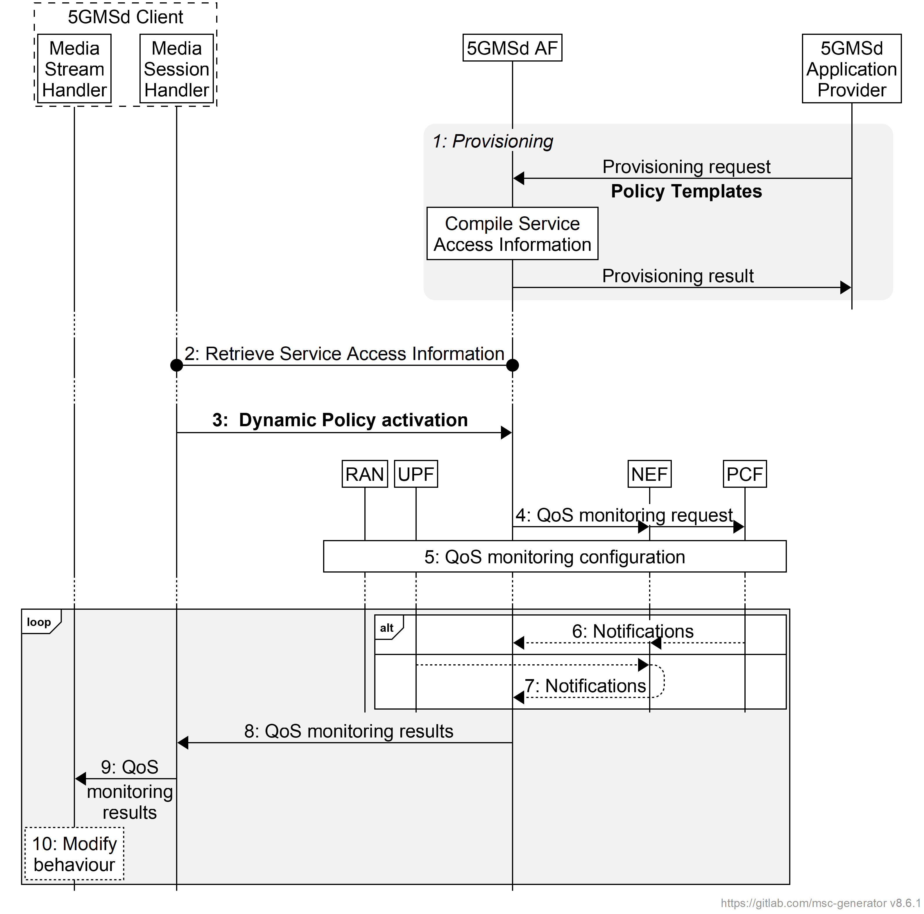

Figure 5.7.10-1: High-level call flow for QoS monitoring for downlink Media Streaming

The steps are as follows:

1. *Policy Template Provisioning.* A Policy Template is provisioned and shall **include the QoS monitoring configuration**. The QoS monitoring configuration includes the parameters to be monitored, the reporting frequency (event triggered, periodic), and optionally the target entity of reporting. and optionally the notification via local UPF.

NOTE: In case the 5GMSd AS is deployed as an EAS instance in the Edge DN, a local UPF can also be inserted for local access to the 5GMSd EAS. In order to reduce the latency used for exposure of the QoS monitoring results, the local UPF is expected to provide the notifications of network status directly to the 5GMSd AF and 5GMSd AS, or via a locally deployed NEF as defined in clause 5.8.2.17 of TS 23.501 [2].

2. *Service Access Information retrieval*. The Media Session Handler retrieves Service Access Information from 5GMSd AF via M5d.

3. *Dynamic Policy activation.* The Media Session Handler within the 5GMSd Client obtains Service Access Information and triggers a dynamic policy activation. A Policy Template Binding is present within the Service Access Information for each provisioned Policy Template. **Policy Template Bindings suitable for QoS monitoring are indicated by a QoS monitoring configuration. The selected Policy Template is configured with the QoS monitoring configuration.**

4. *QoS Monitoring request.* The 5GMSd AF invokes the Npcf_PolicyAuthorization service or the Nnef_AFsessionWithQoS service **with the requested QoS monitoring configurations**. In the case where the 5GMSd AS is deployed in the Edge DN, the 5GMSd AF may additionally enable the exposure of QoS montoring results via the local UPF or local NEF in this step.

5. The PCF accepts the request and enables QoS monitoring within the 5G System, i.e., by configuring the RAN and/or the (local) UPF for monitoring and reporting of target QoS parameters for the downlink media streaming.

Following the QoS monitoring request(s):

6. The PCF may expose the QoS monitoring results to the 5GMSd AF periocially or by event triggers.

7. Alternatively, the QoS monitoring results may be exposed to the 5GMSd AF by the UPF directly using the Nupf_EventExposure_Notify service or via a locally deployed NEF using the Nnef_EventExposure_Notifyservice at reference point N33.

8. If QoS monitoring was requested by the Media Session Handler, **the 5GMSd AF sends the notifications of the QoS monitoring results to the Media Session Handler** via reference point M5d.

**9. The Media Session Handler provides the QoS monitoring results to the Media Stream Handler at reference point M11d.**

**10. The Media Stream Handler may use the notified QoS monitoring results to modify its behaviour. For example, in the case of downlink media streaming, the Media Player may use the monitored packet latency to determine when to request the next media segment, and/or to change the bit rate of the next media segment based on the monitored congestion status.**

## ===== CHANGE =====

#### 6.2.2.1 Domain model

The M1u baseline domain model is depicted in figure 6.2.2.1-1 overleaf. It consists of a Provisioning Session, which contains at least one of the following:

- A Content Publishing Configuration,

- A Policy Template,

- One or more Content Preparation Templates,

- An *Edge Resources Configuration* specifying the requirements for edge processing as defined in TS 23.548 [15] and TS 23.558 [16] in support of the Provisioning Session, including eligibility criteria that indicate the circumstances in which edge computing is to be used for Media Streaming sessions associated with this Provisioning Session and parameters indicating the tolerance of the application for relocation of the Edge AS, or

Each Provisioning Session is uniquely identified within the 5GMS System by a Provisioning Session identifier.

When a certain 5GMS feature (such as content publishing configuration, policy template, content preparation template or edge resource configuration) is selected, the 5GMSu AF compiles the resulting Service Access Information that the 5GMSu Client needs to have to access the services via M5u.



Figure 6.2.2.1-1: M1u provisioning domain model

The M3u baseline domain model used by the 5GMSu AF to configure Content Publishing in the 5GMSu AS is depicted in figure 6.2.2.1-2 below. It comprises a set of Content Publishing Configurations, each containing one or more Contribution Configurations and one Publishing Configuration. A Contribution Configuration may reference Server Certificates for presentation at reference point M4u and/or Content Preparation Templates specifying media manipulation by the 5GMSu AS between media contribution at reference point M2u and media egest at reference point M4u.



Figure 6.2.2.1-2: M3u configuration domain model

#### 6.2.2.2 Baseline provisioning procedure

This clause describes the baseline procedure to provision the features using the 5GMS System.

NOTE 1: SLA negotiations between the 5GMSu Application Provider and the 5GMS System provider are outside the scope of the present specification and are included in the figure below for illustrative purposes only.



Figure 6.2.2.2-1: High-level procedure for provisioning the 5GMS System  
for uplink media streaming sessions

Steps:

1. The 5GMSu Application Provider authenticates itself with the system. This procedure reuses existing authentication/authorization procedures, e.g., as defined for CAPIF [13].

2. The 5GMSu Application Provider creates a Provisioning Session, providing its 5GMSu Application Provider identifier as input. 5GMSu Application Provider queries the capabilities and authorized features.

3. The 5GMSuApplication Provider specifies one or more 5GMSu features in the Provisioning Session. A set of authorized features is activated, such as content dynamic policy; network assistance; and content publishing (including egest).

When the content publishing feature is offered and selected, the 5GMS Application Provider provides a Content Publishing Configuration to configure the content publishing behaviour of the 5GMSu AS (see next step), including selecting the uplink ingest protocol and format, content preparation and egest protocol and format.

When the dynamic policy feature is offered and selected, the 5GMSu Application Provider specifies a set of policies which can be invoked for the uplink streaming session. The UE becomes aware of the selected policies in the form of a list of valid Policy Template Ids. For example, when 5GMSu Application Provider sets an *L4S enablement* flag for a Policy Template, the 5GMSu Client gets aware of this Polity Template after fetching the Service Access Information from the 5GMSd AF. Then 5GMSu Client may select this Policy Template to activate the ECN marking for L4S in the 5G System.

When the edge computing feature is offered and selected, the 5GMSu Application Provider provides one or more Edge Resources Configurations that can be used to support either client-driven management or Application Provider-driven management of edge resources associated with the Provisioning Session.

4. When content publication is desired, the 5GMSu AF interacts with the 5GMSu AS at reference point M3u to configure any necessary Server Certificates and/or Content Publishing Templates and to allocate resources for M2u egest protocol and format by means of a Content Publishing Configuration. The 5GMSu AS responds to the 5GMSu AF with the M2u content egest address.

5. The 5GMSu AF compiles the Service Access Information. The Service Access Information contains access details and options such as the Provisioning Session identifier, M5u (Media Session Handling) addresses for uplink entry point, dynamic policy, network assistance, etc.

6. The 5GMSu AF provides the results to the 5GMSu Application Provider.

The following steps:

7. When the 5GMSu Application Provider has selected full Service Access Information, the results are provided in the form of addresses and configurations for M2u (content egest), M5u (Media Session Handling) and M4u (Media Uplink Streaming). The 5GMSu Application Provider provides a subset of this information to the 5GMSu-Aware Application through M8u.

8. When the 5GMSu-Aware Application decides to activate the streaming service transmission, the Service Access Information is provided to the 5GMSu Client.

9. The 5GMSu Client requests the 5GMSu AF to initialise uplink media streaming (M5u), including reservation of any resources required for content preparation.

Or, alternatively:

10. The 5GMS-Aware Application requests the 5GMSu Client to start an uplink streaming session (M6u/M7u).

11. When the 5GMSu Application Provider has delegated Service Access Information handling to the 5GMS System, a reference to the Service Access Information (e.g. an URL) is provided. The Media Session Handler fetches the full Service Access Information later from the 5GMSu AF.

Then:

12. The 5GMSu Client streams the content to the 5GMSu AS.

13. When content publishing is offered and has been selected in step 4, the 5GMSu Application Provider can start retrieving the content from the M2u egest interface.

Optionally:

14. The 5GMSu Application Provider may update the Provisioning Session.

According to schedule, or upon request by the 5GMSu-Aware Application:

15. The 5GMSu Application Provider may manually terminate the Provisioning Session (at any time). All associated resources are released. Content may be removed from the 5GMSu AS. The 5GMSd Application Provider may configure a schedule for Provisioning Session termination.

16. The 5GMSu AF sends a notification to the 5GMSu Client upon Provisioning Session termination.

The 5GMSu AF may request the creation or reuse of one or more network slices for ingesting the content of the provisioned session. If more than one network slice is provisioned for the ingest of the content of a session, the list of allowed S‑NSSAIs shall be conveyed to the target UE (e.g. through URSP or through M8u, step 7, or M5u, step 10).

NOTE 2: The 5GMSu AS receiving the content is only accessible through the DNN(s) used by the network slice(s) provisioned for the distribution of that content.

## ===== CHANGE =====

### 6.9.2 Provisioning

The provisioning for the dynamic policy procedure follows the general procedure from clause 6.2.2. Specifically, the Dynamic Policy feature is activated and, as result, the 5GMSu Application Provider is able to provision one or more Policy Templates.

The domain model of M1u and M5u APIs is depicted in figure 6.9.2-1. Realization of the dependencies between M1u and M5u data entries are up to implementation.

NOTE: Multiple M5u 5GMSu AF nodes may reference the same M1u resource.



Figure 6.9.2-1: Domain model for dynamic policies for uplink streaming

A Policy Template is identified by a Policy Template Id and contains semi-static parameters, including the API entry for the PCF/NEF interactions. The list of provisioned Policy Template Ids is communicated as valid Policy Template Ids to the Media Session Handler. The Media Session Handler uses one of the valid Policy Template Ids when invoking a dynamic policy.

## ===== CHANGE =====

### 6.9.8 Dynamic Policy of ECN marking for L4S for uplink media streaming

Figure 6.9.8-1 below shows a high-level call flow for uplink media streaming for configuration and usage of ECN marking for L4S. Differences from the procedure for uplink media streaming with dynamic policies defined in clause 6.9.3 are indicated in **boldface**.

The following is assumed:

- The service here is a unicast uplink media streaming service with dynamic policy support.

- As an example, the Layer 4 protocol used for application flows is TCP and the TCP stack used supports L4S.

- The 5GS network supports ECN marking for L4S.

- The application has specifically requested ECN marking for its media delivery session.

- NG-RAN manipulates the ECN bits (per clause 5.37.3.2 of TS 23.501 [2]). It is equally possible that the PDU Session Anchor UPF (PSA-UPF) manipulates the ECN bits (per clause 5.37.3.3 of [2]).

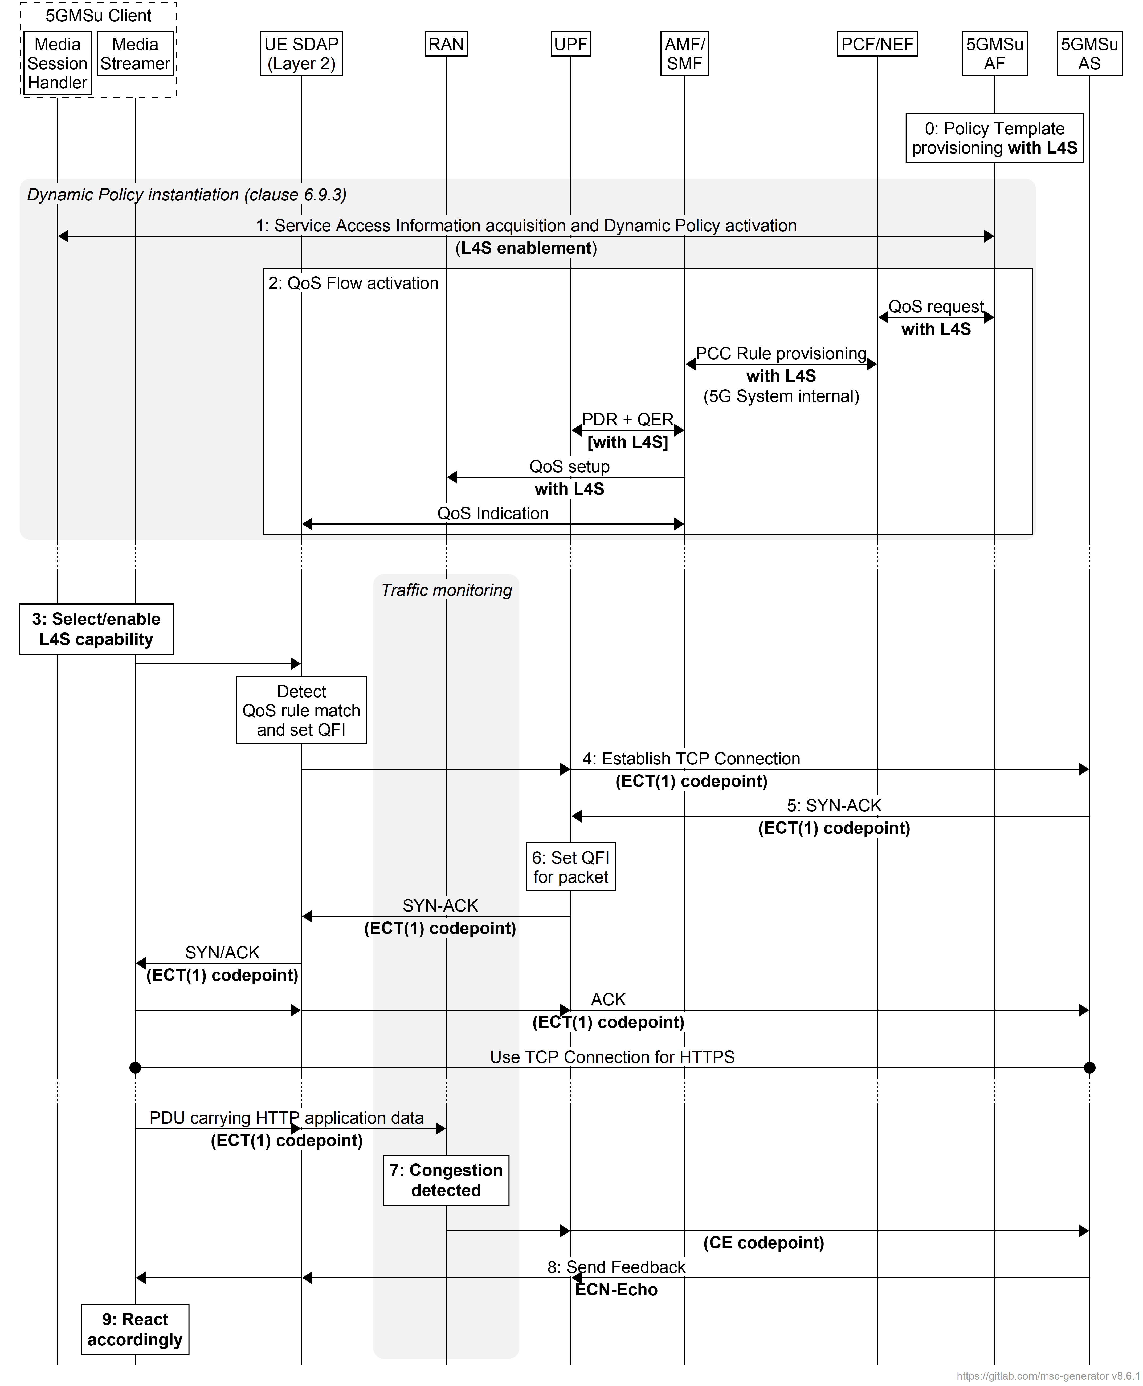

Figure 6.9.8-1: Uplink media streaming call flow for ECN marking for L4S

The steps are as follows:

0: *Policy Template Provisioning.* A Policy Template is provisioned **with the requirement for L4S capability, indicated by setting the *L4S enablement* flag**.

1: *Dynamic Policy activation.* The Media Session Handler within the 5GMSu Client obtains Service Access Information and triggers a dynamic policy activation. A Policy Template Binding is present within the Service Access Information for each provisioned Policy Template. **Policy Template Bindings suitable for L4S are indicated by an L4S enablement flag being set. The 5GMSu Client detects that an L4S-capable media transport stack is present and in use. The selected Policy Template is configured with the L4S enablement flag.**

2: *QoS request.* The 5GMSu AF requests QoS handling using e.g. the Nnef_AfSessionWithQoS service or the Npcf_PolicyAuthorization service. **If the L4S enablement flag is set in the selected Policy Template, this indicates that the new QoS flow is required to be L4S-enabled.** The new QoS flow with the ECN marking for L4S indication setting propagates through the 5G System.

**3: The Media Session Handler may inform the Media Streamer about the successful activation of L4S via the client API at reference point M11u. Subject to availability of API access, the Media Player may use congestion notifications to perform early adaptation.**

4: **If the L4S enablement flag is set in the Policy Template Binding for the selected Policy Template, the 5GMSu Client selects/enables the L4S capability of the used transport protocol.**

NOTE 1: This step may happen implicitly by selecting an L4S-supporting transport protocol stack.

5: The Media Streamer within the 5GMSu Client triggers the establishment of a TCP connection. The ECT(1) codepoint is set in the IP header, indicating an L4S-Capable Transport, and the SDAP entity ensures that the packet is forwarded via the matching QoS flow.

6: The 5GMSu AS responds to the TCP connection establishment request. The 5GMSu AS sets ECT(1) in the IP headers, indicating an L4S-Capable Transport.

7: The UPF finds the matching QoS Flow Identifier for the downlink packet and sends the packet via the corresponding QoS flow to the UE. TCP Connection setup continues, with one ECT bit set in all packets.

8: When the RAN detects an upcoming congestion according to the congestion measurement (based on continuous congestion monitoring), the 5G System the CE (Congestion Experienced) codepoint in the IP header of the uplink packet.

9: The TCP protocol stack used by the 5GMSu AS reflects the Early Congestion Notification to the TCP sender by setting the ECN-Echo (ECE) flag in the TCP header of a downlink PDU of the same TCP connection. The TCP sender reacts to the ECN-Echo accordingly (i.e., by reducing its sending congestion window).

NOTE 2: The ECN-Echo flag is also acknowledged by the TCP sender setting the Congestion Window Reduced (CWR) flag in an outgoing TCP frame, but this acknowledgement is not illustrated in this call flow.

NOTE 3: Classic ECN as specified in RFC 3168 [X4] requires an ECN signal to be treated as equivalent to a packet drop. L4S as specified in RFC 9330 [X1] specifies a more fine-grained response and an early congestion signal triggers a less severe reaction. How a TCP sender behaves "accordingly" is beyond the scope of the present document.

10: Based on the CE indication received in step 8, or by detecting a reduced bit rate in the uplink application flow, the Media Streamer in the 5GMSu Client may react by, for example, changing the bit rate of the representation.

### 6.9.9 QoS monitoring of uplink media streaming based on Dynamic Policy

Figure 6.9.9-1 below shows a high-level call flow for uplink media streaming for configuration and usage of QoS monitoring.

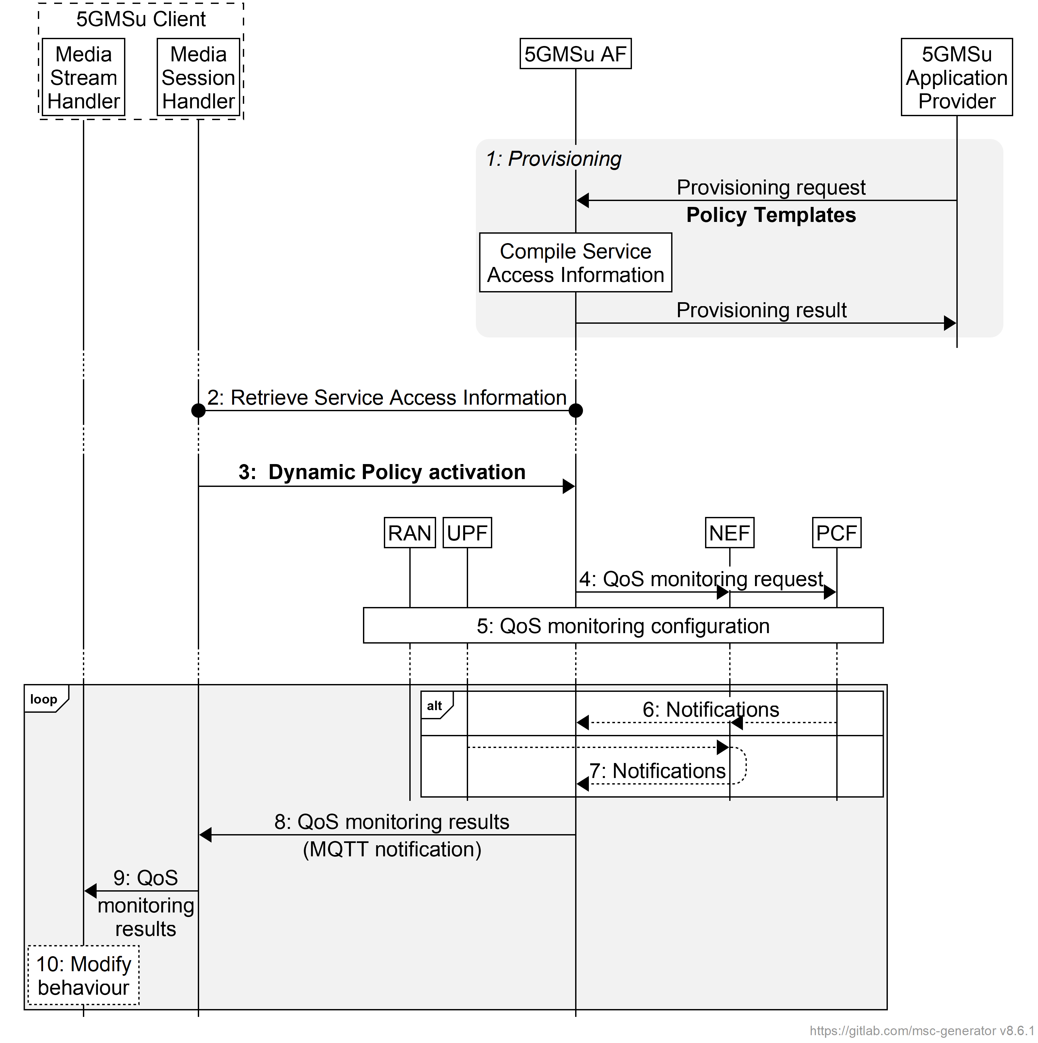

Figure 6.9.9-1: High-level call flow for QoS monitoring for uplink Media Streaming

The steps are as follows:

1. *Policy Template Provisioning.* A Policy Template is provisioned and shall include **the QoS monitoring configuration**. The QoS monitoring configuration includes the parameters to be monitored, the reporting frequency (event triggered, periodic), and optionally the target entity of reporting and optionally the notification via UPF.

NOTE 1: In case the 5GMSu AS is deployed as an EAS instance in the Edge DN, a local UPF can also be inserted for local access to the 5GMSu Edge AS. In order to reduce the latency used for exposure of the QoS monitoring results, the local UPF is expected to provide the notifications of network status directly to the 5GMSu AF and 5GMSu AS, or via a locally deployed NEF as defined in clause 5.8.2.17 of TS 23.501 [2].

2. *Service Access Information retrieval*. The Media Session Handler retrieves Service Access Information from 5GMSu AF via M5u.

3. *Dynamic Policy activation.* The Media Session Handler within the 5GMSu Client obtains Service Access Information and triggers a dynamic policy activation. A Policy Template Binding is present within the Service Access Information for each provisioned Policy Template. **Policy Template Bindings suitable for QoS monitoring are indicated by a QoS monitoring configuration included. The selected Policy Template is one configured with the QoS monitoring configuration.**

4. *QoS Monitoring request.* The 5GMSu AF invokes the Npcf_PolicyAuthorization service or the Nnef_AFsessionWithQoS service **with the requested QoS monitoring configurations**. In the case where the 5GMSu AS is deployed in the Edge DN, the 5GMSu AF may additionally enable the exposure of QoS montoring results via the local UPF or local NEF in this step.

5. The PCF accepts the request and enables QoS monitoring within the 5G System, i.e., by configuring the RAN and/or the (local) UPF for monitoring and reporting of target QoS parameters for the uplink media streaming.

Following the QoS monitoring request(s):

6. The PCF may expose the QoS monitoring results to the 5GMSu AF periocially or by event triggers.

7. Alternatively, the QoS monitoring results may be exposed to the 5GMSu AF by the UPF directly using the Nupf_EventExposure_Notify service or via a locally deployed NEF using the Nnef_EventExposure_Notifyservice at reference point N33.

8. If QoS monitoring was requested by the Media Session Handler, **the 5GMSu AF sends the notifications of the QoS monitoring results to the Media Session Handler** via reference point M5u.

**9. The Media Session Handler provides QoS monitoring results to the Media Stream Handler at reference point M11u.**

**10. The Media Stream Handler may use the notified QoS monitoring results to modify its behaviour.** For example, in the case of uplink media streaming, the Media Player may use the monitored packet latency, congestion status, etc. to determine the bit rate of the uplink streaming.