**3GPP TSG-SA3 Meeting #81-LI-e-b *s3i210345***

**Online, , 19th May 2021 - 21st May 2021**

|  |  |  |  |  |  |  |  |  |
| --- | --- | --- | --- | --- | --- | --- | --- | --- |
| *CR-Form-v12.1* | | | | | | | | |
| **CHANGE REQUEST** | | | | | | | | |
|  | | | | | | | | |
|  | **33.127** | **CR** | **0131** | **rev** | **1** | **Current version:** | **16.7.0** |  |
|  | | | | | | | | |
| *For* [***HE******LP***](http://www.3gpp.org/3G_Specs/CRs.htm#_blank)*on using this form: comprehensive instructions can be found at* [*http://www.3gpp.org/Change-Requests*](http://www.3gpp.org/Change-Requests)*.* | | | | | | | | |
|  | | | | | | | | |

|  |  |  |  |  |  |  |  |  |
| --- | --- | --- | --- | --- | --- | --- | --- | --- |
| ***Proposed change affects:*** | UICC apps |  | ME |  | Radio Access Network |  | Core Network | **X** |

|  |  |  |  |  |  |  |  |  |  |  |
| --- | --- | --- | --- | --- | --- | --- | --- | --- | --- | --- |
|  | | | | | | | | | | |
| ***Title:*** |  | | | | | | | | | |
|  |  | | | | | | | | | |
| ***Source to WG:*** | SA3-LI(OTD) | | | | | | | | | |
| ***Source to TSG:*** |  | | | | | | | | | |
|  |  | | | | | | | | | |
| ***Work item code:*** | LI16 | | | | |  | ***Date:*** | | | 2021-05-19 |
|  |  | | | |  | |  | | |  |
| ***Category:*** | **F** |  | | | | | ***Release:*** | | | Rel-16 |
|  | *Use one of the following categories:* ***F*** *(correction)* ***A*** *(mirror corresponding to a change in an earlier release)* ***B*** *(addition of feature),* ***C*** *(functional modification of feature)* ***D*** *(editorial modification)*  Detailed explanations of the above categories can be found in 3GPP [TR 21.900](http://www.3gpp.org/ftp/Specs/html-info/21900.htm). | | | | | | | | *Use one of the following releases: Rel-8 (Release 8) Rel-9 (Release 9) Rel-10 (Release 10) Rel-11 (Release 11) … Rel-15 (Release 15) Rel-16 (Release 16) Rel-17 (Release 17) Rel-18 (Release 18)* | |
|  |  | | | | | | | | | |
| ***Reason for change:*** | | The current description and diagram for LI at the SGW/PGW do not align and would not function correctly. | | | | | | | | |
|  | |  | | | | | | | | |
| ***Summary of change:*** | | Aligns the description of LI architecture at the SGW/PGW with the diagrams and provides a working solution. | | | | | | | | |
|  | |  | | | | | | | | |
| ***Consequences if not approved:*** | | LI at the SGW/PGW would not function correctly. | | | | | | | | |
|  | |  | | | | | | | | |
| ***Clauses affected:*** | | 6.3.3.1, 6.3.3.6 | | | | | | | | |
|  | |  | | | | | | | | |
|  | | **Y** | **N** |  | | | |  | | |
| ***Other specs*** | |  | **X** | Other core specifications | | | | TS/TR ... CR ... | | |
| ***affected:*** | |  | **X** | Test specifications | | | | TS/TR ... CR ... | | |
| ***(show related CRs)*** | |  | **X** | O&M Specifications | | | | TS/TR ... CR ... | | |
|  | |  | | | | | | | | |
| ***Other comments:*** | |  | | | | | | | | |
|  | |  | | | | | | | | |
| ***This CR's revision history:*** | | S3i210345 | | | | | | | | |

*** Start of First Change ***

#### 6.3.3.1 Architecture

In the EPC network, the SGW is the gateway which terminates the user plane interface as specified in TS 23.401 [22]. The PGW is the gateway which terminates the SGi interface towards the PDN as specified in TS 23.401 [22]. Additionally, the PGW is the user plane anchor for mobility between 3GPP access and non-3GPP access as specified in TS 23.402 [23].

NOTE 1: The present document supports LI for non-3GPP accesses connected to EPC using GTP-based S2a or GTP-based S2b as specified by TS 23.402 [23]. Other scenarios are covered by TS 33.107 [11].

The SGW and PGW shall include an IRI-POI that has the LI capabilities to generate the target UE’s bearer related xIRI.

In addition, the SGW and PGW shall include a CC-POI that has the LI capabilities to duplicate the user plane packets from the EPS bearers related to a target UE.

Figure 6.3-2 shows the LI architecture for SGW/PGW based interception.

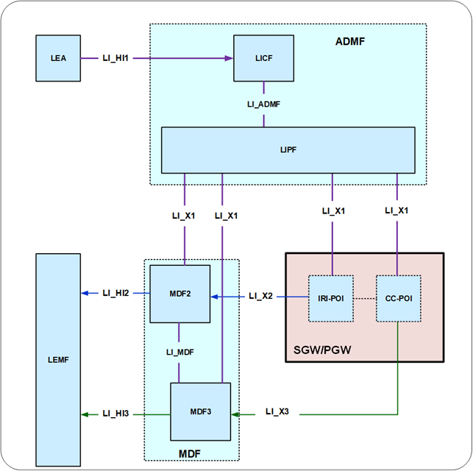

Figure 6.3-2: LI architecture for LI at SGW/PGW

The LICF present in the ADMF receives the warrant from an LEA, derives the intercept information from the warrant and provides the same to the LIPF.

The LIPF present in the ADMF provisions IRI-POI present in the SGW/PGW and the MDF2 over the LI_X1 interfaces. To enable the interception of the target's user plane packets (e.g. when the warrant requires the interception of communication contents), the LIPF present in the ADMF also provisions the CC-POI present in the SGW/PGW and the MDF3 over the LI_X1 interfaces.

NOTE 2: The IRI-POI and CC-POI represented in figure 6.3-2 are logical functions and require correlation information be shared between them; they may be handled by the same process within the SGW/PGW.

The IRI-POI present in the SGW/PGW detects the target UE's bearer activation, modification and deactivation and generates and delivers the xIRI to the MDF2 over LI_X2. The MDF2 delivers the IRI messages to the LEMF over LI_HI2.

The CC-POI present in the SGW/PGW generates the xCC from the user plane packets and delivers the xCC (that includes the correlation number and the target identity) to the MDF3. The MDF3 delivers the CC to the LEMF over LI_HI3.

A warrant that does not require the interception of communication contents, may require IRI messages that have to be derived from the user plane packets. To support the generation of related xIRI (i.e. that requires access to the user plane packets), the present document supports two implementation approaches:

- In approach 1, the IRI-POI in the SGW/PGW generates the xIRI (that includes the correlation number and the target identity) from the user plane packets and sends it to the MDF2. The MDF2 generates the IRI messages and send them to the LEMF.

- In approach 2, xCC is generated by the CC-POI as if the warrant involves the interception of communication contents. To enable this, the CC-POI is presumed to be present and provisioned in the SGW/PGW even when the warrant does not require the interception of communication contents. As explained before, the CC-POI generates the xCC and sends it to the MDF3. The MDF3 (based on the provisioned intercept information) does not generate and deliver the CC to the LEMF. Instead, the MDF3 forwards the xCC to the MDF2 over LI_MDF interface. The MDF2 then generates the IRI messages from xCC and delivers those IRI messages to the LEMF.

*** Start of Change 2 of 2 ***

#### 6.3.3.6 Network topologies

The SGW shall provide the IRI-POI and CC-POI functions in the following network topology cases:

- Based on the deployment option, in a non-roaming case for E-UTRAN.

- Roaming case, in VPLMN.

The PGW shall provide the IRI-POI and CC-POI functions in the following network topology cases:

- Based on the deployment option, in a non-roaming case for E-UTRAN.

- Roaming case, in HPLMN.

- Non-3GPP access case, in the HPLMN.

For the case of access to EPC via E-UTRAN, in case of non-roaming, at least one between SGW and PGW shall provide the IRI-POI and CC-POI.

When the target UE has multiple bearers active, the generation and delivery of xCC for each bearer shall be done independently, each with separate correlation information.

*** End of All Changes ***