**3GPP TSG-SA3 Meeting #81-LI-e-a *s3i210237***

**Online, 12th Apr 2021 - 16th Apr 2021**

|  |  |  |  |  |  |  |  |  |
| --- | --- | --- | --- | --- | --- | --- | --- | --- |
| *CR-Form-v12.1* | | | | | | | | |
| **CHANGE REQUEST** | | | | | | | | |
|  | | | | | | | | |
|  | **33.127** | **CR** | **0121** | **rev** | **1** | **Current version:** | **17.0.0** |  |
|  | | | | | | | | |
| *For* [***HE******LP***](http://www.3gpp.org/3G_Specs/CRs.htm#_blank)*on using this form: comprehensive instructions can be found at* [*http://www.3gpp.org/Change-Requests*](http://www.3gpp.org/Change-Requests)*.* | | | | | | | | |
|  | | | | | | | | |

|  |  |  |  |  |  |  |  |  |
| --- | --- | --- | --- | --- | --- | --- | --- | --- |
| ***Proposed change affects:*** | UICC apps |  | ME |  | Radio Access Network |  | Core Network | **X** |

|  |  |  |  |  |  |  |  |  |  |  |
| --- | --- | --- | --- | --- | --- | --- | --- | --- | --- | --- |
|  | | | | | | | | | | |
| ***Title:*** | LI for NIDD in EPS in TS 33.127 | | | | | | | | | |
|  |  | | | | | | | | | |
| ***Source to WG:*** | SA3LI (Ministère Economie et Finances) | | | | | | | | | |
| ***Source to TSG:*** | SA3 | | | | | | | | | |
|  |  | | | | | | | | | |
| ***Work item code:*** | LI17 | | | | |  | ***Date:*** | | | 2021-04-15 |
|  |  | | | |  | |  | | |  |
| ***Category:*** | **B** |  | | | | | ***Release:*** | | | Rel-17 |
|  | *Use one of the following categories:* ***F*** *(correction)* ***A*** *(mirror corresponding to a change in an earlier release)* ***B*** *(addition of feature),* ***C*** *(functional modification of feature)* ***D*** *(editorial modification)*  Detailed explanations of the above categories can be found in 3GPP [TR 21.900](http://www.3gpp.org/ftp/Specs/html-info/21900.htm). | | | | | | | | *Use one of the following releases: Rel-8 (Release 8) Rel-9 (Release 9) Rel-10 (Release 10) Rel-11 (Release 11) … Rel-15 (Release 15) Rel-16 (Release 16) Rel-17 (Release 17) Rel-18 (Release 18)* | |
|  |  | | | | | | | | | |
| ***Reason for change:*** | | NIDD (Non-IP Data Delivery) service cannot be intercepted in EPS | | | | | | | | |
|  | |  | | | | | | | | |
| ***Summary of change:*** | | Adds stage 2 for NIDD in EPS | | | | | | | | |
|  | |  | | | | | | | | |
| ***Consequences if not approved:*** | | Regulatory issue. NIDD solution for LI would continue to be missing in EPS | | | | | | | | |
|  | |  | | | | | | | | |
| ***Clauses affected:*** | | 2, 6.3.3, 6.3.X (New) | | | | | | | | |
|  | |  | | | | | | | | |
|  | | **Y** | **N** |  | | | |  | | |
| ***Other specs*** | | **X** |  | Other core specifications | | | | TS 33.128.CR 183 | | |
| ***affected:*** | |  | **X** | Test specifications | | | | TS/TR ... CR ... | | |
| ***(show related CRs)*** | |  | **X** | O&M Specifications | | | | TS/TR ... CR ... | | |
|  | |  | | | | | | | | |
| ***Other comments:*** | | Related to CR s3i210238 (stage 3) | | | | | | | | |
|  | |  | | | | | | | | |
| ***This CR's revision history:*** | | s3i210237 | | | | | | | | |

First change

2 References

The following documents contain provisions which, through reference in this text, constitute provisions of the present document.

- References are either specific (identified by date of publication, edition number, version number, etc.) or non‑specific.

- For a specific reference, subsequent revisions do not apply.

- For a non-specific reference, the latest version applies. In the case of a reference to a 3GPP document (including a GSM document), a non-specific reference implicitly refers to the latest version of that document *in the same Release as the present document*.

[1] 3GPP TR 21.905: "Vocabulary for 3GPP Specifications".

[2] 3GPP TS 23.501: "System Architecture for the 5G System".

[3] 3GPP TS 33.126: "Lawful interception requirements".

[4] 3GPP TS 23.502: "Procedures for the 5G System; Stage 2".

[5] 3GPP TS 23.271: "Functional stage 2 description of Location Services (LCS)".

[6] OMA-TS-MLP-V3_5-20181211-C: "Open Mobile Alliance; Mobile Location Protocol, Candidate Version 3.5", <https://www.openmobilealliance.org/release/MLS/V1_4-20181211-C/OMA-TS-MLP-V3_5-20181211-C.pdf>".

[7] ETSI TS 103 120: "Lawful Interception (LI); Interface for warrant information".

[8] ETSI TS 103 221-1: "Lawful Interception (LI); Internal Network Interfaces; Part 1: X1 ".

[9] 3GPP TS 33.501: "Security Architecture and Procedures for the 5G System".

[10] ETSI GR NFV-SEC 011: "Network Functions Virtualisation (NFV); Security; Report on NFV LI Architecture".

[11] 3GPP TS 33.107: "3G Security; Lawful interception architecture and functions".

[12] 3GPP TS 23.214: "Architecture enhancements for control and user plane separation of EPC nodes; Stage 2".

[13] 3GPP TS 23.228: "IP Multimedia Subsystem (IMS); Stage 2".

[14] 3GPP TS 38.413: "NG-RAN; NG Application Protocol (NGAP)".

[15] 3GPP TS 33.128: "Protocol and Procedures for Lawful Interception; Stage 3".

[16] ETSI TS 103 221-2: " Lawful Interception (LI); Internal Network Interfaces; Part 2: X2/X3".

[17] MMS Architecture OMA-AD-MMS-V1_3-20110913-A.

[18] Multimedia Messaging Service Encapsulation Protocol OMA-TS-MMS_ENC-V1_3-20110913-A.

[19] 3GPP TS 22.140: "Multimedia Messaging Service (MMS); Stage 1".

[20] ETSI GS NFV-IFA 026: "Network Functions Virtualisation (NFV) Release 3; Management and Orchestration; Architecture enhancement for Security Management Specification".

[21] 3GPP TS 33.108: "Handover Interface for Lawful Interception (LI)".

[22] 3GPP TS 23.401: "General Packet Radio Service (GPRS) enhancements for   
Evolved Universal Terrestrial Radio Access Network (E-UTRAN) access".

[23] 3GPP TS 23.402: "Architecture enhancements for non-3GPP accesses".

[24] 3GPP TS 23.280: "Common functional architecture to support mission critical services; Stage 2".

[25] OMA-AD-PoC-V2_1-20110802-A: "Push to talk over Cellular (PoC) Architecture".

[26] GSMA IR.92: "IMS Profile for Voice and SMS".

[27] GSMA NG.114: "IMS Profile for Voice, Video and Messaging over 5GS".

[28] 3GPP TS 24.147: "Conferencing using the IP Multimedia (IM) Core Network (CN) subsystem; Stage 3".

[29] ETSI GS NFV-SEC 012: "Network Functions Virtualisation (NFV) Release 3; Security; System architecture specification for execution of sensitive NFV components".

[XX] 3GPP TS 23.682: "Architecture enhancements to facilitate communications with packet data networks and applications".

[XY] 3GPP TS 29.128: "Mobility Management Entity (MME) and Serving GPRS Support Node (SGSN) interfaces for interworking with packet data networks and applications, Stage 3".

[XZ] 3GPP TS 29.122: "T8 reference point for Northbound APIs".

Second change

6.3.3.X. LI at SGW/PGW for NIDD

6.3.3.X.1. Architecture

Functions for NIDD (Non-IP Data Delivery) may be used to handle Mobile Originated (MO) and Mobile Terminated (MT) communication for unstructured data (also referred to as Non-IP). Such delivery to the SCS/AS is accomplished by one of the following two mechanisms as defined in TS 23.682 [XX]:

* Delivery using SCEF;
* Delivery using a Point-to-Point (PtP) SGi tunnel. (This use case is simpler to handle with the existing LI standard for EPS)

Whether or not a SCEF shall be invoked for a PDN connection is determined by the presence of a "SCEF Identity for NIDD" in the APN configuration in the UE subscription.

If the subscription includes a "SCEF Identity for NIDD" corresponding with the APN information, then the MME selects that SCEF and uses the T6a interface to that SCEF (see TS 29.128 [XY]), otherwise, the MME selects a SGW and PGW which handle this PDN connection. The PDN GW shares a SGi tunnel with the SCS/AS for the NIDD traffic exchange. When SCEF is used, SCEF sends the NIDD traffic over the T8 interface (see TS 29.122 [XZ]) to the SCS/AS (Service Capability Server/ Application Server).

6.3.3.X.2. LI for SGW/PGW for NIDD using a Point-to-Point (PtP) SGi tunnel

In non-roaming scenario, the PGW provides an IRI POI, an IRI-TF and a CC-POI.

In roaming scenario, the visited SGW provides an IRI POI, an IRI-TF and a CC POI and the home PGW provides an IRI-POI, an IRI-TF and a CC-POI.

In case of non-roaming scenario, the NIDD traffic sent by UE as DoNAS (Data over NAS) is forwarded by the MME to the SGW via S11 interface. SGW forwards the NIDD traffic to PGW via S5 interface. PGW delivers that NIDD traffic over a PtP SGi tunnel to the SCS/AS (Figure 6.2-XA). The tunnel is typically a UDP/IP tunnel.

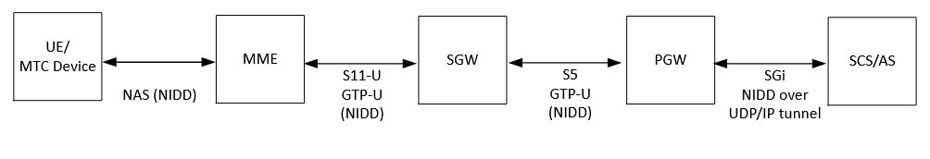Figure 6.3-XA: EPS Architecture for NIDD using a PtP SGi tunnel

In case of roaming scenario, the NIDD traffic sent by the UE as DoNAS is forwarded by the visited MME to the visited SGW via S11 interface. Visited SGW forwards the NIDD traffic to the home PGW over S8 interface. Finally, home PGW forwards that NIDD traffic over a PtP SGi tunnel to the SCS/AS (Figure 6.3-XB).

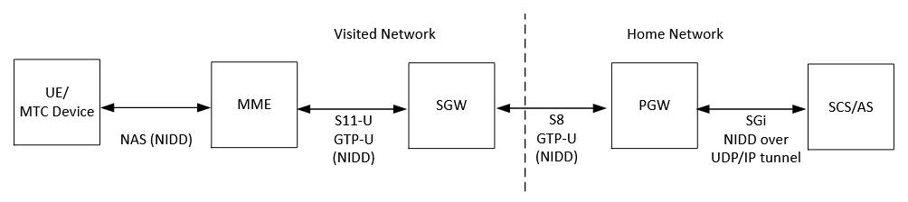

Figure 6.3-XB: EPS Architecture for NIDD using a PtP SGi tunnel in roaming situation

The LI architecture for SGW/PGW for NIDD using a PtP SGi tunnel is the same as presented in figure 6.3-2.

The same xIRIs defined in 6.3.3.3 for IP-based PDN connections and the same xCC are also considered for PDN connections for NIDD using a PtP SGi tunnel (Figure 6.3-XB).

Third change

6.3.X. LI at SCEF

6.3.X.1. LI for NIDD using SCEF

6.3.X.1.1. Architecture

As mentioned in 6.3.3.X.1, NIDD delivery may be handled by the SCEF.

In non-roaming scenario, the NIDD traffic sent by the UE as DoNAS is forwarded by the MME to the SCEF using T6a interface (see TS 29.128 [XY]. The SCEF delivers NIDD traffic to the SCS/AS using the T8 interface (see TS 29.122 [XZ]). Figure 6.3-XC shows the EPS architecture for NIDD using SCEF.

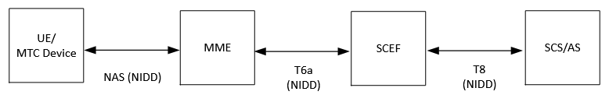

Figure 6.3-XC: EPS Architecture for NIDD using SCEF

In roaming scenario, the V-MME forwards the NIDD traffic to the IWK-SCEF (SCEF in the visited network) over T6a interface. The IWK-SCEF forwards the NIDD traffic to the SCEF over T7a interface (see TS 29.128 [XY]). Finally, SCEF delivers the NIDD to the SCS/AS over T8 interface (Figure 6.3-XD).

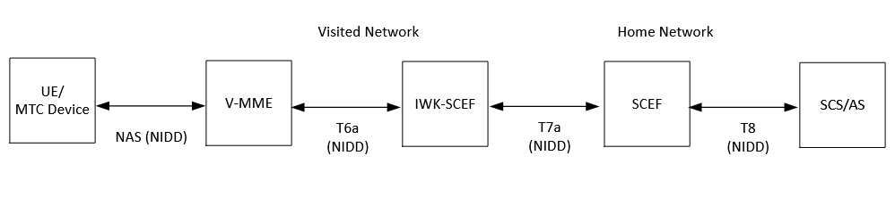

Figure 6.3-XD: EPS Architecture for NIDD using SCEF in roaming situation

For that purpose, the SCEF in the home network and the IWK-SCEF in the visited network shall provide both IRI-POI and CC-POI functions. The figure 6.3-XE gives a reference point representation of the LI architecture with SCEF as a CP NF and UP NF providing the IRI-POI and CC-POI functions for NIDD using SCEF. SCEF is the anchor point for PDN connection establishment for NIDD and NIDD traffic.

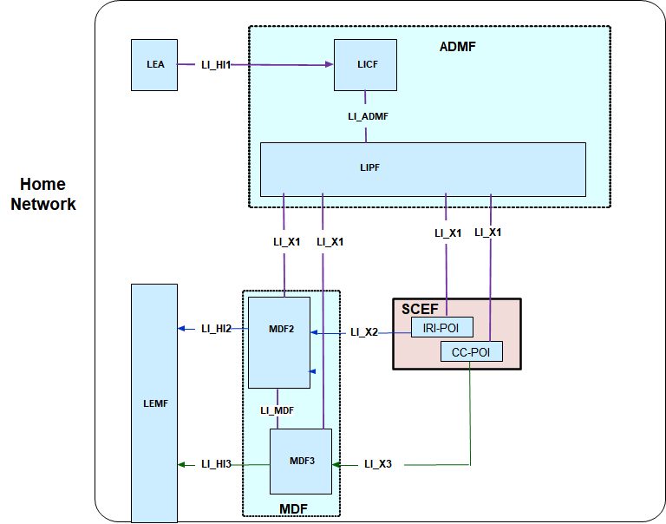

Figure 6.3-XE: LI architecture for NIDD using SCEF showing LI at SCEF/IWK-SCEF

#### 6.3.X.1.2. Target identities

The LIPF present in the ADMF provisions the intercept information associated with the following target identities to the IRI-POI present in the SCEF:

* IMSI.
* MSISDN
* External Identifier

The interception performed on the above three identities are mutually independent, even though, an xIRI may contain the information about the other identities when available.

#### 6.3.X.1.3. IRI events

The IRI-POI in the SCEF/IWK-SCEF shall generate xIRI when it detects the following specific events or information in both roaming and non-roaming situations:

* PDN connection establishment,
* PDN connection update,
* PDN connection release,
* Start of interception with established PDN connection,
* Unsuccessful procedure

The PDN connection establishment xIRI is generated when the IRI-POI present in the SCEF/IWK-SCEF detects that a PDN connection for NIDD using SCEF has been established for the target UE. The SCEF plays the role of anchor point for that PDN connection.

The PDN connection update xIRI is generated when the IRI-POI present in the SCEF/IWK-SCEF detects that a PDN connection for NIDD using SCEF is modified for the target UE.

The PDN connection release xIRI is generated when the IRI-POI present in the SCEF/IWK-SCEF detects that a PDN connection for NIDD using SCEF is released for the target UE.

The start of interception with an established PDN connection xIRI is generated when the IRI-POI present in a SCEF/IWK-SCEF detects that interception is activated on the target UE that has an already established PDN connection for NIDD using SCEF in the EPS. When a target UE has multiple PDN connections, this xIRI shall be sent for each PDN connection with a different value of correlation information.

When additional warrants are activated on a target UE, MDF2 shall be able to generate and deliver the start of interception with an established PDN connection related IRI messages to the LEMF associated with the warrants without receiving the corresponding start of interception with an established PDN connection xIRI.

The unsuccessful procedure xIRI is generated when the IRI-POI present in the SCEF/IWK-SCEF detects an unsuccessful procedure for PDN connection establishment, update, release or data delivery, data reception.

SCEF/IWK-SCEF generates xCC for NIDD using SCEF if CC is requested.

End of all changes