**3GPP TSG-SA3 Meeting #81-LI-e-a *s3i210217***

**Online, 12th Apr 2021 - 16th Apr 2021**

|  |  |  |  |  |  |  |  |  |
| --- | --- | --- | --- | --- | --- | --- | --- | --- |
| *CR-Form-v12.1* | | | | | | | | |
| **CHANGE REQUEST** | | | | | | | | |
|  | | | | | | | | |
|  | **33.127** | **CR** | **0116** | **rev** | **1** | **Current version:** | **17.0.0** |  |
|  | | | | | | | | |
| *For* [***HE******LP***](http://www.3gpp.org/3G_Specs/CRs.htm#_blank)*on using this form: comprehensive instructions can be found at* [*http://www.3gpp.org/Change-Requests*](http://www.3gpp.org/Change-Requests)*.* | | | | | | | | |
|  | | | | | | | | |

|  |  |  |  |  |  |  |  |  |
| --- | --- | --- | --- | --- | --- | --- | --- | --- |
| ***Proposed change affects:*** | UICC apps |  | ME |  | Radio Access Network |  | Core Network | **X** |

|  |  |  |  |  |  |  |  |  |  |  |
| --- | --- | --- | --- | --- | --- | --- | --- | --- | --- | --- |
|  | | | | | | | | | | |
| ***Title:*** | LI for NIDD in 5GS in TS 33.127 | | | | | | | | | |
|  |  | | | | | | | | | |
| ***Source to WG:*** | SA3LI(Ministère Economie et Finances) | | | | | | | | | |
| ***Source to TSG:*** | SA3 | | | | | | | | | |
|  |  | | | | | | | | | |
| ***Work item code:*** | LI17 | | | | |  | ***Date:*** | | | 2021-04-15 |
|  |  | | | |  | |  | | |  |
| ***Category:*** | **B** |  | | | | | ***Release:*** | | | Rel-17 |
|  | *Use one of the following categories:* ***F*** *(correction)* ***A*** *(mirror corresponding to a change in an earlier release)* ***B*** *(addition of feature),* ***C*** *(functional modification of feature)* ***D*** *(editorial modification)*  Detailed explanations of the above categories can be found in 3GPP [TR 21.900](http://www.3gpp.org/ftp/Specs/html-info/21900.htm). | | | | | | | | *Use one of the following releases: Rel-8 (Release 8) Rel-9 (Release 9) Rel-10 (Release 10) Rel-11 (Release 11) … Rel-15 (Release 15) Rel-16 (Release 16) Rel-17 (Release 17) Rel-18 (Release 18)* | |
|  |  | | | | | | | | | |
| ***Reason for change:*** | | NIDD (Non-IP Data Delivery) service cannot be intercepted in 5GS | | | | | | | | |
|  | |  | | | | | | | | |
| ***Summary of change:*** | | Adds stage 2 for NIDD in 5GS | | | | | | | | |
|  | |  | | | | | | | | |
| ***Consequences if not approved:*** | | Regulatory issue for CSPs as NIDD LI solution would continue to be missing in 5GS | | | | | | | | |
|  | |  | | | | | | | | |
| ***Clauses affected:*** | | 2, 6.2.3.X (New), 6.2.X (New) | | | | | | | | |
|  | |  | | | | | | | | |
|  | | **Y** | **N** |  | | | |  | | |
| ***Other specs*** | | **X** |  | Other core specifications | | | | TS 33.128 ... CR 0171 | | |
| ***affected:*** | |  | **X** | Test specifications | | | | TS/TR ... CR ... | | |
| ***(show related CRs)*** | |  | **X** | O&M Specifications | | | | TS/TR ... CR ... | | |
|  | |  | | | | | | | | |
| ***Other comments:*** | | Related to CR s3i210218 (stage 3) | | | | | | | | |
|  | |  | | | | | | | | |
| ***This CR's revision history:*** | | s3i210217 | | | | | | | | |

First change

2 References

The following documents contain provisions which, through reference in this text, constitute provisions of the present document.

- References are either specific (identified by date of publication, edition number, version number, etc.) or non‑specific.

- For a specific reference, subsequent revisions do not apply.

- For a non-specific reference, the latest version applies. In the case of a reference to a 3GPP document (including a GSM document), a non-specific reference implicitly refers to the latest version of that document *in the same Release as the present document*.

[1] 3GPP TR 21.905: "Vocabulary for 3GPP Specifications".

[2] 3GPP TS 23.501: "System Architecture for the 5G System".

[3] 3GPP TS 33.126: "Lawful interception requirements".

[4] 3GPP TS 23.502: "Procedures for the 5G System; Stage 2".

[5] 3GPP TS 23.271: "Functional stage 2 description of Location Services (LCS)".

[6] OMA-TS-MLP-V3_5-20181211-C: "Open Mobile Alliance; Mobile Location Protocol, Candidate Version 3.5", <https://www.openmobilealliance.org/release/MLS/V1_4-20181211-C/OMA-TS-MLP-V3_5-20181211-C.pdf>".

[7] ETSI TS 103 120: "Lawful Interception (LI); Interface for warrant information".

[8] ETSI TS 103 221-1: "Lawful Interception (LI); Internal Network Interfaces; Part 1: X1 ".

[9] 3GPP TS 33.501: "Security Architecture and Procedures for the 5G System".

[10] ETSI GR NFV-SEC 011: "Network Functions Virtualisation (NFV); Security; Report on NFV LI Architecture".

[11] 3GPP TS 33.107: "3G Security; Lawful interception architecture and functions".

[12] 3GPP TS 23.214: "Architecture enhancements for control and user plane separation of EPC nodes; Stage 2".

[13] 3GPP TS 23.228: "IP Multimedia Subsystem (IMS); Stage 2".

[14] 3GPP TS 38.413: "NG-RAN; NG Application Protocol (NGAP)".

[15] 3GPP TS 33.128: "Protocol and Procedures for Lawful Interception; Stage 3".

[16] ETSI TS 103 221-2: " Lawful Interception (LI); Internal Network Interfaces; Part 2: X2/X3".

[17] MMS Architecture OMA-AD-MMS-V1_3-20110913-A.

[18] Multimedia Messaging Service Encapsulation Protocol OMA-TS-MMS_ENC-V1_3-20110913-A.

[19] 3GPP TS 22.140: "Multimedia Messaging Service (MMS); Stage 1".

[20] ETSI GS NFV-IFA 026: "Network Functions Virtualisation (NFV) Release 3; Management and Orchestration; Architecture enhancement for Security Management Specification".

[21] 3GPP TS 33.108: "Handover Interface for Lawful Interception (LI)".

[22] 3GPP TS 23.401: "General Packet Radio Service (GPRS) enhancements for   
Evolved Universal Terrestrial Radio Access Network (E-UTRAN) access".

[23] 3GPP TS 23.402: "Architecture enhancements for non-3GPP accesses".

[24] 3GPP TS 23.280: "Common functional architecture to support mission critical services; Stage 2".

[25] OMA-AD-PoC-V2_1-20110802-A: "Push to talk over Cellular (PoC) Architecture".

[26] GSMA IR.92: "IMS Profile for Voice and SMS".

[27] GSMA NG.114: "IMS Profile for Voice, Video and Messaging over 5GS".

[28] 3GPP TS 24.147: "Conferencing using the IP Multimedia (IM) Core Network (CN) subsystem; Stage 3".

[29] ETSI GS NFV-SEC 012: "Network Functions Virtualisation (NFV) Release 3; Security; System architecture specification for execution of sensitive NFV components".

[XX] 3GPP TS 29.522: "5G System; Network Exposure Function Northbound APIs; Stage 3"

[XY] 3GPP TS 29.541: "5G System; Network Exposure (NE) function services for Non-IP Data Delivery (NIDD); Stage 3".

[XZ] 3GPP TS 29.122: "T8 reference point for Northbound APIs".

Second change

6.2.3.X LI for SMF/UPF for NIDD

6.2.3.X.1. Architecture

Functions for NIDD may be used to handle Mobile Originated (MO) and Mobile Terminated (MT) communication for unstructured data (also referred to as Non-IP). Such delivery to the AF is accomplished by one of the following two mechanisms:

* Delivery using NEF,
* Delivery using UPF via a Point-to-Point (PtP) N6 tunnel (This use case is simpler to handle with the existing LI standard for 5GS)

Whether or not the NEF shall be invoked for a PDU session for NIDD is determined by the presence of a "NEF Identity for NIDD" for the DNN/S-NSSAI combination in the UE subscription.

If the subscription includes a "NEF Identity for NIDD" corresponding to the DNN and S-NSSAI information, then the SMF selects that NEF and uses the N29 interface (see TS 29.541 [XY]) for that PDU session, otherwise, the SMF will select a UPF as the anchor of this PDU Session. If NEF is used, the NIDD traffic is forwarded by NEF to the AF using the N33 interface for NIDD (see TS 29.522 [XX], TS 29.122 [XZ] and TS 29.541 [XY]).

Figure 6.2-XA presents the architecture for delivery of NIDD using UPF via a PtP N6 tunnel while figure 6.2-XB illustrates the architecture for delivery of NIDD using NEF.

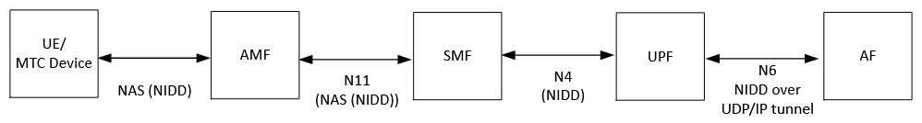

Figure 6.2-XA: 5GS Architecture for NIDD using a PtP N6 tunnel

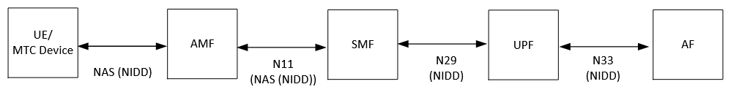

Figure 6.2-XB: 5GS Architecture for NIDD using NEF

6.2.3.X.2. LI for V-SMF for NIDD using NEF

In non-roaming scenario, only NEF will provide IRI POI and CC POI. In roaming scenario, V-SMF in 5GC as IWK-SCEF in EPC shall provide the IRI-POI and CC-POI functions for the visited network while NEF in the home network provides IRI POI and CC POI.

In non-roaming scenario, NIDD using NEF requires a control plane PDU session. The PDU session is established between UE and NEF via AMF and SMF. The user traffic is exchanged with DoNAS (Data over NAS) between UE and AMF, over N11 interface between AMF and SMF, over N29 interface between SMF and NEF and finally over N33 interface between NEF and AF (Figure 6.2-XB).

In roaming scenario, the PDU session for NIDD using NEF is established between the UE and NEF via V-AMF, V-SMF and H-SMF. The user traffic is exchanged with DoNAS (Data over NAS) between UE and AMF, over N11 interface between AMF and V-SMF, over N16 interface between V-SMF and H-SMF and over N29 interface between SMF and NEF and finally over N33 interface between NEF and AF. Figure 6.2-XC shows the architecture for delivery of NIDD using NEF in roaming situation.

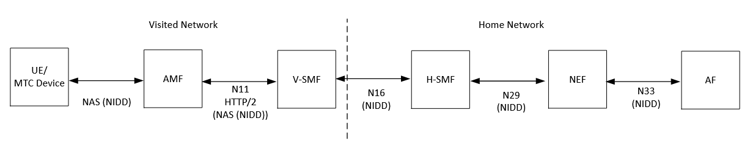

Figure 6.2-XC: 5GS Architecture for NIDD using NEF in roaming situation

The access method for the delivery of xCC related to NIDD using NEF is based on duplication of packets without modification of the packets at the V-SMF (in case of roaming) and NEF in the home network. The duplicated packets with additional information in a header are sent to MDF3 via LI_X3 for further delivery to the LEMF via LI_HI3. The figure 6.2-XD below gives a reference point representation of the LI architecture with V-SMF as a CP NF and UP NF providing the IRI-POI and CC-POI functions for NIDD using NEF.

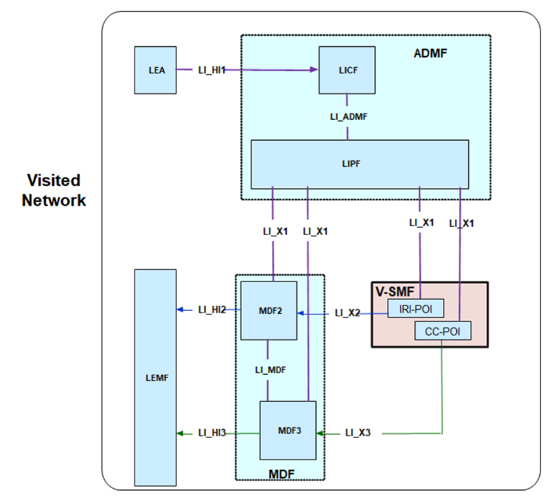

Figure 6.2-XD: LI architecture for NIDD using NEF showing LI at V-SMF

The IRI-POI present in the V-SMF handles the same records included in xIRIs for NIDD using NEF as those identified in 6.2.3.3.

* PDU session establishment
* PDU session modification
* PDU session release
* Start of interception with established PDU session

For NIDD using NEF with or without roaming situation, the IRI-POI present in the H-SMF shall avoid generating xIRIs since NEF will always provide the xIRIs for the home network.

6.2.3.X.2 LI for V-SMF for NIDD using a Point-to-Point (PtP) N6 tunnel

In non-roaming scenario, the SMF will provide an IRI POI while UPF shall include a CC-POI. In roaming scenario, V-SMF and H-SMF shall provide the IRI-POI and V-UPF and H-UPF shall include the CC-POI function as shown in Figure 6.2-4 which also concerns IRI-POI and CC-POI functions for IP-based and Ethernet-based PDU sessions.

In case of non-roaming scenario, the data traffic sent by UE as DoNAS (Data over NAS) is forwarded by the SMF to the UPF via N4 interface. UPF delivers that non-IP data traffic over a point-to-point N6 tunnel to the AF. The tunnel is typically a UDP/IP tunnel (Figure 6.2-XA).

In case of roaming scenario, the user traffic sent by the UE as DoNAS is forwarded by the V-SMF to the V-UPF via N4 interface. V-UPF forwards the user traffic to the H-UPF over N9 interface. Finally, H-UPF forwards that non-IP data traffic over a point-to-point N6 tunnel to the AF (Figure 6.2-XE). The tunnel is typically a UDP/IP tunnel.

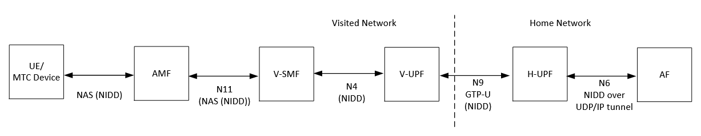

Figure 6.2-XE: 5GS Architecture of NIDD using a PtP N6 tunnel in roaming situation

The LI architecture for SMF/UPF for NIDD using a PtP N6 tunnel is the same as presented in figure 6.2-4.

The same xIRIs defined in 6.2.3.3. for PDU sessions of IP or Ethernet type and the same xCC are also considered for PDU sessions for NIDD using a PtP N6 tunnel, considering GTP-U as the payload format.

Third change

6.2.X LI at NEF

6.2.X.1. LI for NIDD using NEF

6.2.X.1.1. Architecture

The NEF shall provide both IRI-POI and CC-POI functions. The figure 6.2-XF gives a reference point representation of the LI architecture with NEF as a CP NF and UP NF providing the IRI-POI and CC-POI functions. NEF is the anchor point for PDU session establishment and user traffic. The user traffic is forwarded by NEF to the AF over the N33 interface.

Figure 6.2-XF: LI architecture for NIDD using NEF showing LI at NEF

6.2.X.1.2. Target identities

The LIPF present in the ADMF provisions the intercept information associated with the following target identities to the IRI-POI present in the NEF:

* SUPI.
* GPSI.

The interception performed on the above two identities are mutually independent, even though, an xIRI may contain the information about the other identities when available.

6.2.X.1.3. IRI events

NEF handles xIRIs including the following records for NIDD using NEF in both roaming and non-roaming situations

* PDU session establishment
* PDU session modification
* PDU session release
* Start of interception with established PDU session
* Unsuccessful procedure

The PDU session establishment xIRI is generated when the IRI-POI present in the NEF detects that a PDU session for NIDD using NEF has been established for the target UE. The NEF plays the role of anchor point for that PDU session.

The PDU session modification xIRI is generated when the IRI-POI present in the NEF detects that a PDU session for NIDD using NEF is modified for the target UE.

The PDU session release xIRI is generated when the IRI-POI present in the NEF detects that a PDU session for NIDD using NEF is released for the target UE.

The start of interception with an established PDU session xIRI is generated when the IRI-POI present in the NEF detects that interception is activated on the target UE that has an already established PDU session for NIDD using NEF in the 5GS. When a target UE has multiple PDU sessions, this xIRI shall be sent for each PDU session with a different value of correlation information.

When additional warrants are activated on a target UE, MDF2 shall be able to generate and deliver the start of interception with an established PDU session related IRI messages to the LEMF associated with the warrants without receiving the corresponding start of interception with an established PDU session xIRI.

The unsuccessful procedure xIRI is generated when the IRI-POI present in the NEF detects an unsuccessful procedure for PDU session establishment, modification or release.

NEF handles xCC for NIDD using NEF if CC is requested.

End of all changes