have the pleasure of inviting you to
3GPP SA2#91, SA3#67, CT1#78, CT3#69, CT4#57, CT6#64
in Kyoto, Japan from Monday 21 May to Friday 25 May, 2012

3GPPSA2#91 | 21 - 25 May 2012
3GPPSA3#67 | 21 - 25 May 2012
3GPPCT1#78 | 21 - 25 May 2012
3GPPCT3#69 | 21 - 25 May 2012
3GPPCT4#57 | 21 - 25 May 2012
3GPPCT6#64 | 22 - 25 May 2012

3GPP SA2#91, SA3#67, CT1#78, CT3#69, CT4#57, CT6#64

Dear Delegates,

The Japanese Friends of 3GPP, eAccess, Ericsson Japan, Fujitsu, Hitachi, Huawei Technologies Japan, KDDI, KYOCERA, MITSUBISHI ELECTRIC, NEC, Nokia Siemens Networks Japan, NTC, NTT DOCOMO, OKI, Panasonic, Qualcomm Japan, SHARP, SOFTBANK MOBILE and Sony Ericsson have the pleasure of inviting you to the above-mentioned meeting.

The meeting will start on Monday at 9:00 (CT6 will start on Tuesday at 9:00) and it is expected to end on Friday at Chairman's discretion.

We look forward to seeing you all in Japan.

Yours sincerely,
"Japanese Friends of 3GPP"

Meeting Registration
Please register for the meeting online via 3GPP website.

Host Contacts
For any questions about the meeting, please contact our Meeting Coordinators.

ILCC Co., Ltd

Ms. Sakagami and Ms. Sudo
E-mail: sactwgs_jf3@ilcc.com Tel: +81-3-5562-3677

Meeting Venue
Kyoto Research Park (KRP)
134, Chudoji Minami - machi, Shimogyo-ku, Kyoto 600-8813, Japan

 | Meeting Venue
3GPPSA2#91 | Main | Buzz Hall, B1F, Building No. 4, Western Zone
3GPPSA2#91 | Breakout | Banquet Hall, B1F, Building No. 4, Western Zone
3GPPSA2#91 | Breakout | Room 2B, 2F, Building No. 4, Western Zone
3GPPSA3#67 | Innovation Room, 2F, KISTIC Building, Eastern Zone
3GPPCT1#78 | Main | Science Hall, 4F, Building No. 1, Eastern Zone
3GPPCT1#78 | Breakout | Meeting Room A, 4F, Building No. 1, Eastern Zone
3GPPCT3#69 | Main | Audio Visual Meeting Room, 4F, Building No. 1, Eastern Zone
3GPPCT3#69 | Breakout | Meeting Room B, 4F, Building No. 1, Eastern Zone
3GPPCT4#57 | Main | Room 1, 2F, Building No. 4, Western Zone
3GPPCT4#57 | Breakout | Room 2A, 2F, Building No. 4, Western Zone
3GPPCT6#64 | Meeting Room C, 4F, Building No. 1, Eastern Zone

5 min. by JR San-in Honsen (JR Sagano line) train from Kyoto Sta. to Tanbaguchi Sta.
+ 5 min. walk to Kyoto Research Park

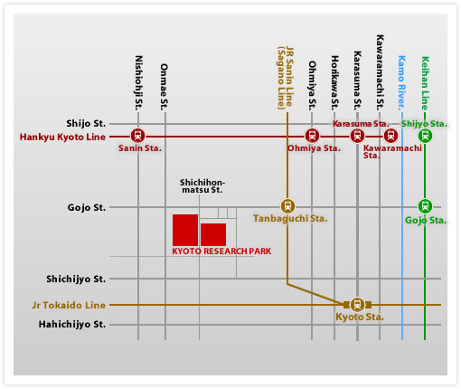
*Map used under the permission of Kyoto Research Park Corp.
Building No. 4Western Zone
Building No. 1, Eastern Zone
KISTIC Building, Eastern Zone

Transportation to Kyoto
For access to Kyoto, please refer to http://www.krp.co.jp/english/access/index.html

Kansai International airport (KIX) is suggested as the most convenient airport for participants from outside Japan.

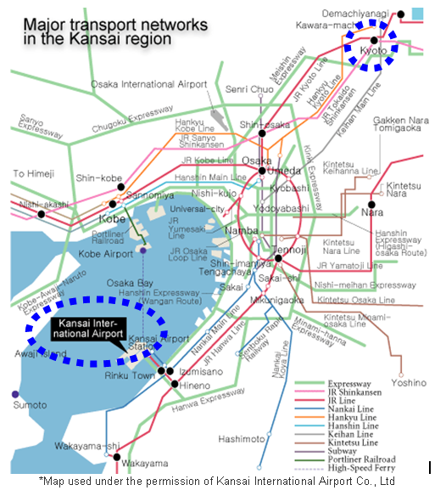

By Train:
Take the Airport express “Haruka” JR west at Kansai International Airport to Kyoto Station (Approx. 75 min., 2,980Yen)
Timetable: http://www.kansai-airport.or.jp/en/access/train/jr_time.html

By Bus:
Take the Airport Limousine at Kansai International Airport to Kyoto Station (Approx. 85 min., 2,500Yen)
Timetable: http://www.kate.co.jp/pc/e_time_table/e_kyoto_tt.html#from
- Tickets can be purchased from the ticket vending machines located outside the
Passenger Terminal Building on the 1st floor. [outside the arrival floor]
- Bus arrives at No.8 stop. Please note that two lines share the bus stop. One for Kyoto Sta.
and the other one for Osaka Airport. So, be careful about destination of the bus before
getting on.
- 2,500Yen for one way, 4,000Yen for round trip [valid for 14 days from the date of purchase]

By Taxi:
Approx. 120 min. 32,000Yen

Accommodation
Block bookings have been arranged at the following hotels for the meetings. Note that the ‘Japanese Friends of 3GPP (JF3)’ is not responsible for reservation confirmations, cancelled or changed reservations or no-shows.

Please access the URL below for online application operated by JTB Global Marketing & Travel Inc. (JTB GMT) to make your hotel reservations.
https://mice.jtbgmt.com/3GPPSA_CTWgs/
If you need to make any change to your reservations, this could also be done online using your ID and Password. Please be sure to reserve your room by 20th April, 2012 (local time=UTC+9h)*.
*Delegates are strongly advised to make their reservations as early as possible. Reservations will be accepted on a first-come, first-served basis.

 | Hotel Name  Internet Access in Room (Check-in & out time) | Room Type | Rate per night  (Single Occupancy)
1 | Kyoto Tokyu Hotel  1,260Yen / 24 Hrs internet access  (13:00/11:00) | Single (21㎡) | 16,000 Yen
1 |  | Twin (26㎡) | 21,000 Yen
2 | APA Hotel Kyoto-Eki-Horikawadori  Complimentary internet access (15:00/11:00) | Single (10㎡) | 9,000 Yen
3 | APA Hotel Kyoto-Ekimae  Complimentary internet access (15:00/11:00) | Single (11㎡) | 8,200 Yen
4 | Hotel Granvia Kyoto  Complimentary internet access  (15:00/12:00) | Twin Room (26㎡) | 17,787 Yen
4 |  | Twin Room (26㎡) | 26,449 Yen (Saturday)
5 | Hotel Hokke Club Kyoto  Complimentary internet access  (15:00/10:00) | Single (13㎡) | 8,400 Yen
5 |  | Twin (25㎡) | 11,000 Yen
6 | Hotel New Hankyu Kyoto  Complimentary internet access (13:00/11:00) | Twin Room (22.5㎡) | 11,600 Yen
7 | Aranvert Hotel Kyoto  Complimentary internet access (14:00/11:00) | Twin Room (25㎡) | 12,300 Yen
8 | Hotel MyStays Kyoto-Shijo  Complimentary internet access (14:00/11:00) | Twin Room (22㎡) | 14,000 Yen
9 | New Miyako Hotel Kyoto  Complimentary internet access (14:00/12:00) | Twin Room (26㎡) | 15,000 Yen
10 | Hotel Kintetsu Kyoto Station  Complimentary internet access (15:00/11:00) | Twin Room (16㎡) | 11,445 Yen
11 | Kyoto Tower Hotel  Complimentary internet access  (13:00/11:00) | Single (14㎡) | 11,000 Yen
11 |  | Twin (22㎡) | 15,000 Yen
12 | Kyoto Dai-ni Tower Hotel  Complimentary internet access  (14:00/11:00) | Single (13㎡) | 10,000 Yen
12 |  | Twin (16㎡) | 14,000 Yen
* Service charge, VAT and breakfast are included in all prices indicated above.
** The above room rates are only applicable to reservations handled by JTB. Please do NOT contact the hotels directly regarding your reservations and the above room rates – all enquiries and booking requests should be made directly to JTB.

For further information regarding hotel bookings, please contact:
Mr. Saito
JTB Global Marketing & Travel Inc.
Tel: +81-3-5796-5445
Fax: +81-3-5495-0685
E-mail: 3GPPsactwgs_hotels@gmt.jtb.jp

Cancellation
In the event of cancellation, a written notification (including email or fax) should be sent to JTB GMT in advance as soon as possible. When any reservation is canceled, the following amounts will be charged to the credit card account given at the time of the reservation.

If the cancellation notice is received by JTB GMT:
Up to 21 days before the first night of stay -------------- None
20 to 10 days before the first night of stay --------------- 10% of daily room charge
9 to 2 days before the first night of stay ------------------ 20% of daily room charge
1 day before the first night of stay -------------------------- 80% of daily room charge
On the day of arrival or no show without notice -------- 100% of daily room charge

Location Map
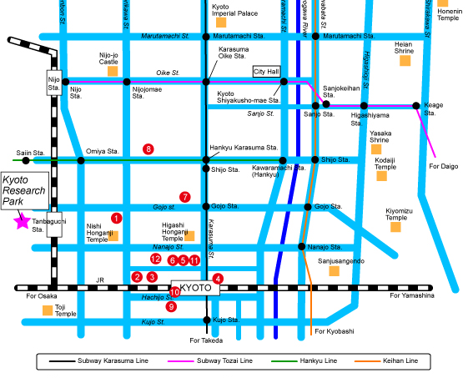
Access from Kyoto Sta. to Hotels
①Kyoto Tokyu Hotel -5min. by taxi
②APA Hotel Kyoto-Eki-Horikawadori -5min. walk from Chuo Exit
③APA Hotel Kyoto-Ekimae -3min. walk from Chuo Exit
④Hotel Granvia Kyoto -Direct connection from Chuo Exit
⑤Hotel Hokke Club Kyoto -1min. walk from Chuo Exit
⑥Hotel New Hankyu Kyoto -3min. walk from Karasuma Chuo Exit
⑦Aranvert Hotel Kyoto -10min. by taxi
⑧Hotel MyStays Kyoto-Shijo -10min. by taxi
⑨New Miyako Hotel Kyoto -2min. walk from Hachijo Exit
➉Hotel Kintetsu Kyoto Station -30sec. walk from Hachijo Exit
⑪Kyoto Tower Hotel -1min. walk from Chuo Exit
⑫Kyoto Dai-ni Tower Hotel -2min. walk from Chuo Exit

Access to Meeting Venue
②～⑥, ⑨～⑫
Kyoto station – Tanbaguchi station (2 minutes by JR Sanin Main Line (Sagano Line))
*Please note that only local train stops at Tanbaguchi station.

①Kyoto Tokyu Hotel
1.6km (approx. 15-20 minutes walk or 5min taxi ride, approx. fare 700 Yen)

⑦⑧
2~2.5km (10~15min taxi ride, approx. fare 1500~2000 Yen)

Visa request
To find out whether you need a visa for entry to Japan, please consult http://www.mofa.go.jp/j_info/visit/visa/faq.html#q1-1 and click the link "the List of Countries and Regions That Have Visa Exemption Arrangements with Japan" in the Q&A No.1. The list shows "Arrangements of Exemption of Visas". If your home country’s name is not shown on the list, you need a visa.

If you need a visa, please fill out the attached invitation letter request form (Annex 1) and send it to visa1@ttc.or.jp by 12:00 (JST), 27th April 2012.
For any questions, please contact visa1@ttc.or.jp or Tel: +81-3-5776-7796 (attn. Mobile WGs secretary in TTC)].

For members in a company who are in the same office facility, it is suggested that you make your requests as a group, if possible.

If you prefer, we may be able to send the digital signature for visa1@ttc.or.jp, simply send an e-mail to visa1@ttc.or.jp for obtaining public key (VeriSign class1) before sending your form with personal information.

WLAN
Wireless LAN is available in the meeting rooms.
Please bring your Wireless LAN card (802.11 a/b/g)

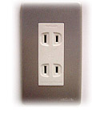
Voltage
100V/60Hz. Japanese plugs are two flat pin type (A-type) plugs. Please make sure you have correct adapters. Voltage converters or adapters will NOT be provided at the meetings.
Please bring your voltage converters and plug adapters! (100 volts)

Currency
Yen (\) http://finance.yahoo.com/currency?u

ATTENTION!!
Credit cards can be taken at most restaurants and hotels in Kyoto, but not at some restaurants, taxis, and shops.

Time Zone
UTC +9 hours

GSM / W-CDMA coverage
Only 3G (W-CDMA) is available. For availability of GSM chip-roaming, please check with your operator.

Weather
http://www.jma.go.jp/en/yoho/211.html

Sightseeing
Japan National Tourism Organization http://www.jnto.go.jp/eng/

(ANNEX 1)
Visa support letter application form

Please fill in the form below and e-mail it to visa1@ttc.or.jp by 12:00 (JST), 27th April 2012.

(Note: you can obtain a public key for e-mail encryption simply by sending an e-mail to visa1@ttc.or.jp with the subject "Public Key request" BEFORE sending your personal information in an attachment.)

IMPORTANT: If your nationality is Chinese, your name should be informed both in alphabets & Chinese letters (=Kanji characters). Just in case, in addition to this form, please edit and send Kanji-name.bmp file which is enclosed in the zip file of the invitation so that we will be able to print your Kanji name properly in the visa support letter.

Family name (Last name) | alphabetical
Family name (Last name) | Kanji (Chinese member only)
Given name (First name) | alphabetical
Given name (First name) | Kanji (Chinese member only)
Date of Birth (dd/mm/yy)
Gender (Male/Female)
Nationality
Valid passport number
Passport Valid until (dd/mm/yy)
Address (Home Country)
Occupation and Job title
Name of Company/Organization
Company/Organization mailing address |  | Address
 |  | Postal Code
 |  | Country
Telephone number |  |  | +
Fax number |  |  | +
Email address
Schedule for your stay |  |  | Please fill in your itinerary below

Itinerary (refer to examples shown in the table.)
DD/MM/YYYY | Schedule | Address and Phone number to reach | Hotel
ex) 15/April/2012 | Arrival from Paris to Osaka, Flight xxx | *1 | *1
ex) 16/ April/2012 - 20/April/2012 | Attending 3GPP SA4 meeting | *1 | *1
ex) 21/April/2012 | Departure from Osaka to Paris, Flight xxx
Fill in your Itinerary blow
*1 Kyoto Tokyu Hotel: Address and phone number will be filled by documents issuer.
*2 APA Hotel Kyoto-Eki-Horikawadori: Address and phone number will be filled by documents issuer.
*3 APA Hotel Kyoto-Ekimae: Address and phone number will be filled by documents issuer.
*4 Hotel Granvia Kyoto: Address and phone number will be filled by documents issuer.
*5 Hotel Hokke Club Kyoto : Address and phone number will be filled by documents issuer.
*6 Hotel New Hankyu Kyoto: Address and phone number will be filled by documents issuer.
*7 Aranvert Hotel Kyoto: Address and phone number will be filled by documents issuer.
*8 Hotel MyStays Kyoto-Shijo: Address and phone number will be filled by documents issuer.
*9 New Miyako Hotel Kyoto: Address and phone number will be filled by documents issuer.
*10 Hotel Kintetsu Kyoto Station: Address and phone number will be filled by documents issuer.
*11 Kyoto Tower Hotel: Address and phone number will be filled by documents issuer.
*12 Kyoto Dai-ni Tower Hotel: Address and phone number will be filled by documents issuer.

