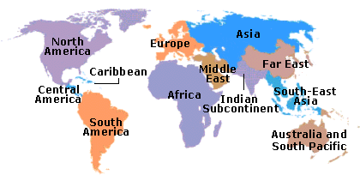

TRAVEL GUIDE

Maurice’s Itinerary

3GPP SA3 in Mainz, Germany

(22-24 February, 2000)

MEETING VENUE: RATP, Canisiusstrasse 21
55122 MAINZ (Contact Peter Trautmann +496131182224)

STARTS AT: 10.00 AM

HOTEL VENUE: TULIP INN -CENTRAL HOTEL EDEN

Bahnhofsplatz 8 Tel: +49 6131 2760

BOOKING: From 21 to 24 of February

FLIGHT DETAILS: DEPARTURE
DATE | FROM | VIA | TO
21.2 | NICE |  | FRANKFURT
 | 14.40 |  | 16.30

FLIGHT DETAILS: RETURN
DATE | FROM | VIA | TO
24.2 | FRANKFURT |  | NICE
 | 21.50 |  | 23.25

CARRIER LF

JET LAG:

LOCAL CURRENCY: MARK CONVERSION: 1 DEM = 0,51 EURO

TYPE OF ELECTRICITY:

WEATHER: 10 DEGREES

MEDICAL ADVISE:

USEFUL TELEPHONE NUMBERS IN THE COUNTRY:

ETSI USEFUL TELEPHONE NUMBERS:

CompuServe ADDRESS:

COORDINATES OF YOUR ASSISTANT: Tel: +33 4 92 94 42 66 Fax: +33 4 93 65 28 17
ENJOY YOUR TRIP, EMMANUELLE

