3GPP TSG-SA3 Meeting #119AdHoc-e S3-250064-r1
Electronic meeting, online 13-16 January 2025

Source: Nokia, Huawei, HiSilicon

Title: TR cleanup

Document for: Approval
Agenda Item: 5.16

1 Decision/action requested
This contribution proposes a TR cleanup prior to plenary approval.

2 References

3 Rationale
The contribution proposes a cleanup of editors notes prior to plenary approval.
This is a merger of S3-250064 and S3-250048.

4 Detailed proposal
It is suggested to approve the cleanup.
*************** Start of the change ****************

5 Key issues

5.1 Key Issue #1: Security aspects of collecting energy related information.

5.1.1 Key issue details
TR 23.700-66 [2] studies the collection of energy related information for potential exposure.
The integrity and confidentiality of the data collected is of importance to produce correct analytics metrics.
Another aspect of collecting energy related information is the granularity at which it’s collected. Further information on the granularities can be found in TR 23.700-66 [2].
The key issue aims to address the security issues, ensuring integrity and confidentiality of the energy related information collected.
There is, depending on the use case, a need to consider towards compliance to regional legislation for collecting energy related information.

5.1.2 Security threats
Lack of confidentiality, integrity, and replay protection in collecting energy related information can lead to disclosure of the information and tampering of the information.

5.1.3 Potential security requirements
The data in transit shall support confidentiality, integrity, and replay protection.

*************** Start of next change ****************

*************** Start of next change ****************

6.3 Solution #3: AF level Authorization for energy level information notification/retrieval

6.3.1 Introduction

This pCR introduces a new solution for KI#2 on authorization of AF when AF subscribes/unsubscribes and retrieve energy related information.

6.3.2 Solution details

6.3.2.1 General
Based on conclusion for KI#1 clause 8.1 in TR 23.700-66 [2] If an AF is deployed outside the 3GPP operator domain, and is an authorized consumer, the granularities include: per application corresponding to the AF, per UE, and per UE per AF and per PDU session. The procedure for notifying and retrieval of energy related information by the AF is described in section 5.2.2.

6.3.2.2 Subscribe/Unsubscribe procedure of energy related information
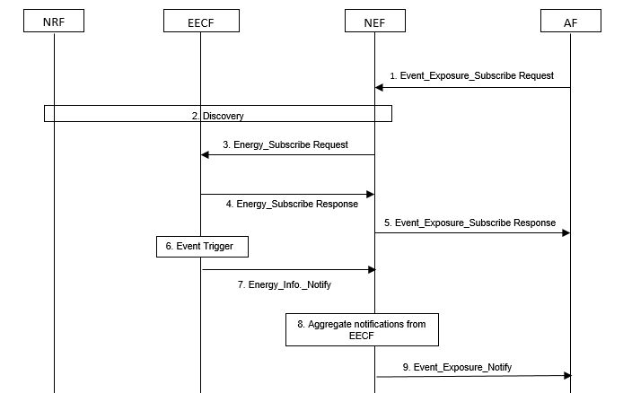
Figure 5.2.2-1: AF level Authorization for energy level information notification/retrieval

The AF authorization is based on clause 13 of TS 33.501 [3]
The token-based authorization mechanism is used. The token is generated for the AF after authorization that includes the level of service access. The token claim may contain the external application ID, UE ID, or AF-Service-Identifier.
1. To subscribe energy related information if the authorized consumer is AF, the granularities include, per UE, per UE per application, per PDU session with the EECF, the AF sends Event_Exposure_Subscribe Request.The message contains the token with token claims as described above. Additionally, the token claims include the type of energy related information i.e., energy consumption information or renewable energy information.
2. The NEF checks whether the AF is authorised for the requested subscription based on the AF token. It needs to check whether the token claims match the AF’s identity and service level access i.e., external application ID, UE ID, or AF-Service-Identifier and type of energy related information. If authorised, the NEF may query the NRF to find the EECF responsible to provide the requested energy related information.
3. The NEF forwards the request to the EECF with subscription based on service level as described in step 2.
4. The EECF acknowledges the execution of request message to the NEF.
5. The NEF based on the confirmation from EECF in step 4, sends a response back to the AF for subscription success.
6–7. The EECF triggers a notification towards the AF and sends the message to the NEF as described in TS 23.502 [5].
8-9. The NEF forwards the message to the AF for single EECF or aggregates reporting information for multiple EECF message as described in TS 23.502 [5].

NOTE: The steps in the scope need to be aligned with the architecture. The EECF is a representation of the EIF.

6.3.3 Evaluation
The solution relies on the Event exposure services offered by the NEF while reusing the existing authorization mechanism based on clause 13 of TS 33.501 [3]. The token-based authorization introduces additional token claims necessary to limit the service level access based on AF subscription policies.
NOTE: Applicability and evaluation of the solution depends on the final procedure and architecture.
*************** Start of next change ****************

*************** Start of next change ****************

7 Conclusions

*************** End of change ****************

