**3GPP TSG-SA3 Meeting #110Adhoc-e *draft_S3-231900-r1***

**e-meeting, April 17-21, 2023**

**Source:**  **Huawei, HiSilicon**

**Title:** **Addressing the editor's note in solution 3**

**Document for: Approval**

**Agenda Item: 5.23**

# 1 Decision/action requested

***It is proposed to approve the change described in this document.***

# 2 References

N/A

# 3 Rationale

Editorial changes are proposed for correction. In addition, additional evaluation are provided to address the editor’s note.

# 4 Detailed proposal

*** 1st CHANGE ***

## 6.4 Solution #3: security protection for UEs in MOCN network sharing scenario

### 6.4.1 Introduction

To address the issue, the solution proposed that MBSF/NEF needs to decide send one or more copies based on security activation status and indicate RAN node. If the security in service layer is not activated, the RAN can reuse the network resource based on the indication and send one copy to save the overhead. Otherwise, more copies are required.

If service layer security is activated, then optimized radio resource utilization for MBS is not used for MOCN network sharing scenario.

### 6.4.2 Solution details

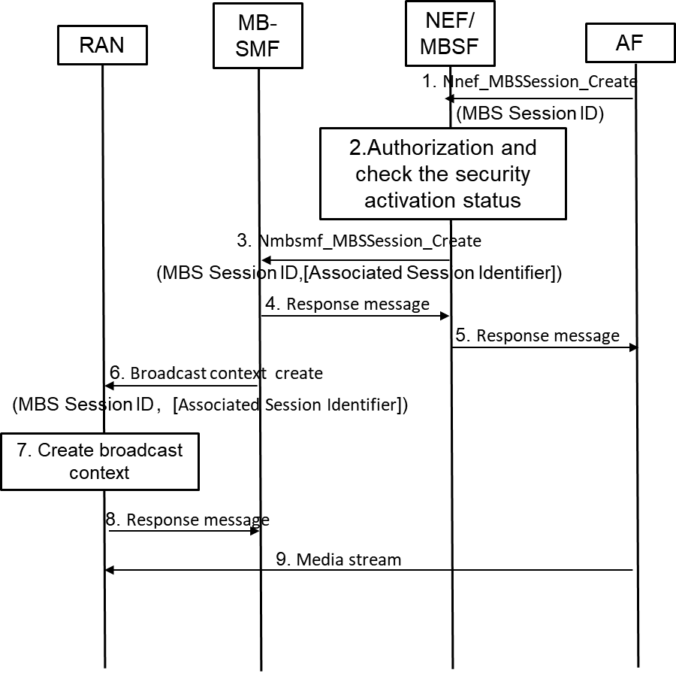

Figure 6.4.2-1 call flow of security protection for UEs in MOCN network sharing scenario

As shown in the Figure 6.4.2-1, the details of security protection is summarized as following:

1. AF performs TMGI allocation and MBS session creation as specified in clause 7.1.1.2 or clause 7.1.1.3 of TS 23.247 [6]. The AF may include Associated Session Identifier in this step.

2. NEF/MBSF checks authorization of AF. In addition, NEF/MBSF confirms the security activation status for the MBS session. The security activation status implies whether security protection is applied or not.

If security protection is applied, then NEF/MBSF removes Associated Session Identifier if received in step 1, which means RAN will not be able to reuse the network resource if already existed for the same service.

3. NEF/MBSF further provides Associated Session Identifier if applicable to MB-SMF.

4-5. Continue the MBS session creation procedure.

6. MB-SMF continues the broadcast MBS session creation towards the NG-RAN as specified in TR 23.700-47[2].

MB-SMF invokes Namf_MBSBroadcast_ContextCreate Request with further including Associated Session Identifier (if applicable) in the N2 SM container received in step 1.

7. As descripted in TR 23.700-47[2], the NG-RAN node checks whether there are other associated broadcast MBS sessions based on the Associated Session Identifier or Pre-configured association of MBS Session ID in the existing Broadcast MBS Session context, i.e., checks if the radio resources were already allocated. NG-RAN node creates a Broadcast MBS Session Context if the Broadcast MBS Session Context does not exist (i.e. the other PLMN network sharing the NG-RAN node has not requested for the same broadcast MBS service to be established at the NG-RAN node) as descripted in TR 23.700-47[2]. If the NG-RAN node already exists, then the NG-RAN node checks the indication.

NOTE: If pre-configured association of MBS Session ID is used, then the security activation status can also be preconfigured. If security protection is applied, RAN will not reuse the network resource if already existed for the same service.

The NG-RAN node determines whether to use the previously allocated radio resources of the MBS session based on whether Associated Session ID is received as specified in TR 23.700-47[2]. When the NG-RAN node receives the DL MBS data of the requested MBS session afterwards, it will not send the received data in the air interface if reusing the network resource. Otherwise, the NG-RAN node treat the session as the newly request session and creates new Broadcast MBS Session Context.

8-9. Continue the procedure as specified in TS 23.247 [6].

### 6.4.3 System impact

The procedure aligns with the broadcast session management procedure as specified in TS 23.247 [6].

### 6.4.4 Evaluation

The solution addresses the key issue#1 in present document and provides a mean to protect the traffic in the service layer in MOCN network sharing scenario. To achieve this, the NEF/MBSF removes the Associated Session ID to the RAN if security protection is applied in service layer.

Editor’s Note: further evaluation is FFS.

*** END OF 1st CHANGE***