**3GPP TSG-SA3 Meeting #109Adhoc-e *draft_S3-230155-r1***

**Online, 16 - 20 January 2023**

**Source:**  **Huawei, HiSilicon**

**Title:** **update the evaluation in solution 1**

**Document for: Approval**

**Agenda Item: 5.19**

# 1 Decision/action requested

***It is proposed to approve the change described in this document.***

# 2 References

[1] TR 23.700-86

# 3 Rationale

The solution proposed to negotiate the ranging parameters to protect the privacy.

The evaluation is updated accordingly.

# 4 Detailed proposal

*** 1st CHANGE ***

## 6.1 Solution #1: Privacy protection for UEs in Ranging

### 6.1.1 Introduction

This solution resolves Key Issue #1 for privacy protection for Ranging/SL Positioning services. In particular, this solution tries to acquire the UE’s authorization. In addition, configuration information is exchanged between the UEs to decide the entity for result calculation.

### 6.1.2 Solution details

The high-level procedure as shown in Figure 6.1.2-1 is based on the procedure descripted in solution 3 of TR 23.700-86 [2].

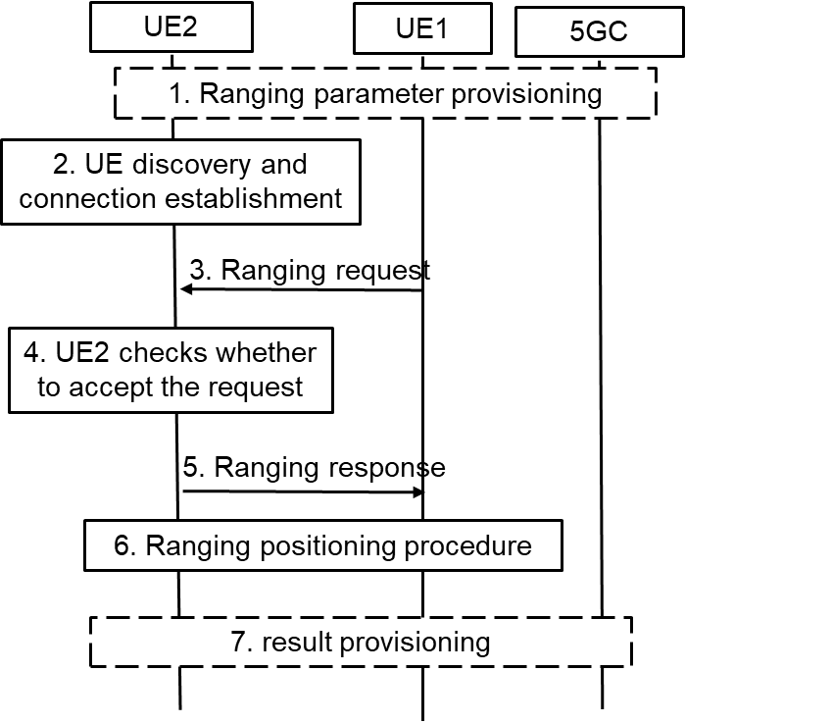

Figure 6.1.2-1: High-level Procedure for Ranging Operation Control

1. UE1 and UE2 may get the ranging parameters from 5GC during registration. UE1 gets the ranging request from the application layer, UE3 or 5GC NF. The ranging request includes the consumer info and/or the purpose of ranging positioning. For example, if the AF wants to acquire the distance between UE1 and UE2 for V2X service. The AF ID and purpose for V2X are included.

2. Discovery and the connection establishment procedure are performed between UE1 and UE2.

NOTE 1: The solution assumes that Ranging authorization is not performed during discovery and communication establishment procedures.

3. UE1 sends the ranging request in the Ranging/SL Positioning layer to the UE2 to check the authorization and negotiate the ranging parameters. The ranging request includes the ranging parameters, e.g. the Ranging role (Reference UE or Target UE), consumer info, purpose, result calculation entity. For example, UE1 decides to calculate the result and not share with UE2, then the result calculation entity means that “UE1 will calculate the ranging result”. If it is implied by the ranging role, the result calculation entity is not needed.

4. UE2 checks whether to accept the ranging request in step #3 in the Ranging/SL Positioning layer based on configuration. For example, UE2 checks whether to allow the ranging result to be provided to the consumer for the claimed purpose based on local policy. UE2 decides whether to accept the ranging role as assigned by UE1. Based on received result calculation entity info, UE2 confirms whether the result can be acquired by UE1 or not.

NOTE 2: The configuration for privacy protection in the Ranging/SL Positioning layer is provided from application layer or other means. It is left to implementation.

5. UE2 sends the ranging response to the UE1. For example, if UE2 does not authorize the ranging positioning for the purpose or the consumer, the reject message with cause will be responded. If UE2 wants to change the Ranging role or result calculation entity, for example due to its privacy consideration, a new Ranging role or result calculation entity is included.

NOTE 2: The solution assumes that UE1 and UE2 can trust each other on the authorization operations during the ranging parameter negotiation.

6. Ranging positioning procedure is performed. The ranging result is calculated based on the negotiation result in step #5.

7. The ranging results may not be shared between the UEs accordingly to the negotiation result. The result calculation entity will provide the result to the application layer, UE3 or 5GC NF.

### 6.1.3 Evaluation

The solution fulfilled the requirement in Key Issue #1 for privacy protection for Ranging/SL Positioning services. Ranging authorization on consumer info, purpose or result calculation entity is performed in the Ranging/SL Positioning layer based on configuration, which may be provided from application layer. The UE determines whether to continue the ranging process according to the authorization and negotiation result. The ranging results may not be shared between the UEs according to the negotiation result.

*** END OF 1st CHANGE***