3GPP TSG-SA3 Meeting #109bis_e S3-230126

Online Meeting, 16 - 20 January, 2023

Source: OPPO

Title: Resolving EN in Solution 22

Document for: Approval
Agenda Item: 5.3

1 Decision/action requested
This contribution proposes to resolve EN in Solution 22.

2 References
[1] TR 33.740 v0.4.1

3 Rationale
This contribution proposes to resolve the following ENs in solution 22:
Editor’s Note: Who determines the common security protection scheme is FFS.
Editor’s Note: The need for E2E security is FFS.
Solution 22 is addressing KI#5 which has the requirement “The 3GPP system shall support a means for the source UE, target UE and U2U relay to use the same security protection method in protecting source UE to target UE traffic via the U2U relay.” The Editor’s Note is neither applicable for the security requirement nor applicable for the solution. The solution addresses the security requirement by providing a mechanism for the source UE, target UE and U2U relay to use the same common security protection. Who or how to decide on which common security protection to use is not part of the solution and it should be left to the security policy of the operator.
It is proposed to resolve the EN by adding a NOTE in place of the first EN that “The use of common security protection scheme is based on operator security policy.” Since the second EN is not relevant, it is propose to remove it.

4 Detailed proposal
It is proposed to include the below pCR in the TR [2].
***** START OF CHANGES *****

6.22 Solution #22: Common security protection setup via UE-to-UE Relay

6.22.1 Introduction
This solution addresses security requirement for the U2U relay and the remote UEs to negotiate a common security protection scheme in key issue #5.
The solution reuses existing provisioning, discovery, authentication, authorization, and PC5 establishment procedures as much as possible. Once Source and Target UEs and U2U relay have been authenticated and authorized, a common protection scheme is applied among Source UE, Target UE, and U2U relay so that the communication between Source UE and Target is protected either using hop-by-hop via the U2U relay or end-to-end between the source and target UEs.

6.22.2 Solution details
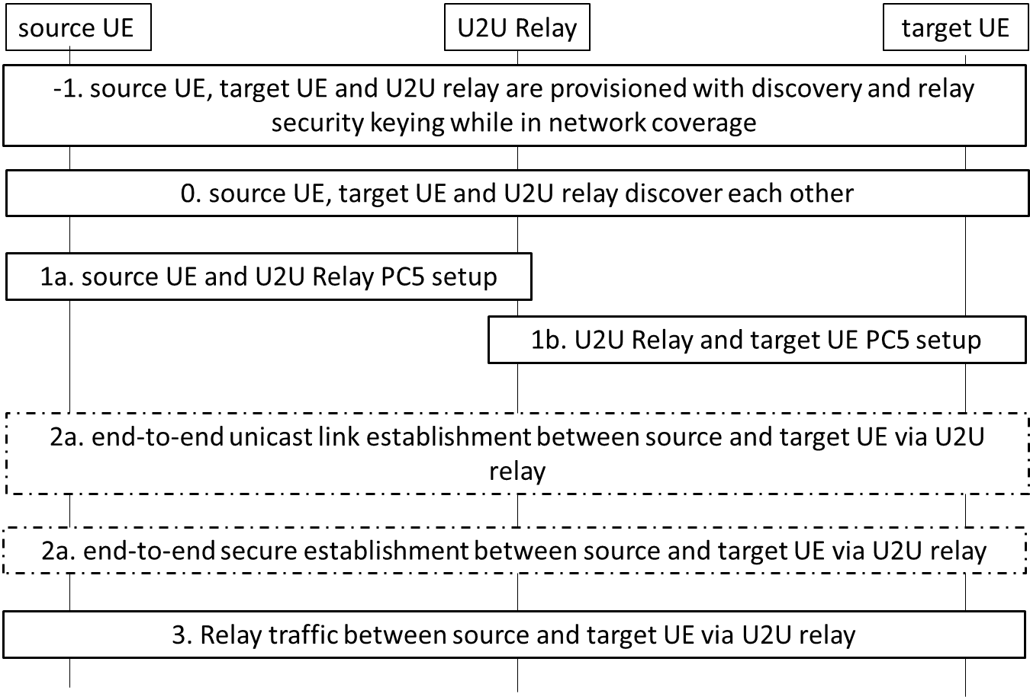
Figure 6.22.2.1: Security establishment for UE-to-UE relay
-1. While still in network coverage, the source UE, target UE and the U2U relay get the discovery parameters. The source and target UEs can be provisioned with the security materials for PC5 security setup or end-to-end security setup. Additionally, source UE, target UE and U2U relay can be provisioned with security policy for the protection scheme to be used for communication between source UE and target UE.
0. The Source UE, Relay UE and Target UE discover each other. This solution does not address the key issue of U2U relay discovery security.
1a. During PC5 link setup procedure between source UE and U2U relay, based on security policy of either the source UE or U2U relay, the PC5 link setup may include security establishment between the source UE and U2U relay. The PC5 link establishment procedure may need to be enhanced to indicate that which security is to be applied. This indication may also be implicit for example if the Direct Communication Request is followed by a Direct Authorization and Key procedure would mean that the PC5 link setup includes security establishment, and that hop-by-hop security is intended. Depending on whether security establishment is done, both source UE and U2U relay are aware of the security protection to be used.
Editor’s Note: Who determines the common security protection scheme is FFS.

1b. During PC5 link setup procedure between target UE and U2U relay, based on security policy of either the target UE or U2U relay, the PC5 link setup may include security establishment between the target UE and U2U relay. The PC5 link establishment procedure may need to be enhanced to indicate that which security is to be applied. This indication may also be implicit for example if the Direct Communication Request is not followed by a Direct Authorization and Key procedure would mean that the PC5 link setup does not include security establishment, and that end-to-end security is intended. Depending on whether security establishment is done, both target UE and U2U relay are aware of the security protection to be used.
2a. If Steps 1a and 1b contain security establishment during PC5 link setup, source UE, target UE and U2U relay are aware PC5 security has been activated, and that end-to-end security is not needed. End-to-end link is established between source UE and target UE via U2U relay. Step 2b is skipped.
2b. If Step 2a is skipped, it means that Steps 1a and 1b do not contain security establishment during PC5 link setup. Source UE, target UE and U2U relay are aware that PC5 security has not been activated and that end-to-end security is needed. End-to-end security establishment proceeds between source UE and target UE.
3. Traffic between source UE and target UE continues. Depending on the previous steps taken, the traffic between source UE and target UE is either protected hop-by-hop or end-to-end.

6.22.3 Evaluation
This solution addresses the requirements in KI#5 by applying a common security protection scheme between Source UE, Target UE, and U2U relay. Existing solutions for provisioning, discovery, authentication and authorization, PC5 link establishment are reused as much as possible.
Editor’s Note: Further evaluation is needed.

***** END OF CHANGES *****

