3GPP TSG-SA3 Meeting #108-e draft_S3-221924-r2

e-meeting, 22 August - 26 August 2022

Source: Philips International B.V.

Title: New Solution: PAKE-based security for UE-to-UE relay

Document for: Approval
Agenda Item: 5.3

1 Decision/action requested
It is requested to approve a new solution in TR 33.740

2 References
[1] 3GPP TR 33.740-33 v0.1.0: " Study on security aspects of Proximity Based Services (ProSe) in 5G System (5GS) phase 2"
[2] 3GPP TS TR 23.700-33 v0.3.0: " Study on system enhancement for Proximity based Services (ProSe) in the 5G System (5GS); Phase 2"

3 Rationale
The communication links between source UE, target UE, and UE-to-UE relay and need to be protected as described in KI#2 in TR 33.740 [1]. The involved devices need also to be authorized to act as UE-to-UE relay or as source/target UE (KI#3 in TR 33.740[1]). As described in KI#1 of the 5G ProSe phase 2 in SA2 [2], the solutions for UE-to-UE relay operation need to support not only in coverage, but also out of coverage operation of Source UE, Target UE as well as the UE-to-UE Relay.
To address these security and operation requirements, this solution proposes the usage of a password-based key establishment (PAKE) for UE-to-UE relay security and authorization. A PAKE allows establishing a secure channel while authenticating the peers based on a password. The PAKE is used to setup the security between:
- the source UE (S-UE) and the UE-to-UE Relay (UE2UE),
- the target UE (T-UE) and the UE2UE and
- the S-UE and the T-UE.
The password(s) may be configured in an initial authorisation and parameter provisioning phase. When this is done, it is ensured that the network remains on control of the UE-to-UE relay secure communication. However, the password(s) may also be entered by a user or generated by the involved devices, e.g., when one of more of the devices are out-of-coverage. This option ensures that the security requirements can be fulfilled even in challenging operational cases.
Furthermore, the usage of a PAKE provides a reasonable approach authentication/authorization of the communicating parties:
- using a balanced PAKE authenticates two peers in a similar role, e.g., source and target UE;
- using an augmented PAKE can be used to differentiate roles, e.g., the role of a UE-to-UE relay and the role of a source/target UE preventing impersonation.
For cases in which these authorisation capabilities are not enough, this solution proposes the optional use of authorization tokens and policies -- deployed in the initial authorisation and parameter provisioning phase – for enhanced authorization capabilities.

4 Detailed proposal

****Start of Change 1****

6.Y Solution #Y: PAKE-based security for UE-to-UE relay

6.Y.1 Introduction
This solution addresses Key Issue #2 and Key Issue #3.
This solution proposes the usage of a password-based key establishment (PAKE) for UE-to-UE relay security and authorization. A PAKE allows establishing a secure channel while authenticating the peers based on a password. The PAKE is used to setup the security between:
- the source UE (S-UE) and the UE-to-UE Relay (UE2UE),
- the target UE (T-UE) and the UE2UE and
- the S-UE and the T-UE.
The password(s) may be configured in an initial authorisation and parameter provisioning phase when the UEs are in coverage. When this is done, it is ensured that the network remains on control of the UE-to-UE relay secure communication. However, the password(s) may also be entered by a user or generated by the involved devices, e.g., when one of more of the devices are out-of-coverage. This option ensures that the security requirements can be fulfilled even in challenging operational cases.
Furthermore, the usage of a PAKE provides a reasonable approach authentication/authorization of the communicating parties:
- using a balanced PAKE authenticates two peers in a similar role, e.g., source and target UE;
- using an augmented PAKE can be used to differentiate roles, e.g., the role of a UE-to-UE relay and the role of a source/target UE preventing impersonation.
For cases in which these authorisation capabilities are not enough, this solution proposes the optional use of authorization tokens and policies -- deployed in the initial authorisation and parameter provisioning phase – for enhanced authorization capabilities.

6.Y.2 Solution details
Figure 6.Y.2-1 depicts the steps of this solution.
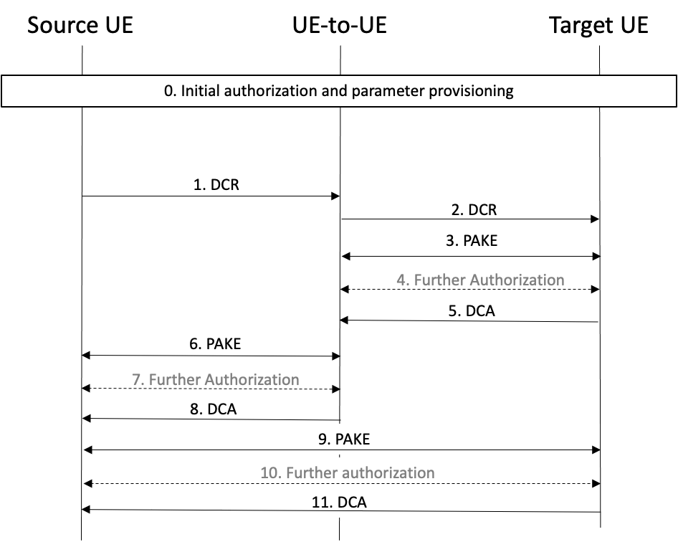
Figure 6.Y.2-1
The required steps are as follows:
- Step 0 is the initial authorization and parameter provisioning of S-UE, UE2UE and T-UE.
- Steps 1 and 2 involve the exchange of an initial Direct Communication Request (DCR) message.
- Step 3 involves the setup of a secure authenticated channel between UE2UE and T-UE based on a PAKE.
- Step 4 involves an optional authorization phase.
- Step 5 involves the exchange of Direct Communication Accept (DCA) from T-UE to UE2UE.
- Step 6 involves the setup of a secure authenticated channel between S-UE and UE2UE based on a PAKE.
- Step 7 involves an optional authorization phase.
- Step 8 involves the exchange of DCA from UE2UE to S-UE.
- Step 9 involves the setup of a secure authenticated channel between S-UE and T-UE based on a PAKE.
- Step 10 involves an optional authorization phase.
- Step 11 involves the exchange of DCA from T-UE to S-UE.
The PAKE in Steps 3, 6, and 8 may rely on a password shared amongst both UEs (in case of balanced PAKE), or a password and a password derived value (in case of augmented PAKE) that might be, e.g., pre-configured in Step 0. This password may also be entered in the involved devices by the users or generated by the devices and exchanged out-of-band.
The PAKE in Steps 3 and 6 may be an augmented PAKE in which, e.g., the Target UE (or Source UE) does not have access to the password itself, but a password-derived value used in the augmented PAKE and from which the actual password can only be retrieved by means of an offline dictionary attack. This prevents the target UE (or Source UE) from impersonating the UE2UE.
The PAKE in Steps 3, 6, and 8 allow the communicating parties to authenticate to each other and establishing symmetric-cryptographic keys used to protect the communication link. This process provides a certain level of authorization, e.g., if two UEs share a same password (-derived) value, the authentication will be successful fulfilling authorization requirements in many scenarios.
NOTE: The PAKE choice and details are left to normative phase.
The optional authorization phase in Steps 4, 7, and 9 might be required when one of the devices requires further authorisation assurances. This phase relies on the exchange of authorization tokens and policies configured in Step 0. For instance, in Step 4, the target UE can send an authorization token so that the UE2UE can verify that the target UE is indeed entitled to use the UE2UE relay.
NOTE: Details on the optional authorization phase in Steps 4, 7, and 9 are left to normative phase.
The message flow in Figure 6.Y.2-1 can be adapted to other message flows, e.g., relying on discovery messages. For instance, the S-UE can send a Discovery Solicitation message towards the T-UE through the UE2UE. The T-UE replies with a Discovery Response message towards the S-UE through the UE2UE. Next, S-UE and UE2UE can establish a secure PC5 interface relying on a PAKE. Next, UE2UE and T-UE can establish a secure PC5 interface relying on a PAKE. And finally, S-UE and T-UE can establish a secure PC5 interface (assuming an L2 UE2UE) based on a PAKE.
Editor’s Note: Which specific PAKE protocols can be used is FFS.
Editor’s Note: How to provision passwords is FFS.

6.Y.3 Evaluation
Editor’s Note: Each solution should motivate how the potential security requirements of the key issues being addressed are fulfilled.
Editor’s Note: Whether PAKE based authentication is in Prose or Application layer scope is FFS.

****End of Change1****

