3GPP TSG-SA3 Meeting #108e-AdHoc S3-222881-r1

e-meeting, 10 - 14 October 2022 Revision of S3-22xxxx

Source: Xiaomi

Title: Evaluation of solution #7 in TR 33.741

Document for: Approval
Agenda Item: 5.7

1 Decision/action requested
This contribution proposes to evaluate the solution #7 in the FS_HN_Auth study TR 33.741

2 References
[1] 3GPP TR 33.741 v0.2.0: "Study on home network triggered primary authentication (HONTRA);"

3 Rationale
This pCR proposes to evaluate solution #7 in TR 33.741 [1].

4 Detailed proposal
*************** Start of the Change ****************

5.7 Solution #7: UDM initiated Primary Authentication

5.7.1 Introduction
This solution describes how the UDM initiates a primary authentication to refresh the long lived key K_{AUSF}. The solution addresses Key Issue #1: Ability of the home network to trigger primary authentication.

5.7.2 Solution details
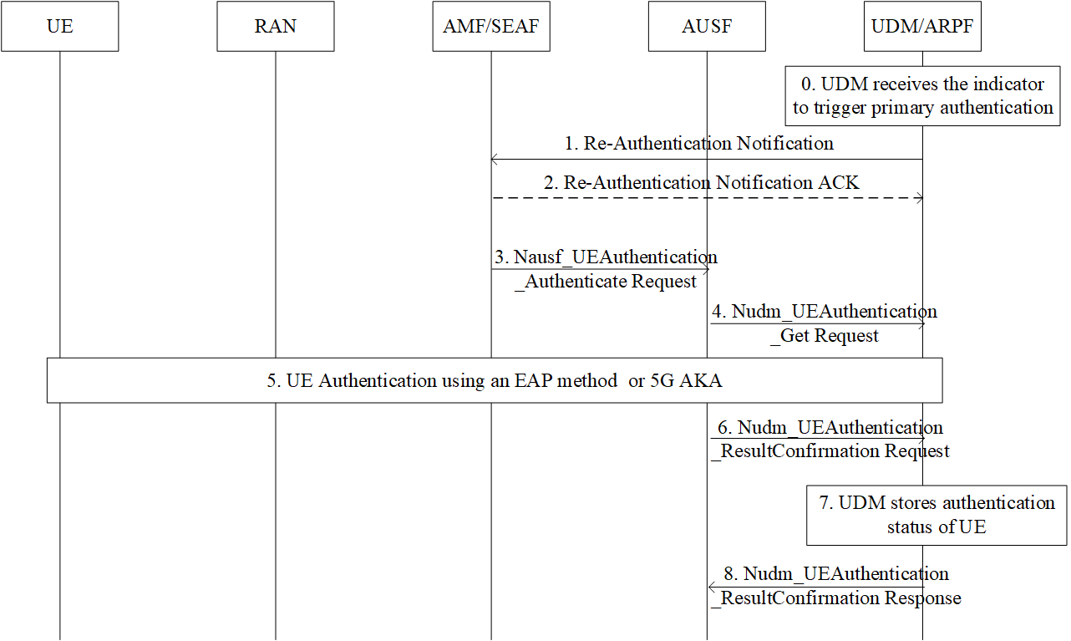
0. Upon receiving a message that contains an application error, the UDM triggers a primary authentication procedure. For example, the UDM receives the Nausf_SoRProtection_response/ Nausf_UPUProtection_response including an application error COUNTER_WRAP indicating the CounterSoR/CounterUPU associated with the K_{AUSF} of the UE is about to wrap around. To refresh the KAUSF, the UDM could initiate a new primary authentication procedure.
Editor’s Note: Which use case this solutions addresses is FFS.
1. The UDM sends the Re-Authentication Notification, e.g. Nudm_UECM_ReAuthenticationNotification, (incl. SUPI, Access Type, Re-Authentication reason) message to the AMF. According to the core network status, the Re-Authentication reason can be set to SoR counter wrap around, UPU counter wrap around, etc.
Editor’s Note: It is FFS if SoR/UPU Counter wrap around reason need to be provided to AMF and what does AMF do with this.
2. If the UDM has requested an acknowledgement from the AMF, the AMF returns the Re-Authentication Notification ACK message to the UDM.
3. The SEAF invokes the Nausf_UEAuthentication service by sending a Nausf_UEAuthentication_Authenticate Request message to the AUSF. The Nausf_UEAuthentication_Authenticate Request message shall contain SUCI or SUPI and the Serving network name, as defined in TS 33.501 [3].
4. The Nudm_UEAuthentication_Get Request sent from AUSF to UDM includes SUPI and the serving network name. Based on SUPI, the UDM/ARPF shall choose the authentication method.
5. Based on the decision of UDM, the UE and the network performs the EAP-AKA’ or 5G AKA procedure.
6. The AUSF shall store the new Kausf and inform UDM about the result and time of the authentication procedure with the UE using a Nudm_UEAuthentication_ResultConfirmation Request. The AUSF also resets the CounterSoR/CounterUPU once the new Kausf is generated.
7. The UDM shall store the authentication status of the UE (SUPI, authentication result, timestamp, and the serving network name).
8. The UDM shall reply to AUSF with a Nudm_UEAuthentication_ResultConfirmation Response.

5.7.3 Evaluation
This solution fulfills the security requirements of Key Issue #1 and relates to use case #2: SoR/UPU Counter Wrap around.
The proposed solution ensures that the home network is able to trigger a primary authentication. In addition, the HN-triggered Re-Authentication request/response messages exchanged between the UE and 5GCS is confidentiality protected, integrity protected and anti-replay protected.
This solution has no impact on the UE.
This solution has impact on the HPLMN. The UDM needs to support a new service operation to notify the AMF of the need for Re-Authentication. If necessary, the UDM also needs to receive the Re-Authentication ACK sent by the AMF to acknowledge the success of the triggered Re-Authentication.
Editor’s Note: Further evaluation is FFS.
*************** End of the Change ****************

