3GPP TSG-SA3 Meeting #108adhoc-e S3-222262

e-meeting, 10 – 14 October 2022

Source: Apple

Title: Solution – AKMA authentication in roaming scenario

Document for: Approval
Agenda Item: 5.6

1 Decision/action requested
It is proposed to add a new solution in AKMA TR 33.737.

2 References
Null

3 Rationale
There are different scenarios on the deployment of AKMA roaming:
Arch #1. VPLMN doesn’t support AKMA, AF is in HPLMN
Arch #2. VPLMN doesn’t support AKMA, AF is in VPLMN/DN
Arch #3. VPLMN supports AKMA, AF is in HPLMN
Arch #4. VPLMN supports AKMA, AF is in VPLMN/DN
In the first 3 architectures, the current AKMA mechanism can be reused without enhancement and extra design. But for Arch#4, there is possibility there AF has multiple choices on whether it shall choose VAAnF or HAAnF for the performing AKMA. This pCR provides a solution on Arch#4.

4 Detailed proposal
****START OF CHANGES ***

6.X Solution #X: AKMA Authentication in roaming scenario

6.X.1 Introduction
This solution addresses the key issue #1: Support for AKMA roaming scenario.

6.X.2 Solution details
In this solution, it is assumed the VPLMN deployed AAnF (shown as VAAnF). There are 2 options for VAAnF to request K_{AF} :
Option#1: VAAnF fetch K_{AF} from HAAnF.
Option#2: VAAnF fetch K_{AKMA} from HAUSF, and VAAnF generates K_{AF} based on K_{AKMA}.

6.X.2.1 Option#1 details

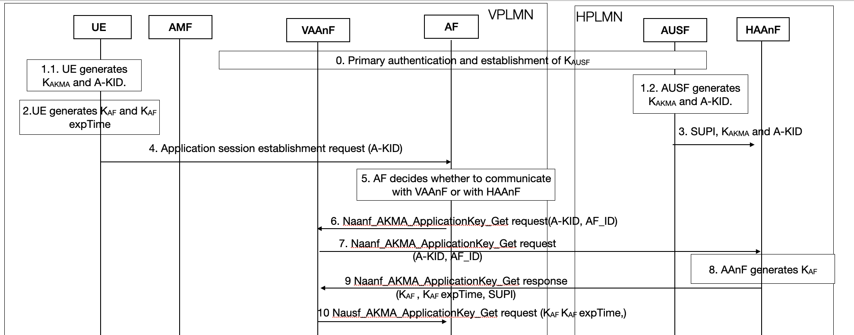
Fig 6.x.2-1 Authentication in roaming scenario – Option#1

Step 0: UE performs primary authentication with the network. Then K_{AUSF} is shared between UE and AUSF in Home network.
Step 1.1: UE generates K_{AKMA} and A-KID following AKMA procedure in TS 33.535 and stores them securely.
Step 1.2: AAnF generates K_{AKMA} and A-KID following AKMA procedure in TS 33.535 and stores them securely.
Step 2: UE derives K_{AF} following AKMA procedure in TS 33.535.
Step 3: AUSF selects the AAnF as defined in clause 6.7 in TS 33.535 and send the generated A-KID and K_{AKMA} to the AAnF together with the SUPI of the UE using the Naanf_AKMA_KeyRegistration Request service operation.
Step 4: UE send Application session establishment request (A-KID) to AF.
Step 5: AF determines on whether to communicate with VAAnF or HAAnF.
NOTE: AF could contact HAAnF for fetch K_{AF}, which is exactly the AKMA feature defined in R17 in TS 33.535. no need to repeat here. But AF may have local policy to decide which AAnF should it contact.
Editor’s Note: How the AF selects the HAAnF when the UE is roaming is FFS
Step 6: AF sends Naanf_AKMA_ApplicationKey_Get request(A-KID, AF_ID) to VAAnF
Step 7: Based on the information provided in A-KID, VAAnF checked this is a roaming UE, so VAAnF sent Naanf_AKMA_ApplicationKey_Get request (A-KID) to HAAnF.
Step 8: HAAnF derives K_{AF} from K_{AKMA} following TS 33.535.
Step 9: HAAnF sent Naanf_AKMA_ApplicationKey_Get response (K_{AF} , K_{AF} expTime, SUPI) to VAAnF.
Step 10: VAAnF send Naanf_AKMA_ApplicationKey_Get response (K_{AF} , K_{AF} expTime, SUPI) to AF.

6.X.2.2 Option#2 details

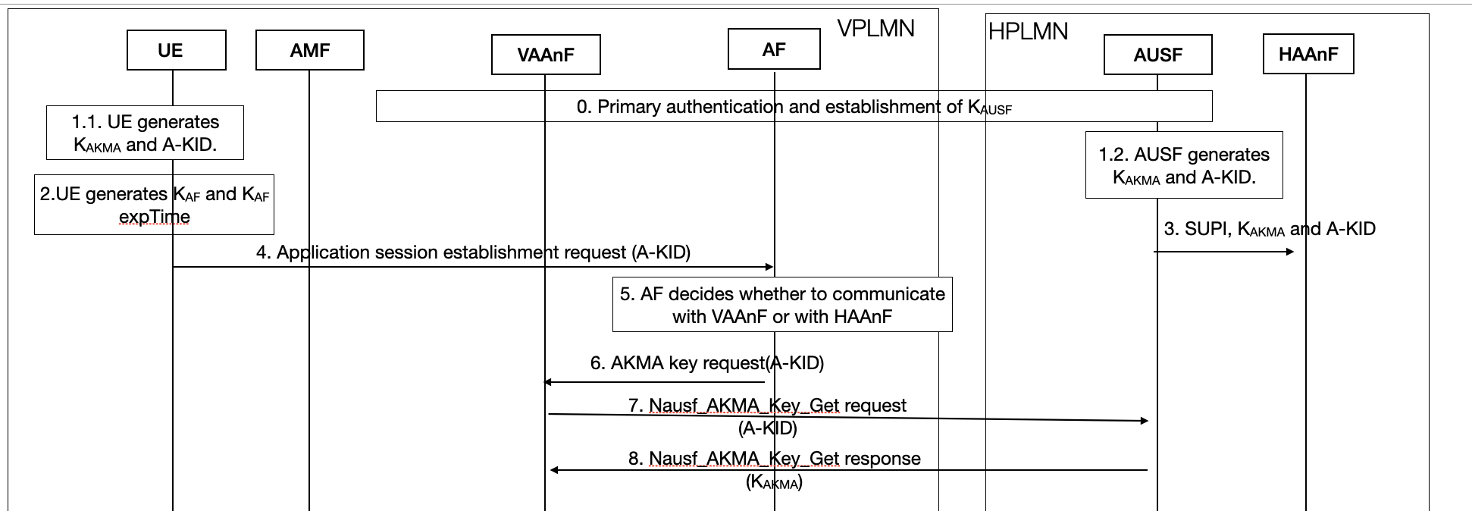
Fig 6.x.2-1 Authentication in roaming scenario – Option#2
Step 0: UE performs primary authentication with the network. Then K_{AUSF} is shared between UE and AUSF in Home network.
Step 1.1: UE generates K_{AKMA} and A-KID following AKMA procedure in TS 33.535 and stores them securely.
Step 1.2: AAnF generates K_{AKMA} and A-KID following AKMA procedure in TS 33.535 and stores them securely.
Step 2: UE derives K_{AF} following AKMA procedure in TS 33.535.
Step 3: AUSF selects the AAnF as defined in clause 6.7 in TS 33.535 and send the generated A-KID and K_{AKMA} to the AAnF together with the SUPI of the UE using the Naanf_AKMA_KeyRegistration Request service operation.
Step 4: UE send Application session establishment request (A-KID) to AF.
Step 5: AF determines on whether to communicate with VAAnF or HAAnF.
NOTE: AF could contact HAAnF for fetch K_{AF}, which is exactly the AKMA feature defined in R17 in TS 33.535, thus no need to repeat here. But AF may have local policy to decide which AAnF should it contact.
Editor’s Note: How the AF selects the HAAnF or VAAnF when the UE is roaming is FFS
Step 6: if AF determines to contact VAAnF in step 5, AF sends Naanf_AKMA_ApplicationKey_Get request(A-KID, AF_ID) to VAAnF
Step 7: Based on the information provided in A-KID, VAAnF checked this is a roaming UE, so VAAnF sent Nausf_AKMA_Key_Get request (A-KID) to AUSF in HPLMN.
Step 8: AUSF response with Nausf_AKMA_Key_Get response (K_{AKMA}) to VAAnF.
Step 9: VAAnF derives K_{AF} , K_{AF} expTime based on K_{AKMA} and AF_ID following the key derivation function defined in A.4 in TS 33.535.
Step 10: VAAnF send Naanf_AKMA_ApplicationKey_Get response (K_{AF} , K_{AF} expTime, SUPI) to AF.

6.X.2.2.1 New service: Nausf_AKMA_Key_Get service operation
Service operation name: Nausf_AKMA_Key_Get.
Description: The NF consumer requests AKMA Application Key and UE ID from the AUSF.
Input, Required: A-KID, AF_ID
Input, Optional: None.
Output, Required: K_{AKMA}
Output, Optional: None.

6.X.4 Evaluation
TBA.

****2nd CHANGES ***

2 References
The following documents contain provisions which, through reference in this text, constitute provisions of the present document.
- References are either specific (identified by date of publication, edition number, version number, etc.) or non-specific.
- For a specific reference, subsequent revisions do not apply.
- For a non-specific reference, the latest version applies. In the case of a reference to a 3GPP document (including a GSM document), a non-specific reference implicitly refers to the latest version of that document in the same Release as the present document.
[1] 3GPP TR 21.905: "Vocabulary for 3GPP Specifications".
[2] 3GPP TR 33.535: " Authentication and key management for applications based on 3GPP credential in 5G （AKMA）".
[3] 3GPP TS 33.220: "Generic Authentication Architecture (GAA); Generic Bootstrapping Architecture (GBA) ".
[x] 3GPP TS 33.222: "Generic Authentication Architecture (GAA); Access to network application functions using Hypertext Transfer Protocol over Transport Layer Security (HTTPS) ".
[y] 3GPP TS 33.210: "Generic AuthenticationNetwork Domain Security (NDS); IP network layer security".

****END OF CHANGES ***

