3GPP TSG-SA3 Meeting #107-e draft_S3-220930-r4

e-meeting, 16 - 20 May 2022

Source: Nokia, Nokia Shanghai Bell

Title: Key issue on Automated Certificate Management for Network Slicing

Document for: Approval
Agenda Item: 5.7

1 Decision/action requested
It is requested to approve the new Key issue for Standardising Automated Certificate Management in SBA

2 References

3 Rationale
In the last SA3 meeting, SID S3-220520 was agreed to address a standardized model and set of procedures for automated certificate management. One of the agreed principles of the SID to be standardized is to be able to support NFs doing mutual TLS in Slicing, and other one refers as well to PNI-NPN scenarios. Different slices may have different requirements for automated certificate management. Also, it is very likely that different Certification Authorities are used for different network slices. This key issue addresses some of these scenarios and intends to set up a security requirement baseline to facilitate the design of corresponding solutions.

4 Detailed proposal
************ START OF CHANGES ************

5.x Key Issue #X: Automated Certificate Management for Network Slicing

5.x.1 Issue details
A network slice can be understood as a logical network on top of a shared infrastructure. Network slicing is a key feature of 5G wireless network standards and allows operators to manage and orchestrate different logical networks for different kinds of service level requirements. For example, the communication services using network slicing may include:
• V2X services
• 5G seamless eMBB service with FMC
• massive IoT connections
There can be different network slices logically isolated based on Slice Service Type (SST) value, as shown in the following diagram:
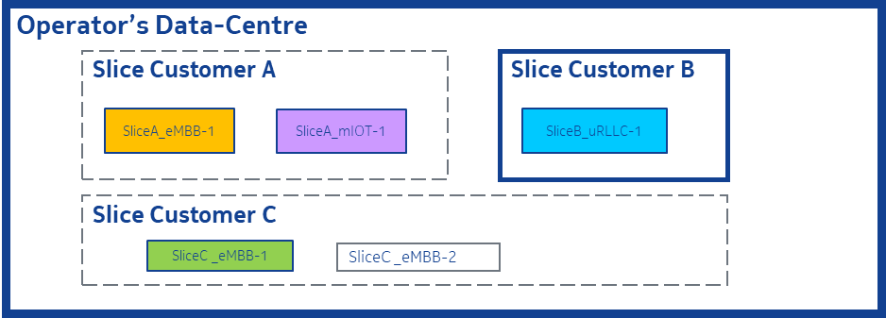
Figure 1 - Different slices logically isolated for different slice customers
Network slicing facilitates a lot of vertical industries to create and manage logically separated resources across the 5G system dedicated for their own applications, while ensuring the desired service level agreements are always met.
Different slices allocated to different slice customers may have different requirements for automated certificate management.
Generally, network slices need to rely on operator-provided services for automated certificate management services. Nevertheless, certain slices allocated to slice customers can require to peform management and operation tasks over operator CA, or even to use their own CA and certificate management procedures for all or part of the slice-specific services and NFs. For the latter case, both operator and slice customer need to agree on how establish the trust between operator and customer domain and interconnect their CAs, e.g., via cross-certification.
There are also several approaches to address access control and authorization of NFs for slicing in SBA. The NF can be deployed to serve a dedicated slice or multiple slices, and network slices can be dynamically or statically created and removed as per business needs. Depending on NF deployment option, the lifecycle of a NF can be different from a lifecycle of network slices assigned to the NF. Therefore, when considering the alignment between NF lifecycle and certificate lifecycle, the network slicing lifecycles can also need to be taken into account depending on NF and network slices deployment solution.

5.x.2 Security Threats
A potential compromise or malfunction in the certificate management framework of the operator may impact in the certificate manament framework of the slice and viceversa. E.g., if automated certificate updates are not completed before the expiration dates, it can lead to service / slice un-availability, requiring manual administration of certificates.
Misalignment between lifecycles of certificate and slices could lead to service unavailability for customer specific slices.

5.x.3 Potential security requirements
The framework should take into account the fact that certificates might belong to different domains, e.g. in deployment where different 3rd party slices co-exist and interoperate.

************ END OF CHANGES ************

