3GPP TSG-SA3 Meeting #107e AdHoc S3-221553-r1

e-meeting, 27 June - 1 July 2022 Revision of S3-22xxxx

Source: Xiaomi

Title: New solution on Interconnection CA Based Trust Chain in the SBA Architecture

Document for: Approval
Agenda Item: 5.5

1 Decision/action requested
This contribution proposes to add a new solution in the FS_ACM_SBA study TR 33.876

2 References
[1] 3GPP TS 33.310 v17.2.0: "Network Domain Security (NDS); Authentication Framework (AF)"
[2] 3GPP TR 33.876 v0.2.0: "Study on Automated Certificate Management in SBA"

3 Rationale
During the standardisation of an automated certificate management procedure in the SBA architecture, the trust relationship among certificate authorities needs to be clarified first. Based on the chain of trust, the SBA entities can verify their obtained certificate and perform the automated certificate management protocol.
As per TS 33.310 [1], the interconnection CA can be used to issue certificates to the SEG CAs, TLS client CA or TLS server CA, of other domains with which the operator’s SEGs and TLS entities have interconnection. Based on the certificate issued by the interconnection CA, the TLS entities under both authorities can trust the other authority's certificates, which could benefit the certificate verification between SEPPs.
Therefore, this pCR proposes a new solution on interconnection CA based trust chain in the SBA architecture, which addresses key issue #4 in TR 33.876 [2] for FS_ACM_SBA.

4 Detailed proposal
*************** Start of the 1st Change ****************

2 References
The following documents contain provisions which, through reference in this text, constitute provisions of the present document.
- References are either specific (identified by date of publication, edition number, version number, etc.) or non-specific.
- For a specific reference, subsequent revisions do not apply.
- For a non-specific reference, the latest version applies. In the case of a reference to a 3GPP document (including a GSM document), a non-specific reference implicitly refers to the latest version of that document in the same Release as the present document.
[1] 3GPP TR 21.905: "Vocabulary for 3GPP Specifications".
[x] 3GPP TS 33.310: "Network Domain Security (NDS); Authentication Framework (AF)"
*************** Start of the 2nd Change ****************

6.Y Solution #Y: Interconnection CA Based Trust Chain in the SBA Architecture

6.Y.1 Introduction
Before performing the automated certificate management protocol, the NFs in the SBA architecture need to obtain the corresponding certificate based on their role, which requires the trust chain of CA. Based on the proposed trust chain in this solution, the SBA entities can verify their obtained certificate and establish the TLS connection.
As per TS 33.310 [x], the interconnection CA can be used to issue certificates to the SEG CAs, TLS client CA or TLS server CA, of other domains with which the operator’s SEGs and TLS entities have interconnection. Based on the certificate issued by the interconnection CA, the TLS entities under both authorities can trust the other authority's certificates, which could benefit the certificate verification between SEPPs.
The proposed solution describes the interconnection CA based trust chain. Based on the trust chain, the certificate of SBA entities can be verified. The solution addresses Key Issue #4: Trust Chain of Certificate Authority Hierarchy.

6.Y.2 Solution details

6.Y.2.1 General architecture
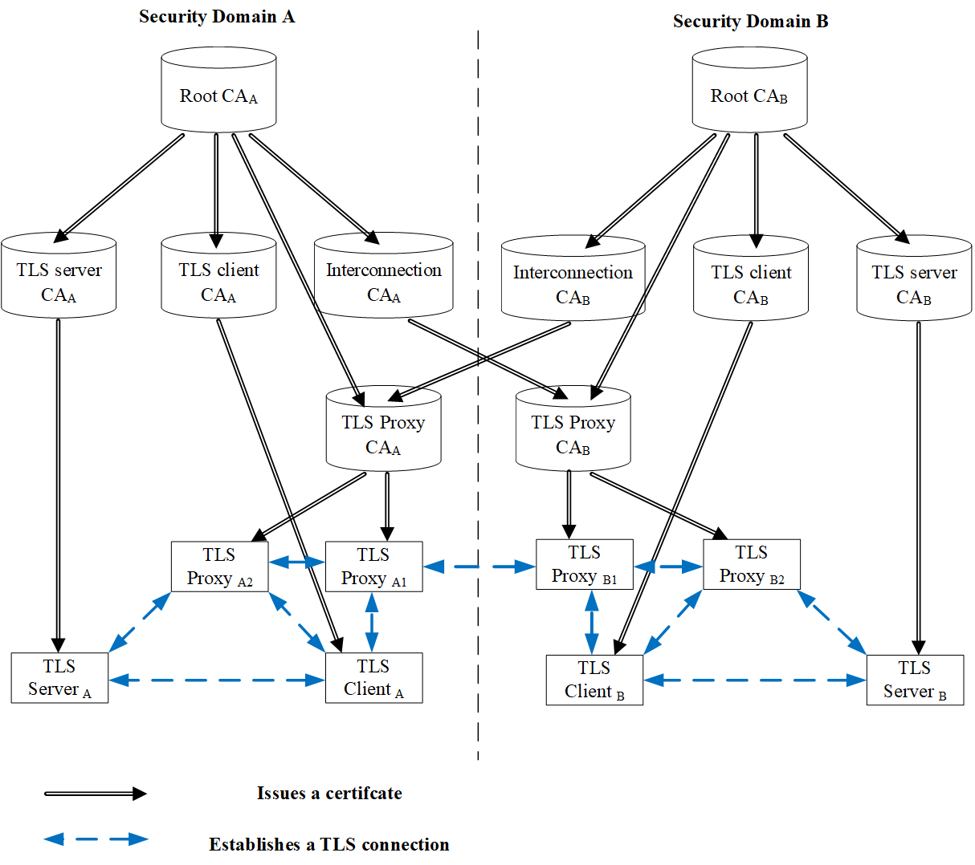
Figure 1: General Architecture
In the following, the architecture for issuing SBA certificates using TLS CAs is described.
- Root CA: A CA serves as the trust anchor in a chain of trust within a security domain. Each security domain can have only one root CA. The root CA generates the self-signed certificate as the root certificate. All certificates in this security domain are signed by the root certificate directly or indirectly.
- TLS client CA: A CA that issues end entity TLS client certificates to TLS entities within a particular operator's security domain.
- TLS server CA: A CA that issues end entity TLS server certificates to TLS entities within a particular operator's security domain.
- Interconnection CA: A CA that issues cross-certificates on behalf of a particular operator to TLS proxy CAs of other domains with which the operator's TLS entities have interconnection.
- TLS Proxy CA: A CA that issues end entity TLS proxy certificates to TLS proxies. The TLS proxy CA can be inter-domain TLS proxy CA or intra-domain TLS proxy CA. The inter-domain TLS proxy CA is used to issue certificates for inter-domain TLS proxies. The intra-domain TLS proxy CA is used to issue certificates for intra-domain TLS proxies.
- TLS server: TLS entities acting as 5G NF producers (e.g. AMF, SMF) are provisioned with TLS server certificates issued by the TLS server CA.
- TLS client: TLS entities acting as 5G NF consumers (e.g. AMF, SMF) are provisioned with TLS client certificates issued by the TLS client CA.
- TLS proxy: The TLS proxy acts as an intermediary point between the TLS client and TLS server, assisting TLS entities to establish intra-domain and inter-domain TLS connections. TLS entities verify the identity of TLS proxies by verifying TLS proxy certificates. Network functions (e.g. SCP, SEPP) that act as proxy functions in SBA architecture are provisioned with TLS proxy certificates issued by the TLS proxy CA.
NOTE: Considering that some TLS entities can act as both NF producers and NF consumers, they may need both TLS client certificates and TLS server certificates.

6.Y.2.2 Verify certificate in SBA architecture
Verify the TLS certificate between intra-domain TLS entities:
It is assumed that the TLS client and the TLS server are within the same security domain and are provisioned with the root CA’s self-signed certificate before establishing the TLS connection. The certificate provisioning may be pre-configured or be provisioned during the enrollment. When the TLS client receives the certificate of the TLS server as part of the SSL/TLS handshake, TLS client performs the following procedure. If the mutual TLS for authentication of NF is used, both the TLS client and TLS server perform the following procedure.
- The receiver checks to ensure that the sender's certificate is not expired. Considering that the sender's certificate is signed by the intermediate CA, the receiver willget the intermediate CA’s certificate. Once the intermediate CA’s certificate is obtained, the receiver uses the intermediate CA’s public key to verify that the sender's certificate is properly signed.
- Then, the receiver attempts to verify that the intermediate CA’s certificate is trusted. Considering that the intermediate CA's certificate is signed by the Root CA, the receiver uses the provisioned self-signed root certificate to verify the signature of the intermediate CA's certificate.
- In a successful transaction, the receiver will come to a self-signed root certificate that the receiver implicitly trusts. At this point, the receiver verifies the identity of sender, builds the chain of trust to the sender, and the intra-domain SSL/TLS handshake can proceed.
Note: The intermediate CA can be seen as the TLS server CA, the TLS client CA or the TLS proxy CA.
Verify the TLS certificate between inter-domain TLS proxy:
It is assumed that the TLS proxy_{A} and the TLS proxy_{B} are in different security domains and are pre-provisioned with their root CA’s self-signed certificate (e.g. TLS proxy_{A} is pre-provisioned with the Root CA_{A}’s self-signed certificate and TLS proxy_{B} is pre-provisioned with the Root CA_{B}’s self-signed certificate). When the TLS proxy_{A} receives the certificate of the TLS proxy_{B} as part of the SSL/TLS handshake, the TLS proxy_{A} performs the following procedure. If the mutual TLS for authentication of NF is used, both TLS proxies perform the following procedure.
- The receiver (i.e. TLS proxy_{A}) checks to ensure that the sender’s (i.e. TLS proxy_{B}) certificate is not expired. Considering that the TLS proxy_{B} 's certificate is signed by the TLS proxy CA_{B}, the TLS proxy_{A} will get the TLS proxy CA_{B}’s certificate. Once the TLS proxy CA_{B}’s certificate is obtained, the TLS proxy_{A} uses the TLS proxy CA_{B}’s public key to verify that the TLS proxy_{B} 's certificate is properly signed.
- Then, the TLS proxy_{A} attempts to verify that the TLS proxy CA_{B}’s certificate is trusted. Considering that the TLS proxy CA_{B}'s certificate is signed by the Interconnection CA_{A}, the TLS proxy_{A} willget the Interconnection CA_{A}’s certificate. Once the Interconnection CA_{A}’s certificate is obtained, the TLS proxy_{A} uses the Interconnection CA_{A}’s public key to verify that the TLS proxy CA_{B}'s certificate is properly signed.
- Then, the TLS proxy_{A} attempts to verify that the Interconnection CA_{A}’s certificate is trusted. Considering that the Interconnection CA_{A}'s certificate is signed by the Root CA_{A}, the TLS proxy_{A} uses the provisioned self-signed root certificate to verify the signature of the Interconnection CA_{A}'s certificate.
- In a successful transaction, the TLS proxy_{A} will come to a self-signed root certificate that the TLS proxy_{A} implicitly trusts. At this point, the TLS proxy_{A} verifies the identity of TLS proxy_{B}, builds the chain of trust to the TLS proxy_{B}, and the inter-domain SSL/TLS handshake can proceed.

6.Y.3 Evaluation

*************** End of the Change ****************

