3GPP TSG-SA3 Meeting #107e AdHoc S3-221551-r2

e-meeting, 27 June - 1 July 2022 Revision of S3-22xxxx

Source: Xiaomi

Title: New solution on AUSF initiated Primary Authentication

Document for: Approval
Agenda Item: 5.7

1 Decision/action requested
This contribution proposes to add a new solution in the FS_HN_Auth study TR 33.741

2 References
[1] 3GPP TS 33.501 v17.5.0: “Security architecture and procedures for 5G system”
[2] 3GPP TR 33.741 v0.1.0: “Study on home network triggered primary authentication (HONTRA)”

3 Rationale
As per TS 33.501 [1], the AUSF is involved in the Steering of Roaming (SoR) or UE Parameter Update (UPU) procedure. In the SoR/UPU procedure, the AUSF is responsible for storing the Counter_{SoR}/Counter_{UPU} and calculating the SoR-MAC-I_{AUSF}/UPU-MAC-I_{AUSF}. As described in TS 33.501 [1], the Counter_{SoR}/Counter_{UPU} is maintained by the AUSF for the lifetime of K_{AUSF} and is incremented by the AUSF for every new computation of the SoR-MAC-I_{AUSF}/UPU-MAC-I_{AUSF}. If the Counter_{SoR}/Counter_{UPU} is about to wrap around, the AUSF shall suspend the SoR/UPU protection service until a new K_{AUSF} is refreshed. Under this situation, the AUSF shall be able to initiate a primary authentication to refresh the K_{AUSF} and make the SoR/UPU protection available.
Therefore, this pCR proposes a new solution on AUSF initiated primary authentication, which addresses key issue #1 in TR 33.741 [2] for FS_HN_Auth.

4 Detailed proposal
*************** Start of the 1st Change ****************

2 References
The following documents contain provisions which, through reference in this text, constitute provisions of the present document.
- References are either specific (identified by date of publication, edition number, version number, etc.) or non-specific.
- For a specific reference, subsequent revisions do not apply.
- For a non-specific reference, the latest version applies. In the case of a reference to a 3GPP document (including a GSM document), a non-specific reference implicitly refers to the latest version of that document in the same Release as the present document.
[1] 3GPP TR 21.905: "Vocabulary for 3GPP Specifications".
[x] 3GPP TS 33.501: “Security architecture and procedures for 5G system”
*************** Start of the 2nd Change ****************

6.Y Solution #Y: AUSF initiated Primary Authentication

6.Y.1 Introduction
This solution describes how the AUSF initiates a primary authentication to refresh the long lived key K_{AUSF}. The solution addresses Key Issue #1: Ability of the home network to trigger primary authentication.

6.Y.2 Solution details
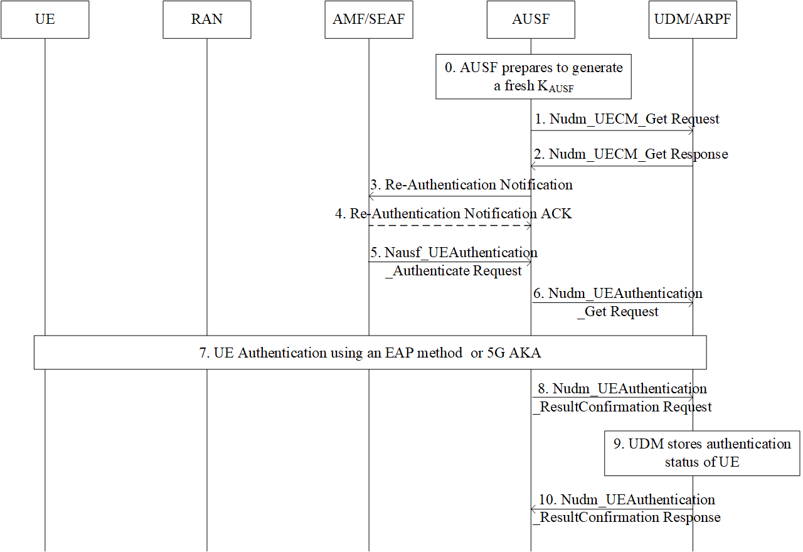
0. For the continuity and security of service, in some scenarios the AUSF can decide to generate a fresh K_{AUSF} by initiating a new primary authentication procedure. For example, if the Counter_{SoR}/Counter_{UPU} associated with the K_{AUSF} of the UE is about to wrap around, the AUSF needs to initiate the primary authentication procedure and generate a fresh K_{AUSF}.
1. The AUSF invokes the Nudm_UECM_Get to retrieve the AMF identity serving for the UE.
2. The UDM retrieves the subscription data for the UE and provides a Nudm_UECM_Get response message. The AMF ID uniquely identifies the AMF serving the UE.
3. The AUSF sends the Re-Authentication Notification, e.g. Nausf_UECM_ReAuthenticationNotification, (incl. SUPI, Access Type, Re-Authentication reason) message to the serving AMF. According to the core network status, the Re-Authentication reason can be set to SoR counter wrap around, UPU counter wrap around, etc.
Editort’s Note: It is FFS if SoR/UPU Counter wrap around reason need to be provided to AMF and what does AMF do with this.

4. If the AUSF has requested an acknowledgement from the AMF, the AMF returns the Re-Authentication Notification ACK message to the AUSF.

5. The SEAF invokes the Nausf_UEAuthentication service by sending a Nausf_UEAuthentication_Authenticate Request message to the AUSF. The Nausf_UEAuthentication_Authenticate Request message shall contain SUCI or SUPI and the Serving network name, as defined in TS 33.501 [x].
6. The Nudm_UEAuthentication_Get Request sent from AUSF to UDM includes SUPI and the serving network name. Based on SUPI, the UDM/ARPF shall choose the authentication method.
7. Based on the decision of UDM, the UE and the network performs the EAP-AKA’ or 5G AKA procedure.
8. The AUSF shall store the new K_{AUSF} and inform UDM about the result and time of the authentication procedure with the UE using a Nudm_UEAuthentication_ResultConfirmation Request. The AUSF also resets the Counter_{SoR}/Counter_{UPU} once the new K_{AUSF} is generated.
9. The UDM shall store the authentication status of the UE (SUPI, authentication result, timestamp, and the serving network name).
10. The UDM shall reply to AUSF with a Nudm_UEAuthentication_ResultConfirmation Response.

6.Y.3 Evaluation
This solution fulfills the security requirements of Key Issue #1.
The proposed solution ensures the home network is able to trigger a primary authentication. In addition, the HN-triggered Re-Authentication request/response message exchanged between the UE and 5GS is confidentiality protected, integrity protected and anti-replay protected.
This solution has an impact on the HPLMN. The AUSF has to support a new service operation to notify the AMF of the need for Re-Authentication. If necessary, the AUSF also has to receive the Re-Authentication ACK sent by the AMF to acknowledge the success of the triggered Re-Authentication.
*************** End of the Change ****************

