3GPP TSG-SA3 Meeting #107e AdHoc S3-221550-r2

e-meeting, 27 June - 1 July 2022 Revision of S3-22xxxx

Source: Xiaomi

Title: New solution on UDM initiated Primary Authentication

Document for: Approval
Agenda Item: 5.7

1 Decision/action requested
This contribution proposes to add a new solution in the FS_HN_Auth study TR 33.741

2 References
[1] 3GPP TS 33.501 v17.5.0: "Security architecture and procedures for 5G system"
[2] 3GPP TR 33.741 v0.1.0: "Study on home network triggered primary authentication (HONTRA)"

3 Rationale
As per 33.501 [1], the UDM is involved in the Steering of Roaming (SoR) or UE Parameter Update (UPU) procedure. During the SoR/UPU procedure, the UDM could receive a response message (i.e. Nausf_SoRProtection_Response or Nausf_UPUProtection_Response) containing an application error. This application error indicates the SoR/UPU counter is wrapped around and the SoR/UPU protection should be suspended until a new K_{AUSF} is refreshed. Under this situation, it is reasonable for the UDM to initiate a primary authentication to refresh the K_{AUSF} and make the SoR/UPU protection available.
Therefore, this pCR proposes a new solution on UDM initiated primary authentication, which addresses key issue #1 in TR 33.741 [2] for FS_HN_Auth.

4 Detailed proposal
*************** Start of the 1st Change ****************

2 References
The following documents contain provisions which, through reference in this text, constitute provisions of the present document.
- References are either specific (identified by date of publication, edition number, version number, etc.) or non-specific.
- For a specific reference, subsequent revisions do not apply.
- For a non-specific reference, the latest version applies. In the case of a reference to a 3GPP document (including a GSM document), a non-specific reference implicitly refers to the latest version of that document in the same Release as the present document.
[1] 3GPP TR 21.905: "Vocabulary for 3GPP Specifications".
[x] 3GPP TS 33.501: "Security architecture and procedures for 5G system"
*************** Start of the 2nd Change ****************

6.Y Solution #Y: UDM initiated Primary Authentication

6.Y.1 Introduction
This solution describes how the UDM initiates a primary authentication to refresh the long lived key K_{AUSF}. The solution addresses Key Issue #1: Ability of the home network to trigger primary authentication.

6.Y.2 Solution details
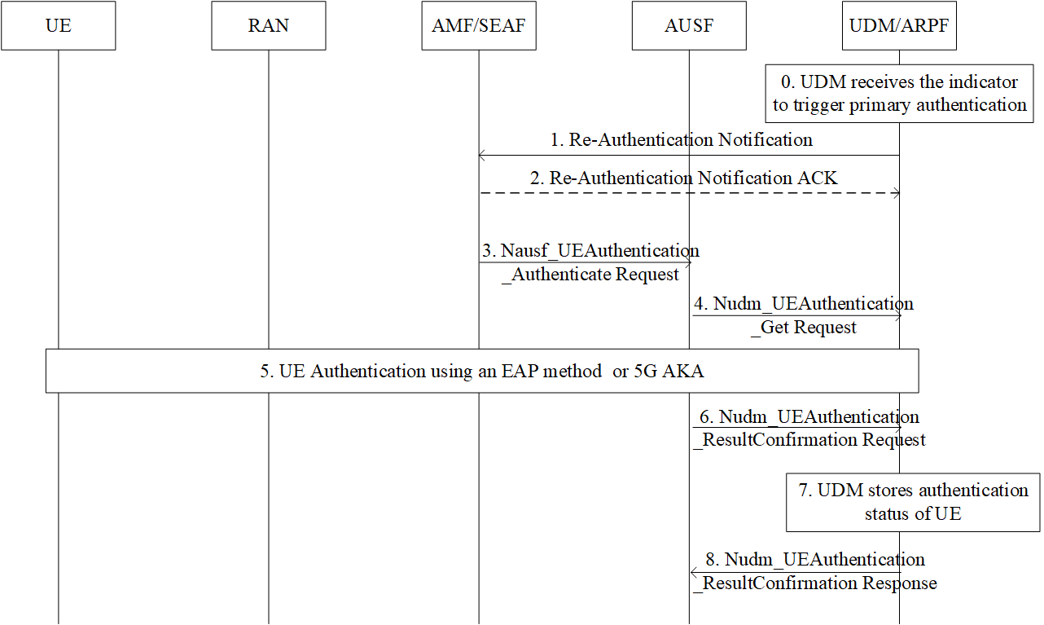
0. Upon receiving a message that contains an application error, the UDM triggers a primary authentication procedure. For example, the UDM receives the Nausf_SoRProtection_response/ Nausf_UPUProtection_response including an application error COUNTER_WRAP indicating the CounterSoR/CounterUPU associated with the K_{AUSF} of the UE is about to wrap around. To refresh the KAUSF, the UDM could initiate a new primary authentication procedure.
Editor’s Note: Which use case this solutions addresses is FFS.
1. The UDM sends the Re-Authentication Notification, e.g. Nudm_UECM_ReAuthenticationNotification, (incl. SUPI, Access Type, Re-Authentication reason) message to the AMF. According to the core network status, the Re-Authentication reason can be set to SoR counter wrap around, UPU counter wrap around, etc.
Editor’s Note: It is FFS if SoR/UPU Counter wrap around reason need to be provided to AMF and what does AMF do with this.

2. If the UDM has requested an acknowledgement from the AMF, the AMF returns the Re-Authentication Notification ACK message to the UDM.

3. The SEAF invokes the Nausf_UEAuthentication service by sending a Nausf_UEAuthentication_Authenticate Request message to the AUSF. The Nausf_UEAuthentication_Authenticate Request message shall contain SUCI or SUPI and the Serving network name, as defined in TS 33.501 [x].
4. The Nudm_UEAuthentication_Get Request sent from AUSF to UDM includes SUPI and the serving network name. Based on SUPI, the UDM/ARPF shall choose the authentication method.
5. Based on the decision of UDM, the UE and the network performs the EAP-AKA’ or 5G AKA procedure.
6. The AUSF shall store the new Kausf and inform UDM about the result and time of the authentication procedure with the UE using a Nudm_UEAuthentication_ResultConfirmation Request. The AUSF also resets the CounterSoR/CounterUPU once the new Kausf is generated.
7. The UDM shall store the authentication status of the UE (SUPI, authentication result, timestamp, and the serving network name).
8. The UDM shall reply to AUSF with a Nudm_UEAuthentication_ResultConfirmation Response.

6.Y.3 Evaluation

*************** End of the Change ****************

