3GPP TSG-SA3 Meeting #107adhoc-e S3-221467

e-meeting, 27 June – 1 July 2022

Source: Apple, OPPO

Title: Solution - Negotiation procedure for the authentication and authorization

Document for: Approval
Agenda Item: 5.9

1 Decision/action requested
This contribution proposes the negotiation procedure for the authentication between EEC and ECS/EES in TR 33.739

2 References
[1] TS 33.739 v010

3 Rationale
This contribution provides solution for key issue #2.2 “Authentication mechanism selection between EEC and ECS/EES”

4 Detailed proposal
It is suggested to approve the following changes.

***************************Start of Change ****************************

6.X Solution #X: Negotiation procedure for the Authentication and Authorization

6.X.1 Solution overview
This contribution addresses key issue #2.2 “Authentication mechanism selection between EEC and ECS/EES”.

6.X.2 Solution details
The negotiation procedure is as following:
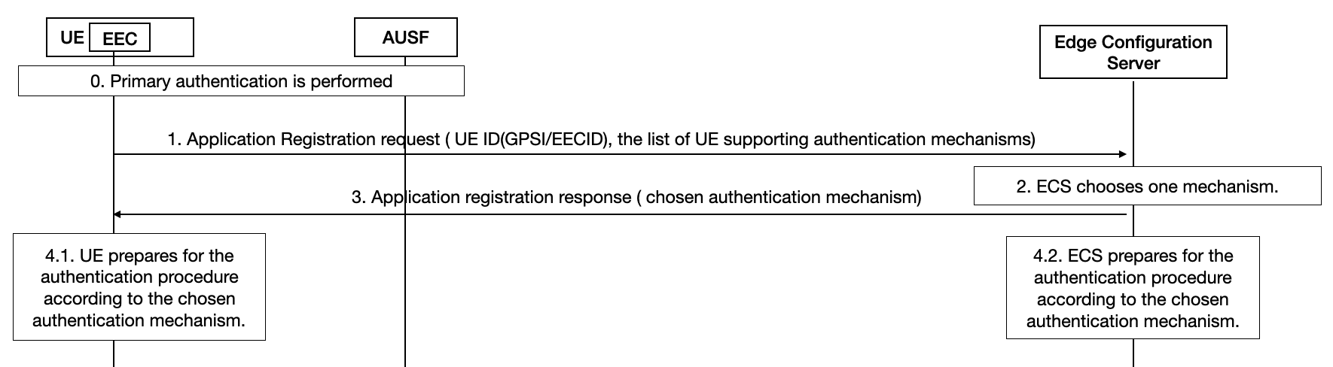
Figure 6.x-1: Negotiation Procedure for the Authentication and Authorization between EEC and ECS
Step 0. Primary authentication is performed as defined in TS 33.501. After this step, UE is successfully registered into the 5GS network.
Step 1. UE sends the EEC Registration Request message as defined in TS 23.558, which includes the list of UE supporting authentication mechanisms. The potential authentication mechanisms list includes TLS with AKMA, TLS with GBA, TLS with certificate, or other mechanisms if any. The order in the list indicates the priority of the UE preference.
Step 2. ECS selects one authentication method from the list of UE supporting authentication mechanisms based on local policy.
Step 3. ECS sends the EEC registration response including the chosen authentication mechanism to UE.
Step 4.1. After receiving the response from ECS in step 3, UE prepares for the authentication procedure according to the chosen authentication mechanism. e.g. generating AKMA/GBA keys or key for other mechanisms. The procedures to derive the credentials follow the TS 33.535 for AKMA, TS 33.220 for GBA, RFC 8446 for TLS 1.3.
Step 4.2. After sending the response to UE in step 3, network prepares for the authentication procedure according to the chosen authentication mechanism. e.g. generating AKMA/GBA keys or generating certificates. The procedures follow the TS 33.535 for AKMA, TS 33.220 for GBA, RFC 8446 for TLS 1.3.
Editor’s Note: It is FFS how to consider the HPLMN’s capability during the negotiation procedure.

6.X.3 Solution evaluation
TBA

***************************End of change****************************

