3GPP TSG-SA3 Meeting #107-e-Ad hoc S3-221399-r7

e-meeting, 27 June- 1 July 2022

Source: Huawei, HiSilicon

Title: Authentication mechanism selection between the EEC and ECS/EES

Document for: Approval
Agenda Item: 5.19

1 Decision/action requested
This contribution proposes to define how to determine the authentication mechanism between the EES and ECS/EES.

2 References
[1] 3GPP TS33.558 Security aspects of enhancement of support for enabling edge applications.
[2] 3GPP TR33.379 v0.1.0 Study on Security Enhancement of Support for Edge Computing — Phase 2.
[3] 3GPP TS 33.535 "Authentication and Key Management for Applications (AKMA) based on 3GPP credentials in the 5G System (5GS)".
[4] 3GPP TS 33.222 “Generic Authentication Architecture (GAA); Access to network application functions using Hypertext Transfer Protocol over Transport Layer Security (HTTPS)”

3 Rationale
This contribution Proposes to resolve the Key issue #2.2: Authentication mechanism selection between EEC and ECS/EES.

4 Detailed proposal
*************** Start of 1st Change ****************

6.X Solution #X: Authentication algorithm selection procedure between EEC and ECS

6.X.1 Solution overview
This solution addresses security requirement for authentication algorithm selection between EEC and ECS in key issue #2.2.
In this solution, the UE first retireves the supported Authentication mechanism (s) of the network during registration, and optionally get the ECS Authentication mechanism capability. When the EEC intend to connect to ECS, the EEC determines the used authentication mechanism or candidate authentication mechanism.

6.X.2 Solution details
This solution assumes that:
- Home network and/or Serving network, UE (EEC), ECS (as NAF in GBA, or AF in AKMA) may support multiple mechanisms (e.g., TLS with AKMA, TLS with GBA).
- Both EEC and ECS supports default authentication mechanism.
Editor’s Note: It is FFS whether the TLS with certificate, TLS with AKMA, or TLS with GBA is selected as the default authentication mechanism.
Editor’s Note: It is FFS whether the default authentication mechanism is necessary or not.
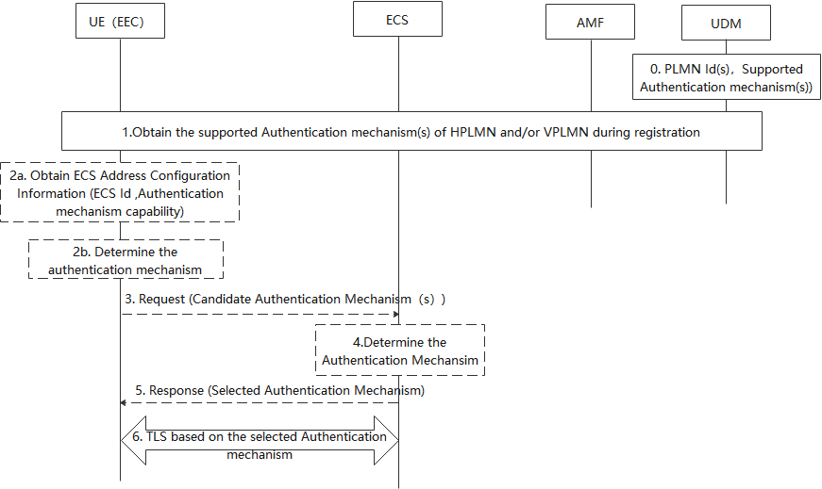
Figure 1 Authentication mechanism selection between the EEC and ECS
0. Supported Authentication method(s) (e.g. GBA, AKMA) of PLMN(s) is stored as UE subscription data in UDM.
1. During the registration procedure, the UE obtains the supported Authentication method(s) of UE HPLMN, if the UE is in roaming case, the UE also obtains the supported authentication mechanism (s) of the UE’s VPLMN.
2a. [Optional] During PDU Session Establishment, the SMF may provide ECS Address Configuration Information (ECS ID (e.g. FQDN or IP address(es) of ECS), [Authentication mechanism capability]) to the UE. The Authentication mechanism capability indicates the authentication mechanism the ECS support. When the UE would like to connect with ECS, if the Authentication mechanism capability recieved, performs step 2b, skip steps 3 to 5. Otherwise, performs steps 3 to 5 and skip step 2b.
2b. [Conditional] The UE determines the available network authentication mechanism based on the received supported authentication mechanism (s) and the PLMN Id of network the ECS located. Then the EEC determines the target authentication mechanism based on EEC authenticatin capability, authentication mechanism capability and the available network authencation mechanism.
If there is no availale authentication mechanism, the EEC will use default authentication mechanism.
Editor’s Note: If there is no available authentication mechanism, it is FFS whether the EEC will use certificate based default authentication mechanism.
3. [Conditional] The UE determines the available network authentication method based on the received supported authentication mechanism (s) and the PLMN Id of network the ECS located. Then the EEC determines the candidate authentication mechanism (s) based on EEC authenticatin capability and the available network authention mechanism. The UE sends request to ECS with candidate authentication mechanism (s).
4. The ECS determines selected authentication mechanism based on the received candidate authentication mechanism.
5. The ECS sends response with selected authentication mechanism to EEC. If there is no availale authentication mechanism, the ECS will indicate the EEC to use certificate based mechanism.
6. EEC and ECS establish the TLS base on the selected authentication mechanism.

6.X.3 Solution evaluation
TBD
*************** Start of 2nd Change ****************

6.Y Solution #Y: Authentication algorithm selection procedure between EEC and EES

6.Y.1 Solution overview
This solution addresses security requirement for authentication algorithm selection between EEC and EES in key issue #2.2.
In this solution, the UE first retireves the supported Authentication mechanism (s) of the network during registration, and optionally get the EES Authentication mechanism capability from ECS. When the EEC intend to connect to EES, the EEC determines the used authentication mechanism or candidate authentication mechanism.

6.Y.2 Solution details
This solution assumes that:
- Home network and/or Serving network, UE (EEC), ECS (as NAF in GBA, or AF in AKMA) may support multiple mechanisms (e.g., TLS with AKMA, TLS with GBA).
- Both EEC and EES supports default authentication mechanism.
Editor’s Note: It is FFS whether the TLS with certificate, TLS with AKMA, or TLS with GBA is selected as the default authentication mechanism.
Editor’s Note: It is FFS whether the default authentication mechanism is necessary or not.

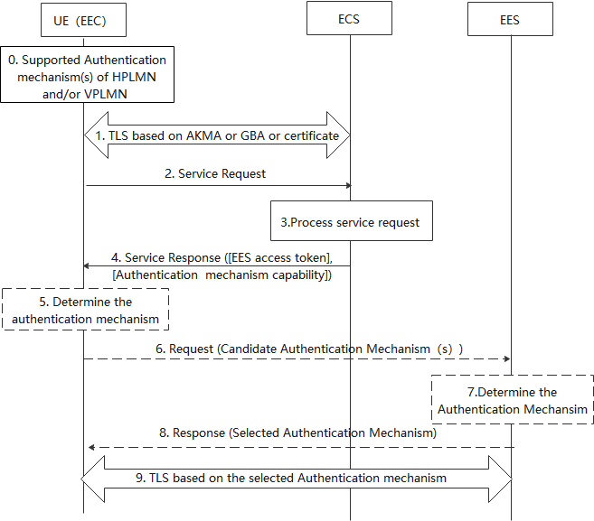
Figure 2 Authentication mechanism selection between the EEC and EES
- During the registration procedure, the UE obtains the supported Authentication method(s) of UE HPLMN, if the UE is in roaming case, the UE also obtains the supported authentication mechanism (s) of the UE’s VPLMN.
- EEC establishes TLS connection with ECS based on the AKMA or GBA or certificate.
- The EEC sends the service request to the ECS.
- The ECS should authorize the EEC by its local authorization policy, if the authentication and authorization is successesful, then the ECS processes the request.
- The ECS decides whether access tokens are required for the candidate EESes using the configuration information and issues separate EES access tokens to be used for each candidate EESes that use token-based authorization. The ECS sends the EES access tokens to the EEC. Optionally, the Authentication mechanism capability is included. The Authentication mechanism capability indicates the authentication mechanism the EES support.
When the EEC would like to connect with EES, if the Authentication mechanism capability recieved, performs step 5, skip steps 6 to 8. Otherwise, performs steps 6 to 8 and skip step 5.
- [Conditional]The UE determines the available network authentication mechanism based on the received supported authentication mechanism (s) and the PLMN Id of network the EES located. Then the EEC determines the target authentication mechanism based on EEC authenticatin capability, authentication mechanism capability and the available network authention mechanism.
If there is no availale authentication mechanism, the UEEEC will use certificate baseddefault authentication mechanism.
Editor’s Note: If there is no available authentication mechanism, it is FFS whether the EEC will use certificate based default authentication mechanism.
[Conditional] The UE determines the available network authentication method based on the received supported authentication mechanism (s) and the PLMN Id of network the EES located. Then the EEC determines the candidate authentication mechanism (s) based on EEC authenticatin capability and the available network authention mechanism. The EEC sends request to EES with candidate authentication mechanism (s).
- [Conditional]The EES determines selected authentication mechanism based on the received candidate authentication mechanism. If there is no availale authentication mechanism, the ECS will indicate the EEC to use certificate based mechanism.
- [Conditional]The EES sends response with selected authentication mechanism to EEC.
- EEC and ECS establish the TLS base on the selected authentication mechanism.

6.Y.3 Solution evaluation
TBD
*************** End of Changes ****************

