3GPP TSG SA WG3 Meeting #107Adhoc-e draft_S3-221382-r1

e-meeting, 27 June – 01 July 2022 revision S3-20abcd

Source: Huawei, HiSilicon

Title: New solution for KI #6 Relation between certificate management lifecycle and NF management lifecycle

Document for: Approval
Agenda Item: 5.5

Decision/action requested
This contribution proposes a new solution in TR 33.876

References
[1] 3GPP TS 23.502: Procedures for the 5G System (5GS)

Rational

Detailed proposal
*************** Start of 1st Change ****************

6.Y Solution #Y: Certificates revocation query procedure based on NRF

6.Y.1 Introduction
This solution addresses KI#6.
When the NF lifecycle is inconsistent with the certificate lifecycle, some security risks are exposed. For example, when the NF lifecycle is longer than the certificate lifecycle, after the certificate expires or is revoked, the NF may still be discovered by the NRF during the NF service discovery procedure and provided to the NF consumer. When the NF consumer setups a TLS connection with the NF producer, the connection between the NF consumer and the NF producer may fail because the certificate of the NF producer is invalid, although the NF consumer can select another NF producer. However, connection setup failures also affect network efficiency.
When the CRL/OCSP is maintained on the NF, an attacker may initiate an attack during the CRL update interval. In addition, if the CRL/OCSP is maintained on a third-party server, a signalling storm may occur when the CRL/OCSP is queried.

6.Y.2 Solution details

6.Y.2.1 General
Based on an existing service discovery procedure, this solution combines the certificate revocation status query with the service discovery procedure, thereby optimizing the efficiency of certificate revocation status query.
This solution also prevents the NRF from providing an NF producer to an NF consumer after the NF producer’s certificate expires or is revoked, that may cause connection setup failures.

6.Y.2.2 NF service Registration procedure
An NF carries its own certificate during registration. The NRF stores the certificate information as the NF context. In addition, when the certificate of the NF is renewed, this certificate needs to be updated in the NRF
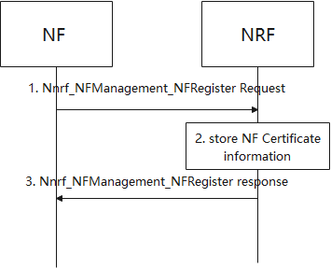
1. NF sends Nnrf_NFManagement_NFRegister Request message to NRF with all certificates of NF.
2. NRF stores the certificate information of certificates from NF.The certificate information can be certificate ID, certificate type and certificate validity time.
3. NRF acknowledge NF Registration is accepted via Nnrf_NFManagement_NFRegister response.

6.Y.2.3 NF/NF service discovery in the same PLMN
In the service discovery procedure, the NRF determines whether to provide the NF producer to the NF consumer based on the certificate status of the NF producer.
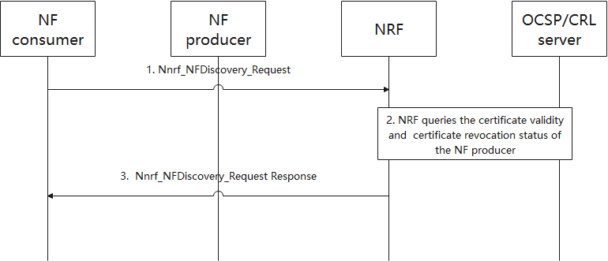
1. NF consumer initiates service discover procedure.
2. After determining the NF producer, the NRF queries the certificate validity of the NF producer through NF context and queries the certificate revocation status of the NF producer through the CRL or OCSP server. The NRF can interact with the CRL/OCSP server directly or through a proxy, depending on where the CRL/OCSP server is deployed.
If multiple NRFs are required to discovery a NF producer, NRF can forward the request to other NRFs as specified in TS23.502[1].
3. NRF sends Nnrf_NFDiscovery_Request Response message to NF consumer.

6.Y.3 Evaluation

*************** End of 1st Change ****************

