3GPP TSG-SA3 Meeting #107-e Ad Hoc draft_S3-221339-r1

e-meeting, 27 June – 1 July 2022

Source: Johns Hopkins University APL, US National Security Agency, CableLabs, InterDigital, AT&T, CISA ECD

Title: Remove EN in clause 6.6.3.4

Document for: Approval
Agenda Item: 5.2

1 Decision/action requested
It is requested to approve removal of EN in clause 6.6.3.4 in TR 33.848

2 References
[1] 3GPP TR 33.848, v 0.12.0: “Study on Security Impacts of Virtualisation”

3 Rationale
This contribution proposes to remove EN: “Communication between the PACF and NFV MANO is FFS”. The PACF needs to communicate with the Verifier entity within the attestation process. The attestation process is outside the domain of 3GPP functional level, however communication requirements between the PACF and Verifier are stated in clause 6.6.3.4 [1]: “The PACF requires a secure communication path to the Verifier. Policy information is sent from PACF to the Verifier. Attestation results are sent from the Verifier to the PACF. A trust relationship must be pre-established between the PACF and the Verifier.”

4 Detailed proposal
****Start of Change ****

6.6.3.4 Profile and Attestation Check Function (PACF)
Since the attestation procedures to verify the trustworthiness of VNFs and NFVI exist outside the domain of the 3GPP functional level, access to the attestation results is needed from within the 3GPP functional level. This access allows attestation to be integrated with select procedures in the control plane, such as NF registration and slicing operations. For instance, enterprise slices for some verticals may require the ability to query for proof of successful attestation to support their use cases. Applicability to NF registration is discussed in 6.6.3.5.
Additionally, default application of the same level of attestation to every virtualized NF in a 3GPP network may not be necessary. In which case, the 3GPP functional level can provide an attestation policy to the infrastructure responsible for attestation. The attestation policy describes the conditions for applying attestation and the type of measurements required to meet a specified level of assurance per VNF.
This solution proposes the PACF to coordinate access to attestation results from the 3GPP functional level and administer policy to help control how and when attestation is applied. Figure 6.6.3.4-1 presents a reference architecture integrating PACF into the NFV architecture. This architecture assumes the NFVI has been successfully attested and the virtualization layer software can act as the attester for VNFs.
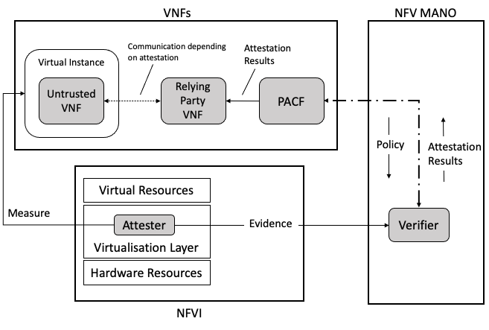
Figure 6.6.3.4-1 Reference architecture with PACF integrated with NFV architecture
The PACF serves as a bridge between the 3GPP functional level and the attestation infrastructure outside its domain. The PACF requires a secure communication path to the Verifier. Policy information is sent from PACF to the Verifier. Attestation results are sent from the Verifier to the PACF. A trust relationship must be pre-established between the PACF and the Verifier. Other network functions acting as Relying Parties must also trust the Verifier. This solution assumes the Verifier is located within the NFV MANO domain. An MnF entity can be embedded in the PACF to provide MnS(s) to interface with the NFV MANO.

****End of Change ****

