3GPP TSG-SA3 Meeting #107-e Ad Hoc S3-221337-r4

e-meeting, 27 June – 1 July 2022

Source: Johns Hopkins University APL, US National Security Agency, CableLabs, InterDigital, AT&T, CISA ECD

Title: Updates to Solution #5

Document for: Approval
Agenda Item: 5.2

1 Decision/action requested
It is requested to approve updates to Solution #5 in TR 33.848

2 References
[1] 3GPP TR 33.848, v 0.12.0: “Study on Security Impacts of Virtualisation”

3 Rationale
This contribution proposes updates to clause 6.6.3.5 in solution #5 of TR 33.848 [1] to address Editor’s Notes: 1) NF profile signing is FFS; 2) “The process for verifying attestation results of the NRF and PACF is FFS”; and 3) “In cases where the NF does not need to register to NRF, the NRF cannot perform verification of the attestation results as proposed in the solution. Evaluation of this case is FFS.”

4 Detailed proposal
****Start of Change ****

6.6.3.5 NF Service Registration Procedure with Remote Attestation
This solution proposes to provide proof to the 3GPP functional domain that a new VNF has been successfully attested before registration occurs in the 5G Core.
The NRF and PACF should operate in a different trust domain than the VNFs being attested during registration. The process for attesting the trustworthiness of the NRF and PACF should be separate from the one for attesting the VNFs. The first instance of a NRF and PACF are considered an edge case in terms of attestation. It will require a system administrator to manually verify that both NFs pass attestation properly.
Editor’s Note: The process for verifying attestation results of the NRF and PACF is FFS.
Once successfully instantiated, a new VNF will register with the NRF. The original NF Service Registration procedure is detailed in [13], clause 4.17.1. The modified NF Service Registration procedure shown in Figure 6.6.3.5-1 includes attestation by adding steps 2, 3, and 4. Steps 1, 5, and 6 are steps from the original procedure.
The modified NF Service Registration procedure retrieves attestation results based on the NF Instance ID in the NF profile. This solution proposes the use of digital signatures to enable integrity protection and verification of the NF profile sent in the registration request by the VNF. The NF profile should be signed by the OAM, NFV MANO, or an authorized delegate when the VNF instance is provisioned and instantiated on the NFVI. The NF profile should only be signed after the integrity of the VNF instance has been verified. Signing the NF profile prevents the registering VNF from altering the NF profile by forging the NF Instance ID of a successfully attested VNF.
NOTE: A signed NF profile is within alignment of TS 23.502 [13] clause 4.17.1. TS 23.502 clause 4.17.1, NOTE 2 states: the NF profile is configured by OAM system and NOTE 3 states: that whether the NF profile sent by NF service consumer to NRF needs to be integrity protected by the NF service consumer and verified by the NRF is to be decided by SA3.

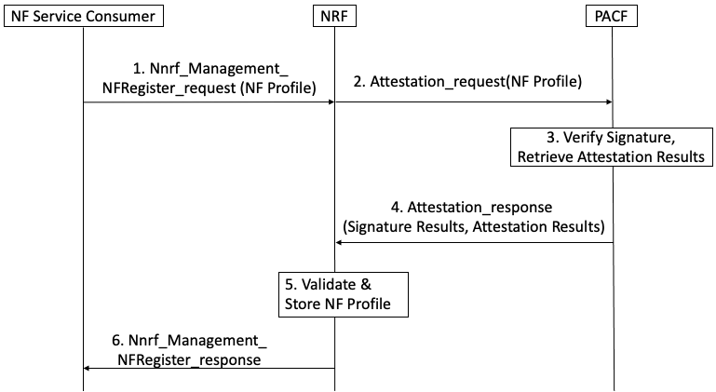
Figure 6.6.3.5-1: NF Service Registration Procedure with PACF

When an NF requires attestation results to register, the following steps are proposed for the registration procedure:
Step 1: NF service consumer, i.e. an NF instance, sends Nnrf_NFManagement_NFRegister Request message to NRF to inform the NRF of its NF profile when the NF service consumer becomes operative for the first time.

Step 2: The NRF initiates a request for attestation results and sends the signed NF profile to the PACF.
Step 3: The PACF verifies the signature on the NF profile and retrieves attestation results from the Verifier using the NF Instance ID from the NF profile.
If signature verification fails, the NF service consumer cannot be trusted and an exception handling procedure should be activated to handle an untrusted NF.

Step 4: The PACF responds to the NRF with attestation results it received from the Verifier.
Step 5: If the attestation results affirm successful attestation, the NF service consumer can be trusted. The NRF stores the NF profile of NF service consumer and marks the NF service consumer available.
Otherwise, if the attestation results affirm an unsuccessful attestation, the NF consumer cannot be trusted and a recovery procedure should be activated to handle an untrusted NF.
Step 6: The NRF acknowledge NF Registration is accepted via Nnrf_NFManagement_NFRegister response.
In cases where an NF does not register to the NRF (e.g., the NF is a pure NF consumer that only consumes but not offers services), retrieval of attestation results should be based on the local policy of the NF Service Producer. If the local policy at the NF Service Producer requires the attestation results of an NF Service Consumer prior to allowing the consumer to access its services, the NF Service Producer can initiate a request for attestation results via the PACF similar to Steps 2-4 in Figure 6.6.3.5-1.
There can also be interactions between NFs with MnF (as defined in TS 28.533) for NF management service.
Besides the above procedures defined in 3GPP, the NFs can also interact with domains defined in other SDOs, e.g., MANO defined in ETSI.
The main idea is requiring the Verifier to expose the attestation results of different layers to the network entities (NRF, NFp, PS, MnF, MANO, OAM, etc.) which will interact with the attested NF, then, on receiving the interaction from the NF, these network entities can invoke the attestation /results and take further actions.
NOTE: The Verifier itself can also be distributed in different layers. The network entities can communicate with the Verifier directly or via a unified proxy

6.6.4 Evaluation
Editor’s Note: To be added.

Editor’s Note: The linkage between provisioning certificates and OAuth tokens to remote attestation is FFS.

****End of Change ****

