3GPP TSG-SA3 Meeting #105e S3-214297

e-meeting, 8 – 19 November 2021 draft_S3-214297-r2

Source: Philips International B.V.

Title: Update Solution 37: Modification to ensure source authenticity in restricted discovery for relay and group discovery

Document for: Approval
Agenda Item: 5.7

1 Decision/action requested
Acceptance of additions in Solution #37 of TR33.847.

2 References

3 Rationale
Solution #37 describes the provisioning of security parameters for relay discovery and group discovery in public safety use cases. This provisioning relies on the distribution of the PSDK from which the DUIK and/or DUSK and/or DUCK are derived.
Key issue #1 requires source authenticity during restricted discovery. Source authenticity means that the receiver can verify that a message originates from a specific sending UE.
If the master key PSDK is delivered to the UEs, as described in Solution #37, source authenticity cannot be guaranteed in relay or group discovery even when the UEs are in coverage. The reason is that the receiving UE can impersonate the sending UEs since the receiving UEs always have access to the DUIK (since it is generated from the PSDK) used to compute the MIC.
In this situation the risk of device impersonation is high since:
- the MIC of the restricted discovery message is very likely to be computed from a common DUIK to be able to address multiple receiving devices and
- those receiving devices might be under the control of malicious parties, in particular, when relay/group discovery is used for commercial services.
Thus, it is of paramount importance to fully address KI#1 and ensure source authenticity in restricted relay discovery.
This solution describes keying procedures to ensure that UEs performing relay discovery can be properly configured to achive the source authenticity requirement and mitigate the risk of impersonation attacks when they are in coverage.

4 Detailed proposal
*** BEGIN OF 1st CHANGE ***

6.37 Solution #37: Keying procedures for Group Member and Relay discovery: public safety case

6.37.1 Introduction
This solution describes how the UE obtains the necessary security parameters to support group members and relay discovery, in coverage and out of coverage, for public safety scenarios. This solution addresses key issues #1, #2, and #4.

6.37.2 Solution details

6.37.2.1 Group member discovery case
Group member discovery is a type of restricted discovery and is expected to be supported in coverage and out of coverage. Group member discovery uses provisioned keys to support integrity, confidentiality and non-trackability of the discovery messages. A discovery root key from which other keys can be derived is used to secure over the air discovery and communications. This root key can be provisioned by the 5G DDNMF and/or by the 5G PKMF – this clarification is left for the normative stage.
The solution follows that of TS 33.303 [2], where for both public safety discovery scenarios – group member discovery and relay discovery – the same solution is provided: a Public Safety Discovery Key (PSDK) is provisioned as the root key that is used for the protection of the Public Safety Discovery messages, and is associated with one or more Application Layer Group IDs or respectively Relay Service Codes (RSCs). Both of these identifiers are defined in TS 23.303 [5].
The procedures are shown below for Group Member Discovery.
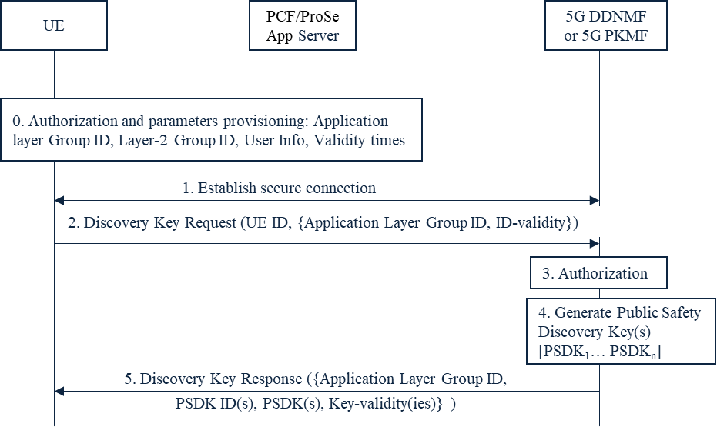
Figure 6.37.2.1-1: Discovery key provisioning for group member discovery, public safety case
Step 0: The UE connects to the network and obtains authorization from the PCF/ProSe App Server to perform Group Member discovery. The UE also gets the address of the 5GDDNMF of its HPLMN and/or of the 5G PKMF. Besides the security policy, the following additional parameters are sent to the UE: a set of one or more (ProSe) Layer-2 Group ID, User Info, Application Layer Group ID and their validity times.
NOTE 1: This step is briefly described in TS 23.304 [3].
Step 1: The UE establishes a secure connection with the 5GDDNMF or the 5G PKMF of its HPLMN. The UE ID is authenticated and authorized by the 5GDDNMF or the 5G PKMF.
NOTE 2: As this connection is established on the user plane, the same mechanism as used to protect the PC3 interface can be re-used. Either solution #5 or solution #11 can be used for securing the connection.
Step 2: The UE sends a discovery key request to the 5GDDNMF or the 5G PKMF of its HPLMN. In the key request includes at least the following information: UE ID, set of one or more Application Layer Group IDs and their validity times.
Step 3: The 5GDDNMF or the 5G PKMF checks whether the UE is authorized for group member discovery.
Step 4: If the check in step 3 is successful, then the 5GDDNMF or the 5G PKMF generates one or more Public Safety Discovery Keys (PSDK₁… PSDK_{n}) corresponding to the Application Layer Group ID and its PLMN ID. More than one PSDK may be generated, but the overall validity time should match the validity times of the corresponding set of Application Layer Group IDs of Step 2. The Expiry Time of the PSDK needs to be set such that the keys for later periods have a longer expiration period. PSDKs that have not expired can be used for discovery in out of coverage cases.
NOTE 3: When and how often the discovery keys need to be generated is left for normative work.
NOTE 4: The security keys in the Code-Sending Security Parameters of discoverer UE and the security keys in the Code-Sending Security Parameters of discoveree UE must be generated from two different PSDKs to avoid impersonation attacks in certain discovery configurations.
Step 5: The 5GDDNMF or the 5G PKMF sends the key response to the UE. The key response message includes at least the following information: UE ID, PSDK identifier(s), PSDK(s), validity time(s).

6.37.2.2 Relay discovery case
The procedures are similar to the ones for Group Member Discovery. For Relay discovery, the procedures for the relay discovery are identical, with the following exceptions:
- The UE is now the Remote UE or the UE-to-network Relay
- Instead of the parameter Application Layer Group ID, the Relay Service Code is used.
- Instead of Layer-2 Group ID, the Destination Layer-2 ID is used

NOTE 5: In Step 5, the 5G DDNMF or 5G PKMF can provision the UE with a subset of keys derived from a PSDK instead of with the PSDK itself. For instance, instead of distributing a PSDK to a UE, the UE is only provisioned with the DUCK and/or DUSK and/or DUIK, derived from the PSDK.

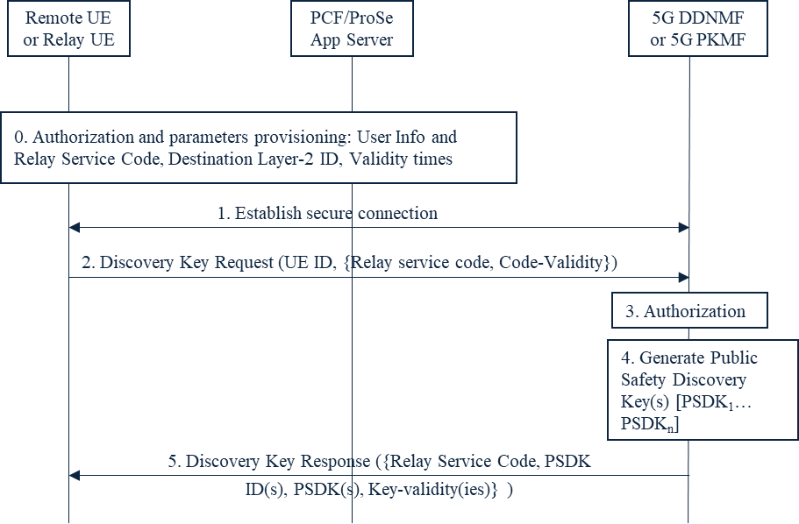

Figure 6.37.2.2-1: Discovery key provisioning for relay discovery, public safety case

6.37.3 Evaluation
The solution addresses key issues #1, and partially key issues #2, and #4 in the following way. Authorization for the UE to act as a group member, or UE-to-network relay, or Remote UE is provided by the PCF/ProSe App Server. The PCF/ProSe App Server provisions both policy as well as a group member and relay discovery parameters, along with their validity times. In addition, this solution describes how the UE obtains discovery keying material to support Group Member Discovery, in coverage and out of coverage. Lastly, the solution describes how the Remote UE and the UE-to-network Relay retrieve the discovery keying material for the corresponding Relay Service Code(s). This solution is intended for Public Safety services.
The following observations are made:
The UE is provisioned by the PCF/ProSe App Server with the address of the 5G DDNMF and/or the 5G PKMF.
This solution has no impact on the RAN or the network nodes AMF, AUSF.
In this solution, the 5G DDNMF, or another NF – the 5G PKMF (located in the UE’s HPLMN or external to it), handles the management of discovery keys for discovering a group member UE or a UE-to-network Relay.
SA2 has defined the 5G DDNMF in TS 23.304 [16] in the architecture, with reference points and services provided.
SA2 has not defined the NF - 5G PKMF, which manages discovery keys, in the architecture for the Group member discovery and UE-to-network relay scenarios as proposed in this solution, but SA2 did not define the PKMF in LTE either.
In LTE, the PKMF is only used for Public Safety. This solution proposes to reuse the logic of the 5G DDNMF (or the ProSe Function in LTE) or the 5G PKMF which is part of the PLMN.
SA2 should make note that the security material for relay discovery is not provisioned by the PCF/ProSe App Server, but by the 5G DDNMF or 5G PKMF.
Key issue #1 requires that “The entity which receives a restricted discovery message on the PC5 interface shall be able to verify the source authenticity.” Source authenticity means that the receiver can verify that a message originates from a (specific) sending UE. In coverage use cases, if the master key PSDK is delivered to the UEs, source authenticity cannot be guaranteed The reason is that the receiving UE can impersonate the sending UEs since the receiving UEs always have access to the DUIK (since it is generated from the PSDK) used to compute the MIC. In this situation there is a risk of device impersonation when:
- the MIC of the restricted discovery message is computed from a common DUIK to support multiple receiving devices and
- one or more of those receiving devices (remote UEs) fall under the control of malicious parties.
This solution allows provisioning a device performing relay discovery without the DUIK. This allows for an “asymmetric” configuration in which only a sending UE (e.g., a single device or a single type of device, e.g., announcing UEs) is provisioned with the DUIK while the rest of receiving devices (e.g., monitoring UEs) do not have access to the DUIK. The receiving UEs can rely on match reports to verify the integrity of the discovery messages. This configuration ensures that a sending UE cannot be impersonated by a receiving UE, and thus, allows for source authenticity as required in KI #1. This configuration is only applicable to relay and remote UEs that are in coverage.
*** END OF 1st CHANGE ***

