3GPP TSG-SA3 Meeting #105-e draft_S3-214218-r4

e-meeting, 08 - 19 November 2021 Merger of S3-214218, S3-214042

Source: Samsung, Interdigital, LG Electronics, Nokia, Nokia Shanghai Bell, Huawei, HiSilicon

Title: Proposal for U2NW relay authentication, authorization and key management

Document for: Approval
Agenda Item: 4.21

1 Decision/action requested
It is requested to approve this pCR for TS 33.503.

2 References
[1] 3GPP TR 33.847 Study on security aspects of enhancement for proximity-based services in the 5G System

3 Rationale
Based on outcome from SA3#104-e Ad-Hoc meeting, it was concluded that AUSF derives the PC5 anchor key (e.g., sol#1, sol#15, sol#30, sol#39) used for PC5 keys derivation and that performing primary authentication during PC5 link establishment (e.g. Sol#1, Sol#10, Sol#30) is supported.
This pCR proposes consolidated mechanisms for L3 U2N Relay authentication, authorization and key management using the primary authentication prior and during PC5 link establishment for PC5 keys establishment. AUSF is used for key derivation and distribution of keys used for UE-to-network relay communication.

4 Detailed proposal

*****Start of 1st Change*****

2 References
[xx] 3GPP TS 23.503: "Policy and charging control framework for the 5G System (5GS); Stage 2".
[yy] 3GPP TS 33.536: "Security aspects of 3GPP support for advanced Vehicle-to-Everything (V2X) services"
[zz] 3GPP TS 33.220: "Generic Authentication Architecture (GAA); Generic Bootstrapping Architecture (GBA)".
[xy] 3GPP TS 33.501: "Security architecture and procedures for 5G System".
[aa] 3GPP TS 23.304: “Proximity based Services (ProSe) in the 5G System (5GS)”.
******2nd Change******

6.4 Security for 5G ProSe UE-to-Network Relay Communication
Editor’s Notes: This clause contains the description of the security for 5G ProSe UE-to-Network Relay Communication.

6.4.1 General

6.4.2 Security requirements

6.4.3 Security for 5G ProSe Communication via 5G ProSe Layer-3 UE-to-Network Relay

6.4.3.1 General
This sub-clause describes the security mechanisms for the L3 U2N Relay authentication, authorization and key management using the primary authentication for PC5 keys establishment. Network entities AMF, AUSF and UDM are involved for key derivation and distribution of keys used for UE-to-network relay communication.

6.4.3.2 UE-to-Network Relay using ProSe Key Management Function
Editor’s Notes: This clause describes the security procedure that uses ProSe Key Management Function to authenticate/authorize UE during 5G ProSe UE-to-Network Relay Communication.

6.4.3.3 Security procedure over Control Plane
The UE shall be provisioned with necessary policies and parameters to use 5G ProSe services, as part of the UE ProSe Policy information as defined in TS 23.503 [xx] clause 4.2.2. PCF shall provision the authorization policy and parameters for 5G UE-to-Network Relay Discovery and Communication as specified in 5.1.4 in TS 23.304 [aa]. Security materials related to the discovery shall be provisioned by 5GDDNMF.

6.4.3.3.1 Connection with UE-to-Network Relay connection with setup of network Prose security context during PC5 link establishment
This subclause describes a procedure for a Remote UE to establish a PC5 link between a Remote UE and a UE-to-Network relay. The procedure includes how the Remote UE is authenticated by AUSF via Relay UE and Relay UE's AMF during 5G ProSe PC5 establishment. The mechanism can be used by a Remote UE while out of coverage.

Figure 6.4.3.3.1-1: UE-to-Network Relay security procedure with setup of network Prose security context during PC5 link establishment
0. The Remote UE and relay UE shall be registered with the network. The UE-to-Network relay shall be authenticated and authorized by the network to support as a relay UE. Remote UE shall be authenticated and authorized by the network to act as a Remote UE.
1. The remote UE shall initiate discovery procedure using any of Model A or Model B method as specified in clause 6.3.1.2 or 6.3.1.3 of TS 23.304 [aa] respectively.
2-5. After the discovery of the UE-to-Network relay, the Remote UE shall send a Direct Communication Request to the relay UE for establishing secure PC5 unicast link. The Remote UE shall include its security capabilities and security policy in the DCR message as specified in TS 33.536 [xx]. The message shall also include SUCI, Relay Service Code, Nonce_1. Upon receiving the DCR message, the Relay UE shall send the relay key request to the relay AMF, including the parameters received in the DCR message. The Relay AMF shall verify whether it is allowed to act as a relay UE. The relay AMF shall select AUSF based on SUCI and forward the key request to the AUSF in Nausf_UEAuthentication_Authenticate Request message.
6-7. The AUSF shall retrieve the Authentication Vectors from the UDM and trigger primary authentication of the remote UE using existing procedure as specified in TS 33.501[xx]. This authentication is perfomed between the AUSF and the remote UE via the relay AMF and relay UE. AUSF shall not make the newly derived K_{AUSF} as the latest K_{AUSF}. At the remote UE, the newly derived K_{AUSF} shall not be taken as latest K_{AUSF} as NAS SMC procedure is not performed between remote UE and relay AMF.
Editor’s Notes: Further details on authentication message handling in UE, Relay UE's AMF and AUSF are FFS.

8. On successful primary authentication, the AUSF and Remote UE shall generate 5GPRUK (as specified in Annex A.Y) and 5GPRUK ID. 5GPRUK ID is in NAI format as specified in clause 2.2 of IETF RFC 7542 [bb], i.e. username@realm. The username part includes the Routing Identifier and the P-TID (ProSe Temporary UE Identifier), and the realm part includes Home Network Identifier. The P-TID derivation is specified in Annex A.Ya using the newly derived K_{AUSF.}
9. The AUSF shall generate the K_{NR_ProSe} key as defined in Annex A.Z.
10-11. The AUSF shall send the 5GPRUK ID, K_{NR_ProSe}, Nonce_2 in Nausf_UEAuthentication_Authenticate Response message to the UE-to-Network relay via relay AMF. When receiving a K_{NR_ProSe} from AUSF, the AMF shall not attempt to trigger NAS SMC procedure with Remote UE. Relay UE derives PC5 session key K_{relay-sess} and confidentiality and integrity keys from K_{NR_ProSe}, in a similar way as K_{NRP-sess} is derived from K_{NRP}, and confidentiality and integrity keys from K_{NRP-sess} in TS 33.536[xy]. K_{NR_ProSe} ID and K_{relay-sess} ID are established in the same way as K_{NRP} ID and K_{NRP-sess} ID in TS 33.536[xy].12. The UE-to-Network relay shall send the received 5GPRUK ID, Nonce_2 to the Remote UE in Direct Security mode command message.
13-14. The remote UE shall use the 5GPRUK ID to locate the K_{AUSF}/5GPRUK to be used for the PC5 link security. Remote UE shall generate the K_{NR_ProSe} key to be used for Remote access via the Relay UE in the same way as defined in step 9. The Remote UE shall derive PC5 session key K_{relay-sess} and confidentiality and integrity keys from K_{NR_ProSe} the same way as defined in step 11. Remote UE shall send the Direct Security mode complete message to the UE-to-Network relay.
Further communication between Remote UE and Network takes place securely via the UE-to-Network relay.

6.4.3.3.2 Connection with UE-to-Network Relay with setup of network Prose security context prior to PC5 link establishment
This subclause describes a procedure for a Remote UE to establish a PC5 link between a Remote UE and a UE-to-Network relay. The procedure includes how the Remote UE has registered with the network and the serving AUSF has established an initial ProSe security context prior to PC5 link establishment.

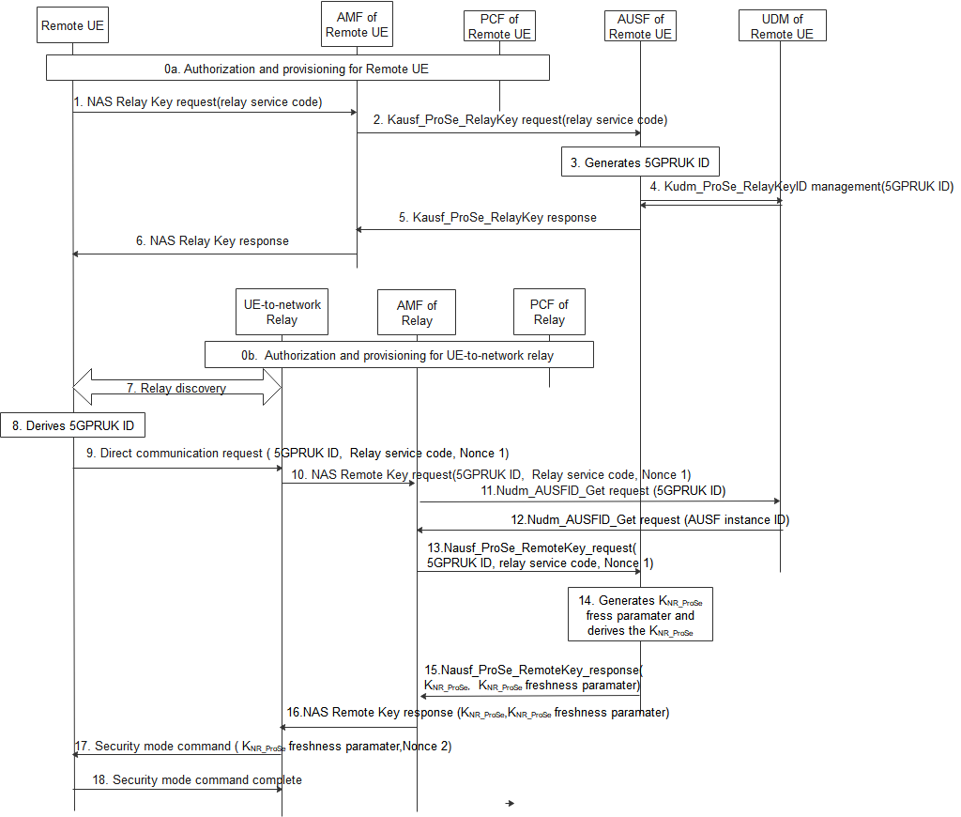
Figure 6.4.3.3.2-1: UE-to-Network Relay security procedure with setup of network Prose security context prior to PC5 link establishment

0. The Remote UE and the UE-to-network relay fetch the parameters necessary to act as a Remote UE and UE-to-network relay respectively (see TS 23.304[aa]).
1. The Remote UE shall send a NAS key request including Relay Service Code(s) message to the remote AMF.
2. After receiving the NAS relay key request from UE, the Remote AMF that serves the remote UE first checks whether the UE is authorized to be as a remote UE. If it is authorized, the Remote AMF further sends Nausf_ProSe_RelayKey request with relay service code(s). The Remote AMF gets the AUSF instance from the Remote UDM.
3. The Remote AUSF that serves the remote UE generates 5GPRUK and 5GPRUK ID for each relay service code in the Nausf_ProSe_RelayKey request.
5GPRUK is derived from K_{AUSF} as specified in Annex A.Y.
5GPRUK ID is in NAI format as specified in clause 2.2 of IETF RFC 7542 [bb], i.e. username@realm. The username part includes the Routing Identifier and the P-TID (ProSe Temporary UE Identifier), and the realm part includes Home Network Identifier.
The P-TID is derived from K_{AUSF} as specified in Annex A.Ya.
4. The Remote AUSF further stores 5GPRUK ID in UDM via Kudm_ProSe_RelayKey service.
5. The Remote AUSF sends Nausf_ProSe_RelayKey response to the AMF.
6. The Remote AMF sends the NAS relay Key response to the UE.
7. The Remote UE discovers the UE-to-network Relay using either model A or model B discovery as described in TS 23.304 [aa].
8. The Remote UE derives 5GPRUK ID based on the relay service code the Remote UE would like to access using the same method as the remote AUSF.
9. The Remote UE sends a Direct Communication Request. The Direct Communication Request contains the Relay Service Code, 5GPRUK ID, and Nonce1.
10. The UE-to-Network relay triggers the PC5 root key (i.e. PC5 root key for communicating with the remote UE) retrieval procedure. The UE-to-Network Relay sends NAS remote Key request with 5GPRUK ID, Relay service code, Nonce 1.
11. The relay AMF that serves the relay UE first check whether the relay UE is authorized to be a relay. If authorized, The AMF discovers the UDM based on the 5GPRUK ID, the relay AMF sends Nudm_AUSFID_Get request with 5GPRUK ID to the UDM.
12. UDM response to relay AMF via Nudm_AUSFID_Get with AUSF instance ID of the AUSF serving the remote UE.
13. AMF further sends Nausf_ProSe_RemoteKey request with 5GPRUK ID, Relay service code, Nonce 1 to the remote AUSF.
14. The remote AUSF generates K_{NR_ProSe} freshness parameter and derives K_{NR_ProSe} using at least 5GPRUK, K_{NR_ProSe} freshness parameter, and Nonce 1 as input.
15. The remote AUSF sends Nausf_ProSe_RemoteKey response with K_{NR_ProSe}, K_{NR_ProSe} freshness parameter to the relay AMF.
16. The relay AMF sends NAS remote Key response K_{NR_ProSe}, K_{NR_ProSe} freshness parameter to the UE-to-network relay.
NOTE: NAS confidentiality protection and intergrity protection is activated.
17. The UE-to-network relay sends a Direct Security Mode Command message to the Remote UE, K_{NR_ProSe} freshness parameter, and Nonce 2 are included in the message.
18. The Remote UE derives K_{NR_ProSe} key in the same way as the remote AUSF in step 14. The DSMC message is integrity and confidentiality protected as in TS 33.536[yy].

6.4.3.3.3 PC5 Key Hierarchy
Figure 6.4.3.3.3-1: PC5 Key Hierarchy for UE-to-Network Relay security

The different layers of keys (see Figure 6.4.3.3.1-1) are the following:
- 5GPRUK: The root credential derived from K_{AUSF} that is the root of security of the PC5 unicast link.
- K_{NR_ProSe}: This is a 256-bit root key that is established between the two entities that communicating using NR PC5 unicast link. It may be refreshed by re-running the authentication to derive a fresh 5GPRUK.
- K_{relay-sess}: This is the 256-bit key that is derived by UE from K_{NR_ProSe} and is used derive keys that to protect the transfer of data between the UEs. The K_{relay-sess} is derived per unicast link same as K_{NRP-sess} specified in TS 33.536 [xy]. During activated unicast communication session between the UEs, the K_{relay-sess} may be refreshed by running the rekeying procedure. The keys for confidentiality and integrity algorithms are derived directly from K_{relay-sess}. The 16-bit K_{relay-sess} ID identifies the K_{relay-sess}.
- K_{relay-int}, K_{relay-enc}: The Krelay-int and Krelay-enc are used in the chosen confidentiality and integrity algorithms respectively for protecting PC5-S signalling, PC5 RRC signalling, and PC5 user plane data. These keys are equivalent to NRPIK and NRPEK as specified in TS 33.536 [xy]. They are derived from K_{relay-sess} and are refreshed automatically every time K_{relay-sess} is changed.

***** 3rd Change*****

Annex A (normative):
Key derivation functions

A.X KDF interface and input parameter construction

A.X.1 General
All key derivations for 5G ProSe shall be performed using the key derivation function (KDF) specified in Annex B.2.2 of TS 33.220 [xx].
This clause specifies how to construct the input string, S, and the input key, KEY, for each distinct use of the KDF. Note that "KEY" is denoted "Key" in TS 33.220 [xx].

A.X.2 FC value allocations
The FC number space used is controlled by TS 33.220 [xx], FC values allocated for the present document are : 0xXX, 0xYY, 0xAA , 0xZZ.

A.Y 5GPRUK derivation function
When deriving a 5GPRUK from K_{AUSF}, the following parameters shall be used to form the input S to the KDF:
- FC = 0xXX;
- P0 = SUPI;
- L0 = length of SUPI.
- P1 = relay service code;
- L1 = length of relay service code.
The input key KEY is K_{AUSF}.
SUPI shall behave the same value as parameter P0 in Annex A.7.0 of TS 33.501 [xx].

A.Ya Derivation of P-TID
When deriving the P-TID from K_{AUSF}, the following parameters are used to form the input S to the KDF:
- FC = 0xAA (to be allocated by 3GPP);
- P0 = "PRUK-ID";
- L0 = length of "PRUK-ID".
- P1 = relay service code;
- L1 = length of relay service code.
- P2 = SUPI;
- L2 = length of SUPI.
The input key KEY is K_{AUSF}.

A.Z K_{NR_ProSe} derivation function
When deriving the K_{NR_ProSe} from 5GPRUK key, the following parameters shall be used to form the input S to the KDF:
- FC = 0xZZ;
- P0 = Nonce_2;
- L0 = length of Nonce_2;
- P1 = Nonce_1;
- L1 = length of Nonce_1
The input key KEY shall be 5GPRUK key.
SUPI shall be have the same value as parameter P0 in Annex A.7.0 of TS 33.501 [xx].

******End of Change******

