3GPP TSG-SA3 Meeting #105-e draft_S3-214042-r1

e-meeting, 08 - 19 November 2021 Revision of S3-20xxxx

Source: Huawei, HiSilicon

Title: Security for 5G ProSe Communication via 5G ProSe UE-to-Network Relay

Document for: Approval, Information, Discussion
Agenda Item: 4.21

1 Decision/action requested
It is requested to approve this pCR for TR 33.503..

2 References
[1] 3GPP TR 33.847 Study on security aspects of enhancement for proximity-based services in the 5G System.

3 Rationale
In last meeting, for the control plane solution, the following conclusion is made:
- For PC5 link security, PC5 keys are derived using keys derived from the primary authentication (e.g., sol#1, #10, #15, #30). The security of the communication between UE-to-Network relay and remote UE is established based on a shared key which is derived and distributed with the assistance of the network. A root credential is configured in the remote UE and the network. The shared key is individually derived from the root credential by the remote UE and the network. The shared key is distributed by the AMF to the UE-to-Network relay.
- AUSF derives the PC5 anchor key (e.g., sol#1, sol#15, sol#30, sol#39) used for PC5 keys derivation.
This contribution proposes to define the procedure on how to estabslish the security between the remote UE and ProSe UE-to-network Relay using primary authentication.

4 Detailed proposal
*****Start of 1st Change*****

6.4.3 Security for 5G ProSe Communication via 5G ProSe Layer-3 UE-to-Network Relay

6.4.3.1 General
The 5G ProSe layer-3 UE-to-network relays procedures are described in TS 23.304 [x]. This clause details the security procedures for 5G ProSe layer-3 UE-to-network relays.

6.4.3.2 Security procedure over User Plane
Editor’s Notes: This clause describes the security procedure that uses ProSe Key Management Function to authenticate/authorize UE during 5G ProSe UE-to-Network Relay Communication.

6.4.3.3 Security procedure over Control Plane
Editor’s Notes: This clause describes the security procedure that relies on primary authentication procedure to authenticate/authorize UE during 5G ProSe UE-to-Network Relay Communication.

6.4.3.3.1 Overview
This subclause describes the overall security procedures for 5G ProSe Communication via 5G ProSe Layer-3 UE-to-Network Relay over control plane. These includes PC5 keys establishment, authorization verification.

6.4.3.3.2 Securty procedure with established ProSe security context
The Remote UE has registered with the network and the serving AUSF has established initial ProSe security context. There is no separate primary authentication procedure executed during 5G ProSe Communication procedure via 5G ProSe Layer-3 UE-to-Network Relay.
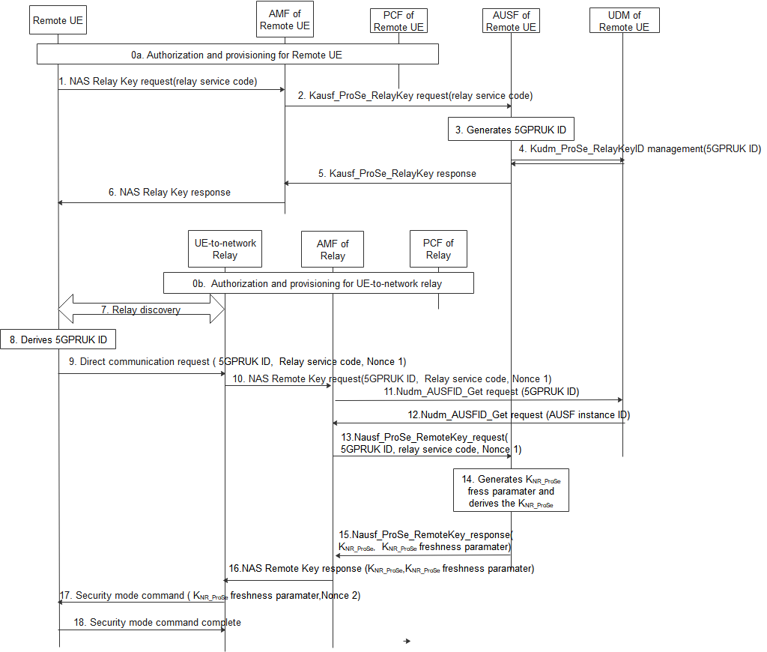
0. The Remote UE and the UE-to-network relay fetch the parameters necessary to act as a Remote UE and UE-to-network relay respectively (see TS 23.304[x]).
1. The Remote UE shall send a NAS key request including Relay Service Code(s) message to the remote AMF.
2. After receiving the NAS relay key request from UE, the Remote AMF that serves the remote UE first checks whether the UE is authorized to be as a remote UE. If it is authorized, the Remote AMF further sends Nausf_ProSe_RelayKey request with relay service code(s). The Remote AMF gets the AUSF instance from the Remote UDM.
3. The Remote AUSF that serves the remote UE generates 5GPRUK and 5GPRUK ID for each relay service code in the Nausf_ProSe_RelayKey request.
5GPRUK is derived from K_{AUSF} as specified in 6.4.3.3.3.
5GPRUK ID is in NAI format as specified in clause 2.2 of IETF RFC 7542 [y], i.e. username@realm. The username part includes the Routing Identifier and the P-TID (ProSe Temporary UE Identifier), and the realm part includes Home Network Identifier.
The P-TID is derived from K_{AUSF} as specified in 6.4.3.3.4.
4. The Remote AUSF further stores 5GPRUK ID in UDM via Kudm_ProSe_RelayKey service.
5. The Remote AUSF sends Nausf_ProSe_RelayKey response to the AMF.
6. The Remote AMF sends the NAS relay Key response to the UE.
7. The Remote UE discovers the UE-to-network Relay using either model A or model B discovery as described in TS 23.304 [x].
8. The Remote UE derives 5GPRUK ID based on the relay service code the Remote UE would like to access using the same method as the remote AUSF.
9. The Remote UE sends a Direct Communication Request. The Direct Communication Request contains the Relay Service Code, 5GPRUK ID, and Nonce1.
10. The UE-to-Network relay triggers the PC5 root key (i.e. PC5 root key for communicating with the remote UE) retrieval procedure. The UE-to-Network Relay sends NAS remote Key request with 5GPRUK ID, Relay service code, Nonce 1.
11. The relay AMF that serves the relay UE first check whether the relay UE is authorized to be a relay. If authorized, The AMF discovers the UDM based on the 5GPRUK ID, the relay AMF sends Nudm_AUSFID_Get request with 5GPRUK ID to the UDM.
12. UDM response to relay AMF via Nudm_AUSFID_Get with AUSF instance ID of the AUSF serving the remote UE.
13. AMF further sends Nausf_ProSe_RemoteKey request with 5GPRUK ID, Relay service code, Nonce 1 to the remote AUSF.
14. The remote AUSF generates K_{NR_ProSe} freshness parameter and derives K_{NR_ProSe} using at least 5GPRUK, K_{NR_ProSe} freshness parameter, and Nonce 1 as input.
15. The remote AUSF sends Nausf_ProSe_RemoteKey response with K_{NR_ProSe}, K_{NR_ProSe} freshness parameter to the relay AMF.
16. The relay AMF sends NAS remote Key response K_{NR_ProSe}, K_{NR_ProSe} freshness parameter to the UE-to-network relay.
NOTE: NAS confidentiality protection and intergrity protection is activated.
17. The UE-to-network relay sends a Direct Security Mode Command message to the Remote UE, K_{NR_ProSe} freshness parameter, and Nonce 2 are included in the message.
18. The Remote UE derives K_{NR_ProSe} key in the same way as the remote AUSF in step 14. The DSMC message is integrity and confidentiality protected as in TS 33.536[z].

6.4.3.3.3 Derivation of 5GPRUK
When deriving the 5GPRUK from K_{AUSF}, the following parameters are used to form the input S to the KDF:
- FC = xxxx (to be allocated by 3GPP);
- P0 = SUPI;
- L0 = length of SUPI.
- P1 = relay service code;
- L1 = length of relay service code.
The input key KEY is K_{AUSF}.
SUPI shall behave the same value as parameter P0 in Annex A.7.0 of TS 33.501 [xx].

6.4.3.3.4 Derivation of P-TID
When deriving the P-TID from K_{AUSF}, the following parameters are used to form the input S to the KDF:
- FC = xxxx (to be allocated by 3GPP);
- P0 = "PRUK-ID";
- L0 = length of "PRUK-ID".
- P1 = relay service code;
- L1 = length of relay service code.
The input key KEY is K_{AUSF}.
*****End of the Change*****

