3GPP TSG-SA3 Meeting #105-e draft_S3-214040-r1

e-meeting, 08 - 19 November 2021 Revision of S3-20xxxx

Source: Huawei, HiSilicon

Title: P-TID Privacy protection in solution 39

Document for: Approval, Information, Discussion
Agenda Item: 5.7

1 Decision/action requested
This contribution proposes to resolve the EN on privacy of P-TID.

2 References
[1] 3GPP TR 33.847 "Study on Security Aspects of Enhancement for Proximity Based Services in 5GS".

3 Rationale
This contribution proposes to resolve the following Editor Note:
Editor’s Note: How to protect privacy of P-TID is FFS.

4 Detailed proposal
*************** Start of 1st Change ****************

6.39 Solution #39: Key management in UE-to-Network Relay based on shared key generated during primary authentication

6.39.1 Introduction
This solution addresses the KI #3, KI#4 and KI#9. This solution provides a mechanism to set up PC5 link security between a remote UE and UE-to-network relay based on primary authentication.

6.39.2 Solution details

6.39.2.1 Procedure
The procedure for key management in UE-to-Network relay shared key generated using primary authentication is depicted in Figure 6.15.2-1.

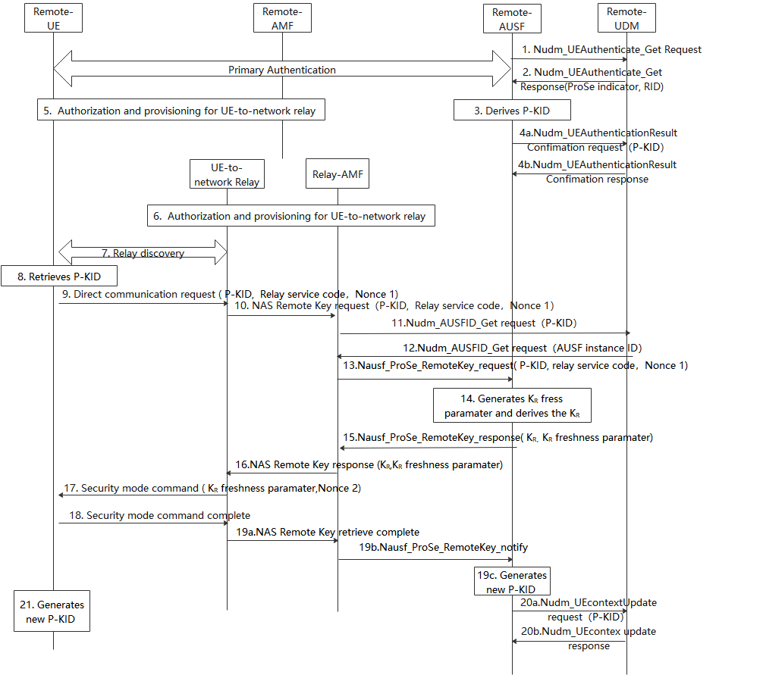
1. During the primary authentication procedure, the AUSF interacts with the UDM in order to fetch authentication information such as subscription credentials (e.g. AKA Authentication vectors) and the authentication method using the Nudm_UEAuthentication_Get Request service operation.
2. In the response, the UDM may also indicate to the AUSF whether ProSe Key Identifier (P-KID) needs to be generated for the UE. If the ProSe Indicator is included, the UDM shall also include the RID of the UE.
3. If the AUSF receives the ProSe indication from the UDM, the AUSF shall store the K_{AUSF} and generate the P-KID from K_{AUSF} after the primary authentication procedure is successfully completed.
P-KID is in NAI format as specified in clause 2.2 of IETF RFC 7542 [6], i.e. username@realm. The username part includes the Routing Identifier and the P-TID (ProSe Temporary UE Identifier), and the realm part includes Home Network Identifier.
The P-TID is derived from K_{AUSF} as specified in 6.39.2.2.
4. AUSF sends the P-KID via Nudm_UEAuthenticationResultConfirmation request to UDM, the UDM stores the P-KID with AUSF instance ID and sends Nudm_UEAuthenticationResultConfirmation response to the AUSF.
5. Authorization and provisioning are performed for the Remote UE.
6. During the Registration procedure, authorization and provisioning are performed for the ProSe UE-to-NW relay.
7. The Remote UE discovers the UE-to-network Relay using either model A or model B discovery.
8. The Remote UE derives P-KID using the same method as the remote AUSF.
9. The Remote UE sends a Direct Communication Request. The Direct Communication Request contains the Relay Service Code, P-KID and Nonce1.
10. The UE-to-Network relay triggers the PC5 root key (i.e PC5 root key for communicating with the remote UE) retrieval procedure. The Relay sends NAS remote Key request with P-KID, Relay service code, Nonce 1.
11. The relay AMF that serves the relay UE first check whether the relay UE is authorized to be a relay. If authorized, The AMF discovers the UDM based on the P-KID, the relay AMF sends Nudm_AUSFID_Get request with P-KID to the UDM.
12. UDM response to relay AMF via Nudm_AUSFID_Get with AUSF instance ID of the AUSF serving remote UE.
13. AMF further sends Nausf_ProSe_RemoteKey request with P-KID, Relay service code, Nonce 1 to the remote AUSF.
14. The remote AUSF generates KR freshness parameter and derives KR using at least Kausf, relay service code, KR freshness parameter and Nonce 1 as input.
15. The remote AUSF sends Nausf_ProSe_RemoteKey response with KR, KR freshness parameter to the relay AMF.
16. The relay AMF sends NAS remote Key response KR, KR freshness parameter to the UE-to-network relay.
NOTE: This solution requires integrity and confidentiality protected NAS messages.
17. The UE-to-network relay sends a Direct Security Mode Command message to the Remote UE, KR freshness parameter and Nonce 2 are included in the message.
18. The Remote UE derives the KR key in the same way as the remote AUSF in step 14. The DSMC message is integrity and confidentiality protected as in TS 33.536[8].
NOTE: The key lifetime issue will further align with the other normative work to address key lifetime

Editor’s Note: Kausf desync should be further studied.
Editor’s Note: How to determine the key lifetime is FFS.
19. The UE-to-network relay notifies the remote AUSF in steps 19a and 19b, about the Remote UE successfully receiving the Direct Security Mode Command message. The AUSF generates a new P-KID from the K_{AUSF} in step 19c (i.e. after step 19a and 19b). Steps 19-21 are skipped if the UE-to-network relay fails to receive the Direct Security Mode Complete message. The new P-KID is also in NAI format as specified in clause 2.2 of IETF RFC 7542 [6], i.e. username@realm. The username part includes the Routing Identifier and the P-TID*, and the realm part includes Home Network Identifier.
The P-TID* is derived from K_{AUSF} as specified in 6.39.2.3.
20. AUSF sends the new P-KID via Nudm_UEContextupdate request to UDM, the UDM stores the P-KID with AUSF instance ID and sends Nudm_UEContextupdate response to the AUSF.
21. Before the remote UE initiates a new DCR, the remote UE derives a new P-KID using the same method as the remote AUSF and include the new P–KID in the DCR.

6.39.2.2 Derivation of P-TID
When deriving the P-TID from K_{AUSF}, the following parameters are used to form the input S to the KDF:
- FC = xxxx (to be allocated by 3GPP);
- P0 = SUPI;
- L0 = length of SUPI.
- P1 = “P-TID”;
- L1 = length of “P-TID”.
The input key KEY is K_{AUSF}.
SUPI has the same value as parameter P0 in Annex A.7.0 of TS 33.501 [2].

6.39.2.3 Derivation of P-TID*
When deriving the P-TID* from K_{AUSF}, the following parameters are used to form the input S to the KDF:
- FC = xxxx (to be allocated by 3GPP);
- P0 = SUPI;
- L0 = length of SUPI.
- P1 = P-TID;
- L1 = length of P-TID.
The input key KEY is K_{AUSF}. The input P-TID is current P-TID.
SUPI has the same value as parameter P0 in Annex A.7.0 of TS 33.501 [2].

*************** End of 1st Change ****************

