3GPP TSG-SA3 Meeting #105-e draft_S3-214019-r4

e-meeting, 08 – 19 November 2021 Revision of S3-21xxxx

Source: Huawei, HiSilicon

Title: Addressing the editor’s notes in sol#27

Document for: Approval
Agenda Item: 5.1

1 Decision/action requested
SA3 is kindly requested to approve the proposed changes to TR 33.809.

2 References
[1] TR 33.809

3 Rationale
The following editor’s notes are addressed in this contribution:
Editor’s Note: analysis of ID based solution is FFS.
Editor’s note: it is FFS to analyze alternative approaches that might allow reusing the same signature in multiple SIBs while minimizing the risk window of SIB replaying attacks.

4 Detailed proposal
*** BEGIN OF 1st CHANGE ***

6.27.1.4 Asymmetric key based digital signatures
Asymmetric key or public key based digital signatures are naturally suited for authenticating broadcasting messages because they allow messages to be broadcast from one party and verified by many parties without the need to share the signing key. This is demonstrated by the proposed solutions (e.g., #7, #11, and #20) based on digital signature with certificates. As an alternative approach, the ID based signature scheme is also introduced (e.g., #12). The unique identity is treated as the public key, which does not require the certificate to be send in the broadcast message.

Editor’s Note: analysis of ID based solution is FFS.
However, there are still some gaps in the existing solutions that require further improvement. Particularly, outstanding issues in key management, replay mitigation, and cell selection need to be resolved for an asymmetric key based solution to be both secure and practical.
This solution fills these gaps and can satisfy the security requirements of KI#2 while also addressing various challenges in the solution deployment.
We next perform comprehensive analysis of various design options and outline the rationale of our design choices in three main areas including authenticity of system information, replay mitigation, and UE cell selection strategy.

*** END OF 1st CHANGE ***
*** BEGIN OF 2nd CHANGE ***

6.27.2.2 Replay mitigation
Digitally signed messages cannot be tampered with but can be replayed. In order to mitigate replay attacks, message timeliness needs to be provided. This is often accomplished by including a time variant parameter along with the message when computing its digital signature. In addition, some properties of a message originator, if they cannot be easily spoofed, can also be included in the computation of the digital signature to further enhance mitigation against replay attacks.

6.27.2.2.1 Message timeliness
…
Third, it is also possible to have multiple SIB1 repetitions within a periodicity or across multiple periodicities that share a common timestamp. To generalize, let’s assume a timestamp is shared by N>=1 SIB1 repetitions. Then the maximum scheduled delay t_s= (N-1)*20ms. Thus, t_w= t_s+ t_d+τ =(N-1)*20ms +3ms. The value of N has two aspects.
On one hand, the smaller the N is, the more effective it is against replay attacks. For example, if N=1 and t_w is set to 3ms, it would make it very difficult, if not impossible, for a false base station to successfully replay a SIB1. Since a replayed SIB1 has to be processed by the UE portion of the false base station and then broadcasted based on scheduling, it could add more than 3ms of delay, thus can be detected. However, if N is larger than 1, e.g.,N=8 and t_w=143ms, it may leave enough time for an attacker to replay a SIB1 without being detected.

Editor’s note: it is FFS to analyze alternative approaches that might allow reusing the same signature in multiple SIBs while minimizing the risk window of SIB replaying attacks.
On the other hand, the smaller the N is, the higher the computational cost it incurs. For example, if N=1, a digital signature needs to be computed every 20ms. Based on the OpenSSL speed test of ECDSA-256, it takes about 24us to compute a digital signature. Although the computational overhead appears small, it is not negligible, particularly when one gNB-CU needs to compute digital signatures for multiple gNB-DUs in a distributed gNB architecture. Therefore, the value of N needs to be balanced between security and performance. To this end, we recommend leaving N configurable.
SIBx (e.g. SIB2/3/4/5) other than MIB and SIB1 are broadcasted at different periodicities. For example, SIB2 is broadcasted at a periodicity of 80ms. SIB3&4 are broadcasted at a periodicity of 160ms while SIB5 is broadcasted at a periodicity of 320ms. There are several options in assigning timestamp (thus a new digital signature) to multiple SIBs.
First, each SIB is assigned a new timestamp. Thus, a new digital signature is also computed for each SIB. In this case, there is no scheduled delay to be accommodated. Thus, t_w= t_d+τ = 1ms+2ms = 3ms.
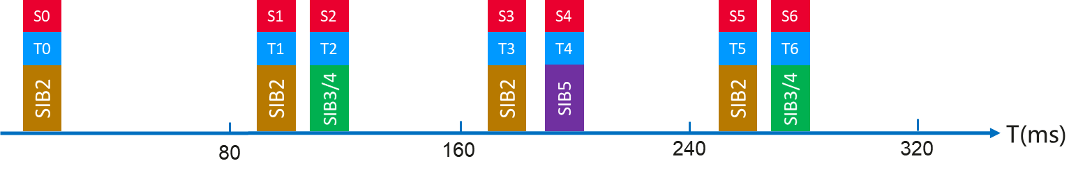
Figure 6.27.2.2.1-X: Each SIB repetition has its own timestamp and a digital signature
Second, multiple SIBs within a periodicity share a common timestamp, as well as a common digital signature. As shown in Fig 6.27.2.2.1-Y, a new timestamp is obtained, and a new digital signature is computed for a periodicity of 80ms. For the SIBs broadcasted in this periodicity, they are all treated as input for the signature calculation. For example, in the calculation of S1, SIB 2/3/4 are the input. Thus, t_w=t_s+t_d+τ=80ms+1ms+2ms=83ms.
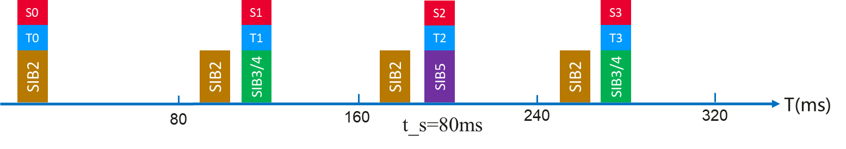
Figure 6.27.2.2.1-Y: Multiple SIB repetitions within a periodicity carry the same timestamp and digital signature
Third, multiple SIBs within a periodicity share a common timestamp, as well as a common digital signature. As shown in Fig 6.27.2.2.1-Z, a new timestamp is obtained, and a new digital signature is computed for a periodicity of 160ms. During this periodicity, if serveral SIBx for the same type are broadcasted, the latest SIBx are used as input for the signature calculation. For example, two SIB2 are broadcasted while the second SIB2 are taken into use for the signature calculation. Thus, t_w=t_s+t_d+τ=160ms+1ms+2ms=163ms.
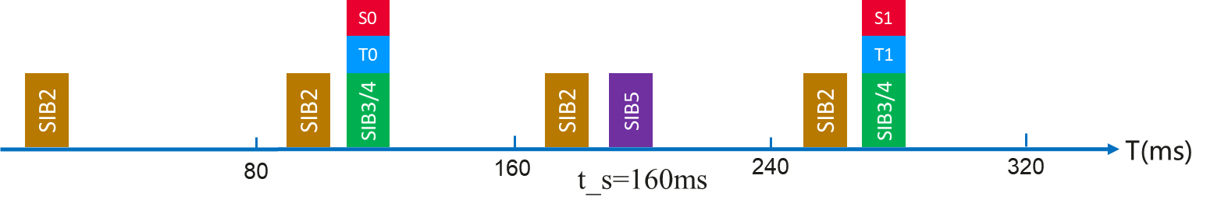
Figure 6.27.2.2.1-Z: Multiple SIB repetitions within a periodicity carry the same timestamp and digital signature
Fourth, multiple SIBs within a periodicity share a common timestamp, as well as a common digital signature. As shown in Fig 6.27.2.2.1-XX, a new timestamp is obtained, and a new digital signature is computed for a periodicity of 320ms. Thus, t_w=t_s+t_d+τ=320ms+1ms+2ms=323ms.
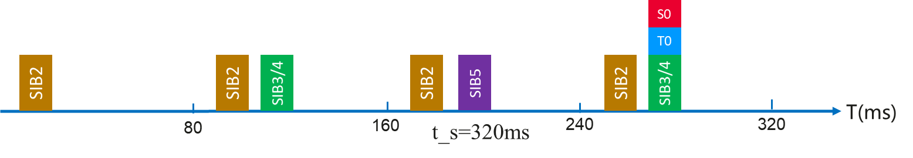
Figure 6.27.2.2.1-XX: Multiple SIB repetitions within a periodicity carry the same timestamp and digital signature
There is a tread-off for the setting of periodicity sharing a common timestamp and signature. On one hand, the smaller the periodicity is, the more effective it is against replay attacks. On the other hand, as the SIBs are not changed frequently, the increased periodicity is more effective for the air interface transmission. To this end, we also recommend leaving the periodicity configurable.
In addition, if UEs check the signed SIB based on the periodicity, the time window for the replay attack will be reduced. The accuracy of above time window of verification is low in approaches that share a common timestamp/signature. This accuracy can be improved if the time and SFN of a SIB carrying the signature are signed since the timing between SIBs is fixed and known, i.e., in which SFNs which SIBs are broadcasted. This alternative approach achieves an accuracy t_w as small as in the case in which each SIB1 includes a new fresh signed timestamp at the cost of increasing the delay in the acceptance/validation of the received SIB proportional to the timestamp reuse
Editor’s note: Details are FFS.

*** END OF 2nd CHANGE ***

