**3GPP TSG-SA3 Meeting #104-e- Ad-hoc *draft_S3-213414-r2***

**e-meeting, 27 – 30 September 2021** Revision of S3-20xxxx

**Source: Huawei, HiSilicon**

**Title: Address EN and add evaluation for solution 4**

**Document for: Approval**

**Agenda Item: 5.5**

# 1 Decision/action requested

***This contribution proposes to address ENs and update evaluation in solution 4 in TR 33.867.***

# 2 References

# 3 Rationale

There are 3 editor’s note in the solution 4:

“Editor’s note: how does the NEF know the purpose from API invocation is ffs.”

“Editor’s note: how to ensure user consent parameters are current / not outdated is ffs.”

“Editor’s Note: Further information elements to uniquely define a purpose are FFS.”

For the 1st EN, it is proposed to add an example for clarification.

For the 2nd EN, it is proposed to subscribe the Nudm_SDM_Subscribe service to keep the user consent parameters up-to-date.

For the 3rd EN, since there is a key issue #5 “Unambiguous naming of purposes”, the issues can be addressed under solution against key issue #5. It is proposed to change the editor’s note to the NOTE which refers to key issue#5.

Besides, the solution can address the requirement in key issue #1, so, it is proposed to add the evaluation part for the solution.

# 4 Detailed proposal

*************** Start of 1st Change ****************

2 References

The following documents contain provisions which, through reference in this text, constitute provisions of the present document.

- References are either specific (identified by date of publication, edition number, version number, etc.) or non‑specific.

- For a specific reference, subsequent revisions do not apply.

- For a non-specific reference, the latest version applies. In the case of a reference to a 3GPP document (including a GSM document), a non-specific reference implicitly refers to the latest version of that document *in the same Release as the present document*.

[1] 3GPP TR 21.905: "Vocabulary for 3GPP Specifications".

[2] 3GPP TS 23.558: "Architecture for enabling Edge Applications (EA) ".

[3] 3GPP TR 33.849: “Study on subscriber privacy impact in 3GPP”.

[4] 3GPP TS 23.288: “Architecture enhancements for 5G System (5GS) to support network data analytics services”

[5] 3GPP TS 23.501: “System architecture for the 5G System (5GS)”

[6] General Data Protection Regulation, <https://eur-lex.europa.eu/legal-content/EN/TXT/HTML/?uri=CELEX:02016R0679-20160504&from=EN>

[xx] 3GPP TS 23.502: “Procedures for the 5G System (5GS)”

*************** End of 1st Change ****************

*************** Start of 2nd Change ****************

7.4 Solution #4: Check of User Consent for 3GPP Service Exposure

7.4.1 Solution overview

The solution addresses key issue #1 “User Consent for Exposure of information to Edge Applications”.

7.4.2 Solution details

7.4.2.1 Check of user consent on NEF/CAPIF

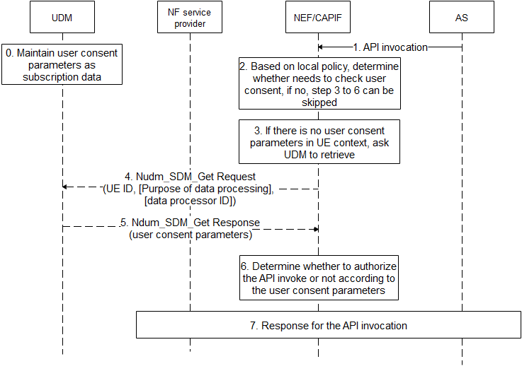

Figure 7.4.2.1-1 Check of User Consent on NEF/CAPIF

1. UDM maintains user consent parameters as subscription data as depicted in 7.4.2.2.
2. AS sends API invocation to NEF/CAPIF, requesting for processing user’s data, e.g. if the invocated service is “Nnef_Location_LocationUpdateNotify” with inputs with AF ID, and GPSI, it means that the AF asks NEF/CAPIF to retrieve location of UE identified by the GPSI.
3. The NEF/CAPIF determines whether the invocated service needs to check user consent based on operator’s local policy, e.g. whether regulation is required, whether the invocated service is to process user’s personal information, etc.. If there is no need to check user consent, step 3-6 can be skipped.

Editor’s note: how does the NEF know the purpose from API invocation is ffs.

1. If there is no related user consent parameters in UE context, the NEF/CAIPF invokes Nudm_SDM_Get Request service to retrieve related user consent parameters. Otherwise, step 4-5 can be skipped.
2. The NEF/CAPIF sends Nudm_SDM_Get Request message to the UDM, the message shall include UE ID, and may include purpose of data processing, data processor ID. The UE ID can be SUPI which is resolved with the GPSI by NEF/CAPIF using existing mechanism. The purpose of data processing is format combined with service operation name and some of specific inputs which are derived from the API invocation, The data processor ID can be AF ID or more generic which is resolved from the AF ID in the API invocation.

Editor’s note: how does the NEF know the purpose from API invocation is ffs.

1. The UDM returns requested user consent parameters, which includes user consent result.
2. The NEF/CAPIF determines whether to authorize the API invocation or not according to the user consent parameters. If the user consent result of the purpose of data process is not allowed, the NEF/CAPIF rejects the AF’s request with specific cause. If the user consent result of the purpose of data process is allowed, the NEF/CAPIF accepts the AF’s request. If there is no explicit user consent results, the NEF/CAPIF can decide to reject or accept the AF’s request based on operator’s local policy. Besides, if the user consent result of the purpose of data process is allowed, the NEF/CAPIF uses Nudm_SDM_Subscribe service to subscribe the change of user consent parameters event on the UDM to maintain the non-outdated user consent parameters.
3. The NEF/CAIPF response for the API invocation based on determination in step 6.

7.4.2.2 User Consent Parameter

The UDM maintains the following user consent parameters:

* UE ID: can be SUPI.
* Data Processor ID: refers to a data processor who process data for the UE, can be AF ID, or more generic, e.g. “3rd party” or “all”.
* Purpose of data processing: combined with service operation name and some of specific inputs, e.g. Nnef_AnalyticsExposure_Subscriber with Analytic ID set to “UE communication analytics”, which means to allow AF to ask for UE’s communication analytics information.
* Editor’s Note: Further information elements to uniquely define a purpose are FFS.User Consent Result: whether there is consent for data processor to process the data according to purpose of data processing.

7.4.3 Solution evaluation

TBA.*************** End of 2nd Change ****************