**3GPP TSG-SA3 Meeting #104-e- Ad-hoc *draft_S3-213410-r1***

**e-meeting, 27 – 30 September 2021** Revision of S3-20xxxx

**Source: Huawei, HiSilicon**

**Title: Common Architecture**

**Document for: Approval**

**Agenda Item: 5.5**

# 1 Decision/action requested

***This contribution proposes a content for clause 5B in TR 33.867.***

# 2 References

# 3 Rationale

The contribution proposes context for clause 5B common architecture.

# 4 Detailed proposal

*************** Start of 1st Change ****************

5B Common architecture

The common architecture for user consent is shown in figure 5B-1.

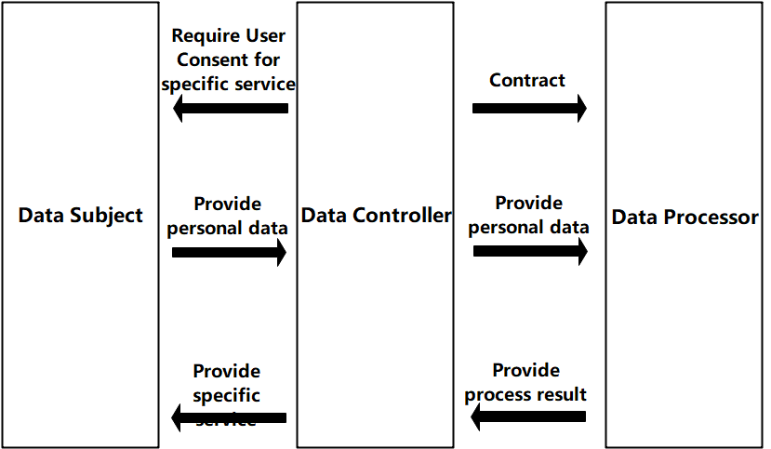

5B-1 Common Architecture for User Consent

The data subject is provided specific services from the data controller, if the service needs user consent, e.g. the service requires to process the personal data, the data subject is required by the data controller for user consent for the service from the data controller. The data subject decides whether to grant the consent. In 3GPP, the data subject is end-user.

The data controller requires data subject to provide user consent for specific service if the service needs user consent. If the consent is granted from the data subject, the data controller collects and stores the personal data, and provides the personal data to the data processor. Once process result is received, the data controller provides the specifica service to the data subject. In 3GPP, the data controller is operator. the data controller will sign a contract with the data processor, the contract limits the data processing to the contracted out purpose

The data processor receives personal data from the data controller and provide process result to the data controller. In 3GPP, the data processor is data controller itself (i.e. operator) or 3rd party.

The consent may be also given for defined external data processors (e.g. limited to being located in certain countries).

*************** End of 1st Change ****************