3GPP TSG-SA3 Meeting #102-e S3-210142
e-meeting, 18 - 29 January 2021 (revision of S3-yyxxxx)

Source: ATT, Nokia, Nokia Shanghai Bell, Interdigital, Broadcom, Ericsson, Samsung, Apple, Verizon, T-Mobile, Qualcomm

Title: New WID on Non Seamless WLAN Offload in 5GC using 3GPP credentials

Document for: Approval
Agenda Item: 4.22
3GPP™ Work Item Description
Information on Work Items can be found at http://www.3gpp.org/Work-Items
See also the 3GPP Working Procedures, article 39 and the TSG Working Methods in 3GPP TR 21.900

Title: New WID on Non-seamless WLAN Offload in 5GC using 3GPP credentials

Acronym: NSWO_5G

Unique identifier: TBD
Potential target Release: Rel-17

1 Impacts
Affects: | UICC apps | ME | AN | CN | Others (specify)
Yes |  | x |  | X
No |  |  | x
Don't know | x

2 Classification of the Work Item and linked work items

2.1 Primary classification
This work item is a feature to provide support for Non-seamless WLAN Offload (NSWO) in 5GC using 3GPP credentials.
X | Feature
 | Building Block
 | Work Task
 | Study Item

2.2 Parent Work Item
{"Parent" Work Item refers to the related, earlier Stage, Work Item, e.g. the related Stage 1 Work Item shall be indicated here when a Stage 2 Work Item is presented or e.g. the related Study Item shall be indicated here when a normative-work Work Items is started. List here all parent Work Items of which requirements are either fully or partially covered by the proposed Item. List previous Work Items of earlier releases if relevant.}
{This section is mandatory to be filled out by the rapporteur.}

Parent Work / Study Items
Acronym | Working Group | Unique ID | Title (as in 3GPP Work Plan)

2.3 Other related Work Items and dependencies
Other related Work Items (if any)
Unique ID | Title | Nature of relationship
 |  | {optional free text}
Dependency on non-3GPP (draft) specification: RFC 3748, RFC 4187

3 Justification
4G specifications allow Non-seamless WLAN Offload (NSWO) to the internet using SIM based Wi-Fi access authentication via the mobile network core (described in TS 23.402). This is a deployed feature in 4G networks, where the use cases would be e.g. a Wi-Fi venue like a hotel or stadium where IP connectivity to access internet Wi-Fi offload requires SIM based authentication. This allows the use of mobile network subscription and roaming agreements for Wi-Fi access.
The use case requires AAA interactions between the Wi-Fi AP and the mobile network core (see SWa and SWx in the Figure-1 below). Please note that the user plane doesn’t use the PLMN access network or the core. Such deployments currently exist in mobile operator domain.

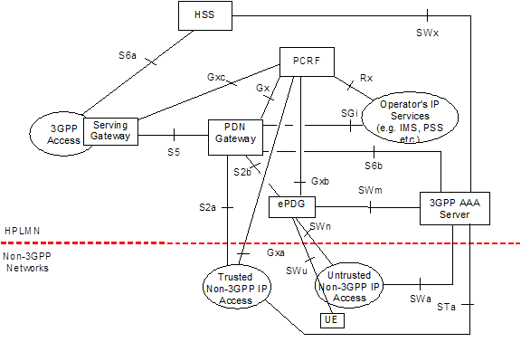
Figure-1
Similar Wi-Fi offload to internet after Wi-Fi access authentication using 5G credentials cannot be currently done via 5G core - support of this capability could not be identified in specifications (see for example Figure-2 below). From our perspective this is a significant shortcoming for 5G core that needs to be rectified in Release 17.

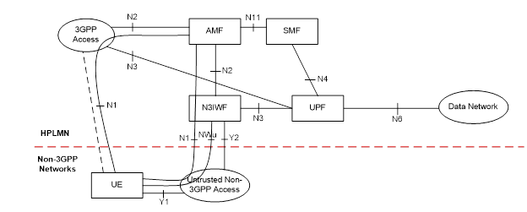
Figure-2
Non-seamless WLAN offload (NSWO) for LTE is defined in TS 23.402. Please note that service continuity between PLMN network and the WLAN access is not supported in Non-seamless WLAN Offload (NSWO).
A UE supporting non-seamless WLAN offload may, while connected to WLAN access, route specific IP flows via the WLAN access without traversing the 5GC. These IP flows are identified via user preferences, the Local Operating Environment Information defined in TS 23.261 [55], and via policies that may be statically pre-configured by the operator on the UE, or dynamically set by the operator. For such IP flows the UE uses the local IP address allocated by the WLAN access network and no IP address preservation is provided between WLAN and 3GPP accesses.
Please note that dynamically setting by the operator does not require EPC rules or changes to 5GC as NSWO is already foreseen in URSP as described in 23.503 Table 6.6.2.1-3: Route Selection Descriptor
Non-Seamless Offload indication | Indicates if the traffic of the matching application is to be offloaded to non-3GPP access outside of a PDU Session. | Optional  (NOTE 4) | Yes | UE context

For performing the non-seamless WLAN offload, the UE needs to acquire a local IP address on WLAN access, and it is not required to connect to an N3IWF.
Also, in the case the WLAN access is EPC connected, it is possible for a UE which also supports seamless WLAN offload to perform seamless WLAN offload for some IP flows and non-seamless WLAN offload for some other IP flows simultaneously.

4 Objective
The overall objective is to support Non-seamless WLAN Offload (NSWO) in 5GC, similar to the existing 4G NSWO feature based on following assumptions:
- it is possible for a UE perform seamless WLAN offload for some IP flows and non-seamless WLAN offload for some other IP flows simultaneously
- NSWO relates only to IP traffic
- the operator can use existing URSP policies (defined in 23.503 clause 6.6.2) to configure which IP flows may be subject of NSWO
- 5GC level of security is provided for the UE authentication (and authorization) to use NSWO
- the WLAN deployments (of the WLAN partners of the MNO) should not need updates to support the 5GC authentication and authorization of NSWO

The work part of this WID
- To optionally support NSWO in 5GC, a UE authentication with 5G credentials need to be supported. The UEs while accessing the WLAN AP, present the 5G credentials belonging the PLMN subscription for authentication. The WLAN AP routes the authentication request to the 5GC to authenticate the UE and provide services when UE authentication and authorization has been successfully completed.
- Define procedures to support EAP-AKA’ authentication methods in 5GC for NSWO.
- Define mechanisms, similar to the SUCI, to protect the privacy of the subscribers.

5 Expected Output and Time scale
New specifications {One line per specification. Create/delete lines as needed}
Type | TS/TR number | Title | For info  at TSG# | For approval at TSG# | Rapporteur
 |  | {Title of the specification (as per TR 21.801 §6.1.1), to be aligned as much as possible with the WI/SI title} | {E.g.  "TSG#87"} | {E.g.  "TSG#89"}
{Note 1: Only TSs may contain normative provisions. Study Items shall create or impact only TRs.
"Internal TR" is intended for 3GPP internal use only whereas "External TR" may be transposed by OPs.}
{Note 2: The first listed Rapporteur is the specification primary Rapporteur. Secondary Rapporteur(s) are possible for particular aspect(s) of the TS/TR. In this case, their responsibility has to be provided as "Remarks".}

Impacted existing TS/TR {One line per specification. Create/delete lines as needed}
TS/TR No. | Description of change | Target completion plenary# | Remarks
TS 33.501 | Potential addition of a clause or annex for the addition of authentication for non-seamless WLAN offload using 5G credentials. | SA#92 (June 2021) | No independent TS is anticipated at this time.

6 Work item Rapporteur(s)
Nair, Suresh, Nokia, suresh.p.nair@nokia.com

7 Work item leadership
SA3

8 Aspects that involve other WGs

SA2 (architectural aspects, if any)

9 Supporting Individual Members

Supporting IM name
ATT
Nokia
Nokia Shanghai Bell
Interdigital
Broadcom
Ericsson
Samsung
Apple
Verizon
T-Mobile
Qualcomm

