3GPP TSG-SA3 Meeting #102e S3-210136-r4

e-meeting, 18 - 29 January 2021

Source: Nokia, Nokia Shanghai Bell

Title: Solution for protecting the privacy of the UE identity.

Document for: Approval
Agenda Item: 5.12

1 Decision/action requested
The contribution proposes a solution to protect the privacy of the UE identity.

2 References
[1] 3GPP TR 33.857:” Study on enhanced security support for Non-Public Networks”
[2] 3GPP TR 23.700-07:” Study on enhanced support of non-public networks”

3 Rationale
This pCR proposes a solution to preserve the privacy of the UE identity using already defined methods and identifiers. The solution uses terms already defined in [2], onboarding SUCI and onboarding SUPI, which is the identity of the UE used during onboarding registration (initial access). The usage of the terms is further explained in the conclusion of [2] as,
“
- During the onboarding registration procedure, the UE registers with its Onboarding SUCI which is based on the Onboarding SUPI. Onboarding SUPI is encoded as a network specific identifier taking the format of a NAI (i.e. user@realm). The SNPN, which interacts with DCS, may determine the corresponding DCS identity or address/domain, based on the input from the UE or when primary authentication is used based on information (e.g. DCS address) locally provisioned at SNPN, using mechanisms similar to those for AUSF and UDM discovery and selection described in TS 23.501 [4].
Editor's note: SA WG3 should provide feedback on whether the UEs permanent identifier (SUPI or SUCI) may be used for finding the DCS identity or address/domain that can authenticate the UE, as well their security properties.
“
The solution aims to describe the mechanisms and interactions between the network functions located either in the trust domain of the onboarding network or default credential owner domain (within the DCS). The contribution covers the case where there is a trust relationship between the AUSF and DCS.

4 Detailed proposal
It is proposed that SA3 agree the below pCR for inclusion in the TR [1].
**** START OF CHANGES ****

3 Definitions of terms, symbols and abbreviations

3.1 Terms
For the purposes of the present document, the terms given in 3GPP TR 21.905 [1] and the following apply. A term defined in the present document takes precedence over the definition of the same term, if any, in 3GPP TR 21.905 [1].
Provisioning Server: The server that provisions the authenticated/authorized UE with the NPN credentials.
SNPN credentials: Information that the UE uses for authentication to access a SNPN.
For the purposes of the present document, the following terms and definitions given in 3GPP TR 23.700-07 [3] apply:
Default UE credentials: Information that the UE have before the actual onboarding procedure to make it uniquely identifiable and verifiably secure.
Default Credential Server (DCS): The server that can authenticate a UE with default UE credentials or provide means to another entity to do it.
NPN: Non-Public Network as defined in TS 23.501 [4]. The terminology NPN refers to both SNPN and PNI-NPN in this TR unless otherwise stated.
Onboarding Network (ON): The network providing initial registration and/or access to the UE for UE Onboarding.
Onboarding SUCI: A SUCI created from the Onboarding SUPI and used for onboarding purposes.
Onboarding SUPI: A SUPI that is based on the Unique UE Identifier and/or the Default UE Credentials and is used for onboarding purposes.
Subscription Owner (SO): The entity that stores and as result of the UE Onboarding procedures provide the subscription data and optionally other configuration information via the PS to the UE.
Unique UE identifier: Identifying the UE in the network and the DCS and is assigned and configured by the DCS.
NOTE 1: The unique UE identifier is assumed to be unique within the DCS. It takes the form of a Network Access Identifier (NAI) using the NAI RFC 7542.

**** NEXT CHANGES ****

6.Y Solution #Y: Privacy protection of UE onboarding identifier

6.Y.1 Introduction
This solution addresses key issue#4 Securing initial access for UE onboarding between UE and SNPN. The solution aims to address the potential privacy issue introduced by sharing the onboarding SUPI in plaintext. Privacy concerns are strongly related to the trustworthiness of the networks and therefore also the thrust model – who trusts who.
It assumed that the UE and DCS can trust the Onboarding network. This implies that the onboarding network has performed mutual authentication between the entity connected to the DCS and the DCS. Therefore, it implies by the transitive property that the UE can trust the onboarding network. The trust relation is a fundamental property and therefore cases where this is not achieved is out of scope for this solution.

- In the next section, the details of the solution are explained..

6.Y.2 Solution details
Figure 6.Y.2-1 shows a generalisation of the solution. The solution assumes, the AUSF and DCS has proven the mutual trust. The prove of mutual trust can be achieved by, but not limited to, authentication mechanism, authorisations schemes, token schemes, certification etc. The trust between DCS and AUSF can also be achieved by business agreements and other out of band solutions. This is not part of the figure.
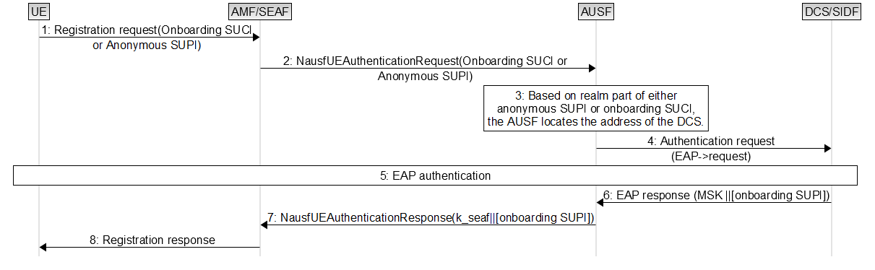
Figure 6.Y.2-1: initial access and sharing of identity.
1. The UE sends a registration request to the onboarding network. The request contains either the onboarding SUCI or anonymous SUPI. At this point, the UE are not aware whether the onboarding network can be trusted and therefore the onboarding SUPI can only be shared anonymous or concealed.
2. AMF/SEAF forwards the registration request to the AUSF.
3. Based on either the realm of the anonymous SUPI or onboarding SUCI the AUSF identifies the address path of the DCS.
4. The AUSF initiates the authentication by sending an EAP message to the DCS.
5. The authentication might cover multiple messages including requesting the identity. Different EAP protocols have different termination points of the security channel, like TLS and TTLS.
6. Depending on the authentication result, the DCS will return the MSK (assuming TLS) and optionally the onboarding SUPI depending of the trust model.
7. If the EAP result contains the onboarding SUPI it will be forward in the response to the AMF/SEAF.
8. Registration response.

6.Y.3 System impact
This solution is having impact on AUSF.
AUSF: Capability to forward the authentication request to the DCS.

6.Y.4 Evaluation
Editor’s Note: Each solution should motivate how the potential security requirements of the key issues being addressed are fulfilled.

****** END OF CHANGES ****

