3GPP TSG-SA3 Meeting #102bis-e draft_S3-211041-r2

e-meeting, 1 – 5 March Revision of S3-21xxxx

Source: Nokia, Nokia Shanghai Bell

Title: Solution on Privacy preservation of data

Document for: Approval, Information, Discussion
Agenda Item: 2.16

1 Decision/action requested
Introduction of a solution for privacy preservation of transmitted data

2 References
[1] 3GPP

3 Rationale
A key issue has been introduced on privacy preservation for transmitted data between multiple NWDAF instances. This contribution provides a solution.

4 Detailed proposal

SA3 is kindly requested to agree to the below pCR to TR 33.866.

********** START OF CHANGES

6.Y Solution#Y: Privacy preservation of transmitted data
Editor's Note: The solution needs to be revised to cut off the relation with user consent.

6.Y.1 Introduction
This solution addresses key issue #3.1.
During the transfer of data/metadata/analytics-output from one NWDAF to another NWDAF, it should be ensured that any information that can reveal the identity of the user or compromise in another way the privacy of the user is protected.
Therefore, appropriate measures should be taken by the sender NWDAF to protect any information that can hamper privacy and maybe reveal the identity of the user. Some of the examples are positioning information, user profile information, etc. These information should be processed/filtered by a NWDAF before sending the data to another NWDAF.
Thus, the privacy-sensitive information has to be protected (in accordance with the regulatory requirements and the operator's policies) before being transferred to any other NWDAF.

6.Y.2 Solution details
To protect the sensitive and private information of the user, a privacy framework is introducedBy this, different privacy rules can be applied by different operators/vendors based upon specific policies and requirements, e.g. by local policy.
The privacy rules can be stored in the home network in
- UDM/UDR if privacy is configured per subscriber, or
- NRF if privacy is generic for all the subscribers of one or several NFs.
User privacy policies and rules can be retrieved from UDM. NRF can also push this information to NFs.
Service requests related to User data need to be indicated, e.g. by an IE 'DataPurposeID'. The NF Service Consumer (i.e. requester NWDAF1 NF) needs to send this 'DataPurposeID' along with the request to the NF Service Producer (e.g. NWDAF2). Based on this IE, the NWDAF2 will process privacy related data accordingly to the specific policy or requirement valid in this operator network, before sending a service response to the requester NWDAF1.

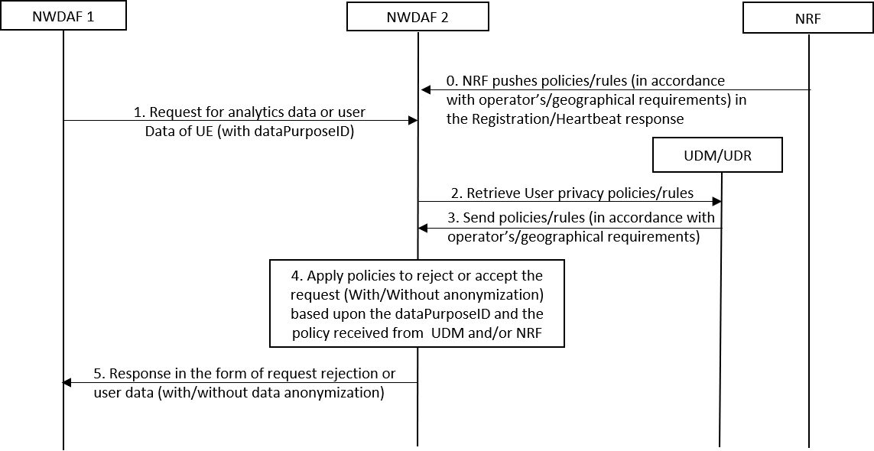
Figure 6.Y.2-1: Generic Procedure to preserve user privacy based upon the predefined policies
Step 0: If an operator configures the privacy rules in the NRF (generic for all subscribers), then the NRF can push the policy/rules to NF in the response of registration/heartbeat. A heartbeat message is sent by NFs every some seconds (i.e. 10-20 seconds). Therefore whenever the privacy rule is changed in the NRF, the NRF can push updated rules to the NFs.
EN: Definition on policies/rules to be added. Clarification needed how to specify them in our TR/TS.
Step 1: NWDAF1 sends a user data request to NWDAF 2 (Sending NWDAF Instance) with an additional IE DataPurposeID indicating the purpose.
NOTE: DataPurposeID specifies the purpose of the user data request corresponding to an analytics ID. For instance, the DataPurposeID can be 'Advertisement' corresponding to the user data request of analytics ID 'location'.
Step 2: NWDAF2 sends a request to retrieve the user privacy policies for a specific subscriber from the UDM/UDR. Or it can use the locally configured policies based upon the operator's or geographical requirements.
Step 3: UDM/UDR sends the privacy policies configured for the subscriber either by the operator or by the user or based upon the privacy local policy for a specific geographical region.
EN: Clarification needed on what is privacy local policy of a specific geographical region.
Step 4: NWDAF2, after receiving the policies, applies them to the requested user data for the DataPurposeID. For instance, because of the privacy policy it can either reject the request completely or it sends the data without or with anonymization. The latter preserves the sensitive information of the user. Policies received in Step 0 are also applied along with policy received in Step 3.
EN: Clarification needed on "DataPurposeID" in relation with privacy.
Step 5: NWDAF2 sends the processed data to NWDAF1 as a response to the initial request.

6.Y.3 Evaluation
TBD

********** END OF CHANGES

