3GPP TSG-SA3 Meeting #102bis-e draft_S3-210918-r2

e-meeting, 1 – 5 March 2021

Source: Huawei, Hisilicon

Title: New solution to update the keys used to protect the MBS traffic

Document for: Approval
Agenda Item: 2.11

1 Decision/action requested
This contribution proposes to add the solution for TR 33.850.

2 References
[1]

3 Rationale
The solution proposes to use the signalling messages to update the keys to protect the MBS traffic. The MBS traffic is protected between MBSF-U and UEs.

4 Detailed proposal
It is proposed to approve the following changes in TR 33.850.
*** BEGIN OF 1st CHANGE ***

6.X Solution #X: Update the keys used to protect the MBS traffic

6.X.1 Introduction
This solution addresses Key issue #2 to update the keys to protect the MBS traffic. The MBS traffic is protected between MBSF-U and UEs. The basic idea is to use the signalling messages for the key update procedure. The UEs, which belong to a multicast group, acquire the same group keys as in the MBSF-U. The security protection is enabled in service layer.

6.X.2 Solution details

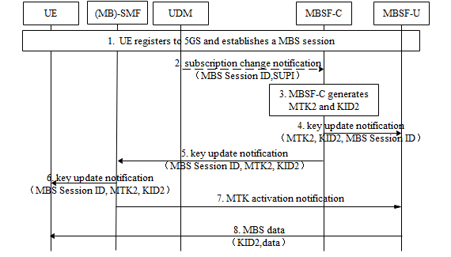
Figure 6.X.2 -1: Procedure for MTK update
1. The UE registers to 5GS and establishes a MBS session, during which MBSF-C generates MTK1&KID1 and distributes them to MBSF-U and UEs. MTK1&KID1 are used to protect the MBS traffic. Details can be found in solution 3 or solution 8.
2. MBSF-C subscribes to the UDM/UDR on the changes of the multicast information including the authorization information. The UDM/UDR notifies the MBSF-C when the authorization for a UE to join the multicast service/application is revoked. The MBS Session ID and UE identifier (i.e. SUPI) is included in the notification. The MBS Session ID may be a Temporary Mobile Group Identifier (TMGI) or a multicast address.
Editor’s Note: Why SUPI needs to be provided to MBSF-C is FFS.
3. MBSF-C triggers the MTK update based on the changes of authorization info or the key lifetime of MTK1. MBSF-C generates MTK2 and KID2 for this MBS session.
4-5. MBSF-C distributes MTK2, KID2 and MBS Session ID to (MB)-SMF and MBSF-U respectively.
6. (MB)-SMF distributes MTK2, KID2 and MBS Session ID to the authorized UEs whose MBS sessions are not released. Confirmation for update notification is responsed to (MB)-SMF. With the confirmation info, (MB)-SMF determines to activate MTK2 based on local policy.
7. If the procedure to update the key in UE side is finished, (MB)-SMF indicates MBSF-U to activate the MTK2 for the corresponding MBS session.
8. MBSF-U uses MTK2 and KID2 to protect the MBS traffic.
The above text describes the security handling when SMF and MB-SMF are co-located. If SMF and MB-SMF are deployed separately, MBSF-C distributes MTK2, KID2 and MBS Session ID to MB-SMF. Afterwards, MB-SMF distributes MTK2, KID2 and MBS Session ID to the authorized UEs via SMF. MB-SMF indicates MBSF-U to activate the MTK2

6.X. 3 Evaluation
This solution addresses Key issue #2 to update the key for protecting the MBS session.
MBSF-C decides to trigger the MTK update procedure. The new MTK and KID are sent to UE and MBSF-U respectively.
Editor’s Note: Further evaluation is FFS.
*** END OF 1st CHANGE ***

